Thursday Q1 Patient Care

Attendees | E-mail
Michael Tan (chair and scribe) | tan@nictiz.nl
Kevin Coonan | kevinCoonan@gmail.com
Tom de Jong | tom@nova-pro.nl
Laura Heermann | Laura.heermann@imail.org
Jim McClay | jmcclay@unmc.edu
Patricia Greim | Patricia.greim@va.gov

- Topic Health Concern:
  - Kevin Coonan is working on Problem Oriented Medical Record.
  - SOAP not suitable to organize and monitor topics over time.
  - Health concern is any related issue that require tracking.
  - Concerns can be multi hierarchy with overarching concerns (for example eye problems for a diabetes patient).
  - An important use case is a multi user environment where various care providers would like to link artifacts to each other.
  - Discussion of who is responsible for the concern (especially in a distributed environment) .
  - In Kevin’s view you need a custodian. Other care provides would need a publish and subscribe mechanism to be able to know who the present custodian is.
  - We should use storyboards to verify the mechanism of health concerns. For example what happens in a multi system environment when a patient is transferred from one care provider to another institution.
  - Possible next steps for health concerns:
    - Make a DAM ( describing the use case)?
    - Marketing?
    - Whitepaper?
  - Tom expresses his worry about the scope of the project. The ambition of Kevin is high and looks very complex. Most countries only need a fraction of the requirements to be able to organize problems.
  - A suggestion from Jim is to write a white paper explaining the concept and structure of health concerns. Kevin Coonan will write a white paper because he also has a current assignment to produce a white paper.
  - We run through the project scope statement for Health concern and work out the different steps and products in the plan. This project scope statement is not completed yet and has to be discussed with the other co-chairs of Patient Care. (See PSS).
  - Will there be conference calls? Yes, they are planned for the Thursday.
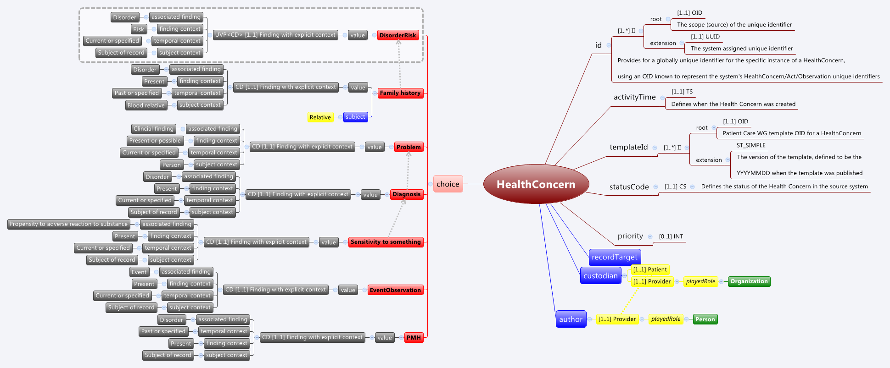
Figuur 1 diagram concept of Concerns

