Adverse Event FHIR Resource Proposal
- AdverseEvent
  - 1.1 Owning committee name
  - 1.2 Contributing or Reviewing Work Groups
  - 1.3 FHIR Resource Development Project Insight ID
  - 1.4 Scope of coverage
  - 1.5 RIM scope
  - 1.6 Resource appropriateness
  - 1.7 Expected implementations
  - 1.8 Content sources
  - 1.9 Resource Relationships
  - 1.10 Timelines
  - 1.11 gForge Users

AdverseEvent

Owning committee name
Patient Care

Contributing or Reviewing Work Groups
RCRIM, Pharmacy, CDS, PHER, EC

FHIR Resource Development Project Insight ID
? Use of existing PSS

Scope of coverage
Based on TANSI/HL7 V3 ICSRP1, R2-2012 HL7 Version 3 Standard: Pharmacovigilance - Individual Case Safety Report, Part 1: The Framework for Adverse Event Reporting, R2 (revise and partition ANSI/HL7 V3 RRCS, R1-2005)1/31/2012
ICSR Part 1 is http://www.hl7.org/implement/standards/product_brief.cfm?product_id=266
ICSR Part 2 is http://www.hl7.org/implement/standards/product_brief.cfm?product_id=267. (medicinals only)
To enhance patient safety, it is noted that many countries have strong needs to exchange product safety information between varieties of stakeholders in the healthcare domain. Currently many regulatory agencies collect safety reports of adverse drug reactions, adverse events, infections, contamination and other incidents from consumers, pharmaceutical companies and healthcare professionals.
The adverse event resource will address the exchange of the following types of information:
- Individual Case Safety Report (ICSR): framework for data exchange and information sharing by providing a common messaging format for transmission of ICSRs for adverse drug reactions (ADR), adverse events (AE), product problems and consumer complaints that may occur upon the administration or use of one or more products or substances. The reports can relate to a specific subject or may be used to relay an issue or finding related to a specific substance, product or device.
- (Not in current standard) – Individual Occurrence Report (IOR): the identification and characterization of exceptional events related to patient care, patient safety, protocol implementation, and service delivery. Examples might be falling out of bed, slipping on a wet floor, inappropriate use of restraints.
Does the concept of sentinel event need to be included?

RIM scope
- InvestigationalEvent: Class Code INVSTG
- Causality: ? Code based on event
- Report: Class Code CACT (can have multiple reports)
Common data elements for ICSR
- Identifiable patient (Note that this may be restricted by regulation and can be masked using "Privacy" or initials. However, for product problems there may or may not be an identifiable patient.)
- Identifiable reporter
- Date of Event
- Description of the event or problem
- Substance or Product name
Common data elements for IOR
- Identifiable patient (Note that this may be restricted by regulation and can be masked using "Privacy" or initials. However, for product problems there may or may not be an identifiable patient.)
- Identifiable reporter
- Date of Event
- Description of the event or problem

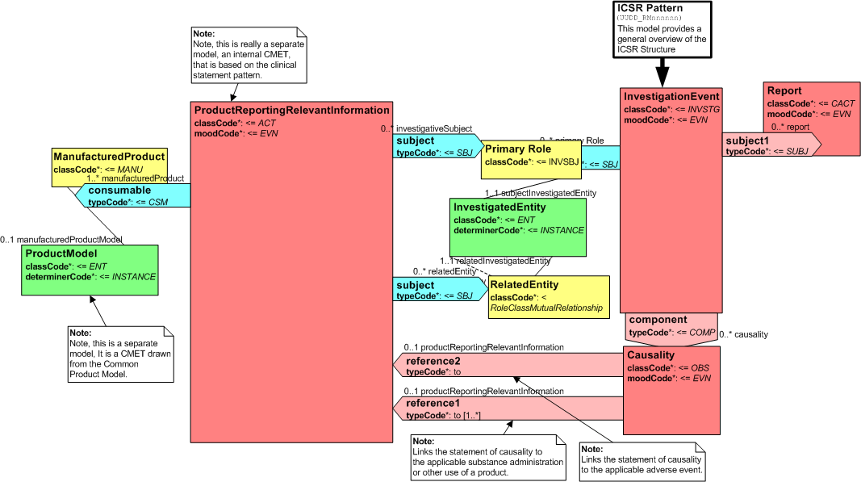

Resource appropriateness
An adverse event is a well-known healthcare concept that is regularly tracked and reported for clinical care, public health and research.

Expected implementations
An integral part of any care setting, research setting or public health reporting entity.

Content sources
Existing ISO/HL7/CEN standards as well as examples of health care institution occurrence reporting systems.

Resource Relationships
AllergyIntolerance, Condition, Procedure, Risk Assessment?, Medication Statement, Immunization, Observation,

Timelines
DSTU 2.1 - DRAFT

gForge Users
Lloyd McKenzie, Michelle Miller

