HL7 Patient Care Work Group
Allergy/Intolerance/Adverse Reaction Topic Sub-Group Meeting Minutes

Date: July 16, 2014
Phone Number: +1 770-657-9270
Participant Passcode: 943377
Co-Chairs: Stephen Chu/Elaine Ayres Scribe: Elaine Ayres
Name | Present on July 16, 2014
Elaine Ayres | X
Stephen Chu | X
Lisa Nelson | X
Russ Leftwich | X
Rob Hausam | X
Lee Unangst | X
Lynette Elliot | X
Joanne Chan | X
Maxim Topaz | X
Kevin Coonan | X

Agenda for July 16, 2014
- Review agenda
- Approve Minutes for June 11 and June 25 (see wiki site)
- PSS with Vocab re SNOMED terms (Rob Hausam)
- C-CDA Harmonization - with associated terminology (Lisa Nelson, Russ Leftwich, Rob Hausam)
- Agenda for July 23, 2014

Minutes June 11, 2014:

June 11, 2014 Move: Stephen/Rob Abstain: 1 Negative: 0 Approve: 7

Minutes June 25, 2014:

June 25, 2014 Move: Stephen/Rob Abstain: 1 Negative: 0 Approve: 7

Clinical Models – publication pending

PSS with Vocab – Rob Hausam to review with Vocab group.

OpenEHR – CKM archetype review process for adverse reaction/allergy and intolerance now open. (Note – need to sign up for an account)

C-CDA Harmonization:
- Address need for a Criticality Observation for the Allergy Intolerance Observation in place of current duplicate use of Severity template (on reaction and allergy observation) - PENDING
- Allergy/Adverse event type value set – NAME: Allergy and Intolerance Type Value Set (7/16/14)
- Concepts for value set: Use existing and add intolerance to substance, or come up with question and answer sets?
- Null flavor concepts
- Assertion?
- Negation indicator
- Review the entryRelationship type from allergy-intolerance Observation to reaction
- Review entryRelationships
- SAS: SubstanceAdministration
- Subj: Medication Activity
- Subj: Procedure
- StatusCode versus Use of Allergy Status entryRelationship

Name of Value Set:

Currently: Allergy/Adverse Event Type

Use various value sets for type of substance. Categorize at least to select the correct value sets. If A – use this value set, …..

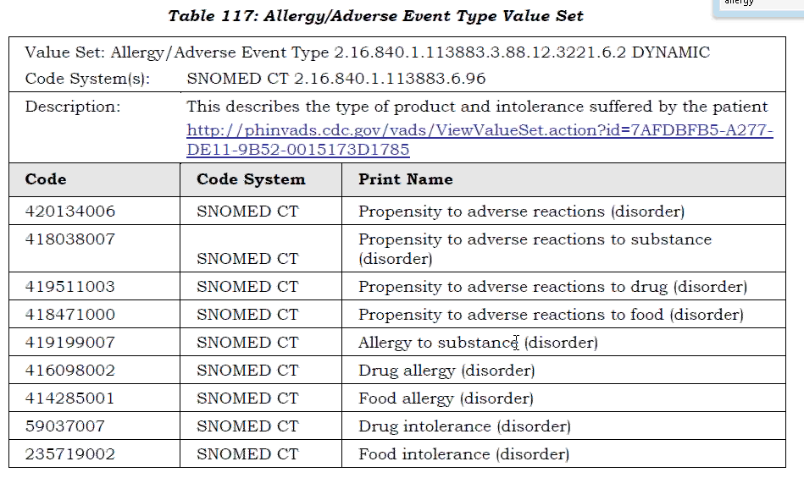

FROM conversation on 6/26/14 – Ayres/Hausam/Leftwich

Table Name: Allergy and Intolerance Classification Type Value Set – APPROVED on 7/16/14

Propensity to adverse reactions to a substance (undifferentiated allergy or intolerance (synonym))

Allergy to substance – ok as is

Intolerance to substance – need to add as SNOMED concept

Discussed use of LOINC as alternative – as observations these values should remain as SNOMED.

This is the relationship of these concepts:
  - Propensity to adverse reactions
    - Hypersensitivity disposition
    - Propensity to adverse reaction to a substance
      - Allergy to a substance (**two parents)
        - Drug Allergy**
        - Food Allergy**
      - ADD Intolerance to substance
      - Propensity to adverse reaction to a drug
        - Drug Allergy**
        - Drug Intolerance
      - Propensity to an adverse reaction to food
        - Food Allergy**
        - Food Intolerance

Do we need a separate value set for a “Known Allergy”?

What is the concept of certainty? In the allergist community there is a patient report reaction, vs a reaction that is observed by a physician. The latter is more certain.

Another use case – multiple meds with a reaction, but which is causing. There is uncertainty about which drug, but how to you record? Are you allergic to all, or might be allergic to all three?

Possible concepts – current:

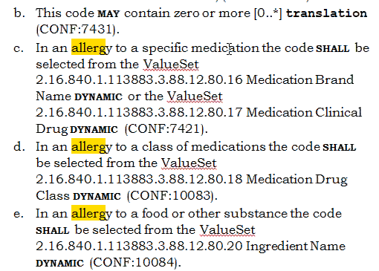

What is the value set designed to accomplish? Allergy Problem Act – (or concern act). Problem Observation or other problem observation related to the concern. Clinical Statement (the act) allergy or adverse reaction exists or does not exist. The code (SNOMED) is an assertion carried in the terminology. What type of allergy is this??? The causative agent is noted as a specific entity.

Suggested: Allergy and Intolerance Category

Need a concept to tell us what category we are in….a medication, a class of medications, or a food or other substance. Would need categories that do not overlap.

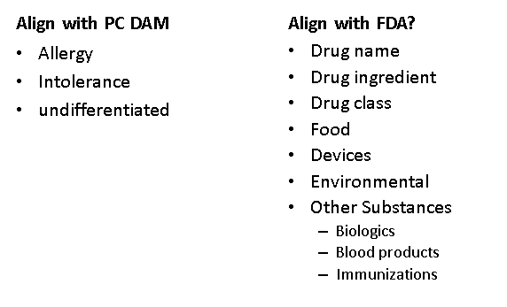

Question and Answer table: use same value set for each question.

 | Allergy? | Intolerance? | Undifferentiated?  Undetermined | Value Set
Drug Name | Code– Allergy to named drug? | Code – Intolerance to named drug? | Code – allergy or intolerance to a named drug? | Value set of drug names

Drug Ingredient

Drug Class

Food
Devices | May be in RxNorm

Environmental

Other Substances

…

Code in cell/Fifth column with a value set of substances.

What is the issue (Code) – and then name the thing (Substance).

Meaningful use – classified allergy as an immunological reaction. Everything else is an intolerance (these have a variety of mechanisms). Both are unique to the individual.

In the C-CDA – Allergy Problem Act, there is a LOINC code to call out an allergy, adverse reaction or alert, or you can put “concern”. The substance is noted as manufactured product with a code.

Need 21 variants of the concepts across to make the case statement work. Need a coded value. Use qualifiers? Need to come up with the terms of the value set, and the representation of the allergy, intolerance and undifferentiated classes.

ACTION – determine concepts and complete grid. Complete seven rows.

Note there is a reaction template and a severity template as well. There may be a reaction noted, and there may need a high level concept that notes there is some sort of allergy/tolerance. There might not be a substance – need a null flavor.

Discuss -- How do you differentiate between allergies and intolerances? Cannot always tell which it is. What if an allergist wants to say something very specific? Can we model this? Need to enable decision support via an accurate allergy and intolerance list.

ACTION – work on Allergy/AdverseEvent Value Set

Look at the correct set of answers

Then look at the answers

Look at assertion – should these be LOINC codes vs. SNOMED?

TermInfo – structural vs. terminology – mixing models and terminology. Assert and then provide a value set. The use assertion pattern makes coupling of concepts impossible – e.g. a question and an answer. Need to move beyond the assertion pattern. Suggest – not use the assertion pattern – rather use the code to represent a question and a code to represent the answer.

Criticality discussion: (on 7/2/14 with Russ, Rob and Elaine)

Current FHIR value set (Allergy and Intolerance).

1.14.2.1.33.1 Criticality

The criticality of an adverse sensitivity

This value set defines its own terms in the system http://hl7.org/fhir/criticality
Code | Display | Definition
fatal |  | Likely to result in death if re-exposed.
high |  | Likely to result in reactions that will need to be treated if re-exposed.
medium |  | Likely to result in reactions that will inconvenience the subject.
low |  | Not likely to result in any inconveniences for the subject.

These codes are used in the following places:
- AllergyIntolerance.criticality (Fixed)

The OID for the value set is 2.16.840.1.113883.4.642.2.33 33 (OIDs are not used in FHIR, but may be used in v3, or OID based terminology systems).

See the full registry of value sets defined as part of FHIR.

OPTIONS: In many cases, not carried forward from one record to another.

This is a probability assessment. Criticality = Seriousness (Open EHR)(Note – OpenEHR applies seriousness to a condition as well)(Open EHR has contraindication and absolute contraindication)

May have judgment, may not have enough information to make a judgment. C-CDA will allow null flavors.

In FHIR – do not have to have a value. So look at concepts for probability:
- Flag for criticality – 0 or 1
- High or Low or No code (leave blank)
- High or Low or Unable to Determine or Unknown (e.g. from another system)
  - Currently has 0..1
  - Change cardinality to 1..1 (? FHIR) (need to be sure that codes convey definitions.

Code for HIGH - Definition: May result in a life threatening or organ system threatening outcome.

Code for LOW – Definition: Unlikely to result in a life threatening or organ system threatening outcome.

Unable to Determine – Definition: Unable to assess with information available.

Unknown – Definition: No information (Null) (Value set in FHIR, flavors of null in C-CDA)

Note that clinical decision support is dumb – can’t distinguish between severity and criticality unless specified.

Added 7/16/14: Alternative definition for criticality: Exposure to identified substance is predicted to result in an adverse effect which is potentially fatal, loss of limb, spontaneous abortion, or irreversible organ failure.

FHIR may not like the 1..1 cardinality – will probably suggest 0..1. 1…1 is only at the profile level.

ACTION – need to decide on how to represent criticality and what elements can be included in C-CDA.

Agenda for July 23, 2014
- Review agenda
- Approve Minutes for July 16
- PSS with Vocab re SNOMED terms
- Stephen will review the CKM process
- C-CDA Harmonization - with associated terminology
- Agenda for August 6, 2014

