Use cases for order management

This document describes the use cases for the ordering workflows around Pharmacy. Its purpose is to illustrate the different interoperability steps that may be present in medication ordering processes.
The sequence diagrams may contain implicit requirements – such as the status management or any metadata to steer the information flow.

Basic order, no pharmacy, medication dispensed at ward

The physician enters an order for medication that is available at the ward. The CPOE sends to pharmacy system that translates it into a proper administration plan. The order is detailed and the administration plan is sent to the nursing system. Eventually, the CPOE receives updates upon each administration.
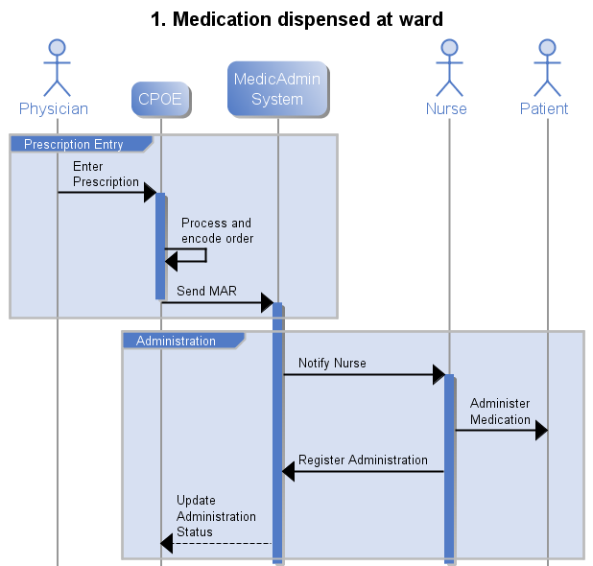

Basic order, no pharmacy, medication dispensed at Pharmacy and ward

The physician enters an order for medication that is available at the ward. The CPOE sends to pharmacy system that translates it into a proper administration plan. The order is detailed and the administration plan is sent to the nursing system, and also to the dispensing system. The dispensing system then updates the nursing system after dispensing.
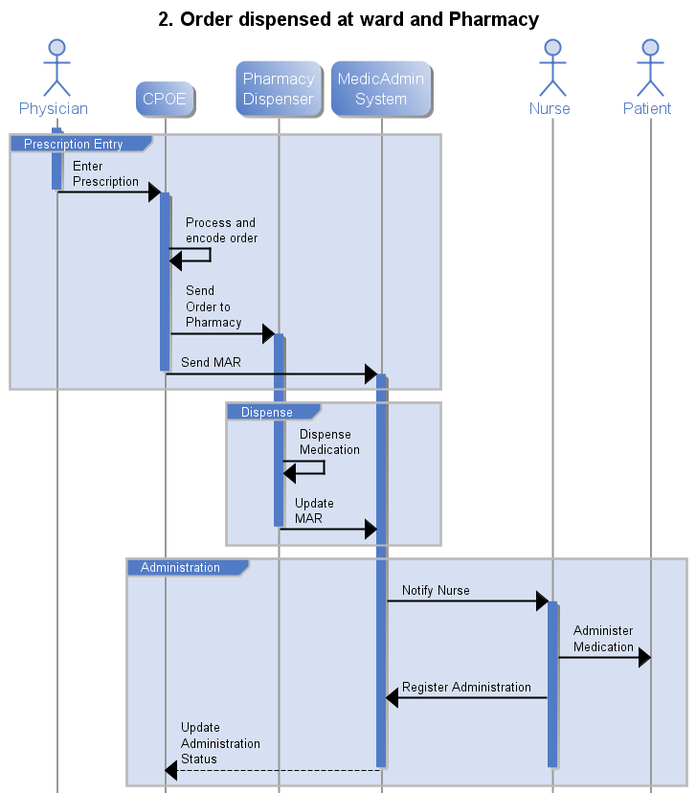

Order reviewed and complemented at pharmacist system. Dispensed at Pharmacy and ward
The physician enters an order for medication that is available at the ward. The CPOE sends to a pharmacy system that reviews the order for completion. The administration plan is sent to the nursing system, and also to the dispensing system. The dispensing system then updates the nursing system after dispensing.
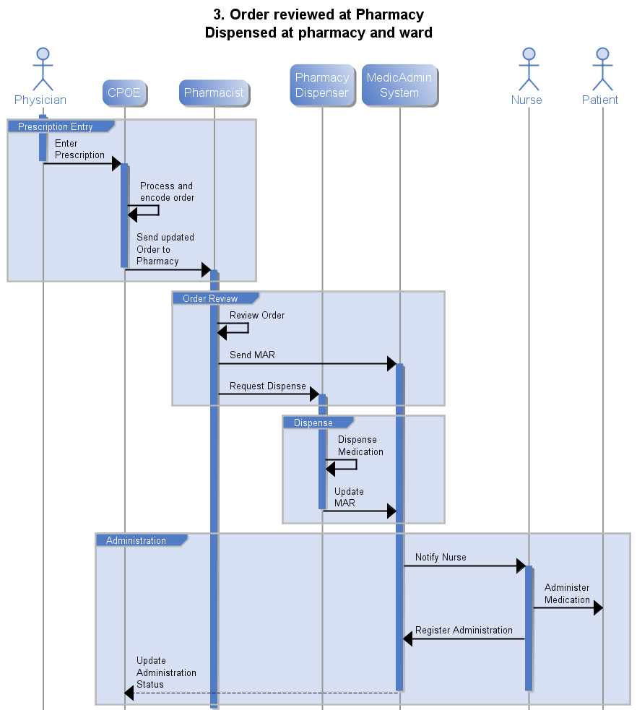

Order reviewed and countered by pharmacist. Physician may (or is expected to) review the order.
The physician enters an order for medication that is available at the ward. The CPOE sends to a pharmacy system that reviews the order for completion. Upon review, the pharmacist sees the need to add comments about one prescription item (over dosage) or a combination of two items (e.g. an interaction). The physician may want to review the order and/or update it. Note: in some cases the review or change is mandatory – e.g. insufficient stock. The administration plan is sent to the nursing system, and also to the dispensing system, which after dispensing, also updates the nursing system.
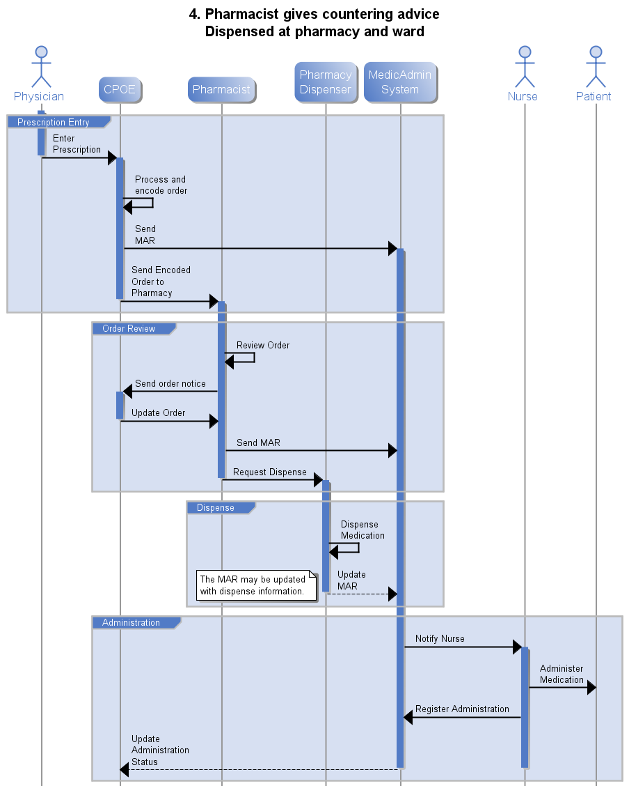

Order review is optional and simple advice. Physician may (or is expected to) review the order.
Physician enters an order, and the pharmacist checks for possible interactions. The physician receives the feedback from the pharmacist and sees this indication as a “warning”, which he acknowledges and overrides any warning and confirms the prescription. The prescription is confirmed despite the warnings from the pharmacist. The advice is recorded for auditing reasons of patient safety and for the ICA system internal control.

Order reviewed and countered by pharmacist. Physician must review order .
In a surge of an infection, several physicians look up the codes and generic product descriptions for antibiotics, and order some treatment based on active substance. The CPOE selects the first available product, and the “substitution allowed” option is active. The physician signs and authorizes. In the Pharmacy, due to a dispensing bottleneck, the pharmacist reviews the order and changes to another equivalent product. Since the substitution is allowed, the physician does not get called, he can just review later (comparing the initial order with the one altered by the pharmacist).
Some medication can only be prescribed with a valid diagnosis properly encoded. The physician does not do this at first, and the pharmacist reviews and warns the physician.

Requirements and coverage

From use cases

Use Case 1
CPOE handles everything, so only the MAR is needed. The MAR can be aa detailed instruction set to the nurses, expliciting every planned administration.
Optionally, the CPOE may require an administration status
Required: MAR (from CPOE to Nursing system)
Optional: Administration update (from Nursing to CPOE)

Use Case 2
CPOE handles everything except dispense, besides the MAR to the nursing system, an order must be sent to the pharmacy dispensing. The MAR may be updated by the dispensing sub-process (e.g. adding data about the items dispensed for barcode reading, or updating the administration cycles to match the dispense cycles.)
How does the Nursing system handle the fact that the same MAR may be updated from several systems? Consistency, etc…
Required: Order (from CPOE to Dispensing system)
Required? Statuses for handling concurrent MAR updates? (MAR can be updated from several sources)

Use Case 3
Introduces the order review. This can be an optional or mandatory step. We can assume that e.g. one of the items in the prescription is a controlled substance and thus requires review and validation for dispensing. In this use case, the contents of the validated order may simply be a status update for an individual item.
How does the dispensing system handle the fact that the same order may be updated from several systems?
Required: Order Review (from Pharmacist system to Dispensing system)
Required? Statuses for handling concurrent order updates? (updates from CPOE and from pharmacist)

Use Case 4
Introduces an interactive order review which may contain added content. The notice or review from the pharmacist (or from a specialist, or a senior physician) may contain information about the issue that needs the physician’s attention. This must not replace the original order, but be attachable to it. There may also be metadata to differentiate if the review is blocking – the pharmacist cannot continue unless the physician reviews – or if it is a simple notice. These may trigger that the CPOE displays for example blocking warnings first, and optional reviews later. Or that blocking reviews are notified and require action, while the others can be postponed to next day.
Note: this review can be extended several times until the order is acceptable, or to allow order review and acknowledgement by several participants.
Required: Order Review (from Pharmacist system to CPOE) that contains separate content (notices) and metadata (status…) for the original prescriber to display and evaluate.
Required: Statuses for handling the review iterations if they exist.

