Project id:

Cross-Paradigm Storyboard Artifact: Payer Perspective
Release 1 (WORKING DRAFT)
June 2017

Sponsored by:
HL7 Attachments Work Group

Copyright © 2017 Health Level Seven International ® ALL RIGHTS RESERVED. The reproduction of this material in any form is strictly forbidden without the written permission of the publisher. HL7 and Health Level Seven are registered trademarks of Health Level Seven International. Reg. U.S. Pat & TM Off.
Use of this material is governed by HL7's IP Compliance Policy.

Revision History
Document Version | Date | Description

Acknowledgements
The authorship for this storyboard includes a variety of value-based care stakeholders in the U.S. Realm healthcare industry. Each is experienced in the operational realities of implementing and managing high-volume environments across multiple providers, multiple vendors in the HIPAA and cybersecurity environment in the U.S.. As co-authors, they each agree this Story Board illustrates care delivery, planning and value-based assessment, as well as operational issues important to Payers.
PRIMARY AUTHORS
- Lisa Nelson, Principal Consultant, Life Over Time Solutions
- Chris Johnson, Strategy Consultant Technical Advisor, Blue Cross and Blue Shield of Alabama
- Lenel James, Business Lead, Health Information Exchange, Blue Cross Blue Shield Association
- Dennis Brinley, Senior Architect, Highmark Health
- John Kelly, Principal Business Advisor, Edifecs
- Craig Gabron, Co-chair HL7 Attachments Workgroup, Blue Cross Blue Shield South Carolina
CO-AUTHORS
- Patrick Murta, Principal Solution Architect, Humana
- Linda Michaelsen,Healthcare Interoperability Subject Matter Expert, Optum
- Corey Spears, Director of Healthcare Interoperability Standards, Infor
- Aditya Kandregula, Associate Director – Product Innovations, ZeOmega
- Penny Probst, Sr. Compliance Analyst, Highmark Health
- Durwin Day, Health Information Manager, Health Care Services Corporation
- Amol Vyas, Enterprise Architect – Interoperability, Integration & EDI, Cambia Health Solutions
- Mike Gould, Clinical Data Architect, Independence Blue Cross
- MORE TO FOLLOW……

This material includes content copyrighted by Health Level Seven® International and is used with permission of Health Level Seven® International. ALL RIGHTS RESERVED. HL7, Health Level Seven and CDA are registered trademarks of Health Level Seven International. Reg U.S. Pat & TM office.

Table of Contents
1 Value Based Care Storyboard – Payer Perspective 6
1.1 Background 6
1.2 Introduction 6
1.3 Care Context and Key Concepts in the Care and Data Sharing Environment 7
1.3.1 The Care Environment 7
2 Sequence of Care Events 13
2.1 Encounter Information for Sofia’s Care Timeline 14
2.1.10 Self Breast Exam 14
2.1.20 Visit with OB/GYN – Reason for visit: patient concern about lump in breast 14
2.1.30 Visit with Breast Specialist – Referral from OB/GYN 15
2.1.40 MRI and Biopsy Procedure – Ordered by Breast Specialist 15
2.1.50 Follow-up Visit with Breast Specialist – Review results, diagnosis and plan 15
2.1.60 Visit with PCP – Address Patient concerns and discuss treatment options 16
2.1.70 Visit with Breast Cancer Specialist – Referral from PCP 16
2.1.80 MRI and Other Testing 16
2.1.90 Need to Name this Encounter 16
2.1.100 Need to Name this Encounter 17
2.1.110 Need to Name this Encounter 17
2.1.120 Need to Name this Encounter 17
2.1.130 Need to Name this Encounter 17
2.1.140 Need to Name this Encounter 18
2.1.150 Need to Name this Encounter 18
2.1.160 Need to Name this Encounter 18
2.1.170 Need to Name this Encounter 18
2.1.180 Need to Name this Encounter 18
2.1.190 Need to Name this Encounter 19
2.1.200 Need to Name this Encounter 19
2.2 Encounter Information for Samuel’s Care Timeline 22
2.2.10 Fall at Mother’s House in Michigan (out of local area) 22
2.2.11 EMS Transport to Emergency Department 23
2.2.12 Emergency Department Visit / Inpatient Admission 23
3 Key Interoperability Issues to Be Addressed 24
3.1 Solution Version Variations 24
3.2 Value-Based Care 24
3.3 Quality Measurement 24
3.4 Care Planning 24

Value Based Care Storyboard – Payer Perspective

Background - About the Storyboard Artifact
Health insurance providers seek to leverage health IT standards rapidly being adopted by EHR systems and other care service providers across the healthcare ecosystem in order to promote high-quality, cost effective, value-based care that is patient-focused. Payers also strive to manage complex operations environments efficiently and effectively, and contribute to care coordination that yields positive health outcomes for their members.
The storyboard illustrates a sequence of care events in a family’s life. It was developed from the health insurer perspective to describe the multi-city, multi-provider, multi-vendor, multi-HIE, multi-payer reality of care operations in the US-realm that are relevant for Payers. The information flow implied by the story can be used across multiple standards paradigms to inform a variety of broad or narrow use cases pertinent to Payers. It shows information processing issues that are important to Payers and need to be addressed by solutions positioned to move health information exchange forward.
Use cases extracted from this storyboard will exercise a wide rane of functional and interoperability requirements that are important to Payers. They also will align with the vision for the future from the Payer’s perspective. They will represent where Payers expect value-based care will go, not just where things stand today.
The storyboard scenario includes a number of aspects designed to demonstrate interoperability issues considered to be critical from the Payers’ perspective:
- Data sharing partners in the healthcare ecosystem are not all using the same version of Health IT standards and a variety of standards paradigms are deployed.
- Care delivery includes services that are fueled by more effective information sharing. The services support value-based care activities such as medication and care plan reconciliation, support for evidence-based medicine, care coordination across the entire care team, quality measurement of care processes and care outcomes.
- Data required for quality reporting is readily available and collected in a way that reduces burden on care providers while supporting the knowledge management needs of a learning health system.
- Care delivery documentation seemlessly supports claims adjudication and care planning activities based on best practices and focused on the health goals and treatment preferences of the individual.
Creation of this cross-paradigm storyboard is an approach to help drive progress forward in a coordinated way, organized around a rich and realistic life story that helps standards developers and implementers visualize payer requirements for standards-based information exchange as part of the overall requirements under consideration. The development of this storyboard utilizes principles established by Harvard Business School to develop high-value case studies that support many use cases.

Introduction – Overview of the Story
This story is about a married couple, Samuel and Sofia Mateos, who live in Pittsburgh, PA.
Sofia is diagnosed with breast cancer, seeks treatment from a breast cancer specialist in Philladelphia. Shortly after Sofia begins her care in Philadelphia, Samuel has to make an unexpected trip to Livonia, MI to help move his aging mother into an assisted living center. While moving his mother’s couch he falls and breaks his wrist. An orthopedic surgeon from Henry Ford Hospital operates on his wrist and does the post-op care, but Samuel is anxious to get home to his wife who has just been diagnosed with breast cancer, so Samuel works with his care team to transfer his follow-up care to a orthopedic provider back in Pittsburgh. Samuel’s injury prevents him from driving for a period of time and this becomes a barrier to care for Sofia. Her care team works together to address Sofia’s transportation challenges. The team works out a way for the remainder of Sofia’s cancer treatment to be delivered back in Pittsburgh.
Samuel was born on January 2, 1957. Sofia was born on February 1, 1959. He turns 59 and she turns 57 during the year. They have one grown daughter who is married with two children and lives in another state. Samuel and Sofia have deferent payers. Samuel works for Co XYZ and his health insurance plan is through Highmark. She works for Co ABC and her health insurance plan is through Humana.
Samuel has multiple health conditions. He developed Asthma as a child but controls it with medication and an inhailer. He was diagnosed with adult Type-2 diabetes in 2014 and was put on medication to help control his blood sugar. He received education on how to check his sugar-levels and monitors them regularly. He is engaged in the care plan his care team has developed for him. In 2015, Samuel joined a local gym and began working with a nutritionist. He began exercising regularly and started watching his weight. He lost over 50 pounds in 2015.
Sofia had good health over the course of her lifetime thus far. She had just one daughter with no complications. She eats well and belongs to a walking group for exercise. She smoked in her twenties, but gave that up when she became pregnant. Sofia also has a care plan to remind her of any upcoming appointments, and track her personal exercise goals.

Storyboard Assumptions
The storyboard covers a 12 month period of time in their life between January 1, 2016 and December 31, 2016, however, the HIT technology available is not limited to technology that had been available at that time.
The year is omitted from the story so that any year can be selected. The care events are depicted within one calendar year to reduce complexity. The frame of reference is the future, not the past. The storyboard is visionary. It is not intended to mirror the way things work today.
The storyboard encompass multiple care encounters, in multiple cities, across two regional HIE and one out-of-state HIE.
The storyboard encompases not only Sam and Sofia, the patients, but two different payers and several providers across two different states. The information below summaries key information about the people, their roles in the story, and the HIT systems involved in managing and sharing the data.
All aspects of the story don’t need to be covered at the same depth of detail. Areas of the story that are relevant to four prime objectives will include more detail and other areas will include less.
Available synthetic data will be used where possible to create identity information for patients, providers, and organizations in the story. Patient demographics and medical history information will also be developed using synthetic data and other fabricated details developed solely for the purpose of meeting objectives for the storyboard.
Care pathways will be developed using clinical resources participating in the project. The Care pathways need to be realistic, however, the priority is for the course of care to include challenges that demonstrate issues pertinent to Payers concerns and perspectives. The goal of the storyboard is not to teach clinical care practices not to suggest best practices for treating a particular illness or condition. The clinical details will be relevant and sufficiently accurate for the objectives of the storyboard.
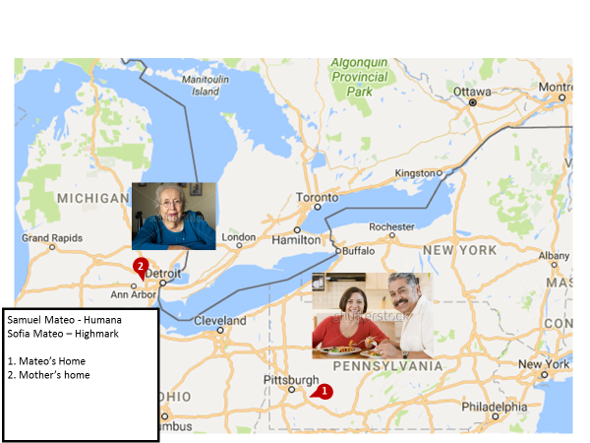

Care Context and Key Concepts in the Care and Data Sharing Environment

The Care Environment
In Sofia’s situation, resources at the Accountable Care Organization (ACO) where she receives her primary care employ a Care Manager that helps patients navigate the health system and support their care. The ACO contracts with Payers to provide Disease Mangement and Case Management services. In Samuel’s situation, resources at her Patient-Centered Medical Home play the role of Care Manager and Disease Manager. Samuel’s Payer employs a Case Manager to address complex patient situations.
The storyboard introduces care planning roles which are emerging and new care management processes are emerging to support the shift to value-based case. The concepts of disease management, case management, and care management are defined below as well as the roles of Disease Manager, Case Manager, and Care Manager. As new operating models emerge to support Patient Centered Medical Homes and Accountable Care Organizations, the division of responsibilities for disease management, care management, and case management may be shared differently between Payers and care providers.The storyboard includes two different examples to demonstrate that differences in the responsibility for these roles needs to be taken into consideration when planning for interoperability.
Disease Management
The Disease Management Association of America defines this term as “a system of coordinated healthcare interventions and communications for populations with conditions in which patient self-care efforts are significant. Disease management supports the physician or practitioner/patient relationship and plan of care, emphasizes prevention of exacerbations and complications utilizing evidence-based practice guidelines and patient empowerment strategies, and evaluates clinical, humanistic, and economic outcomes on an ongoing basis with the goal of improving overall health.” Full-service disease management programs include the following six components: 1. processes to identify specific population, 2. evidence-based practice guidelines, 3. practice models based on collaboration between physicians and other supporting service providers, 4. self-management education for patients, 5. measurement of process and outcomes, and 6. routine reporting to provide a feedback loop among participants. In addition, disease management and case management programs have been included together under the umbrella of “coordinated care models” in reports intended to guide the Medicare Coordinated Care Demonstration Projects.
Case Management
The Case Management Society of America defines case management as “a collaborative process of assessment, planning, facilitation and advocacy for options and services to meet an individual's health needs through communication and available resources to promote quality cost-effective outcomes”. According to a Mathematica report that included case management in its definition of care coordination, “case management implicitly enhances care coordination through the designation of a case manager whose specific responsibility is to oversee and coordinate care delivery [targeted to] high-risk patients [with a] diverse combinations of health, functional, and social problems.”
Care Management
This term care management is often used interchangeably with care coordination. In a background paper, Mechanic states “care management programs apply systems, science, incentives, and information to improve medical practice and help patients manage medical conditions more effectively. The goal of care management is to improve patient health status and reduce the need for expensive medical services. The principal challenge is finding effective ways to change physician and patient behavior.”
Care Manager, Disease Manager, and Case Manager
The term care manager describes a role involved in disease management or case management. In some cases, one person may fill both roles, hence the more general role of care manager can be used to describe someone acting in either role or both roles. Care managers coordinate care and may provide nursing functions according to their credentials, the patient’s needs, the established care guidelines, and business rules governing the situation. Disease managers are population-based disease specialists who work with, advise, coach and monitor patients in self-management of their disease. Case Managers are focused on the individual patient as generalists. Care managers may be nurses, but this is not always the case. It depends on what services they are employed to provide.
This storyboard specifically demonstrates the value of effective, timely sharing of care plan information and other related clinical information with payer stakeholders to improve medication adherence, avoid adverse medication interactions, support the patient in making informed care decisions (that minimize financial impacts), and increase the patient’s understanding of and ability to self-manage a chronic condition. This improves communication by all stakeholders involved in the care and monitoring of the patient, and illustrates the importance of the patient being a well-informed member of the care team. The story board expresses a forward looking view of what could be possible with greater use of clinical information exchange to support effective care coordination from a payer perspective.
Self Care
Should we write something about these patients having a PHR and being a part of the set of stakeholders who need to share information digitally?
Terms to describe data sharing
This Care Plan DAM is implementation agnostic. Terms used with this storyboard to describe data exchange are purposely general. The term “share” does not imply a specific implementation technology. The expression, “care plan information is made available to be shared”, indicates no particular data sharing paradigm. The sharing could be achieved through any number of technical implementations. Information exchange could be achieved via a health information exchange (HIE) using a federated registry model or a centralized data repository model. It could be achieved using direct point-to-point mechanisms, or other application interface (API) mechanisms that exchange information through shared data resources. The diagram in Figure 1 is used to indicate that no specific data sharing technology is implied when the exchange of information is depicted in the diagram. Questions in Chapter 3 may include inquire about interoperability at specific points in the story if certain assumptions about the technological environment were applied.

Figure 1: Representation of "implementation agnostic" data exchange.
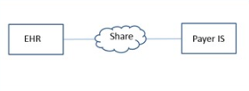

Storyboard Actors and Roles
- Patient: Samuel Mateo
Demographics
Address
Health Insurance | Highmark Insurance through Employer XYZ

Samuel’s Care Team Members – [This will be the list of all involved care team members]
Role | Provider/Person | Scoping Organization
Self | Samuel Mateo

- Patient: Sofia Mateo
Demographics
Address
Health Insurance | Humana Insurance through Employer ABC

Sofia’s Care Team Members– [This will be the list of all involved care team members]
Role | Provider | Scoping Organization
Self | Sofia Mateo
Primary Care Provider | Dr. Patricia Primary | UPMC Pittsburgh
Specialist Care Provider
Health Plan Disease Management Nurse | Pamela Care-Manager, RN, CCM

The Data Sharing System Environment
Terms used with this storyboard to describe data exchange are purposely focused on the operations challenge of a 2018 implementation of FHIR. It will be anticipated to involve a combination of direct point-to-point mechanisms and HIE-supported application interface (API) mechanisms that exchange information .. The diagram in Figure 1 is used to indicate examples of data sharing technology when the exchange of information is depicted in the diagram.
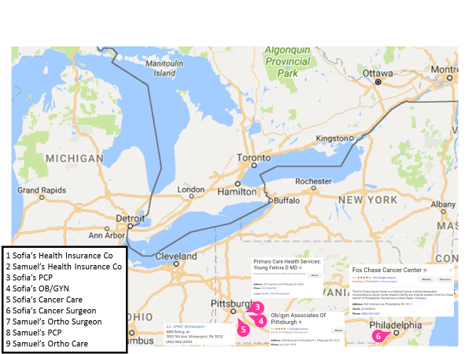
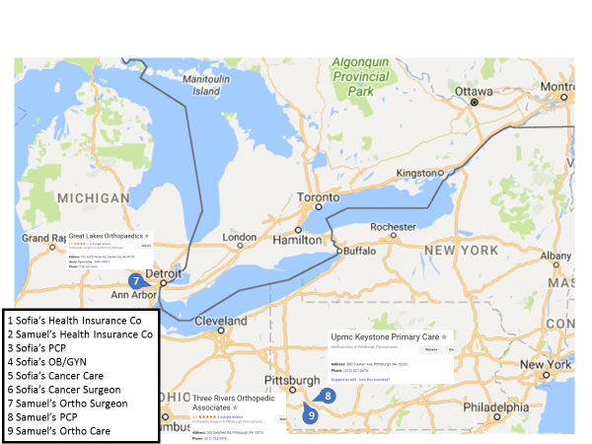
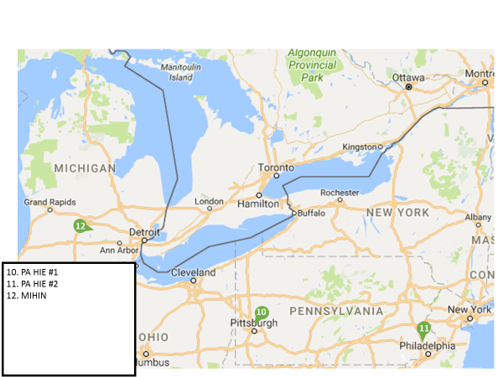

Need Pictures for other HIE’s in Pittsburgh and Philly

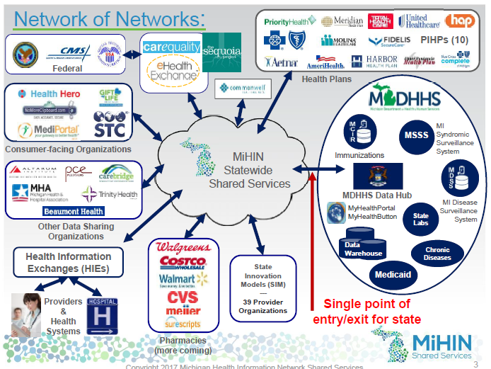
[This will be a list of all the organizations involved in the storyboard with information about the technical solution they are running and version assumptions, etc.]
# | Organization | Technology Solution

Storyboard Data Exchange Entities and Software Solutions
- ClinicalConnect HIE, Pittsburgh (Supporting the Argonaut Implementation Guide)
- HealthShare Exchange, Philadelphia (Supporting the Strategic HIE Coalition IG)
- Cerner EHR, DSTU2 FHIR (Provider Hospital, Lab & Pharmacy)
- Allscripts EHR, DSTU2 & STU3 FHIR (Provider Medical Management Group)
- Zeomega Population Health & Analytics, STU3 FHIR (Payer)
- Payer Member Portal & PHR, DSTU2
- Sych-for-Science NIH Precision Medicine Research (Third Party App)

Sequence of Care Events
Chapter 2 summarizes the sequence of care events going on in this family’s life. The reason the whole family is considered in the story is to see if a storyboard scoped to cover the whole family will reveal other issues that may be relevant to value-based care. Chapter 2.1 depicts the sequence of events involved in the storyboard about Sofia’s breast cancer diagnosis and treatment, and Chapter 2.2 depicts Samuel’s wrist fracture and recovery.
Several key questions about information exchange are addressed in Chapter 3 in order to better understand how standards are used to share data in certain areas of the storyboard.

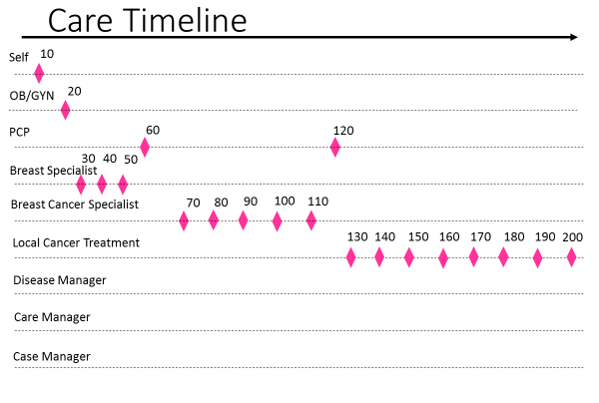
Summary of Care Events over the course of a year
# | Start Date | Description

For Samuel Mateo
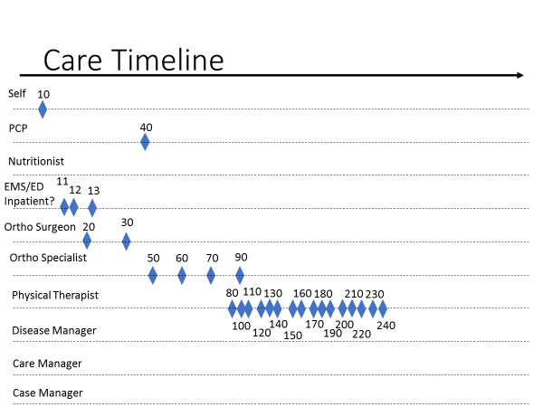

Summary of Care Events over the course of a year
# | Start Date | Description

Encounter Information for Sofia’s Care Timeline

Self Breast Exam
Describe here.

Pre-condition
Describe here.

Encounter / Care Event
Describe here.

Post-condition
Describe here.

Visit with OB/GYN – Reason for visit: patient concern about lump in breast
Describe here.

Pre-condition
Describe here.

Encounter / Care Event
Describe here.

Describe here. Post-condition
Describe here.

Visit with Breast Specialist – Referral from OB/GYN
Describe here.

Pre-condition
Describe here.

Encounter / Care Event
Describe here.

Describe here. Post-condition
Describe here.

MRI and Biopsy Procedure – Ordered by Breast Specialist
Describe here.

Precondition
Describe here.

Encounter / Care Event
Describe here.

Post-condition
Describe here.

Follow-up Visit with Breast Specialist – Review results, diagnosis and plan
Describe here.

Precondition
Describe here.

Encounter / Care Event
Describe here.

Post-condition
Describe here.

Visit with PCP – Address Patient concerns and discuss treatment options
Describe here.

Precondition
Describe here.

Encounter / Care Event
Describe here.

Post-condition
Describe here.

Visit with Breast Cancer Specialist – Referral from PCP
Describe here.

Precondition
Describe here.

Encounter / Care Event
Describe here.

Post-condition
Describe here.

MRI and Other Testing
Describe here.

Precondition
Describe here.

Encounter / Care Event
Describe here.

Post-condition
Describe here.

Need to Name this Encounter
Describe here.

Precondition
Describe here.

Encounter / Care Event
Describe here.

Post-condition
Describe here.

Need to Name this Encounter
Describe here.

Precondition
Describe here.

Encounter / Care Event
Describe here.

Post-condition
Describe here.

Need to Name this Encounter
Describe here.

Precondition
Describe here.

Encounter / Care Event
Describe here.

Post-condition
Describe here.

Need to Name this Encounter
Describe here.

Precondition
Describe here.

Encounter / Care Event
Describe here.

Post-condition
Describe here.

Need to Name this Encounter
Describe here.

Precondition
Describe here.

Encounter / Care Event
Describe here.

Post-condition
Describe here.

Need to Name this Encounter
Describe here.

Precondition
Describe here.

Encounter / Care Event
Describe here.

Post-condition
Describe here.

Need to Name this Encounter
Describe here.

Precondition
Describe here.

Encounter / Care Event
Describe here.

Post-condition
Describe here.

Need to Name this Encounter
Describe here.

Precondition
Describe here.

Encounter / Care Event
Describe here.

Post-condition
Describe here.

Need to Name this Encounter
Describe here.

Precondition
Describe here.

Encounter / Care Event
Describe here.

Post-condition
Describe here.

Need to Name this Encounter
Describe here.

Precondition
Describe here.

Encounter / Care Event
Describe here.

Post-condition
Describe here.

Need to Name this Encounter
Describe here.

Precondition
Describe here.

Encounter / Care Event
Describe here.

Post-condition
Describe here.

Need to Name this Encounter
Describe here.

Precondition
Describe here.

Encounter / Care Event
Describe here.

Post-condition
Describe here.

Encounter Information for Samuel’s Care Timeline
[Same approach here. We need the group to agree on the series of care events and name each of them. Once that agreement is reached, the details will be scetched into each care event.]

Fall at Mother’s House in Michigan (out of local area)
Describe here.

Pre-condition
Describe here.

Encounter / Care Event
Describe here.

Post-condition
Describe here.

EMS Transport to Emergency Department
Describe here.

Pre-condition
Describe here.

Encounter / Care Event
Describe here.

Post-condition
Describe here.

Emergency Department Visit / Inpatient Admission
Describe here.

Pre-condition
Describe here.

Encounter / Care Event
Describe here.

Post-condition
Describe here.

Key Interoperability Issues to Be Addressed
[This chapter will clarify all the key interoperability questions that need to be addressed as Payers strive to consider how to implement interoperable information exchange in this complex environment using currently available standards.]

Solution Version Variations
- What will happen to a Pittsburgh-based payer’s interoperability when it gets both DSTU2 FHIR and STU3 FHIR from a local health system with a primary care provider using STU3 FHIR/Allscripts at the Ambulatory practice, and DSTU2 FHIR/Epic when caring for patients at the DSTU2 hospital…with no “header” metadata to document the DSTU2 versus STU3?
- What will happen to a Pittsburg-hbased payer’s interoperability when the DSTU2 FHIR/Epic hospital does its 2018 upgrade to STU3 FHIR over a weekend, and with the hospital focused on go-live with internal staff, neglects to informal the payers about the upgrade, nor inform the regional HIE to update the provider directory/registry.
- [Questions need to be fleshed out.]

Value-Based Care
Adam’s has a specialist in-state.However, thespecialist is hours away at a medical group in a city served by a different regional HIE than the one serving his primary care provider & payer.
- What if the Specialist is on DSTU2 Allscripts, sharing with a DSTU2 HIE in Philadelphia, that shares with a DSTU2 HIE in Pittsburg, that share the record with the Provider on STU3 Allscripts.
- Multiple Payers with multiple different insurance PPO versus Flat Fee.
- [Questions need to be fleshed out.]

Quality Measurement
[Questions need to be fleshed out.]

Care Planning
[Questions need to be fleshed out.]

