HL7 CDS WG Conference Call
6 July 2016, 12-1pm US ET

Attendees:

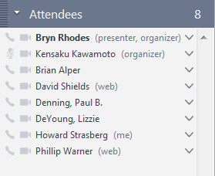
Claude Nanjo

Agenda:
* WG Health measures
* Approvals for resource proposals (ActivityDefinition, PlanDefinition)
* Review/approve CDS-related tracker items (Most of these have to do with the RiskAssessment resource)
* Review changes based on Workflow Task Force recommendations

Minutes:

- Reviewed harmonization proposals
  - Many involved V2 tables
  - Move to approve: Ken/Bryn: 7/0/0
  - Ken will notify the relevant list that CDS WG has no issues
- SSD Co-Chair election
  - Move to vote for Austin: Ken/Dave: 7/0/0
- FHIR DeviceUseRequest and DeviceUseStatement resources
  - OO would like to take over ownership from CDS
  - CDS would like to request courtesy invites when they are discussing changes
  - Motion to move to OO or PC: Bryn/Ken: 8/0/0
- FHIR resource proposals: ActivityDefinition, PlanDefinition
  - PlanDefinition – analogous to an HeD knowledge document UC1
  - PlanDefinition references ActivityDefinition
  - OrderSet and Protocol harmonized to create PlanDefinition
  - OrderSet and Protocol are going away
  - DecisionSupportRule also going away in favor of a profile of PlanDefinition
    - To be included within CQF IG
  - New resources would be part of FHIR STU3
  - Move to approve: Bryn/Ken: 7 for/1 abstention/0 against
- Review FHIR changes based on Workflow Task Force recommendations
  - Business identifier for GuidanceResponse
    - Optional cardinality
    - We have the requestId, but it’s client-generated, so we cannot guarantee uniqueness
    - This identifier would allow the server to tag the response with the event
  - basedOn – no actual request resource to reference
    - we already have requestId
    - add to RiskAssessment
  - parent
    - add to RiskAssessment

Next call: Wed 13 July 12 PM EDT

