HL7 WG Meeting Technical White Paper, SEP2018
HL7 RDAM Mapping Project #1413 Immunization Pilot Study
Within a CIMI-Compliant HL7 Cross-Family Interoperability Strategy
For Healthcare Information Networks (HINs), e. g., TEFCA RCE QHINs
Current Version at: http://wiki.hl7.org/images/b/bd/-RDAM-Mapping_Immunization-Pilot_Paper_Sep2018.docx
HL7 CIC, PHER, EHR, CQI, CDS, CIMI, STRUCDOC, O&O, M&M, VOCAB, FHIR-I, SOA, DevicesOnFHIR WGs & ArB
Stephen.Hufnagel.HL7@gmail.com facilitator, 2018-09-26

EXECUTIVE SUMMARY
This white paper is intended to be a discussion baseline for the Baltimore HL7 WG meeting.

SEP2018 STATUS (HL7 RDAM Mapping Project #1413 Immunization Pilot Study, http://wiki.hl7.org/images/b/bd/-RDAM-Mapping_Immunization-Pilot_White_Paper_Sep2018.docx): "The TSC has reviewed the larger topic of the creation of an over-arching methodology for HL7 and reached out to the governance and methodology committees and found insufficient interest in doing the work to align with an over-arching strategy, Consequently the TSC has decided not to move forward with this at this time. [Paul Knapp 2018-09-25].

FY2018 SCOPE: For Sep2018, the RDAM project #1413 mapped the EHR-S FM to FHIM demonstrating the mapping process and producing an object-oriented logical information model (LIM) precursor to a Service Oriented Architecture (SOA) suitable for federated Healthcare Information Networks (HINs), such as the TEFCA RCE QHINs. The strategic value proposition of CIMI-compliant (FHIM, CQF, EHR-S FM, CIMI-BMM, SOLOR) SOA is consistency, requirements traceability, reusability and improved computable semantic interoperability across HINs.

FY2018 LESSONS LEARNED: The RDAM project fits within the emerging CIMI methodology's "happy path"; where, 1) the CIMI value proposition is consistency and requirements traceability across implementations and 2) SOA adds implementation flexibility, reusability, reliability, testability, maintainability and reduced overall lifecycle cost. Based on recent WG peer review feedback, a conclusion section was added. It presents the pragmatic "Interoperability Conundrum" lesson learned of immutable inconsistencies across standards; where, data (granularity, pre/post coordination, types, value/code sets, metadata) variations negatively impact Healthcare IT value (patient safety, care quality, cost). SOLOR has the potential to improve this situation.

SEP18 HL7 WG MEETING DISCUSSION RECOMMENDATIONS: Considering the interoperability conundrum, the recommended HL7 Sep18 WG discussion questions is, what CIMI-BMM modifications are sufficient for efficient and effective CIMI-compliant tooling to generate semantically interoperable V2, FHIR, C-CDA, NIEM, etc.? How do we operationalize the emerging CIMI-compliant (strategy, technologies, methodology, tools, value proposition) to meet "CIMI's mission to improve the interoperability of healthcare systems through shared implementable clinical information models. (A single curated collection.)"? … Currently, a CIMI-compliance tooling oxymoron, e.g., CIMI-compliant DCMs, CQMs and KNARTS mapped to FHIR, C-CDA and V2 compliant implementation guides, using non-bidirectional mappings. Considering the interoperability conundrum, what CIMI-BMM or other pragmatic modifications are sufficient for efficient and effective CIMI-compliant tooling to generate semantically interoperable V2, FHIR, C-CDA, NIEM, etc.?

PROPOSED/REJECTED FY2019 PSS:
1) Sustain and use the FY2018 CIMI aligned FHIM-MDHT and FHIM mapped EHR-S FM immunization profile.
2) In collaboration with the HL7 Public Health Emergency Response (PHER) workgroup
clinically validate and harmonize the HL7 Immunization DAM and FHIM mapped EHR-S FM immunization profile,
3) In collaboration with the OpenGroup Healthcare Forum
- use OpenGroup patient-centric and customer-focused Healthcare Enterprise Reference Architecture (HERA)
iterative cycles of refinement (Strategy & Plan, Build & Deliver, Operate & Evolve) to
- document the software development lifecycle for an Immunization FHIR exemplar.
- produce HL7 CIMI-BMM (FHIM) ballot materials, ballot them in Jan19, reconcile ballot comments and re-ballot in May19,
under the 2017 HL7 Integration of Information Models and Tools (IIM&T) PSS #31316,
Including the immunization exemplar.
4) Use and document the "CIMI-compliant" open-source Model Driven Healthcare Tool (MDHT),
- to specify and ballot FHIM-based CIMI-BMM and logical Detailed Clinical Models (DCMs)
- express DCMs as FHIR Structure Definitions (FSDs).
- express logical FSDs as interoperable platform specific FHIR profiles and extensions.
- if time is available, express logical FSDs as interoperable platform specific C-CDA and NIEM.
- If time is available, use and map-and-gap capabilities across tools e.g., MITRE, Penrod, Intermountain, Cognitive, MDHT.
5) For the Jan19, May19 and Sep19 HL7 WG meetings develop and present short FHIM and MDHT using HERA
- status, lessons learned and recommendations white papers/briefs, which are generally less than 1000 words each.
- if time is available, targeted training videos, which are generally less than 5 minutes each.

TECHNICAL SUMMARY

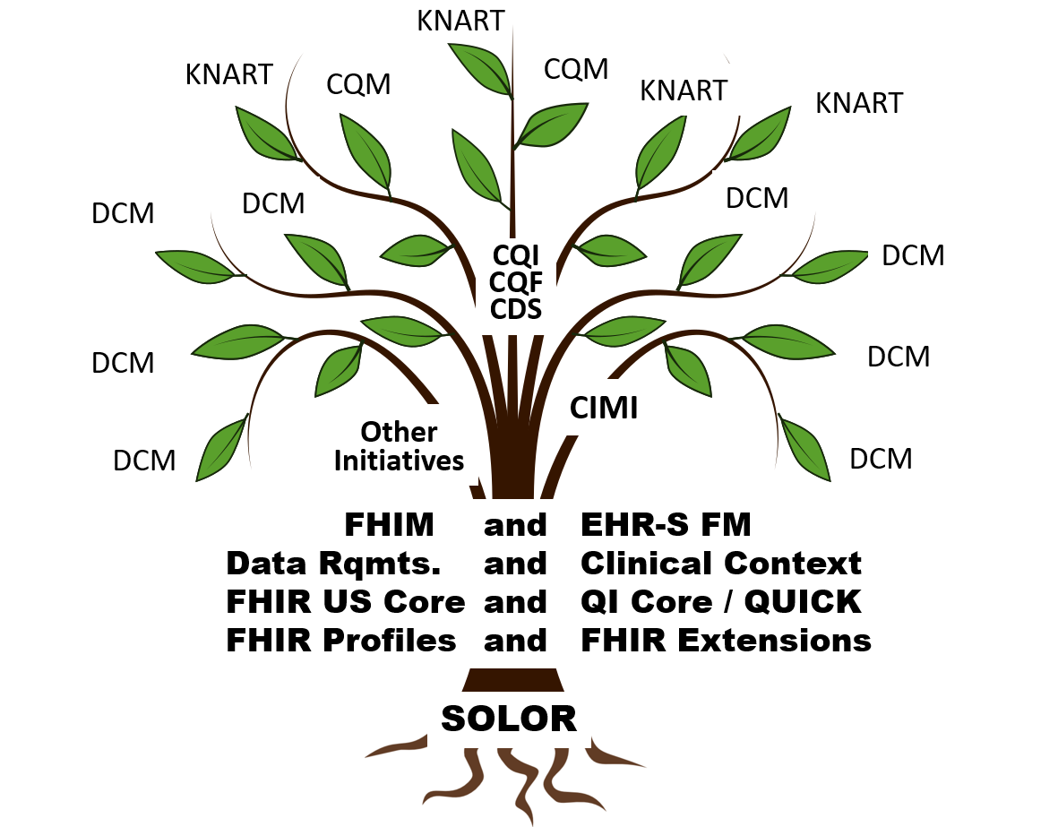
The HL7 Reference Domain Analysis Model (RDAM) Mapping Project Number 1413's Immunization Pilot Study maps the EHR System Functional Model (EHR-S FM) [Ref 1] to the Federal Health Information Model (FHIM) [Ref 2] within the EHR-S FM Immunization Functional Profile Spread Sheet [Ref 3].

This white paper addresses "Solving the Modeling Dilemma as a Foundation for Interoperability" [Ref 4]; where, this paper describes the RDAM Mapping within a Use-Case Scenario driven "Emerging CIMI-compliant Software Development Lifecycle (SDLC) Methodology" [Fig 1] for CIMI-compliant (FHIM, QUICK, CIMI BMM, SOLOR, EHR-S FM) models [Fig 2] to meet Healthcare Information Technology (HIT) Information Exchange Requirements (IERs). Use Case Scenario IERs can be specified as Detailed Clinical Models (DCMs) [Ref 5], Knowledge Artefacts (KNARTS) [Ref 6] and Clinical Quality Measures (CQMs) expressed as FHIR Structure Definitions (FSDs) [Ref 7], including QI Core / QUICK (Quality Improvement Clinical Knowledge data model) [Ref 8] supporting FHIR Clinical Reasoning [Ref 9]. These FSDs can be transformed into consistent HL7 (V2, C-CDA, FHIR) profiles and extensions used in Healthcare Information Networks' (HINs) test and certification Enterprise Compliance and Conformance Framework (ECCF) [Fig 3], e.g., TEFCA RCE QHIN [Ref 10].
CLINICAL MODELS SUMMARY

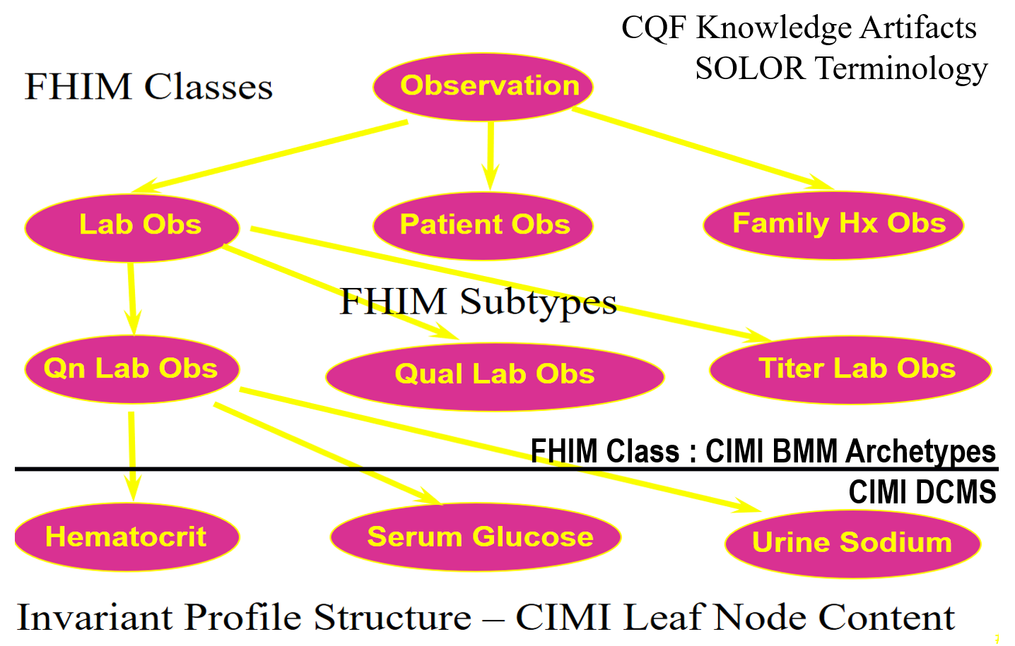
The CIMI-compliant (FHIM, QUICK, CIMI BMM, SOLOR, EHR-S FM) logical models are built on a standards foundation. CIMI BMM is based on ISO 13606 and SOLOR is a SNOMED extension including LOINC and RxNorm using EL++ descriptive logic. QI Core / QUICK data model and Clinical Reasoning module are FHIR STU3 & STU4 IGs. The FHIR Clinical Reasoning module (CQL (Clinical Quality Language), CQF (Clinical Quality Framework), CDS Hooks) are FHIR Standards for Trial Use (STU3 and STU4) Implementation Guides provides resources and operations to enable the representation, distribution, and evaluation of clinical knowledge artifacts (KNARTs) such as clinical decision support rules, quality measures, order sets, and protocols. In addition, the reasoning module describes how expression languages can be used throughout the specification to provide dynamic capabilities. FHIM has over 10 years of clinical input and standards alignment; but, is not HL7 balloted. EHR-S FM R2 is a normative HL7 and ISO standard.

BUSINESS CASE SUMMARY

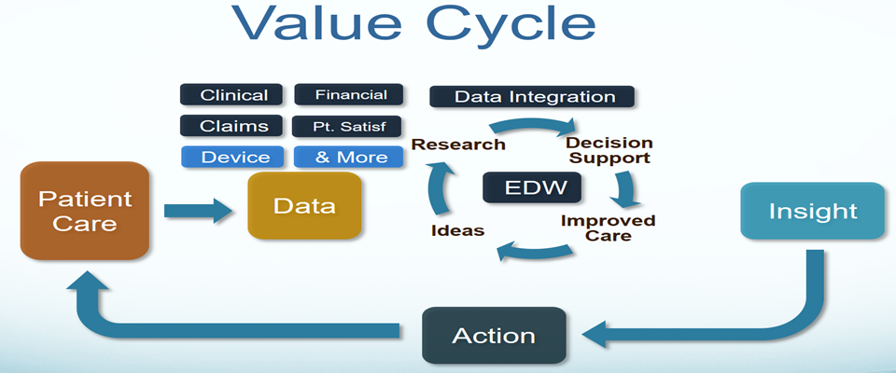

- Problem: HL7 (V2, C-CDA, FHIR) implementation-and-mapping variability results in 1) semantic inconsistency-and-ambiguity, 2) reduced interoperability and 3) reduced HIT value (patient safety, care quality, low cost) across Federated HINs.
- Strategic Goals: Semantic Integrity across
  - HL7 Product lines and product families (V2, C-CDA, FHIR)
  - TEFCA RCE QHINs
    - https://www.healthit.gov/sites/default/files/draft-guide.pdf
  - FHIR US-Core and FHIR QI-Core future normative ballots
    - http://www.hl7.org/fhir/us/core/
    - http://hl7.org/fhir/us/qicore/index.html
- Approach: Separation of Clinical Statement (syntax, context/semantics, services, terminology, workflow) data-quality concerns; where, CIMI-compliant (FHIM, QUICK, CIMI BMM, SOLOR, EHR-S FM) logical-specification of DCMs, KNARTS and CQMs are expressed as FSDs for interoperable V2, C-CDA and FHIR implementations.
- Value Proposition: CIMI-compliance improves semantic integrity resulting in improved patient value within HL7 cross family scalability (interoperability) with reduced complexity (cost) across federated HINs, e.g., TEFCA RCE QHINs.

BACKGROUND
HL7 is a critical leader and driver in the U.S. and international healthcare standards arena. HL7 is comprised of members from over 50 countries and is integrally involved in global standards policy, regulation and harmonization. The HL7 product lines and product families – including the widely adopted and rapidly evolving HL7 FHIR® along with CDA/C-CDA and Version 2 message standards in sustainment - provide the underpinnings for connected, patient-centered health care on a global scale and an information highway for improving patient safety, advancing research into treatments, and achieving ambitious visionary programs such as precision medicine. CIMI's clinical goal is to help people live the healthiest lives possible by enabling Learning Health Systems in supporting additional areas such as, but not limited to clinical decision support, population-based medicine, and genomics. "Data quality is the lynchpin of patient safety." CIMI's Healthcare IT objective is to make quality data available when, where and how it is needed across different platforms empowering computable semantic-interoperability.

CIMI's goal is “to help people live the healthiest lives possible” by enabling a “Learning Healthcare System” supporting areas such as, but not limited to, precision medicine.” This requires data that is computable, usable and interpretable across disparate systems. Our current Healthcare IT state is unable to deliver on this goal; however, there is a solution. We have made significant inroad with the exchange of data and standards and their adoption. To make additional advancements, we must return our focus on clear, complete, concise, correct and consistent quality-data and its context (aka semantics).

HL7 Work Groups are spearheading the HL7 Terminology Authority (HTA) and Universal Terminology Governance (UTG) harmonization processes to improve data quality. CIMI WG is collaborating with stakeholder clinical domain WGs. CIMI's Integrated Information Models and Tools (IIM&T) project is collaborating with the Health Services Platform Consortium's (HSPC) SNOMED extension for LOINC and RxNorm (SOLOR) project. The overall goal is to improve Healthcare IT value (patient-safety, care-quality, reduced-cost) for developers and users.

"Healthcare IT Computable-Interoperability Strategy --- Methodology to manage data-quality risk by standardizing data In accordance with 21st Century Cures Act, TEFCA and USCDI", HL7 Newsletter, May 2018, P16-18, http://www.hl7.org/documentcenter/public/newsletters/HL7_NEWS_20180523.pdf. The May 2018 article discussed HL7 supporting the Common Data Interoperability (USCDI) agenda across US Office of the National Coordinator (ONC) Trusted Exchange Framework Common Agreement (TEFCA) among Qualified Health Information Networks (QHINs) managed by a Recognized Coordinating Entity (RCE).

LESSONS LEARNED
HL7 success comes from stakeholder participation resulting-in lessons-learned based standards-evolution.
- Maintaining computable semantics across the HIT landscape is a HIN interoperability challenge. Unconstrained (V2 Z-segments, C-CDA templates and FHIR extensions) one-offs are suitable for limited scope exchanges; where, unconstrained one-offs degrade HIN interoperability.
- Complexity from 30+ years of HL7 product line separate evolutions reduces cross family interoperability, increases bureaucracies and increases operating (mapping) costs, due to institutionalized implementation variations, e.g., data types, meta-data, code sets and value sets.
APPROACH
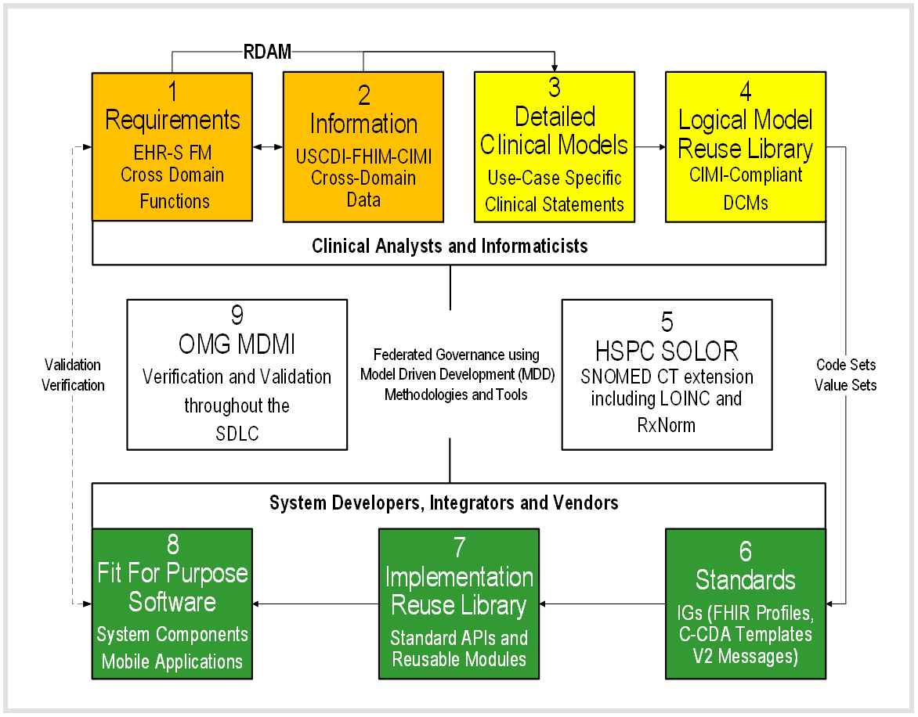
Fig 1: Emerging CIMI Compliant Software Development Lifecycle (SDLC) Methodology

The HL7 Reference Domain Analysis (RDAM) project is mapping Fig 1 steps 1-2 EHR System Functional Model (EHR-S FM) with the Federal Health Information Model (FHIM) enabling the formation of a Service Aware Interoperability Framework (SAIF) reference model for open distributed processing. RDAM domain-specific cohesive object spheres, of knowledge, activities and influence can maintain conceptual integrity within loosely coupled HIT components; where, context-specific clinical object (function, data) models can be validated by clinical domain workgroups and stakeholders. In Fig 1, a clinical analyst and informaticist can bootstrap a new project with 1: EHR-S FM clinical-requirements stated as conformance criteria, mapped to 2: FHIM domain-specific data requirements. This domain data can be constrained to 3: application-specific clinical statements specified as 4: logical CIMI-compliant Detailed Clinical Models (DCMs), which can be represented as FHIR Structure Definition (FSD). DCMs can be bound to 5: SOLOR terminology to specify consistent and requirements traceable 6: Standard Implementation Guides (IGs) for FHIR profiles, C-CDA templates and V2 artefacts. Step 6 includes CIMI-compliant DCMs, CQMs and KNARTS mapped to FHIR, C-CDA and V2 compliant implementation IGs in a potentially non-bidirectional fashion, due to .inconsistency across standards; where, there are data (granularity, pre/post coordination, types, value/code sets, metadata) variations.

Large scale enterprise initiatives can have rigorous development of DCMs by seasoned clinical professionals in steps 1-6, resulting in faster, better and cheaper re-usable software components by Healthcare IT developers in Steps 6-8. SDLC consistency can be verified by Model Driven Message Interface (MDMI) tools in Step 9 resulting-in improved interoperability from CIMI (FHIM, QUICK, CIMI BMM, SOLOR, EHR-FM) compliance.

Small scale site initiatives can have individual developers profile or extend 6: FHIR, CDA or V2 standards OR start with 7: Reusable Component Libraries to create 8: Fit for Purpose Software. In step 9: fit-for-purpose systems can be verified, in run-time, to have improved interoperability by maintaining CIMI compliance.

Fig 2 CIMI (FHIM, QUICK, CIMI BMM, SOLOR, EHR-S FM) STRATEGY AND VALUE PROPOSITION
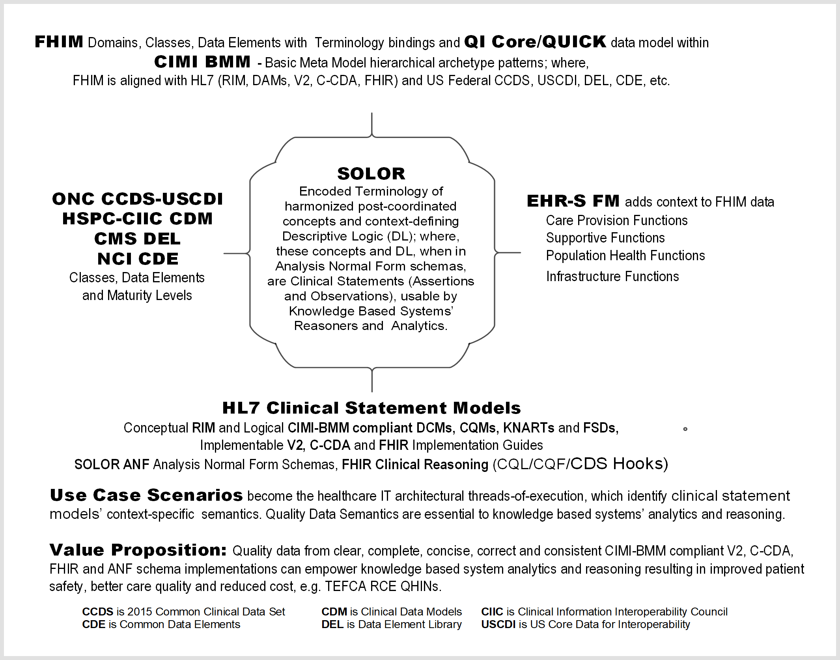
In summary, the proposed CIMI (FHIM, QUICK, CIMI BMM, SOLOR, EHR-S FM) data-quality strategy operationalizes HL7 lessons learned to simplify and improve HL7 governance, products, processes, and reduce healthcare IT costs. The collaboratively developed RDAM will take time to mature across clinical domains; where, CIMI collaboration and compliance, among workgroups, HTA, UTG and HSPC, can positively influence value (patient safety, care quality, cost) by finding inflection points; where, HL7 products and services efficiently and effectively meet HIT developer and clinical user needs.

CONCLUSION
The Interoperability Conundrum is immutable inconsistency across standards; where,
data (granularity, pre/post coordination, types, value/code sets, metadata) variations
negatively impacting Healthcare IT value (patient safety, care quality, cost).

Situation: CIMI's mission is to specify computable semantics within logical models (DCMs, CQMs, KNARTS), ideally specified as FHIR Structure Definitions (FSDs), on the Software Development Lifecycle path to HL7 (FHIR, C-CDA or V2) implementation guides (IGs) and implementation artefacts. Efficient and effective Tools and (sometimes impossible and often costly) bi-directional mappings are essential to manage complexity and to empower a deterministic development process for clinical users and implementers. Currently, CIMI-compliant Basic Meta Model (BMM) development of HL7 (FHIR, C-CDA, V2) compliant IGs and implementation artefacts results in a dilemma from which there is no escape because of mutually conflicting data types and value/code sets; where, CIMI compliant logical models must be "mapped" to FHIR, C-CDA or V2 compliant IGs and reusable implementation artefacts. This situation is a tooling oxymoron.

Problem: HL7 (FHIR, V2, V3) and ISO data types are locked down. Backward compatibility rules prevent CIMI from making changes to any of them to the degree necessary to support full interoperability. Similarly, differing choices for value sets are consciously and architecturally driven. V3 has null flavor. FHIR and v2 do not. That inconsistency, alone, impacts value set design. V2 terminology is often a mess because we often didn't understand the ramifications of design choices when we added codes to v2. V3 and FHIR made different choices to address those problems. C-CDA is inconsistent with V3 and FHIR. New HL7 product families are introduced specifically *to* make breaking changes with what's come before." [Lloyd McKenzie, 2018-09-11]

Strategy: In the short term, this problem can only be mitigated with mapping; but, is there a practical strategic path forward, such as?
- CIMI Product Family? Currently, this seems a nonstarter; but, can it be the next wave when FHIR hits the Gartner "trough of disillusionment" ?
  - CIMI product family - do you mean as something that would compete with CDA and FHIR rather than leveraging them? I'm not sure if that's an HL7 non-starter, but I suspect it would be an implementer non-starter. [Lloyd McKenzie, 2018-09-11]
- CIMI-compliant FHIR (US Core, QI Core), C-CDA template and V2 version? Is this an HL7 nonstarter?
  - CIMI compliant - if you mean making breaking changes to any of the existing specifications, then yes that's probably off the table. There are still large parts of FHIR where some degree of harmonization is possible, but the starting points are somewhat different. FHIR is driven by current implementer convention/capability. CIMI is driven by models and perceived "ideal" behavior. Where those come into conflict, implementer convention/capability is likely to win out in the FHIR space. That said, we're certainly open to improving our existing models where that's in alignment with convention/capability. [Lloyd McKenzie, 2018-09-11]
- Three or more CIMI BMM variants for 1) FHIR (US Core, QI Core), 2) C-CDA templates, 3) V2 version? Is this a CIMI nonstarter?
  - CIMI BMM defines data types and reference Architypes (data classes/modules) and sub Patterns for DCMs, CQMs and KNARTs, including context specific terminology bindings. Ideally, tooling, based on a CIMI BMM variant would directly produce appropriate FHIR, C-CDA, V2 IGs and implementation artefacts, without a final mapping step.
    - if you have magic tooling that can do this, great. If your tools are struggling due to misalignment of the underlying standards, then that makes more sense to me and isn't terribly surprising. [Lloyd McKenzie, 2018-09-11]
  - Tooling folks will determine a "practical" solution; where. "CIMI-Compliance" is debatable across alternatives. [Steve Hufnagel, 2018-09-11]
    - MITRE tool is FHIR specific from start to finish
    - Cognitive tool is CIMI/ISO 13606 compliant; and, maps DCMs to FHIR compliant FSDs as a final step.
    - Penrod requirements-focused tool potentially feeds into the Cognitive tool.
    - FHIM-MDHT tool can do it all; but, require significant mapping setup for each implementation target.
    - Intermountain Tools map Clinical Element Models (CEMs) to CIMI BMM and finally to FHIR
  - MDMI maintains a "referent" index for each implementation paradigm and can provide real-time mapping; but, it may not be bi-directional!
- Costly HL7 curated mapping tables for its product family data types and value/code sets, which are inherently non-bidirectional?
  - This one seems most likely to me. [Lloyd McKenzie, 2018-09-11] I think the simple answer is that straightforward bidirectional conversion across the product families is a non-starter. Any implementation guide that wants to support multiple product families will have to perform IG-specific mappings and translation guidance taking into account both the rules of each specification and implementer convention in the use of those specifications. Mappings are best done in a narrow known context, and CIMI is as narrow as it gets. So, my guess is that a lot of the mapping pain is going to end up being yours to own... [Lloyd McKenzie, 2018-09-11]
- Directed HL7 Cross family data type and value/code set harmonization is a nonstarter within HL7.
  - There is no chance of moving the v2, v3, CDA and FHIR families to use the same (or even fully mappable) data types. [Lloyd McKenzie, 2018-09-11]

In summary, the HL7 mapping problem between CIMI, v2, CDA and FHIR isn't any different from mapping between HL7 standards and X12 or NCPDP or SDTM. Each standard has its own implementer community that won't tolerate the sort of radical breaking change that would be necessary to support full bidirectional interoperability across them. And, if you tried to force it, then you'd lose the bidirectional interoperability between the old version of the legacy spec and the new "aligned" version - so you'd just be moving the mapping problem around. [Lloyd McKenzie, 2018-09-11]

Issues:
- How can CIMI-compliant (EHR-S FM, CIMI-BMM {FHIM, CQF}, SOLOR) DCMs, CQMs, KNARTs be constructively operationalized at HL7?
- Does SOLOR Analysis Normal Form (ANF) hold the key to interoperability? Is SOLOR ANF mapping sufficiently bidirectional?
  - How do we handle inconsistencies, such as V3 null flavors vs. V2 and FHIR negation, seafood vs. mollusks granularity?
- Would RCE mandated CIMI compliance by QHINs be helpful in meeting the 21st Century Cures Act, TEFCA and USCDI interoperability goals?
  - How can CIMI compliance be efficiently and effectively operationalized by federated TEFCA RCE QHINs?
    - RCE managed logical models and open-source tools?
    - RCE managed data sharing HL7 Implementation Guides, HSPC (SOLOR Terminology, SDKs, APIs, modules/components)?

POSTSCRIPT
(Architectural Perspective)
For Healthcare Ontology Cats
SOLOR "Separation of Concerns" Interoperability Specification Stack
- Configuration Management (CM): Version, Object ID, STAMP (status, time, author, module, and path), etc.
- SOLOR Language and Dialect: assignment of language and dialect information to an identified object.
- SOLOR Logical Definition: OWL EL++ with concrete domains, e.g., properties like weight, name, or age, having concrete values such as integers or strings, with built-in predicates, such as ≤ or =.
- Assertional Knowledge that does not depend on a statement model. Layer 4 enables a sharable knowledge base built on a common layer 2-3 language and logic.
  - An example might be "aspirin may be used to treat headache".
  - EHR examples might include patient defined problems or clinician defined diagnoses.
  - Value and code sets, CQMs are a kind of assertional knowledge, which also live in level 4.
  - CCDS-USCDI, DEL, CDM, CDE live here too.
- Observational Knowledge Statement Model (FHIM Domain Models, CIMI Detailed Clinical Models, FHIR Structure Definitions etc.), based on assessments and evaluations represented as V2, C-CDA or FHIR pre-coordinated Clinical (observation) Input form, which should be bi-directionally mapped to layer 2-3 post-coordinated Request-for and Performance-of Action Analysis Normal Form (ANF), to improve data quality, analytics and reasoning.
  - Descriptive logic of SOLOR concepts in an ANF schema is a DCM duality
    - e.g., DCMs, KNARTS, CQMs in ANF are statement models.
  - Use-case scenarios (EHR-S FM tasks mapped to FHIM) can be represented as an ANF sequence.
- Procedural knowledge software scripts, APIs and components, such as IF statement indicates chief complaint of condition, THEN search assertional knowledge for treatments (e.g., medications) that treat condition, and present to user. KNARTs can live here and depend on lower layers. Layer 6 is where reusable knowledge representation and problem-solving methodologies can live (episodic skeletal plan refinement), e.g., assertions with associated observations.

The engineering challenge is to efficiently and deterministically separate the layered concerns.

The Fig 1 methodology can incorporate the CIMI-SOLOR Separation of Concerns Principle within Fig 3 HL7 SAIF ECCF. It cleanly separates responsibility between a CIMI statement model and a SOLOR encoded terminology for concerns such as encoded action, subject of information (aka Evaluations), and measurement (aka Assessment). SOLOR normalizes and standardizes layers' 2-3 (below) content language, dialect and logical definitions, with a reusable knowledge representation foundation aka SNOMED extension with SNOMED, LOINC, etc. configured into an Analysis Normal Form (ANF) suitable for knowledge-based systems.

To help separate the layered concerns, project architectural documentation can be organized into a Fig 3 HL7 SAIF reference model for open distributed processing called Enterprise Compliance and Conformance Framework (ECCF) used for the specification and test of components within federated network platforms; where, the ECCF can be a TEFCA RCE QHIN interoperability test-and-certification architecture.

Fig 3 CIMI (FHIM, QUICK, CIMI BMM, SOLOR, EHR-S FM) within HL7 SAIF ECCF aka ISO RM-ODP
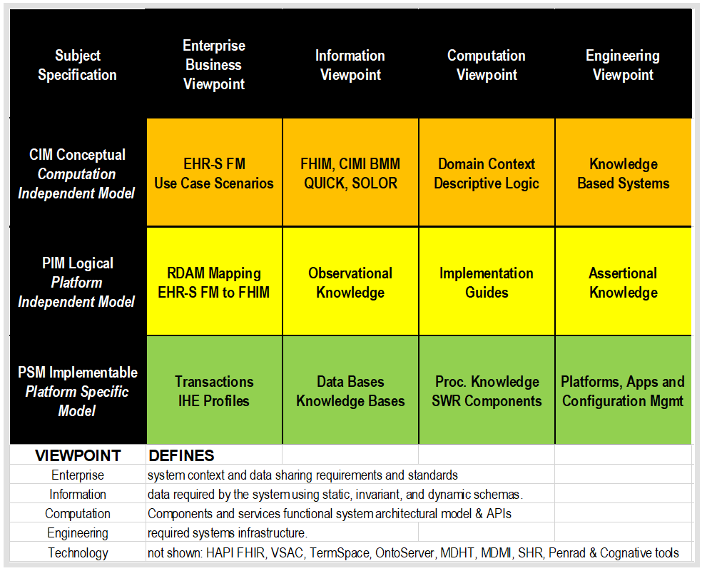

REFERENCES
- HL7 EHR System Functional Model (EHR-S FM) R2 http://www.hl7.org/implement/standards/product_brief.cfm?product_id=269
- Federal Health Information Model (FHIM) Immunization Domain Model http://www.fhims.org/content/_420A62FD03B64295E8200076-content.html
- Immunization Functional Profile Mapping Spread Sheet http://wiki.hl7.org/index.php?title=EHR_Immunization_Functional_Profile
- Solving the Modeling Dilemma as a Foundation for Interoperability by Berndt Blobel and Frank Oemig, Intl. HL7 Interop Conference (IHIC) 2018 in Portsmouth, UK. https://www.ejbi.org/abstract/solving-the-modeling-dilemma-as-a-foundation-for-interoperability-4614.html
- CIMI Detailed Clinical Models https://CIMI.HL7.org
- HL7 Knowledge Artefact (KNART) Specification http://wiki.hl7.org/index.php?title=Knowledge_Artifact_Specification
- FHIR Immunization Resources https://www.hl7.org/fhir/immunization.html
- QI-Core IG http://hl7.org/FHIR/us/qicore/2016Sep/index.html
- FHIR Clinical Reasoning Module http://www.hl7.org/fhir/clinicalreasoning-module.html http://wiki.hl7.org/index.php?title=Clinical_Reasoning_Module
- HL7 May 2018 Newsletter Article http://www.hl7.org/documentcenter/public/newsletters/HL7_NEWS_20180523.pdf

EVENTS AND NOTES
2018-09-29 HL7 Workgroup Meeting. Baltimore, MD, USA
2018-09-25 TSC-SGB found "insufficient interest in doing the work to align with an over-arching strategy" and dis-approved the project.
2018-09-14 TSC requested no further HL7 WG white paper distribution, pending sponsoring Co-chair review.
2018-08-26 FINAL DRAFT to stakeholders
2018-08-22 Gary Dickinson, Berndt Blobel, Thomas Beale, Gerard Frer, Mark Kramer, Keith Campbell guidence. Added SOLOR separation of concerns to CIMI (FHIM, CIMI BMM, SOLOR, EHR-S FM) in HL7 SAIF ECCF.
2018-07-16 (Nona Hall): Next article should be on projects with tangible CIMI and SOLOR accomplishments
2018-07-12 article was discussed at CIMI WG call, reduced to ~800 Century Cures Act words.
2018-07-10 CIMI-SOLOR Map-and-Gap done with Keith Campbell's SOLOR Information Architecture Work Group
2018-07-10 Infrastructure Steering Division (ISD) approved Technical RDAM (Mapping) PSS
2018-07-09 Article due; where, publication was deferred, pending TSC-SGB RDAM Investigative study on the article's suggested CIMI methodology impact on HL7 product lines, families and procedures.
2018-06-27 TSC requested RDAM Investigative Study by Standards Governance Board's (SGB)
2018-06-24 CIMI BMM-ADL Compliance section added to article, as presented by Stan Huff at CIMI WG calls
2018-06-22 RDAM Deep Dive added to article and it was distributed to WGs for feedback
2018-06-13 Article Title and Abstract submitted to Andrea Ribick
2018-06-01 (Andrea Ribick) Call for Story Ideas for HL7 September 2018 Newsletter
2018-05-12 "Healthcare IT Computable-Interoperability Strategy --- Methodology to manage data-quality risk by standardizing data In accordance with 21st Century Cures Act, TEFCA and USCDI", HL7 Newsletter, May 2018, P16-18, http://www.hl7.org/documentcenter/public/newsletters/HL7_NEWS_20180523.pdf. The May 2018 article discussed HL7 supporting the Common Data Interoperability (USCDI) agenda across US Office of the National Coordinator (ONC) Trusted Exchange Framework Common Agreement (TEFCA) among Qualified Health Information Networks (QHINs) managed by a Recognized Coordinating Entity (RCE).

