20170627_LabUSRealm_Notes
Attendees: Hans, Kathy, David B, Riki, Andrea
No call next week = July 4th
For July 11 plan on talking about LOI#135
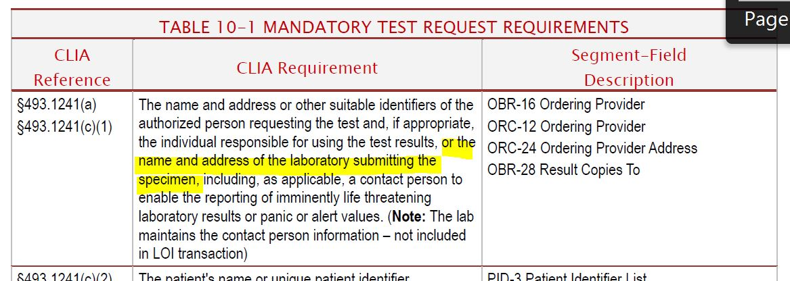
David has to drop off 4:30 PM EDT
LOI#133: Find persuasive with mod = Make element O – Riki, Kathy, no further discussion, against: 0, abstain:0, in favor: 4
LOI#34: Find persuasive – Riki, Kathy, no further discussion, against: 0, abstain:0, in favor: 4
LOI#95: Motion to use XPN_03 in both LOI and LRI for PID-5 – Riki, Andrea, no further discussion, against: 0, abstain: 0, in favor: 4
LOI#97: Accept the proposed text as written – Riki, David B, further discussion: add the LOINC name in (birth plurality of pregnancy) – this is sent as optional OBX in addition to PID-24 and PID-25, against: 0, abstain: 0, in favor: 4
LOI#33: Accept as proposed – Riki David B, further discussion: Usage note is specific to the NDBS profile? Yes, against: 0, abstain: 0, in favor: 4
LRI:
LRI#117: Accept as proposed – Riki, David: further discussion: idea here is to just change the usage in NDBS component – so make usage varies, where NDBS as proposed, against: 0, abstain:0, in favor: 4
LRI#118: Make NK1-30 and NK1-32 O for NDBS component – Riki, Andrea, no further discussion, against: 0, abstain: 0, in favor: 4
LRI#220: Find persuasive – Riki, David B, further discussion: sounds like the indication for order only or result only is not just the recommendation, but is stronger – so add suggestion – also does not describe “Both” option = add that in – ALSO make the same change in LOI – that makes this persuasive with mod, against: 0, abstain: 0, in favor: 4
Completed NDBS in LRI
Filter on open Negs – filter out CG – Hans to Follow out
Take out PH for Thursday
LRI#149: Need to sync Table 8-19 with the value set for HL70085 (O is R for ALL guides) = make a note that this table ONLY applies, when OBX-29 = “RSLT”
OBX-23-25 are O in LOI – MUST have partner agreement to support – so make the same in LRI for OBX-29 = QST or SCI – same goes for OBX-15/16 – already are optional, so don’t need to
For OBX-11, just make sure the table is considered for RSLT only, but do NOT limit the OBX-11 value to “O”, in case folks do want to use F or C
Motion to approve as documented in the spreadsheet Riki, Kathy, no further discussion, against: 0, abstain: 0, in favor: 4 – persuasive with mod
LRI#151: Motion to find persuasive Riki, David B, no further discussion, against: 0, abstain: 1, in favor: 3
LRI#153: not sure what the problem with this comment it – need clarification from submitter – Kathy to reach out to Donna
LRI#158: Suggest to sync FHS-3 with BHS-3 usage, cardinality and datatypes
LRI#159: Suggest to sync FHS-4 with BHS-4 usage, cardinality and datatypes
LRI#160: Suggest to sync FHS-5 with BHS-5 usage, cardinality and datatypes
LRI#161: Suggest to sync FHS-6 with BHS-6 usage, cardinality and datatypes
Discuss all together – since file scan have multiple batches and batches could have different sending facilities – should ALWAYS know the sending application and facility, but you may not know the receiving application potentially – Motion to find persuasive for all 4 comments – David B, Riki, no further discussion, against: 0, abstain: 1, in favor: 3
Next call Thursday 3 – 4 PM EDT

