20170314_LOI_Notes

Attendees: Bob Y, Carolyn, Freida, Hans, Gail, Shennon, Riki, Kathy, Andrea, Cindy, Clem, Dan

LOI:

* Both Blockvotes (3/14) - (3/16) will be on Thursday to give folks the full week to review
  + LOI#84 to pull:

Updated text to use: 1.4.13 Error Handling:  Content in MSA-1, ERR-3, and ERR-5 is being combined to differentiate between "hard" and "soft" errors.  The HL7 EHR-S Functional Requirements: S&I Framework Laboratory Results Messages, Release 1 - US Realm (EHR-FR-LR) has been released to support the result counterpart of this Implementation Guide and defines responses to specific error types. The concepts described there are applicable to this Implementation Guide as well and so an excerpt is included below:

Motion to approve block vote as listed including the updated LRI#84 – Riki, Kathy, No further discussion, against: 0, abstain: 1, in favor: 8

* LOI#37: Fixed submitter (was me) and withdrawn – recorded with today’s date
* LOI#133: Need to ask David where in the IG this was
* LRI NDBS Block Vote:
  + Pulled items:
    - LRI#18
    - LRI#286
    - LRI#198
    - LRI#61 - also LRI#130 / LRI#498 (were not listed as part of block) – title for result linkage handling is related to grouping discussion
    - Grouping related (were not listed as part of the block) = LRI#344 / LRI#200 / LRI#131 / LRI#501 = see below
  + Items included in block vote = LRI#3, LRI#4, LR#6, LRI#8, LRI#17, LRI#20, LRI#21, LRI#28, LRI#29, LRI#30, LRI#31, LRI#32, LRI#33, LRI#46, LRI#47, LRI#49, LRI#55, LRI#81, LRI#85, LRI#86, LRI#90, LRI#91, LRI#92, LRI#99, LRI#167, LRI#170, LRI#191, LRI#192, LRI#193, LRI#194, LRI#194, LRI#195, LRI#197, LRI#199, LRI#216, LRI#260, LRI#284, LRI#294, LRI#313, LRI#374, LRI#427, LRI#441, LRI#491, LRI#499, LRI#500

Motion to accept NDBS Block vote 3/14 – Riki, Andrea No further discussion, against: 0, abstain: 3, in favor: 6

* Grouping discussion:
  + LRI#344: use same approach for all
  + LRI#200: option 2 or 1 both work, 2 may be > 1
  + LRI#131: option 1 preferred
  + LRI#501: option 2 seems to work as would option 1 – use the same or explain why different

Option 1: Use of OBX-4

* + - OG datatype covers only 2 levels – does not work well for CG
    - Use of OG.1 with dot notation – current choice for CG – labels are available because the per the syntax each dot notation has a specific association to a group and can be looked up per the LOINC panel definition
    - That same approach would work for NDBS – can that same level of definition be achieved with use of the newer OG fields?
    - Hard to know how easy it is to implement

Option 2: Parent Child linkage via OBR-29 for the order number and OBR-50 to link to the ordered test

* + - Could OBR-50 be used to create a hierarchy, i.e. the first result OBR-50 point to the ordered LOINC, the next one to that first result OBR-4 etc?
    - Is it permissible to use the OBR-29 IDs form the original order, when OBR-50 is not listed on that order (only implied due to the defined LOINC panel in use?)

Option 3: Establishes hierarchy by use of ordered OBRs

* + - Relies on order of segments in message - not good practice
    - Currently Observation group is C(R/O) with Condition Predicate: If OBR-25 (Result Status) is valued ‘A’, ‘C’, ‘F’, ‘P’, or ‘M’.
      * How would one indicate that the overarching panel, that in itself might not have results is Final – review this usage
      * OBR-25 status codes, where Observation group is O: O, I, S, R and X – none would work well

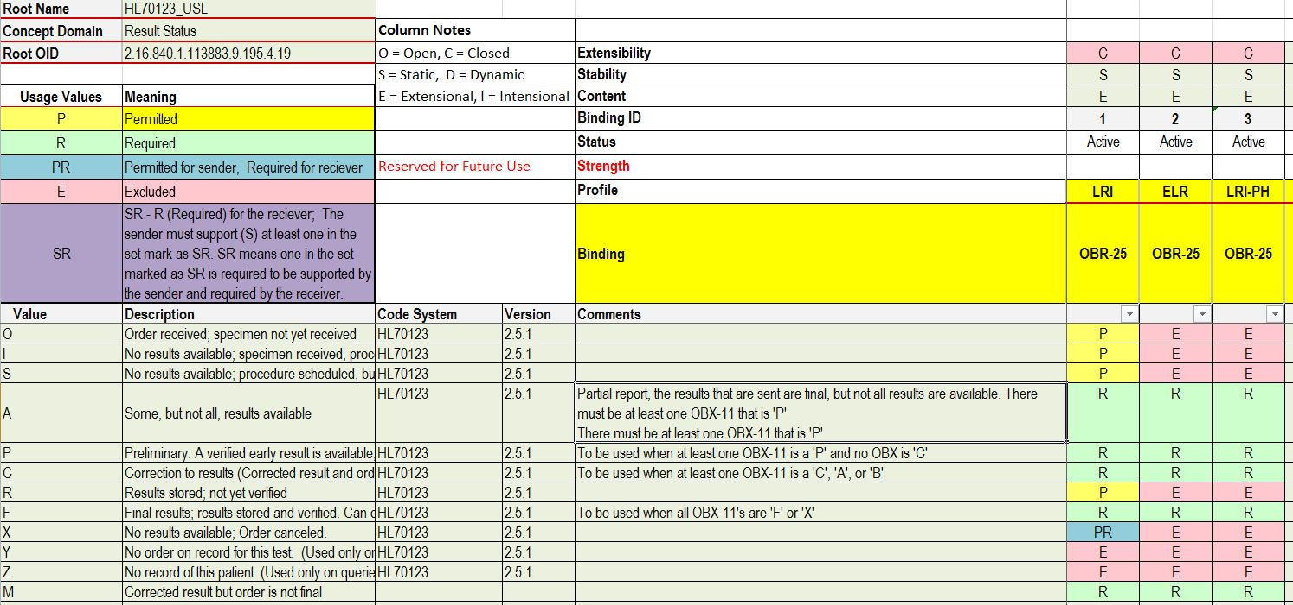

Want to allow nested OBRs after ORC and allow OBRs without OBX groups

Could highlight in this ballot round that we are changing the Usage for the Observation group

If parent field is valued, then allow to NOT have the Observation group

So change Condition Predicate from “If OBR-25 (result Status) is valued: ‘A’, ‘C’, ‘F’, ‘P’, or ‘M’.” to “If OBR-25 (Result Status) is valued: ‘A’, ‘C’, ‘F’, ‘P’, or ‘M’ AND OBR-29 (Parent) is NOT valued.”

Notes to Balloter can be in the section, where the question is located might be easier to have the context. Add a comment into the document.

In NDBS sections excludes CCHD – why, because they have a separate specification available for that

LRI#227:

CWE_0x datatype review:

Must have code system when CWE.1 is valued AND CWE.14 is NOT valued.

Ensure that if CWE_0x.1 is valued that either code system, just OID or both are present

Clem, Riki, further discussion: where is this used? In CG profile in OBX-5 – also need to update HL70125 and figure out, this is the one datatype that will he one to always be used in CG in OBX-5 ONLY; need in CG for OID is the reference sequence that is being used. If it is applicable for other use cases can expand in the future, against: 0, abstain: 5, in favor: 5

Freida dropped

Do we need to impose a CLength for CWE.2_0x – base v2.8.2 – conformance length of 199# - that means that 199 is the minimum length to support and if you truncate you have to indicate that – cannot truncate under 199 – set CLength for the CWE_0x.2 to 800# - list that as a comment and do we also need to change the convention section – currently have 289 so far, but 500 should be safe considering that OBX-5 cannot be truncated

Freida back

Motion add note as documented in the LRI guide – Clem, Riki, no further discussion, against: 0, abstain: 5, in favor: 5

* Is in CG chapter – check for input from Shennon / Clem; they may have fixed already:
  + LRI#13
  + LRI#14
  + LRI#15

Those were fixed in CG – will need to get the final CG

LOI#37: withdrawn by submitter on 3/14/2017

LOI#133: sent email to submitter – submitter is on vacation – unless we hear otherwise and can always submit another comment – we know the answer, but we can’t find where to fix it;

We are not going to publishing and we are going to another ballot round and anything that is still open for review will be picked up in the next ballot round – Motion to find not persuasive as we cannot locate the area where to apply the fix – Bob Y, Riki, no further discussion, against: 0, abstain: 4, in favor: 5

LOI AND LRI items:

* ACK related:
  + LOI#155: Draft of section – Kathy / David to provide – Riki shared John Roberts’ document as a starting point for background (numbers changed since we move the section down in the document) – Hans will take a look at this before Thursday’s call
  + LRI#361: How to use MSH-21 with the ACK components
    - Only the Application level ACK uses the End to End component, the Communication level is not using the End to end component
    - Motion to clarify that Application ACK is the ONLY one using the end to end MSH-21 value, while the Communication level is only between two immediate points – Bob to wordsmith from here – Riki, Freida, no further discussion, against: 0, abstain:1, in favor: 8
  + LRI#41: use application level ACKS
    - Yes we have not used it before and has caused issues knowing if messages arrived, having the end to end profile allows us to verify receipt, when desired; allow parties to choose the level of CK that best suits their environment, – question answered
  + LRI#39 / LRI#40 (the retry is internally in the lab, not part of the message) diagrams for ACK flow – mark both as questions answered; considered for future use/ LRI#52 mark as considered for future use and request a starting verbiage
  + Sync these ACK related comments:
    - LOI#105: John shared document: Section 2 dot 3 ACKs rewrite.docx
    - LRI#174 = LRI#44 John Roberts cannot get the writing done = LRI#263 = LRI#428 = LRI#175 = LRI#366
      * In notes to balloters we want to invite comments on the ACK section and will consider all the ACK related comments that have not been addressed as well as new comments will be addressed as ballot recon process
    - Motion to rather than delaying the ballot we want to proceed and seek further comments and will address the resolutions to be part of the next ballot reconciliation round – still persuasive with mod – this motion applies for LRI#439, LRI#40,LRI#52, LRI#174, LRI#44, LRI#263, LRI#428, LRI#175, LRI#366 and will add note to balloters to that effect into the document, Riki, Cindy, no further discussion, against: 0, abstain:1, in favor: 7
* NB Component:
  + LOI#102: same as LOI#6, LOI#12 – same as LRI#259:
    - LOI#6: Motion already points to LRI verbiage, so if we update LRI, we are ok with this one
    - Motion to re-open LOI#12 Riki, Dan, no further discussion, against: 0, abstain:1, in favor: 8
    - LRI#259: Motion to apply to also LOI#6, LOI#102, LOI#12 and LRI#259 use text in LRI#259, Riki, Andrea, no further discussion, against: 0, abstain:3, in favor: 7

LRI NDBS Block Vote pulled items:

* LRI#18: we don’t want to accommodate some folks for some things and not others for others – so make this use for PID-7 only - how to adjust the LOINC table in this case to O or to X or?

Start here on Thursday!

* LRI#286
* LRI#198

More LRI:

* LRI#142 – security related items – DoD vote withdrawal email has been sent – no answer so far – this s not exact wording as the others from Kathleen, but related
* LRI#442: NDBS use of X – the following elements are intentionally left O in NDBS_Component – would it be a solution to list all of these in the NDBS component with a remark that NDBS programs should decide if they want to constrain these and then make a statement, that after these and any other O element that has been further constrained have been agreed upon by data exchange partners to apply the XO_Component rather than list all of them in the respective tables?
* Found items:
  + LRI#989: Typo on CNN – should be CNN_01 – what do we need to do here?
  + LRI#988: the SN datatype mislabeling – Proposed motion use definition of LOI SN_01
  + LOI#999 = LRI#987: XPN flavors – there are 4 different versions

PREP THIS

* LRI#54: parent child linkage across messages?
* LRI#43: Why DSC = X?
* LRI#458 + LRI#459: reorganization of the guide
* LRI#376: deprecated CS handling

For Thursday’s LRI Discussion –PH items:

* LRI492 – remove note about SCT not being required under organism table
* LRI419 – Conformance statements or changed usage for AOE in some OBX elements
* LRI#381 / LRI#177 / LRI#163 = Batch message and ACKs