**HL7 Patient Care Work Group**

**Allergy/Intolerance/Adverse Reaction Topic Sub-Group Meeting Minutes**

**Date: March 26, 2014**

Phone Number: +1 770-657-9270  
 Participant Passcode: 943377

[www.webex.com](http://www.webex.com) – meeting number 195 316 591

Co-Chairs: Stephen Chu/Elaine Ayres Scribe: Elaine Ayres

|  |  |
| --- | --- |
| **Name** | **Present on 3/26/14** |
| Elaine Ayres | X |
| Stephen Chu | X |
| Kathy Walsh | X |
| Lisa Nelson | X |
| Russ Leftwich | X |
| Laura Heermann Langford | X |
| Rob Hausam | X |
| Kevin Coonan | X |

**Agenda for March 26, 2014 5:00 PM EDT**

1. Review Agenda
2. Approve minutes for March 12, 2014
3. Status of publication requests for DAM and Clinical Models (Elaine)
4. IHTSDO Implementation and Mapping SIGs (Rob Hausam)
   1. Update on meeting
   2. Issue of availability of HL7 documents for non-HL7 members
5. List-serv issues related to CCDA-FHIR
6. CCDA Examples task force issues with allergies – specifically severity and criticality
7. Continuation of Lisa Nelson’s review of the C-CDA on February 20.
8. Testing resources for DSTU
9. FHIR resource management and maintenance
10. Next Meeting – Wednesday, April 9 at 5 PM EDT – Suggested Agenda (Elaine unavailable)

**Minutes** – March 12, 2014 Move:Stephen/Russ Abstain –1 , Negative –0 , Approve – 7

**Publication –** DAM to be published -- needed for 2015 NPRM response. Clinical Models to come soon.

**IHTSDO Implementation and Mapping SIGs – Rob Hausam Updates**

Meeting on 3/25/2014 re allergy topic – Rob shared the HL7 PC work (e.g. the Allergy and Intolerance Domain Analysis Model). Looked also at criticality and with explanation the group understood the difference between severity and criticality. The IHTSDO group is looking at an IG using SNOMED to guide allergy and intolerance in an EHR. Group felt that the DAM was a good foundation for this work.

Able to show the DAM but not distribute according to the publication schedule. This is an impediment to on-going cross-collaborative work. Can we perhaps get a waiver for collaborative work with SDO’s. Does JIC cover IHTSDO? Talk with HL7 re this issue, or distribute specific use cases. Question use of Creative Commons for draft models.

A Project Scope Statement including IHTSDO as a collaborative project would mitigate intellectual property issues for the IG/terminology for Allergies and Intolerances. Would work with the Implementation SIG of IHTSDO. Next steps – create a PSS, share with the IHTSDO SIG.

ACTION: PC WG will develop (Elaine and Rob).

**CCDA Examples Task Force –** SDWG project – several examples noted:

1. Allergy/drug with RxNorm – penicillin allergy recording a reaction of anaphylaxis as “severe” as severity of the condition, not the reaction.
2. Need a path forward for reconciliation.

**C-CDA – Review by Lisa Nelson**

Lisa is sharing slides. In thinking about templates – think of the purpose of the templates. If a template purpose is not correct, then need to correct this. Then clinical statements will align with the template. Vocabulary bindings then enhance each concept. Reviewing R1.1 templates. There are two allergy and intolerance sections -- one requires entries, one does not. The CCD is required, Progress note, H & P, Consult Note, D/C summary and Procedure note have optional entries. A required entry means that information would be available in human readable and machine readable entry. The allergy and intolerance section includes all types of allergies and intolerances.

Entry templates for the Allergy Problem Act (note that the word concern is not included). The Allergy Problem Act functions like a concern act. Includes the Allergy-Intolerance observation. Brings in the allergy status observation (deprecated in C-CDA R 2.0. Includes the Severity Observation and a Reaction Observation.

The mind map helps to show the relationships.

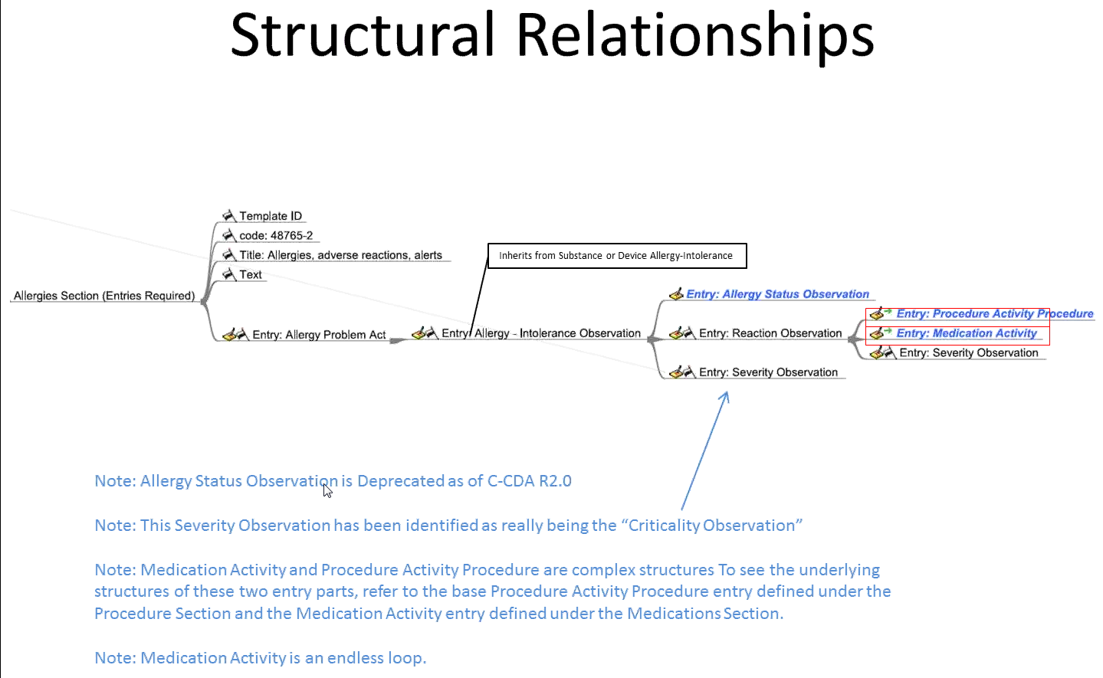

The criticality issue entered as a Severity Observation is a known issue. Also need to review the purpose statements for each template. Given each template, look at the semantic meaning of the template to evaluate the observations and terminology come together. Need to evaluate the value sets included in R1.1 The severity value set has six gradations of severity. Need a value set for criticality. The modeling of the criticality observation needs to be developed.

Note bindings to value sets – (RxNORM, NDFRT) Medication Brand Name, Medication Clinical Drug, Medication Drug Class and Ingredient Name (UNII).

What are the current issues between R1.1 and the PC Allergy and Intolerance Model?

The implementation guide allows you to view the templates in entirety. Document templates are linked.

**Issue list with C-CDA:**

Allergy problem act (one allergy intolerance observation, but no grouping) vs. Problem concern act (groups multiple problem observations)

Allergy concern act does not exist in C-CDA R1.1 but is included in R2.0.

In the C-CDA examples task force – developing now how to implement allergy and intolerance templates. How do we make our concerns know to the development group. Examples are informative, not normative. But implementers using these to move forward.

According to list-servs – these misinterpretations are already in the meaningful use rules. How do we recommend changes. Need an official DSTU comment against R1.1 with a proposed approach. Can also comment against R2.0 before release. Have to be watching R3 work.

Look at previous comments that have been posted – Meetings on Thursday morning.

Stephen, Russ, Elaine and Kevin will develop a DSTU comments against R1.1 and R2.0. Need to supply a criticality template looks like – purpose, observation, value sets, entry relationships.

**List Serv discussions:**

Consensus position response needed from Patient Care.

R2.0 - Allergy Concern Act (V2). What does this template do especially if it is mandatory? The allergy concern act allows for multiple allergy intolerance observations. There is a timing issue of the concern, as well as when the intolerance happened. There are two longitudinal aspects that both need to be represented. We need to see if these construct is useful, or not. Stephen has put together several XML examples.

We need to reach out to the SDWG co-chairs. We need to include user stories. We need to show timing.

Rob and Lisa will put together XML examples along with clinical stories.

**Agenda for April 9, 2014 5:00 PM EDT**

1. Review Agenda
2. Approve minutes for March 12, 2014
3. Criticality template elements review
4. XML statements for examples to use as DSTU comments for C-CDA R1.1 and R2.0
5. Need clinical stories with timing
6. Next Meeting – Monday March 31 at 5 PM EDT