CDAR2_IG_OFFICIAL_DOC_NAME

HL7 Implementation Guide for CDA® Release 2:
Clinical Guidance on Relevant and Pertinent Data to Include in Automatically Generated Patient Summaries
Draft, September 1, 2016

Sponsored by:
Structured Documents Work Group
Cosponsor Workgroup

Copyright © 2015 Health Level Seven International ® ALL RIGHTS RESERVED. The reproduction of this material in any form is strictly forbidden without the written permission of the publisher. HL7 and Health Level Seven are registered trademarks of Health Level Seven International. Reg. U.S. Pat & TM Off.
Use of this material is governed by HL7's IP Compliance Policy.
Structure of This Guide

Co-Chair |  | Primary Editor: | David Tao, Robert Dieterle, Keith Boone
Co-Editor: |  | Technical Editor:
Current Work Group includes

Acknowledgments
Holly Miller, Russell Leftwich (for questionnaire)
AHA, AMA, AAFP for their support of responses

Contents
1 Introduction 7

1.1 Purpose 7

1.2 Audience 7

1.3 Organization of the Guide 7

1.4 Contents of the Package 7
2 Background 9

2.1 CCD and C-CDA 9

2.2 Current Project 9
3 Method 10

3.1 Short Survey 10

3.2 Long Survey 10
4 Results, Interpretation, and Recommendations 11

4.1 Short Survey 11

4.1.1 Cohort that Responded 11

4.1.2 Experience with Transitions of Care (ToC) Documents 15

4.1.3 General Discussion: Approach and Limitations 17

4.1.4 Overall Results 18

4.1.5 Transitions of Care from Hospital Discharges 21

4.1.6 ToC from Ambulatory Visits 29

4.1.7 Medications 35

4.1.8 Alternative Approaches 37

4.2 Long Survey 38

4.3 Comparison of Results against Meaningful Use Requirements 38
5 Conclusions and Recommendations 39

5.1 Guidance on use of the results 39

5.1.1 Classification of relevance 39

5.1.2 Use of Classifications 39

5.2 FHIR Considerations 39
6 References 40
Appendix A — Acronyms and Abbreviations 41

Figures
Figure 21: XML Document Example 11
Figure 22: XPath Expression Example 11
Figure 23: ClinicalDocument Example 12

Tables
Table 1: Contents of the Review Package 7

Introduction

Purpose
This “Relevant and Pertinent” (RnP) project will deliver an informative document providing principles for developing, and guidance on what information should and should not be present and appropriate in both entries and narrative content in an automatically generated clinical summary (e.g., CCD, Discharge Summary, etc.). It will not create new templates or models, but simply explain how to use existing templates in current HL7 work products.

The project also attempted to understand the various contexts and their impacts on the information requirements (e.g., Patient Summary vs. Transfer of Care).

We reached out to clinical professional societies, provider organizations and organizations representing patients to present the project, gather feedback, develop recommendations, and review results. We executed this process with a number of organizations in order to gather the best possible recommendations. Participation was open to any organization that shows interest and commits to meeting the project requirements and schedule.

The guidance delivered in this document is structured in a way that it could be automatically tested for conformance against coded and structured data, but also could be applied to narrative sections. It is assumed that most respondents to the survey formed their opinions by reading the documents as rendered on screen or paper.

Audience
- Developers and Implementors of Automated C-CDA Generating Systems
- Clinicians and other generators and users of C-CDA Documents
- Policy Makers

Organization of the Guide
This document provides
- Chapter 1 — Introduction
- Chapter 2 — Background
- Chapter 3 – Method
- Chapter 4 – Results, Interpretation, and Recommendations
- Appendices. The Appendices include

Contents of the Package
The following files comprise this implementation guide package:
Table 1: Contents of the Review Package
Filename | Description | Standards Applicability
 |  | Informative
 |  | Informative
 |  | Informative
 |  | Informative
 |  | Informative

Background

CCD and C-CDA
The Continuity of Care Document (CCD) Release 1.0 and its successor (version 1.1 found in the Consolidated CDA (C-CDA) specification) are required for use under Meaningful Use regulation in the US. Due to short timelines, many organizations have opted to automatically generate these documents. As a result, some organizations and software products are generating CCD documents that span dozens of pages even for the simplest of cases, making these documents unusable for their intended purpose.

Method
Built the surveys, short and long

Short Survey
reviewed them internally,
reviewed them with external stakeholders,
sent them out to AMA, ACP, AAFP, AHA, HIMSS, Holly’s group and others. From __/__/__ to __/__/__

Responses back, AMA (433), AAFP (103), AHA (34), and ACP and others (43) (613 total)

Long Survey
Long Survey (13 results back) from …

Results, Interpretation, and Recommendations

Short Survey

Cohort that Responded
The short survey was distributed to a significant number of individual providers through the cooperation and participation of the national offices of the American Academy of Family Physician (AAFP), the American Hospital Association (AHA) and the American Medical Association (AMA.) Many other groups were asked to participate (American College of Physicians, CHIME, Department of Defense, EHR Association, Federal Health Architecture, Health Story Project, HIMSS, Taconic IPA, Veterans Administration), but did not provide significant numbers of responses. Each professional group select a relevant sub-set of its membership based on their internal criteria and forwarded, under their individual cover, the survey overview and a link to the survey that was individualized for each organization to allow us to capture the number of responding providers by society. The total for the responses is listed in Table XXX below. We aggregated into “other” the responses from a number of other limited attempts to reach practicing physicians.
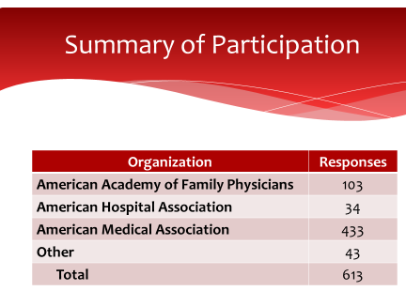

Overall, 613 physicians completed the short survey.

We requested some basic provider and practice demographic information from each of the respondents to enable us to evaluate the applicability of the responding cohort to the overall provider population. These demographics included: 1) practice location (urban, suburban and rural), indication of specialty (based on the published AMA list), 2) practice type based on self-identification of the practice makeup (primary care, specialty, multispecialty, hospital based, skilled nursing facility and ownership and 3) practice size and payer mix. It should be noted that the respondents were allowed to select more than one practice type. The results are summarized in tables xxxx,xxxx,and xxxx.
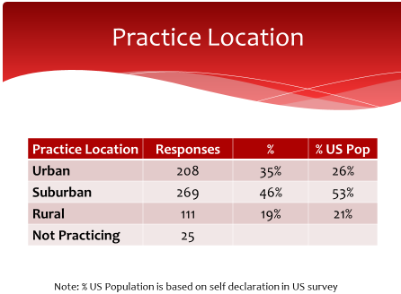
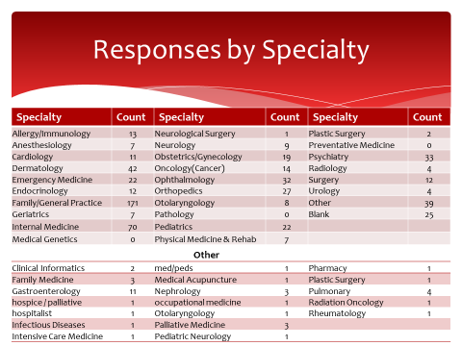
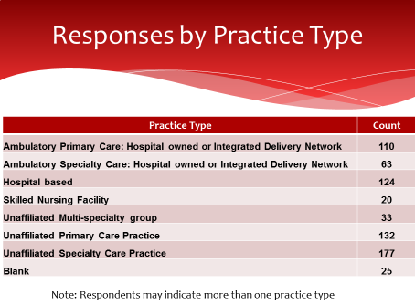
Evaluation of the results:
- Practice location distribution matches the US population distribution
- Primary care and all relevant (based on planned use of ToC documents) specialties are represented
- All practice types (IDN/Hospital/Unaffiliated) are represented
- Response by practice size represents solo to >20 provider practices
- All payer types are represented
Conclusion:
The cohort of respondents to the short survey are representative of the overall population of physicians in the United States based on practice location, specialty, practice type practice size and payer mix.

The participating physicians were asked to indicate the number of years (<1, 1-3, 3-8, > 8) they have used an Electronic Health Record (EHR). The results were analyzed based on declared practice size (see table xxxx). The resulting analysis is presented in Table xxxx below.

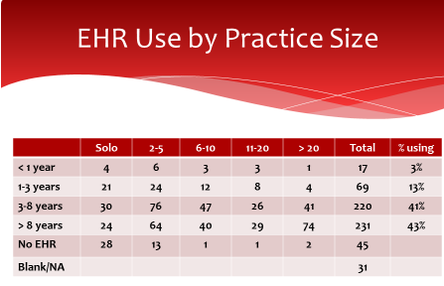
Results:
- 84% of the respondents indicate using an EHR for 3 or more years
- 43% of the respondents indicate using an EHR for over 8 years
- Smaller practices (< 5 physicians) indicate no EHR use more frequently than for larger (6 or greater) practices.
Conclusion:
All practice sizes indicate a significant experience in EHR use and over 84% of all physician indicate experience for three or more years. This provides a population of experienced EHR users that are responding to the remainder of the survey.

Experience with Transitions of Care (ToC) Documents

The survey request information on the current experience in and future plans to send and receive ToC documents.

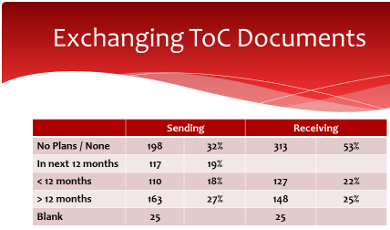
Results:
These results show that only about 47% of the respondents had actual experience receiving ToC documents electronically, about 25% for more than a year, and 22% for less than a year. Nevertheless, since most of the questions asked about preferences for what data providers wanted to see, we include all responses in most of our analysis. Even if providers have received only paper documents (e.g., discharge summaries, FAXed records), their opinions about what is important are still valuable.

Conclusion:
We compared the results of those with experience with ToC documents (the 47%) vs those without experience, and found that there were not major differences in their preferences.

To understand provider experience with Transitions of Care (ToC) documents, we request the respondents to identify the average number (None, 1-5, 6-10, 11-20, >20) of each type / source of document (Hospital Discharge, Referral Request, Consult, Home Health, Long Term Care / SNF, Behavioral Health) received per month. The results are shown in Table XXXX below.

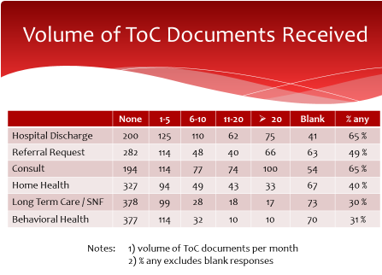
Results:
To read this table, note that the numbers in each cell are not the “volume of ToC documents received” but rather the number of respondents in each cell. The volumes per month are the column headers. So for example, for Hospital Discharge documents, 200 respondents said they do not receive any Hospital Discharge documents per month. 75 respondents said they receive more than 20 Hospital Discharge documents per month. Similarly, 114 respondents said they receive 1-5 Referral Request documents per month.

The most often received documents came from Consultations and Hospital Discharges. Not surprisingly, there were far fewer documents received from Long Term Post Acute Care (LTPAC), Behavioral Health, and Home Health settings, since those are known to have less EHR usage. What is slightly surprising is the fact that only 49% received ToC documents from a referral request. The numbers in this table are far less than the 613 respondents, since about half the respondents did not have actual experience receiving ToC documents electronically.

Conclusion:
There was a reasonable balance among documents from hospital discharges, ambulatory consultations, and ambulatory referrals. LTPAC and Behavioral health were received much less often, but still are an important part of the transitions that occur.

General Discussion: Approach and Limitations
There are two primary types of transitions of care (ToC) about which the survey asked.
- Hospital Discharge. Patient is discharged from a hospital, and transitions to an ambulatory provider (e.g., the PCP or a specialist who admitted the patient). A document is sent from the hospital to the ambulatory provider. The specifics are not known from the survey, but we assume that ambulatory specialists or PCPs responding to the survey are thinking of those instances when they received a ToC document directly from the hospital.
- Ambulatory ToC. Patient transitions from ambulatory provider 1 to ambulatory provider 2. A document is sent from provider 1 to provider 2. This may be the result of a referral from provider 1 to provider 2, may be the “closing of the referral loop” where provider 1 sends a ToC document to provider 2 after a consultation, or may be some other unspecified transition. The data to distinguish these types of transitions is not available in the survey, so all ambulatoryambulatory transitions are grouped together.
Hospital Discharge vs Ambulatory ToC preferences and experiences are different enough that we discuss the results for each separately.
For type of ToC, we first describe providers’ preferences for what they would like to receive, and then we discuss their experience of what they actually receive. We infer that satisfaction will increase to the extent that preferences are met in actual experience, and that dissatisfaction will increase to the extent that preferences are not met.
LIMITATIONS. Sometimes the survey answers can be reported without interpretation, i.e., the results speak for themselves and can help our target audience simply by giving them the facts. There are other times, however, when some degree of interpretation, or “reading between the lines” is necessary to arrive at meaningful recommendations. For example, there may be a difference between preferences and experience, but the specific factors are hard to know with certainty. In writing this report, we distinguish between those recommendations based on the actual facts, and others based on our interpretation of what were probably contributing factors. We use our collective experience, and the wisdom of our reviewers, to assist in these interpretations and recommendations, and will explain where we make plausible interpretations or recommendations that were not directly stated in the survey data.
To give an example of where interpretation is needed, consider the following: a high percentage of providers said that they were “missing important information for patient care” in the ToC documents from hospital discharges. But what specific data were they missing? That was not specifically asked, though a few wrote free-form comments. However, we do know what data was required in Certification and Meaningful Use Stage 1 and Stage 2 regulations. So the “missing information” was probably something outside of the MU-required data set. We can then analyze which sections of data were not normally included in the most common ToC documents (CCD), and narrow down the range of possibilities for missing information.
Although the survey did not ask providers which specific CDA document types they received (because we thought many would not know), we have reason to believe that the vast majority of document were Continuity of Care Documents (CCD), either constrained by HITSP C32 specification (for MU1), or using C-CDA 1.1 (MU2). To state it differently, we believe that a very low percentage of the documents received by the survey respondents were non-CCD document types such as Discharge Summary, Referral Note, Consultation Note, Progress Note, or History and Physical.
Under this very plausible assumption, how many CCDs lacked a section that has a narrative summary of the hospitalization? At the time the survey was taken in late 2015, based on CMS attestation statistics, only a small percentage of providers (57Kout of 357K, or about 16% of those registered for MU) had attested to MU2, therefore over 80% were operating under MU1. Most of those were probably receiving C32 CCD (in MU1 there originally was no C-CDA and no option to send other document types other than CCR or CCD). (NOTE: how many on MU1 might have started receiving enhanced Stage 1 documents, using C-CDA 1.1, as of late 2015?).
A potential follow-up survey could statistically analyze the actual documents generated in transitions of care, or simply survey vendors to ask which documents they generated. But it is highly probable that we would not find a significant volume of other documents besides CCDs, so such a survey might be much effort to simply reinforce our existing conclusion.
We assume that most documents came from “push” messages shortly after completion of a visit or hospitalization, rather than via queries (XDS, XCA, FHIR), because of the Meaningful Use incentives to push ToC documents using Direct messaging. but there is no way to prove this assumption, since the method of obtaining the document was not asked on the survey, and the transport method is immaterial to the conclusions of this project anyway.

Overall Results
Incorporation of Documents

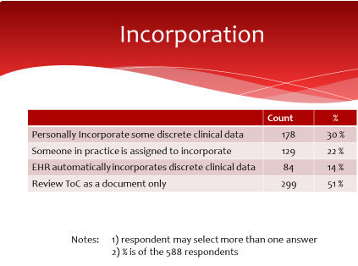
Results:
- Over half (51%) of the respondents review the ToC as a document
- Incorporation of specific data into the clinical record is done by a combination of the physician (30%), their staff (22%) or the EHR technology (14%)
Conclusion:
It is noteworthy that, despite difficulties such as lack of automated incorporation of data from ToC documents, a significant percentage of respondents are at least trying to incorporate data into their EHR, either personally or through staff. If the recommendations of this report are followed, coupled with EHRs providing improvements in C-CDA rendering and incorporation tools, we expect that the experience with incorporation will improve.
General Issues

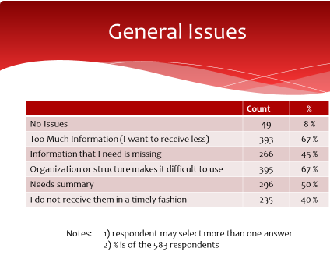
Results:
- 67% declare there is too much information
- 45% declare that needed information is missing
- 67% declare organization makes it difficult to use
- 40% did not receive the ToC in a timely fashion

Conclusion:
Base on the responses, we can reach two general conclusions: 1) the information provided needs to be more selective (see answers to later questions) and better organized and 2) required information is frequently missing and the documents are not received in a timely fashion. Since the organization is primarily ….(TO BE ADDED)

Transitions of Care from Hospital Discharges

Preference vs Experience
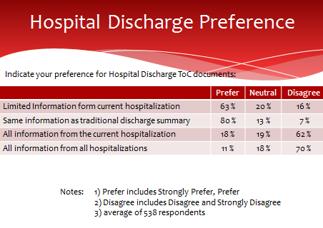
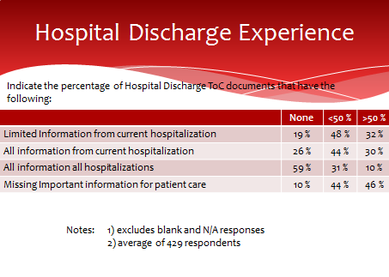
First, we compare the survey respondents preferences vs their actual experiences.

DESCRIPTION
Despite the “Hospital” in the title, these results represent mostly the experience of ambulatory providers who received documents FROM hospital discharges of their patients, more so than experiences of hospital providers. Less than 20% of the responses were from hospital-based physicians, as described earlier in the analysis of the demographics of respondents.

The key point is that providers want a SUMMARY and ”LIMITED Information from current hospitalization.” The word “current” is really best described as “at the time of discharge from that hospitalization” (since the patient is no longer in the hospital when the ToC document is received). A strong preference (80%) was expressed in favor of “traditional discharge summary” which is what the C-CDA Discharge Summary represents: it includes a narrative summary of hospital course, as well as structured data. However, per the preceding General Discussion: Approach and Limitations, it’s very unlikely that providers received Discharge Summaries instead of CCD.

The last two questions indicate strong preferences for not “all” information from latest hospitalization or certainly not ALL hospitalizations. That would be far too much information.

Comparing the table of experience vs the preferences, we see that there is a mix of “too much information” but also “missing information.”
- Too much. All information from current hospitalization, or all info from all hospitalization, is received much of the time (40% say they receive these more than 50% of the time), despite only 18% saying they wanted all info from latest, and only 11% saying they wanted all info from all hospitalizations.
- Yet too little. On the other hand, even though some are receiving what they prefer (limited info from latest hosp), the information may be TOO limited, because 46% of respondents say that they are “missing important information for patient care” more than 50% of the time.

INTERPRETATION

How can proper balance be struck between “too much” and “not enough?” First, we need to understand what this “missing information” is. Based on the 50% of respondents (slide 15) raising the general issue that the document “Needs summary” we infer that the “patient story” in the Hospital Course section of a Discharge Summary is often missing, and that instead, there may be too much irrelevant detail from the latest and/or previous hospitalizations.

Similarly, Chief Complaint (or Chief Complaint/Reason for Visit), History of Present Illness, and Hospital Consultations are all highly valued sections, each typically narrative summaries. History of Present Illness is complementary to Hospital Course because it describes what led up to the hospitalization, rather than what happened during it. While parts of Plan of Treatment are in the CCD definition, Hospital Course, Chief Complaint, Reason for Visit, History of Present Illness, and Hospital Consultations, are neither part of the CCD definition, nor in the common MU data set or MU1 C32 requirements. Any of them may be added to a CCD document, since “open templates” allow addition of sections to documents that do not include them in their definition. However, it is unlikely that these sections actually are added in most CCDs.

Value of Data
See Figures ____ below for details of respondents’ perception of “value.” It is significant that probably four of the top 12 value sections, ones that tell the patient story, are not usually included in the ToC documents that are usually sent.

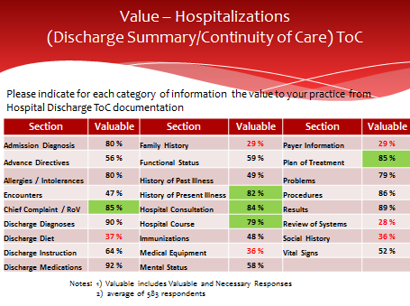
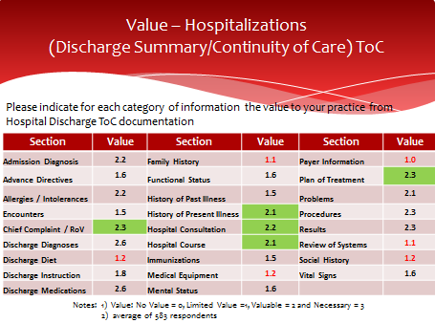

Respondents were asked on a four point scale about the value of specific categories of information (these correspond to Consolidated C-CDA sections, though respondents were not expected to know that). The possible answers for each category were “No Value,” “Limited Value,” “Valuable,” and “Necessary.” Figure ____ above summarizes the percentage who chose either “valuable” or “necessary.” Figure ____, represents the same data as a weighted average, which is a way of representing the data on the previous table as a single number, giving higher weight to “necessary” than “valuable” (whereas both were added together to yield the percentage in the previous table). The maximum possible value of weighted average = 3.0. Scores above 2.0 can be considered high value (valuable to necessary).

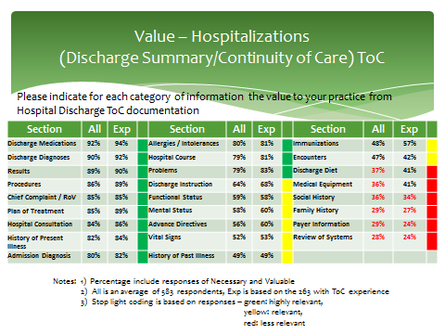

Figure ____ rearranges the data from previous tables, to show the sections in order from high to low perceived value. There were no major differences in results between respondents who had actually received ToC documents electronically, and those respondents who had not.

Note that some data sections may be valuable to the provider, even necessary, but may not have been deemed important to obtain from ToC documents because it is gathered another way. For example, Payer information is almost always gathered directly from the patient and reverified frequently in person, rather than relying on prior providers for it.

Just because a section received a low score does not necessarily mean it should always be excluded. Clinical judgment should still be applied to decide. However, the table indicates the overall relative importance of these sections for a cross-section of providers. For example, a patient with a social history indicating past substance abuse problems, discharged on narcotic pain medications, would almost certainly be relevant. Similarly, an implanted device that affects the ability to perform future imaging or surgical procedures would be important (that would be in the Medical Equipment section). (Any more clinical examples of when something with a “low score” above might still be important to include?)

It is unlikely that most of the “low value” sections (red) are included in typical ToC documents, since none of them are required by MU or certification, except for smoking status in the Social History Section. Family History is often collected, and may be present if available.

RECOMMENDATIONS
- Ensure that ToC documents from hospital discharges include a summary of the patient story, using Hospital Course plus one or more of the following sections for which information is available: Chief Complaint, Chief Complaint and Reason for Visit, History of Present Illness, Hospital Consultations, and Plan of Treatment.
- Alternatively, consider generating the C-CDA Discharge Summary for hospital discharges.
- Avoid including detail from prior hospitalizations, and include only the relevant data from the current hospitalization

Amount of Data
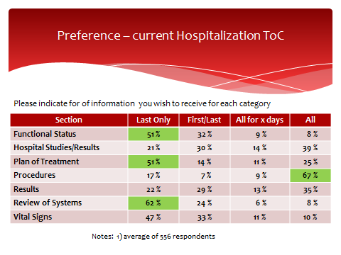
DESCRIPTION
This question asked about certain sections which contain data with the potential to be voluminous or repetitive. There were significant differences in some:
- Procedures (probably meaning surgical procedures) were deemed significant enough that 67% of respondents wanted to receive all procedures.
- For Functional Status, Plan of Treatment, and Review of Systems, if they are done multiple times during a hospitalization, most providers generally wanted to receive only the last one, or the first and last, though 25% of providers wanted “all” of the plans of treatment.

INTERPRETATION
These data inform us, in more detail, of what providers mean when they prefer “limited data from current hospitalization.” They want more of some types of data than others, especially Procedures.

RECOMMENDATIONS
- Consider these preferences for the amount of each section to include, since most providers wanted a summary of the most recent hospitalization, not all details
- Strongly consider including all procedures done during the hospitalization. However, we clarify that “procedures” was probably assumed by respondents to mean surgical or invasive procedure procedures, and not to include routine things such as insertion of an I/V line which technically can be considered a procedure but us probably not of interest to most providers.

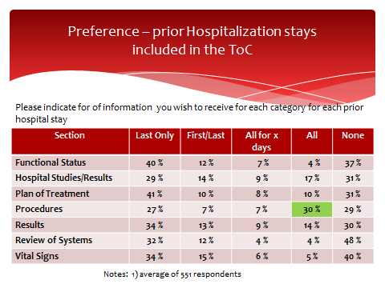
DESCRIPTION
Most providers said they did not want information from prior hospitalizations, but preferred “limited information from current hospitalization.” Because over 80% of providers wanted “the traditional discharge summary,” which is not likely to have data from prior hospitalizations, this table only applies for approximately 20% of the time, when providers want data from more than one hospitalization.

INTERPRETATION
Procedures stand out as the one category of data where all historical procedures might be more desirable than for other categories of data, but it is still only 30% who want “all.”

RECOMMENDATIONS
- Since most providers wanted a summary of the current hospitalization, not all details, consider these preferences when deciding what to include. If anything earlier than the latest hospitalization is included, be parsimonious and consider the volume.
- Consider including historical procedures and even procedures done long ago, if major and/or pertinent to the treatment being given now. For example suppose the current procedure is Right Lower leg amputation. If the patient had a Left lower leg amputation 5 years ago, realizing that the patient is now a bilateral lower extremities amputee will affect discharge planning and care provision. As another example, consider a patient scheduled for Cardiac surgery, who is a repeat CABG (patient s/p CABG 3 years ago). Hemodynamic stability needs to be considered as part of cardiac rehab planning and care.

Differences depending on Specialty

The above three recommendations are applicable regardless of whether the respondent is in Primary Care, Internal Medicine, or specialty care. However, there are a few interesting nuances from the survey results.

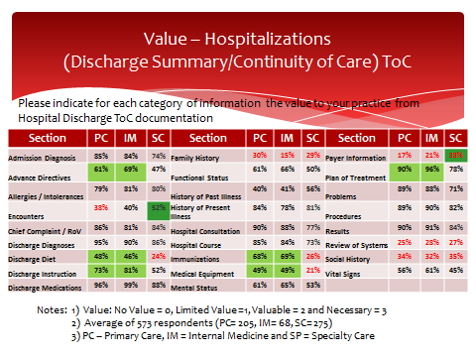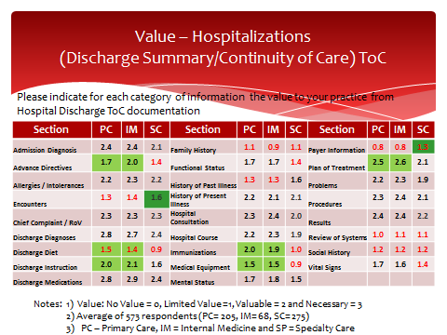

DESCRIPTION
These tables are similar to previous ones, except they stratify data between primary care (PC), Internal Medicine (IM), and Specialty Care (SC – everything else). To a large extent, PC and IM are similar, and many persons have an Internist as their PCP). Nevertheless, the data were separated because there are some subspecialties of Internal Medicine, and in case there were any significant differences. As it turns out, there were no noteworthy differences between PC and IM results.

INTERPRETATION
Comparing PC/IM vs specialists, there are a few noteworthy differences (>0.4 difference in weighted average) in level of interest in types of information. For example,
- Immunizations, Medical Equipment, Advance Directives, Discharge Diet, Discharge Instructions and Plan of Treatment are all viewed as much more valuable/necessary by PC/IM, vs specialists. These differences are highlighted in green above. These differences seem seem explainable. For example, immunizations are commonly managed by PC/IM providers. When patients have advance directives, they are typically discussed in more detail with PC/IM providers. Longer term nutrition management are handled by PC/IM providers. Follow-up on discharge instructions are done by PC/IM providers.
- Encounters are viewed as LESS valuable/necessary (though not by a lot) by PC/IM vs specialists. This may be because PC/IM are more likely than specialists to already know about encounters with other providers. Also, Payer Information was deemed more valuable by specialists than by PC/IM, though still a low average score. These differences are highlighted in dark green above. Specialists may be part of referrals by payers.
- Of the high value narrative summary sections previously mentioned as probably missing (Chief Complaint/Reason for Visit, Hospital Course, History of Present Illness, Hospital Consultations, Plan of Care) all were rated high across all types of providers.

RECOMMENDATION
The main conclusion from the stratified data: keep in mind the intended purpose and recipients of the document, e.g., specialty, and understand what is most important to them, regardless of the overall average scores.

ToC from Ambulatory Visits

Preference vs Experience
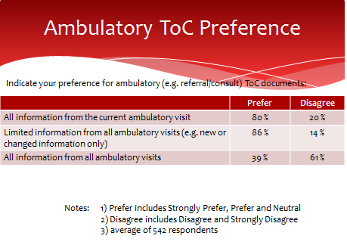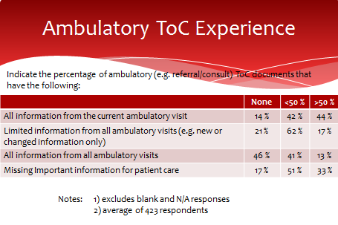
DESCRIPTION
In contrast to the Hospital Discharge experience, the “preference” question pertains to ToC documents received by one provider from another ambulatory provider after a visit, such as from a referral or after a consult.

80% of respondents preferred to receive “all” information from the current ambulatory visit . In addition, 86% of providers want “limited, such as new or changed information, from all ambulatory visits.” Note: “current” really means “after the visit that the provider is summarizing,” since the patient is no longer in the visit being summarized.

The actual experience, compared to the preference, shows that the desire for all information from the latest ambulatory visit is often not met, as only 44% say they receive it most of the time. Correspondingly, the last question says that 84% of respondents they are missing important information for patient care at least some of the time (33% say more than half the time).

INTERPRETATION
In contrast to a hospitalization, there will generally be much less voluminous data for an ambulatory visit, so the preference for “all” from the current visit, and for limited information from previous visits, is not surprising, whereas it would be too overwhelming to do likewise for hospitalizations.

While the last two questions were worded as “all ambulatory visits”, we suspect that respondents did not literally mean that they wanted information from every visit over the patient’s lifetime! Rather, we interpret that they were interested in information from multiple visits relevant to the care they are delivering. Common sense indicates that providers would not be interested in the routine physical exams, or the flu shot, or the sore throat visit from 10 years ago! Of course, in situations such as a referral from a PCP to a specialist, it is understandable that the PCP would want the full reports from multiple visits to that specialist. Thus the volume of data, and the significance, should be context-dependent.

As with hospital discharges, we try to understand what is this missing information? There is no clear indication, except for the general issue of “Needs summary” as also mentioned for hospital discharges, supplemented by comments provided in response to the “long survey” (see ______). In broad terms, the information could be characterized as “provider notes.” But since C-CDA does not have specific sections with that title, we need to postulate the equivalent in C-CDA terms. Comparing the sections that are REQUIRED in ToC documents, and comparing them to the “Value” statements that come up in the following tables, we gain insight. If a section is deemed “Valuable” but is not included, it is a partial answer to the question: “What is the important information for patient care that is missing?”

Value of Data
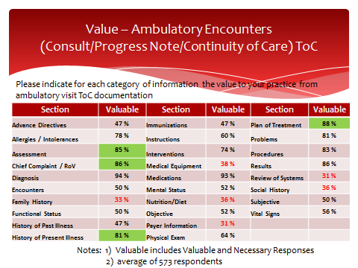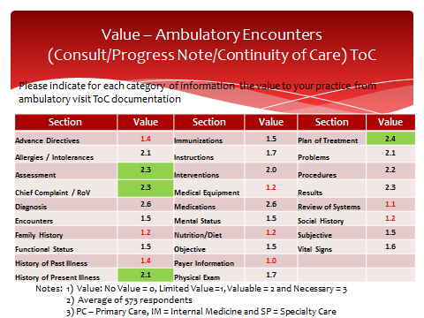
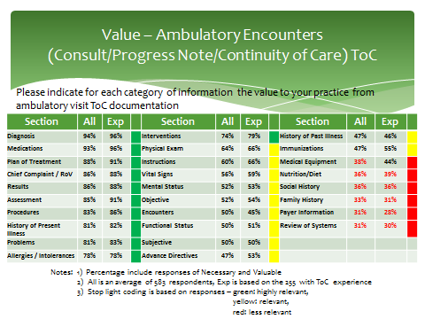
From the tables above, which present the responses first as percentages, then as a weighted average, and lastly ordered from high to low value (as explained for Hospital Discharge), it is apparent that the following sections, which are typically narrative, may contain some or all of the desired summary that is deemed missing. Chief Complaint (or Chief Complaint and Reason for Visit), Assessment, History of Present Illness, and Plan of Treatment. These are four of the top nine most valuable sections, according to respondents. Some aspects of the Plan of Treatment (formerly called Plan of Care) were required in Stage 2 of Certification and Meaningful Use. But it is still significant that probably three of the top nine value sections, ones that tell the patient story, were not usually included.

RECOMMENDATIONS
- Include a narrative describing the patient story, using one or more of the following sections: Chief Complaint/Reason for Visit, Assessment, History of Present Illness, and Plan of Treatment, to the extent that the information is available. These can be added to the summary documents (CCD, etc.) being generated.
- Note to ONC: we recommend allowing more document types to be used. Of the 3 permitted in 2015 edition certification, only Referral Note and CCD apply to an ambulatory ToC. Referral Note is only for the “front end” of the referral loop. Consultation Note, Progress Note, and/or History and Physical would all be valid responses from a consulting provider for the “back end” of the referral loop. TO DO:Clarify MU2&3 vs MACRA – is there a difference?)

Amount of Data
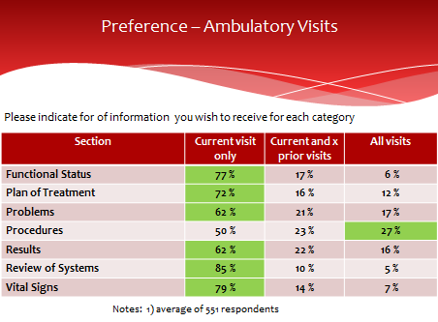
There are different preferences regarding the inclusion of historical data for different sections. Since anecdotal evidence and testimony often referred to “too much information” or “bloated, overly long documents,” we asked specifically about a few types of sections that could potential generate many pages. Some could be voluminous because there really can be large volumes of data generated (e.g., lab results), especially if a long time period is included. Others might not be voluminous for a single visit, but might tend to be repetitive or irrelevant if older instances are superseded by newer ones (e.g., Review of Systems, Plan of Treatment). The results are summarized above. For all, data from the current visit was most often desired. Procedures were the one type of data that stood out as having relatively more value of older data (“all visits”).

Differences depending on Specialty

The above three recommendations apply, regardless of whether the respondent is in Primary Care, Internal Medicine, or specialty care. However, there are a few interesting nuances from the survey results.

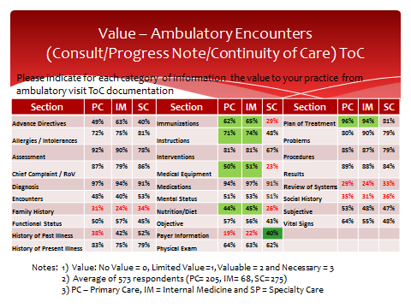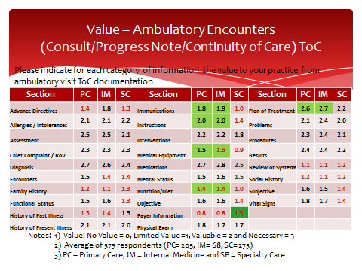

DESCRIPTION
This slide is similar to previous ones, except it stratifies data between primary care (PC), Internal Medicine (IM), and Specialty Care (SC – everything else).

INTERPRETATION
Comparing PC/IM vs specialty, there are some significant differences (>0.4 difference in weighted average) in level of interest in types of information. For example,
- Immunizations, Medical Equipment, Instructions, Nutrition/Diet, and Plan of Treatment, are all viewed as more valuable/necessary by PC/IM, vs specialists.
- Payer information was deemed more valuable by specialists than by PC/IM, though still a low average score.
- Of the high value narrative summary sections previously mentioned as probably missing (Chief Complaint/Reason for Visit, History of Present Illness, Assessment, Plan of Care) all were rated high across all types of providers.

RECOMMENDATION
The main conclusion from these data: keep in mind the intended purpose and recipients of the document, e.g., specialty, and understand what is most important to them, regardless of the overall average scores.

Medications

Medications in Hospital Discharges
In terms of “value” of data sections, Discharge Medications were ranked as the #1 section for hospital discharges, and Medications were ranked as the #2 section for ambulatory ToC. But because of the importance of medication information to clinicians, and the variety of options by which medications can be included (or excluded) in medication lists, a specific set of questions was asked about preferences and experiences for medications. The hospital questions are shown below.
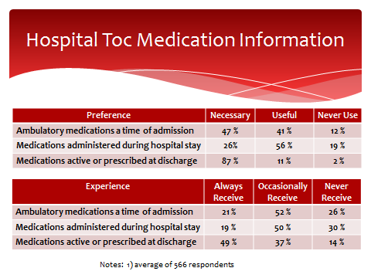
As expected “medications active or prescribed at discharge) have 98% who consider them necessary or useful. This equates to the “Discharge Medications” section. However, some medications were active upon admission but then discontinued, and other medications were administered within the hospital and also not continued. As the table shows, both those are considered necessary or usefulby 88% and 82% respectively. Yet they are not always received. While not considered as overwhelmingly “necessary” as discharge medications, they are still useful.

RECOMMENDATION
- Include Discharge Medications in the Discharge Medications section (of a Discharge Summary), or in the Medications Section (of a CCD).
- Also consider including the Admission Medications Section and the Medications Administered Section where applicable.
- By using three distinct sections, clinicians who are only interested in Discharge Medications will seem them separately, and can ignore the other two sections. The three categories of medications should not be intermixed in a single list that might make it difficult to tell which is which.

Medications in Ambulatory ToC
Five questions were asked about preferences and experiences with medications from ambulatory ToC, as shown in the table below.

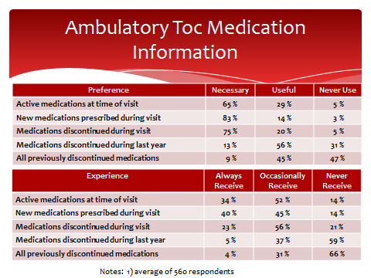
The results show that clinicians consider necessary the active medications at the time of the visit, and also the changes that occurred, new prescriptions and discontinued medications. All of them were not always received, and discontinued medications was the area of largest gap between preference and experience.

Much less value was perceived in historical information such as “all previously discontinued medications,” though even there more than half found them useful.

RECOMMENDATIONS
- Ensure that medications lists include all medications that are active, that are newly prescribed, and that were discontinued. Each of these should be distinctly labeled and identified. The question was not asked whether they should be separate lists, or a single list with new and discontinued medications distinguished somehow.
- If any past medications (discontinued prior to the current visit) are included, separate them from those that were active, new, or discontinued as of the current visit.
- Reasons for discontinuation (e.g., ineffective, condition resolved, superseded by different medication, adverse reaction, etc.) would be valuable information, if available.

Alternative Approaches
While the original premise of the Relevant and Pertinent Project was focused on document generation (and avoiding sending “too much information”), it became apparent that there could be alternative approaches to meeting the needs of clinicians. It is not always feasible – due to lack of knowledge, lack of time, or other reasons -- for the sender to know what the receiver prefers and to modify the document accordingly. Some senders do not feel comfortable withholding information even that they think would not be relevant, at the risk of making the wrong decision. So an alternative question was asked: “Do you prefer to manage ToC content by receiving more information and having better presentation and incorporation capability in your EHR?” If yes, then they were asked about several potential alternatives, as shown in the table below.
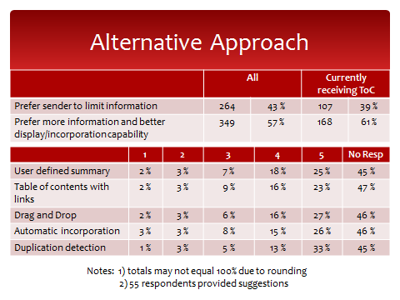
Interestingly, while 39% of receivers prefer to receive less information (limited by the sender), significantly more of them (61%) want to receive more information if they have better display and incorporation capability. A significant had a high degree of interest (score of 4 or 5) in all of the alternatives proposed: detection of duplicate data, drag and drop for incorporation of discrete data, user defined summaries, automated incorporation, and table of contents with links.

RECOMMENDATIONS
Specific recommendations on how to provide these alternatives was beyond the scope of the Relevant and Pertinent project. However, progress can be made by acknowledging and collaborating with other efforts that started after the Relevant and Pertinent survey was conducted.
- EHR developers should seek to innovate and provide features such as (but not limited to) those mentioned above, to provide better tools for receivers of CDA documents, so that they are not totally dependent on the decisions of senders.
- ONC should seek to stimulate and incent innovative research and development of new rendering features, building upon the results and learnings from the Consolidated CDA Rendering Tool Challenge that ONC and HL7 co-sponsored in 2016
- Regarding incorporation of clinical data into receiving systems, ONC and ONC and EHR developers should consider the recommendations of the Interoperability Experience Task Force (an advisory committee to the HIT Joint Committees), including “Challenges” and “Pilots” for clinical information reconciliation, and prioritization of semantic elements that impact the interoperability experience, e.g., auto-reconcilable data elements.

Long Survey
As a supplement and complement to the short survey, which was sent to a large number of persons, who answered questions through the web (without discussion), a “long survey” was created to engage a small number of groups in interactive discussion of the issues. The short-answer, quantitative approach of the short survey was complemented by the more free-form, qualitative discussion engendered by the long survey. 3 Hospitals, 4 health systems, and 4 professional societies agreed to participate in the long survey. (FILL IN NAMES?)

The first two questions asked what percentage of documents received were not helpful, and then asked “why not?” In keeping with the premise of dissatisfaction among clinicians, based on public testimony, which spawned the RnP project.
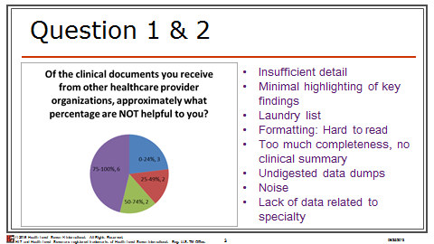

These results are very consistent with the those of the short survey, which said that there was both “too much information” and yet “missing information.” The comments of “too much completeness” and “no clinical summary” match the short survey’s findings, where we have made recommendations for inclusion of narrative and avoidance of excessive history from past (not current) hospitalizations or visits. However, we also pointed out that specialties varied in what they wanted to receive, and recommended that their preferences be taken into account.

The next question pertained to desired document size.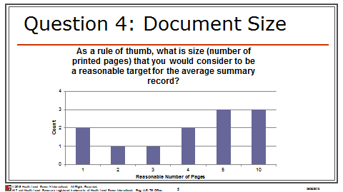

While it is difficult to make specific recommendations as to what to include or not include in documents, based on these responses, it is a useful baseline to understand what is expected. A “page” is subjective (it may refer to a printed page, but might also refer to screens on a display). Nevertheless, we have anecdotal evidence that some CDA documents generate unnecessary pages through their formatting choices (e.g., one result per “page”), and the long survey suggests that it is desirable to keep the page count under 10.

The “value of data” question was addressed in the short survey. The following provides a different perspective on Data Element Relevance, and drills into more detail not just about the value of a “Section” (e.g., Medications, Problems), but about the status of that information, e.g., current/active, recent, planned, historical.
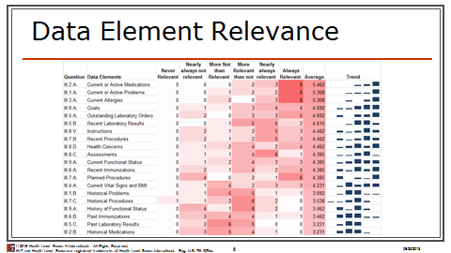

Not surprisingly, the “old” information was considered less relevant. Since there may have been many previous visits or hospitalizations, it can easily be inferred that inclusion of much “old” information can also create large documents and lead to the “undigested data dumps” criticism in response to Question #2.

Comparison of Results against Meaningful Use Requirements
Distinguish between MU1 and MU2 requirements, but apply recommendations towards MU2/MU3 (2014 and 2015 editions) since that is where any software changes will be applied.

Conclusions and Recommendations

Guidance on use of the results

Classification of relevance

Use of Classifications

If you are a generator: Sending Data

If you are a renderer: Viewing Data

If incorporating the data

FHIR Considerations
While this document is focused on Consolidated CDA documents, we recognize that Consolidated CDA content can also be exchanged using FHIR resources. The implications of clinician preferences and experiences, regarding what is relevant and pertinent, may be useful to consider regardless of whether the content is delivered through C-CDA documents, FHIR documents, or FHIR queries.
Say more about similarities and differences…

References
- American Recovery And Reinvestment Act of 2009, US Public Law 111-5, 123 Stat. 115, 516 (Feb. 19, 2009). http://www.gpo.gov/fdsys/pkg/PLAW-111publ5/content-detail.html

- Acronyms and Abbreviations
C-CDA Consolidated CDA
CCD Continuity of Care Document
CDA, CDA R2 Clinical Document Architecture (Release 2)
CFR Code of Federal Regulations
DIR Diagnostic Imaging Report
DSTU Draft Standard for Trial Use (now STU)
STU Standard for Trial Use
EHR electronic health record
EMR electronic medical record
H&P History and Physical
HIT healthcare information technology
HL7 Health Level Seven
HTML Hypertext Markup Language
RFC Request for Comments
LOINC Logical Observation Identifiers Names and Codes
NI no information
ONC Office of National Coordinator
XML eXtensible Markup language
XPath XML Path Language

See slide 3 in the presentation at https://www.healthit.gov/FACAS/sites/faca/files/Joint_Data_Updates_2015-10-06.pdf
* From http://www.bmc.org/Documents/bmc-Transitions-of-Care.pdf recommendations for discharge summary: “Reason for admission and hospital course – This section is dedicated to communicating the “story” associated with the patient’s hospitalization. How did the patient present? What was the key history that provided clues to the diagnosis and severity of presentation? Were there any events that affected management during the course of hospitalization?” And from http://www.ahrq.gov/downloads/pub/advances2/vol2/advances-kind_31.pdf “Hospital course (a description of the events occurring to a patient during his/her hospital stay)”
While the Plan of Care/Plan of Treatment Section may contain structured entries, they are not required by C-CDA or 2011 or 2014 edition Certifications. For the ToC documents for MU1 and MU2,

