CDAR2_IG_OFFICIAL_DOC_NAME

HL7 Implementation Guide for CDA® Release 2:
Clinical Guidance on Relevant and Pertinent Data to Include in Automatically Generated Patient Summaries
Draft, August 4, 2016

Sponsored by:
Structured Documents Work Group
Cosponsor Workgroup

Copyright © 2015 Health Level Seven International ® ALL RIGHTS RESERVED. The reproduction of this material in any form is strictly forbidden without the written permission of the publisher. HL7 and Health Level Seven are registered trademarks of Health Level Seven International. Reg. U.S. Pat & TM Off.
Use of this material is governed by HL7's IP Compliance Policy.
Structure of This Guide

Co-Chair |  | Primary Editor:
Co-Editor: |  | Technical Editor:
Current Work Group includes

Acknowledgments

Contents
1 Introduction 7

1.1 Purpose 7

1.2 Audience 7

1.3 Organization of the Guide 7

1.4 Contents of the Package 7
2 Background 8

2.1 CCD and CCDA 8

2.2 Current Project 8
3 Design Considerations 9

3.1 Compatibility 9

3.2 Narrative Reference 9

3.3 Unknown and No Known Information 9
4 Using This Implementation Guide 10

4.1 Levels of Constraint 10

4.2 Conformance Conventions Used in This Guide 10

4.2.1 Conformance Verbs (Keywords) 10

4.2.2 XPath Notation 11

4.2.3 XML Examples and Sample Documents 11
5 References 13
Appendix A — Acronyms and Abbreviations 14

Figures
Figure 21: XML Document Example 11
Figure 22: XPath Expression Example 11
Figure 23: ClinicalDocument Example 12

Tables
Table 1: Contents of the Review Package 7

Introduction

Purpose

This project will deliver an informative document providing principles for developing, and guidance on what information should and should not be present and appropriate in both entries and narrative content in an automatically generated clinical summary (e.g., CCD, Discharge Summary, etc.). It will not create new templates or models, but simply explain how to use existing templates in current HL7 work products.

The project will also attempt to understand the various contexts and their impacts on the information requirements (e.g., Patient Summary vs. Transfer of Care).

We will develop a process to reach out to clinical professional societies, provider organizations and organizations representing patients to present the project, gather feedback, develop recommendations, and review results. We will execute this process with a number of organizations in order to gather the best possible recommendations. Participation will be open to any organization that shows interest and commits to meeting the project requirements and schedule.

The guidance delivered in this document would be structured in a way that it could be automatically tested for conformance against coded and structured data, but also could be applied to narrative sections.

Audience
- Developers and Implementors of Automated CCDA Generating Systems
- Clinicians and other generators and users of CCDA Documents
- Policy Makers

Organization of the Guide
This document provides
- Chapter 1—Introduction
- Chapter 2—
- Appendices. The Appendices include

Contents of the Package
The following files comprise this implementation guide package:
Table 1: Contents of the Review Package
Filename | Description | Standards Applicability
 |  | Informative
 |  | Informative
 |  | Informative
 |  | Informative
 |  | Informative

Background

CCD and CCDA
The Continuity of Care Document (CCD) Release 1.0 and its successor (version 1.1 found in the C-CDA specification) are required for use under Meaningful Use regulation in the US. Due to short timelines, many organizations have opted to automatically generate these documents. As a result, some organizations and software products are generating CCD documents that span dozens of pages even for the simplest of cases, making these documents unusable for their intended purpose.

Current Project
This project will deliver an informative document providing principles for developing, and guidance on what information should and should not be present and appropriate in both entries and narrative content in an automatically generated clinical summary (e.g., CCD, Discharge Summary, etc.). It will not create new templates or models, but simply explain how to use existing templates in current HL7 work products.
The project will also attempt to understand the various contexts and their impacts on the information requirements (e.g., Patient Summary vs. Transfer of Care).
We will develop a process to reach out to clinical professional societies, provider organizations and organizations representing patients to present the project, gather feedback, develop recommendations, and review results. We will execute this process with a number of organizations in order to gather the best possible recommendations. Participation will be open to any organization that shows interest and commits to meeting the project requirements and schedule.
The guidance delivered in this document would be structured in a way that it could be automatically tested for conformance against coded and structured data, but also could be applied to narrative sections.

Method
Built the surveys, short and long

Short Survey
reviewed them internally,
reviewed them with external stakeholders,
sent them out to AMA, ACP, AAFP, AHA, HIMSS, Holly’s group and others. From __/__/__ to __/__/__

Responses back, AMA (433), AAFP (103), AHA (34), and ACP and others (43) (613 total)

Long Survey
Long Survey (13 results back) from …

Results

Short Survey

Cohort that Responded
BOB DIETERLE, Red Deck Slides 1-7 (all slide numbers refer to red deck, unless specifically stated otherwise)

Overall Results
BOB DIETERLE – General issues, Slides 8-18)
DAVID TAO

General Discussion: Approach and Limitations
There are two primary types of transitions of care (ToC) about which the survey asked.
- Hospital Discharge. Patient is discharged from a hospital, and transitions to an ambulatory provider (e.g., the PCP or a specialist who admitted the patient). A document is sent from the hospital to the ambulatory provider. The specifics are not known from the survey, but we assume that ambulatory specialists or PCPs responding to the survey are thinking of those instances when they received a ToC document directly from the hospital.
- Ambulatory ToC. Patient transitions from ambulatory provider 1 to ambulatory provider 2. A document is sent from provider 1 to provider 2. This may be the result of a referral from provider 1 to provider 2, may be the “closing of the referral loop” where provider 1 sends a ToC document to provider 2 after a consultation, or may be some other unspecified transition. The data to distinguish these types of transitions is not available in the survey, so all ambulatoryambulatory transitions are grouped together.
Hospital Discharge vs Ambulatory ToC preferences and experiences are different enough that we discuss the results for each separately.
For type of ToC, we first describe providers’ preferences for what they would like to receive, and then we discuss their experience of what they actually receive. We infer that satisfaction will increase to the extent that preferences are met in actual experience, and that dissatisfaction will increase to the extent that preferences are not met.
LIMITATIONS. Sometimes the survey answers can be reported without interpretation, i.e., the results speak for themselves and can help our target audience simply by giving them the facts. There are other times, however, when some degree of interpretation, or “reading between the lines” is necessary to arrive at meaningful recommendations. For example, there may be a difference between preferences and experience, but the specific factors are hard to know with certainty. In writing this report, we distinguish between recommendations based on the actual facts, and other recommendations based on our interpretation of what were probably contributing factors. We use our collective experience, and the wisdom of our reviewers, to assist in these interpretations and recommendations, and will explain where we make plausible interpretations or recommendations that were not directly stated in the survey data.
To give an example of where interpretation is needed, consider the following: a high percentage of providers said that they were “missing important information for patient care” in the ToC documents from hospital discharges. But what specific data were they missing? That was not specifically asked, though a few wrote free-form comments. However, we do know what data was required in Certification and Meaningful Use Stage 1 and Stage 2 regulations. So the “missing information” was probably something outside of the MU-required data set. We can then analyze which sections of data were not normally included in the most common ToC documents (CCD), and narrow down the range of possibilities for missing information.
Although the survey did not ask providers which specific CDA document types they received (because we thought many would not know), we have reason to believe that the vast majority of document were Continuity of Care Documents (CCD), either constrained by HITSP C32 specification (for MU1), or using C-CDA 1.1 (MU2). To state it differently, we believe that a very low percentage of the documents received by the survey respondents were non-CCD document types such as Discharge Summary, Referral Note, Consultation Note, Progress Note, or History and Physical.
Under this very plausible assumption, how many CCDs lacked a section that has a narrative summary of the hospitalization? At the time the survey was taken in late 2015, based on CMS attestation statistics, only a small percentage of providers (57Kout of 357K, or about 16% of those registered for MU) had attested to MU2, therefore over 80% were operating under MU1. Most of those were probably receiving C32 CCD (in MU1 there originally was no C-CDA and no option to send other document types other than CCR or CCD). (NOTE: how many on MU1 might have started receiving enhanced Stage 1 documents, using C-CDA 1.1, as of late 2015?).
A potential follow-up survey could statistically analyze the actual documents generated in transitions of care, or simply survey vendors to ask which documents they generated. But it is highly probable that we would not find a significant volume of other documents besides CCDs, so such a survey might be much effort to simply reinforce our existing conclusion.
We assume that most documents came from “push” messages rather than queries (XDS, XCA, FHIR), because of the Meaningful Use incentives to push ToC documents using Direct messaging. but there no way to know, since that was not asked on the survey, and the transport method is immaterial to the conclusions of this project anyway.

Results for Transition of Care from Hospital Discharge
(NOTE TO DAVID. DELETE WHEN DONE: Consider GREEN slides 6, 8-10, 13-15)
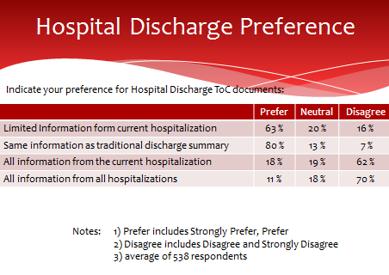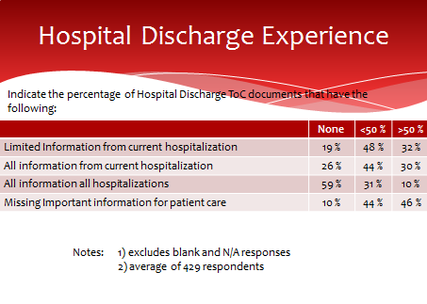
First, we compare the survey respondents preferences vs their actual experiences.

DESCRIPTION
Despite the “Hospital” in the title, these results represent mostly the experience of ambulatory providers who received documents FROM hospital discharges of their patients, not experiences of hospital providers (less than 20% of the responses were from hospital-based physicians, as described earlier in the analysis of the demographics of respondents).

The key point is that providers want a SUMMARY and ”LIMITED Information from current hospitalization.” The word “current” is really best described as “latest” (since the patient is no longer in the hospital when the ToC document is received). A strong preference (80%) was expressed in favor of “traditional discharge summary” which is what the C-CDA Discharge Summary represents: it includes a narrative summary of hospital course, as well as structured data. However, per the General Observations, it’s very unlikely that providers received Discharge Summaries instead of CCD.

The last two questions indicate strong preferences for not “all” information from latest hospitalization or certainly not ALL hospitalizations. That would be far too much information.

Comparing the table of experience vs the preferences, we see that there is a mix of “too much information” but also “missing information.”
- Too much. All information from latest hospitalization, or all info from all hospitalization, is received much of the time (40% say they receive these more than 50% of the time), despite only 18% saying they wanted all info from latest, and only 11% saying they wanted all info from all hospitalizations.
- Yet too little. On the other hand, even though some are receiving what they prefer (limited info from latest hosp), the information may be TOO limited, because 46% of respondents say that they are “missing important information for patient care” more than 50% of the time.

INTERPRETATION

How do we strike the balance between “too much” and “not enough?” First, we need to understand what is this “missing information?” Based on the 50% of respondents (slide 15) raising the general issue that the document “Needs summary” we can surmise that the “patient story” in the Hospital Course section of a Discharge Summary is often missing, and that instead, there may be too much irrelevant detail from the latest and/or previous hospitalizations.
Similarly, Chief Complaint (or Chief Complaint/Reason for Visit), History of Present Illness, Plan of Treatment, and Hospital Consultations are all highly valued sections, each typically narrative summaries. History of Present Illness is complementary to Hospital Course because it describes what led up to the hospitalization, rather than what happened during it. While parts of Plan of Treatment may are in the CCD definition, Hospital Course, Chief Complaint, Reason for Visit, History of Present Illness, and Hospital Consultations, are usually not included in most ToC documents, because they are not part of the CCD definition, nor are they in the common MU data set or MU1 C32 requirements. Any of them may be added to a CCD document, since “open templates” allow addition of section to documents that do not include them in their definition. However, it is unlikely that these sections actually are added in most CCDs.

It is less important than all these sections be included, than that their type of information be included somewhere. Some sections may subsume others (e.g., Hospital Course might discuss chief complaint). See Figures ____ (following) for details of respondents’ perception of “value.” It is significant that probably four of the top 12 value sections, ones that tell the patient story, are not usually included in the ToC documents that are usually sent.

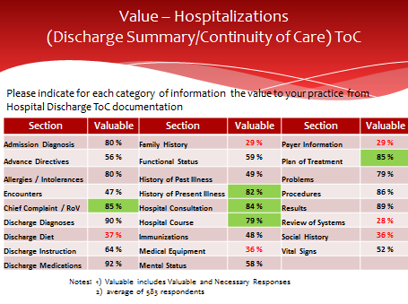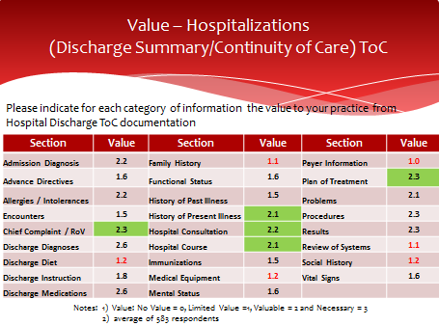

Respondents were asked on a four point scale about the value of specific categories of information (these happen to correspond to Consolidated C-CDA sections, though respondents were not expected to know that). The possible answers for each category were “No Value,” “Limited Value,” “Valuable,” and “Necessary.” Figure ____ above summarizes the percentage who chose either “valuable” or “necessary.” Figure ____, the weighted average table, is a different way of representing the data on the previous table as a single number, giving higher weight to “necessary” vs “valuable” (whereas both were added together to yield the percentage in the previous table). However, we will also display the percentage slides, because they it’s easier to understand “82% found Section X valuable” rather than “Section X had a value score of 2.1.” Max possible value = 3. Scores above 2 can be considered high value (valuable to necessary).

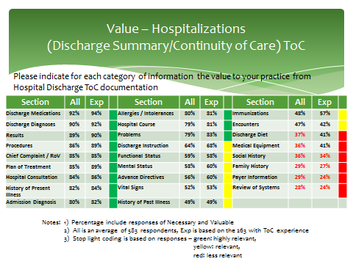

Figure ____ rearranges the data from previous tables, to show the sections in order from the highest perceived value to the lowest. There were no major differences in perceived value between respondents who had actually received ToC documents electronically, and those respondents who had not.

Note that some data sections may be valuable to the provider, even necessary, but may not have been deemed important for ToC documents because it is gathered another way. E.g., payer information is almost always gathered directly from the patient and reverified frequently in person, rather than being replying on prior providers’ for it.

Just because a section received a low score does not necessarily mean it should always be excluded. Clinical judgment should still be applied to decide. However, the table indicates the overall relative importance of these sections for a cross-section of providers. For example (give a clinical example of when something with a “low score” above might still be important to include – e.g., implanted device in Medical Equipment that affects ability to do future imaging or surgical procedures?)
See next slide for interpretation relative to previous tables.

It is unlikely that the “low value” sections (red in the last Figure) are included in typical ToC documents, since none of them are required by MU or certification, except for smoking status in the Social History Section.

RECOMMENDATIONS
- Ensure that ToC documents from hospital discharges include a summary of the patient story, using Hospital Course plus one or more of the following sections: Chief Complaint, Chief Complaint and Reason for Visit, History of Present Illness, Hospital Consultations, and Plan of Treatment.
- Alternatively, consider generating the C-CDA Discharge Summary for hospital discharges.
- Avoid including detail from prior hospitalizations, and include only the relevant data from latest hospitalization

NOTE TO SAY MORE ABOUT THIS – SEE RED SLIDE 20 + Green slide 8 and 9 – 3 point value scale (G,Y, R), recommend inclusion SHALL, SHOULD, MAY, or a 5 point scale? Realize that all data are considered valuable by some percentage, but not equally so. Our recommendation is to consider it all, but certainly to at least prioritize inclusion of the sections that have the highest value. (HIGHLIGHT THESE SOMEHOW)
COMPARISON OF RESULTS FOR PRIMARY CARE, INTERNAL MEDICINE, AND SPECIALTIES.

The above three recommendations apply, regardless of whether the respondent is in Primary Care, Internal Medicine, or specialty care. However, there are a few interesting nuances from the survey results.

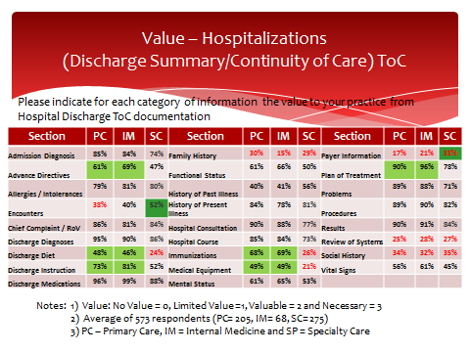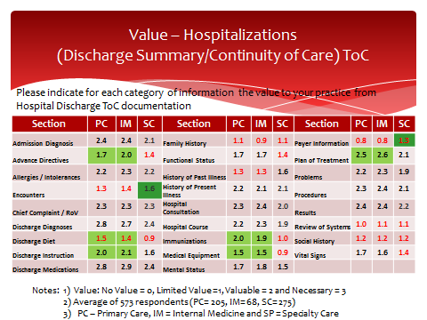

DESCRIPTION
These tables are similar to previous ones, except they stratify data between primary care (PC), Internal Medicine (IM), and Specialty Care (SC – everything else). To a large extent, PC and IM are similar, and many persons have an Internist as their PCP). Nevertheless, the data were separated because there are some subspecialties of Internal Medicine, and in case there were any significant differences. As it turns out, there were no noteworthy differences between PC and IM results.

INTERPRETATION
Comparing PC/IM vs specialists, there are some significant differences (>0.4 difference in weighted average) in level of interest in types of information. For example,
- Immunizations, Medical Equipment, Advance Directives, Discharge Diet, Discharge Instructions and Plan of Treatment are all viewed as much more valuable/necessary by PC/IM, vs specialists. These differences are highlighted in green above. SHOULD WE OFFER PLAUSIBLE EXPLANATIONS OR CLINICAL EXAMPLES FOR WHY THESE DIFFERENCES EXIST?
- Encounters are viewed as LESS valuable/necessary (though not by a lot) by PC/IM vs specialists. This may be because PC/IM are more likely to be more likely than specialists to already know about encounters with other providers. Also, Payer Information was deemed more valuable by specialists than by PC/IM, though still a low average score. These differences are highlighted in dark green above. Specialists may be part of referral by payer.
- Of the high value narrative summary sections previously mentioned as probably missing (Chief Complaint/Reason for Visit, Hospital Course, History of Present Illness, Hospital Consultations, Plan of Care) all were rated high across all types of providers.

RECOMMENDATION
The main conclusion from these data: keep in mind the intended purpose and recipients of the document, e.g., specialty, and understand what is most important to them, regardless of the overall average scores.

ToC from Ambulatory Visit (slides 21-22, 27-28, 33; GREEN slides 7, 8, 11-15)
NEEDS TO BE CONSOLIDATED, RESEQUENCED
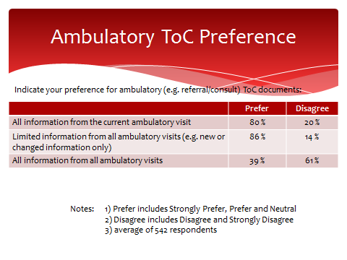
DESCRIPTION
In contrast to the Hospital Discharge experience, this question pertains to ToC documents received by one provider from another ambulatory provider, such as a referral or a consult.
80% of respondents preferred to receive “all” information from the current ambulatory visit . In addition, 86% of providers want “limited, such as new or changed information, from all ambulatory visits.” Note: “current” really means “latest” since the patient is no longer in the visit being summarized.
INTERPRETATION
In contrast to a hospitalization, there will generally be much less voluminous data for an ambulatory visit, so the preference for “all” from the latest visit, and for limited information from previous visits, is not surprising, whereas it would be too overwhelming to do likewise for hospitalizations.

While the last two questions were worded as “all ambulatory visits”, we suspect that respondents did not literally mean that they wanted information from every visit over the patient’s lifetime! Rather, we interpret that they were interested in information from multiple visits related to the care they are delivering. Common sense indicates that providers would not be interested in the routine physical exams or the flu shot or sore throat 10 years ago! Of course, in situations such as a referral from a PCP to a specialist, it is understandable that the PCP would want the full reports from multiple visits to that specialist. Thus the volume of data, and the significance, should be context-dependent.

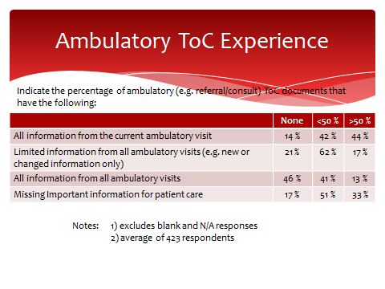
DESCRIPTION
The actual experience, compared to the preference, shows that the desire for all information from the latest ambulatory visit is often not met, as only 44% say they receive it most of the time. Correspondingly, the last question says that 84% of respondents they are missing important information for patient care at least some of the time (33% say more than half the time).

INTERPRETATION
As with hospital discharges, we try to understand what is this missing information? We don’t have a clear indication, except for the general issue of “Needs summary” as also mentioned for hospital discharges. In broad terms, the information could be characterized as “provider notes.” But since C-CDA does not have specific sections with that title, we need to figure out the equivalent in C-CDA terms. Comparing the sections that are REQUIRED in ToC documents, and comparing them to the “Value” statements that come up in the following tables, we gain insight. If a section is deemed “Valuable” but is not included, it is part of the answer to the question: “What is the important information for patient care that is missing?”

From SLIDE 28, we see that the following sections, which are typically narrative, may contain some or all of the desired summary that is deemed missing. Plan of Treatment, Chief Complaint (or Chief Complaint and Reason for Visit), Assessment, and History of Present Illness. These are four of the top nine most valuable sections, according to respondents. Some aspects of the Plan of Treatment (formerly called Plan of Care) were required in Stage 2 of MU. But it is still significant that probably three of the top nine value sections, ones that tell the patient story, were not usually included. It is probably less important than all these sections be included as separate sections, than that their type of information be included somewhere.

RECOMMENDATIONS
- Include a narrative describing the patient story, using one or more of the following sections: Chief Complaint/Reason for Visit, Assessment, History of Present Illness, and Plan of Treatment. These can be added to the CCDs being generated.
- Note to ONC: we recommend allowing more document types to be used. Of the 3 permitted in 2015 edition certification, only Referral Note and CCD apply to an ambulatory ToC. Referral Note is only for the “front end” of the referral loop. Consultation Note, Progress Note, and/or History and Physical would all be valid responses from a consulting provider for the “back end” of the loop. TO DO:Clarify MU2&3 vs MACRA – is there a difference?)

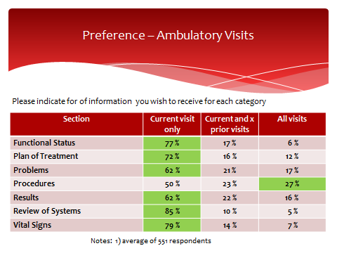

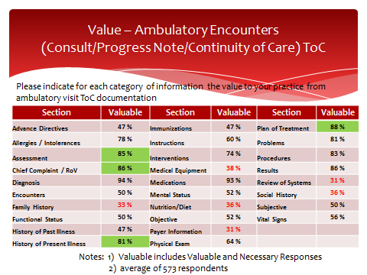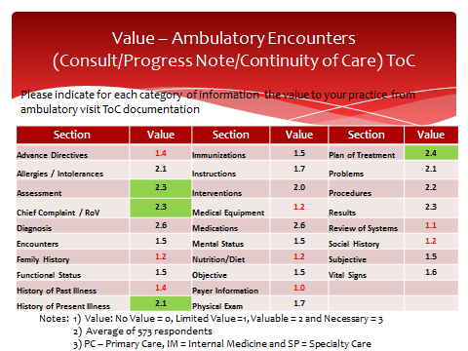
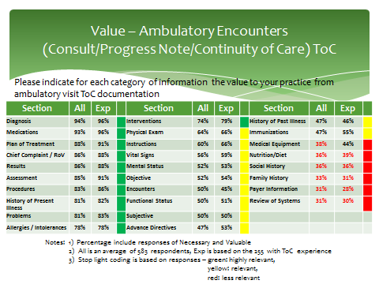

COMPARISON OF RESULTS FOR PRIMARY CARE, INTERNAL MEDICINE, AND SPECIALTIES.

The above three recommendations apply, regardless of whether the respondent is in Primary Care, Internal Medicine, or specialty care. However, there are a few interesting nuances from the survey results.

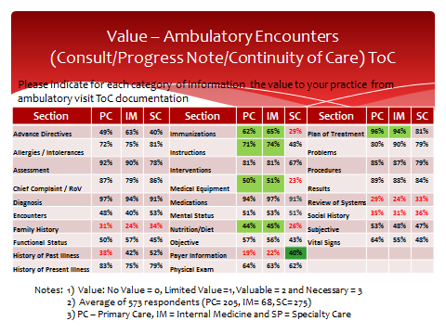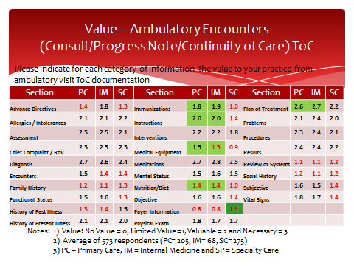
DESCRIPTION
This slide is similar to previous ones, except it stratifies data between primary care (PC), Internal Medicine (IM), and Specialty Care (SC – everything else).

INTERPRETATION
Comparing PC/IM vs specialty, there are some significant differences (>0.4 difference in weighted average) in level of interest in types of information. For example,
- Immunizations, Medical Equipment, Instructions, Nutrition/Diet, and Plan of Treatment, are all viewed as more valuable/necessary by PC/IM, vs specialists.
- Payer information was deemed more valuable by specialists than by PC/IM, though still a low average score.
- Of the high value narrative summary sections previously mentioned as probably missing (Chief Complaint/Reason for Visit, History of Present Illness, Assessment, Plan of Care) all were rated high across all types of providers.

RECOMMENDATION
The main conclusion from these data: keep in mind the intended purpose and recipients of the document, e.g., specialty, and understand what is most important to them, regardless of the overall average scores.

CHECK WHETHER REMAINING AMBULATORY TABLES AND TEXT STILL NEED TO BE TRANSFERRED FROM GREEN OR RED PPT

Differences between Specialty and Primary Care (slides 25-26, 29-30)
THIS SECTION TO BE DELETED. This material been blended into 4.1.3 and 4.1.4 respectively, since it is broken out by Hospital Discharge vs Ambulatory.

Medications
MORE FROM BOB DIETERLE ON SLIDES 34-35, + GREEN 16

Alternative Approaches
MORE FROM BOB DIETERLE ON SLIDES 36-END, + GREEN 17-19

Long Survey

Comparison of Results against Meaningful Use Requirements
Distinguish between MU1 and MU2 requirements, but apply recommendations towards MU2/MU3 (2014 and 2015 editions) since that is where any software changes will be applied.

Conclusions and Recommendations

Guidance on use of the results

Classification of relevance

Use of Classifications

If you are a generator: Sending Data

If you are a renderer: Viewing Data

If incorporating the data

References
- American Recovery And Reinvestment Act of 2009, US Public Law 111-5, 123 Stat. 115, 516 (Feb. 19, 2009). http://www.gpo.gov/fdsys/pkg/PLAW-111publ5/content-detail.html

- Acronyms and Abbreviations
C-CDA Consolidated CDA
CCD Continuity of Care Document
CDA, CDA R2 Clinical Document Architecture (Release 2)
CFR Code of Federal Regulations
DIR Diagnostic Imaging Report
DSTU Draft Standard for Trial Use (now STU)
STU Standard for Trial Use
EHR electronic health record
EMR electronic medical record
H&P History and Physical
HIT healthcare information technology
HL7 Health Level Seven
HTML Hypertext Markup Language
RFC Request for Comments
LOINC Logical Observation Identifiers Names and Codes
NI no information
ONC Office of National Coordinator
XML eXtensible Markup language
XPath XML Path Language

See slide 3 in the presentation at https://www.healthit.gov/FACAS/sites/faca/files/Joint_Data_Updates_2015-10-06.pdf
* From http://www.bmc.org/Documents/bmc-Transitions-of-Care.pdf recommendations for discharge summary: “Reason for admission and hospital course – This section is dedicated to communicating the “story” associated with the patient’s hospitalization. How did the patient present? What was the key history that provided clues to the diagnosis and severity of presentation? Were there any events that affected management during the course of hospitalization?” And from http://www.ahrq.gov/downloads/pub/advances2/vol2/advances-kind_31.pdf “Hospital course (a description of the events occurring to a patient during his/her hospital stay)”

