Hello,

As you know HL7 is currently going through ballot reconciliation for the next release of the Laboratory Reporting Implementation Guide, and specifically the Lab Reporting to Public Health Profile, otherwise known as ELR.

There was a comment included in the ballot regarding specimen that sparked discussion on whether or not the SPM group should be required, thus making the SPM required. Currently in the guide, the Specimen Group is RE [0..*] (required but may be empty, 0 to many repetitions), where if the Specimen group is present, the SPM is required. However, for the public health profile, there is an additional requirement that at least one SPM segment be present in each message. We are unsure of the intent of this additional requirement and so we are looking to gather some information from you on the importance of the SPM segment. See screenshot.

Please send us your feedback on the questions in yellow below by COB Feb 15th.

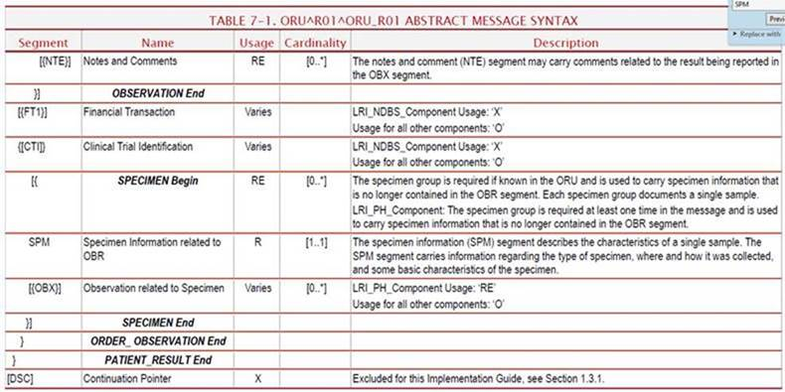

From your public health prospective, how important is it that you get specimen information?

What would happen if you didn’t get an SPM? How does that affect your usage of the ELR message or affect your practice? Is it important to get specimen information about every result? Is it important to get at least one specimen per message?

Additionally, there are questions about whether or not the data element usages for SPM data elements are appropriate based on what information the lab will always have, sometimes have, or may not routinely have in order to require an SPM. For example, a lab may have a specimen ID (SPM2) but may not have Specimen type (SPM4). See screen shot below.

If the SPM segment is R (required), and a lab sends you an ELR message with only a Specimen ID and no Specimen Type, how would that affect your work?

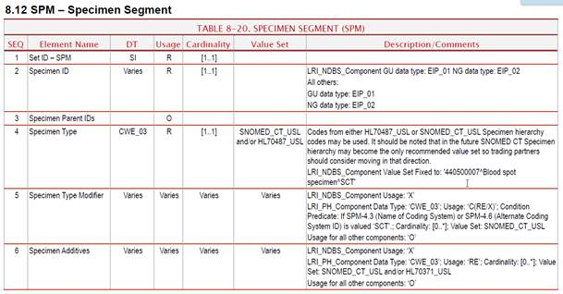…

All other data elements in the SPM have a usage of Varies (have to look at the profile constraints in the description) other than the Specimen Reject Reason and the Specimen Condition which are both RE.

**Erin Holt Coyne, MPH|CPHIO**

Office of Informatics and Analytics

TN Department of Health