HL7 WG Meeting Technical White Paper, SEP2018
HL7 RDAM Mapping Project #1431 Immunization Pilot Study
Within a CIMI-Compliant HL7 Cross-Family Interoperability Strategy
For Healthcare Information Networks (HINs), e. g., TEFCA RCE QHINs
Current Version at: http://wiki.hl7.org/images/b/bd/-RDAM-Mapping_Immunization-Pilot_White_Paper_Sep2018.docx

HL7 CIC, PHER, EHR, CQI, CDS, CIMI, STRUCDOC, O&O, M&M, VOCAB, SOA, DevicesOnFHIR WGs & ArB
Stephen.Hufnagel.HL7@gmail.com facilitator, 2018-09-05 FINAL DRAFT for SEP2018 WG Meeting Discussion
REQUESTED ACTION: Please Reply with Concerns and Suggested Improvements

EXECUTIVE SUMMARY
The HL7 Reference Domain Analysis Model (RDAM) Mapping Project Number 1431 Immunization Pilot Study maps the EHR System Functional Model (EHR-S FM) [Ref 1] to the Federal Health Information Model (FHIM) [Ref 2] within the EHR-S FM Immunization Functional Profile Spread Sheet [Ref 3]. We address "Solving the Modeling Dilemma as a Foundation for Interoperability" [Ref 4]; where, this paper describes the RDAM Mapping within a Use-Case Scenario driven "Emerging CIMI-compliant Software Development Lifecycle (SDLC) Methodology" [Fig 1] for CIMI-compliant (FHIM, QUICK, CIMI BMM, SOLOR, EHR-S FM) models [Fig 2] to meet Healthcare Information Technology (HIT) Information Exchange Requirements (IERs). Use Case Scenario IERs can be specified as Detailed Clinical Models (DCMs) [Ref 5] and Clinical Quality Measures (CQMs) expressed as FHIR Structure Definitions (FSDs) [Ref 6]. These FSDs can be transformed into consistent HL7 (V2, C-CDA, FHIR) profiles and extensions used in Healthcare Information Networks' (HINs) test and certification Enterprise Compliance and Conformance Framework (ECCF) [Fig 3], e.g., TEFCA RCE QHIN [Ref 7].

CIMI BMM is based on ISO 13606 and SOLOR is a SNOMED extension for LOINC and RxNorm. QI Core and QUICK are a FHIR Standard for Trial Use (STU3) Implementation Guide. These are emerging immature-technologies, built on a standards foundation. FHIM has over 10 years of clinical input; but, has not been balloted by HL7. EHR-S FM R2 is a normative HL7 and ISO standard.

Assuming HL7 TSC and HHS ONC concurrence, the Jan 2019 RDAM Mapping next-step plan includes 1) FHIM mapped EHR-S FM defined requirements use-case Scenario events within the CIMI-FSD tool stack, 2) Quality Improvement and Clinical Knowledge (QUICK) data model, 3) immunization DAM and RDAM review and harmonization by clinical workgroups, 4) DCMs and CQMs expressed as FSDs plus 5) CIMI-compliant V2, C-CDA and FHIR profile and extension generation. These next-step tasks support care team (immunization screening, reporting, care delivery and follow-up) and transfers-of-care data-sharing use-case scenarios.
Business Case, in a nutshell

Problem: HL7 (V2, C-CDA, FHIR) implementation-and-mapping variability results in 1) semantic inconsistency-and-ambiguity, 2) reduced interoperability and 3) reduced HIT value (patient safety, care quality, low cost) across Federated HINs.

Strategic Goals: Semantic Integrity across
- HL7 Product lines and product families (V2, C-CDA, FHIR)
- TEFCA RCE QHINs
  - https://www.healthit.gov/sites/default/files/draft-guide.pdf
- FHIR US-Core and FHIR QI-Core future normative ballots
  - http://www.hl7.org/fhir/us/core/
  - http://hl7.org/fhir/us/qicore/index.html

Approach: Separation of Clinical Statement (syntax, context, terminology, workflow) data-quality concerns; where, CIMI-compliant (FHIM, QUICK, CIMI BMM, SOLOR, EHR-S FM) logical-specification of DCMs and CQMs are expressed as FSDs for interoperable V2, C-CDA and FHIR implementations.

Value Proposition: CIMI-compliance positively improves semantic integrity resulting in improved patient value within HL7 cross family scalability (interoperability) with reduced complexity (cost) across federated HINs, e.g., TEFCA RCE QHINs

BACKGROUND
HL7 is a critical leader and driver in the U.S. and international healthcare standards arena. HL7 is comprised of members from over 50 countries and is integrally involved in global standards policy, regulation and harmonization. The HL7 product lines and product families – including the widely adopted and rapidly evolving HL7 FHIR® along with CDA/C-CDA and Version 2 message standards in sustainment - provide the underpinnings for connected, patient-centered health care on a global scale and an information highway for improving patient safety, advancing research into treatments, and achieving ambitious visionary programs such as precision medicine. CIMI's clinical goal is to help people live the healthiest lives possible by enabling Learning Health Systems in supporting additional areas such as, but not limited to clinical decision support, population based medicine, and genomics. "Data quality is the lynchpin of patient safety." CIMI's Healthcare IT objective is to make quality data available when, where and how it is needed across different platforms empowering computable semantic-interoperability.

HL7 Work Groups are spearheading the HL7 Terminology Authority (HTA) and Universal Terminology Governance (UTG) harmonization processes to improve data quality. CIMI WG is collaborating with stakeholder clinical domain WGs. CIMI's Integrated Information Models and Tools (IIM&T) project is collaborating with the Health Services Platform Consortium's (HSPC) SNOMED extension for LOINC and RxNorm (SOLOR) project. The overall goal is to improve Healthcare IT value (patient-safety, care-quality, reduced-cost) for developers and users.

"Healthcare IT Computable-Interoperability Strategy --- Methodology to manage data-quality risk by standardizing data In accordance with 21st Century Cures Act, TEFCA and USCDI", HL7 Newsletter, May 2018, P16-18, http://www.hl7.org/documentcenter/public/newsletters/HL7_NEWS_20180523.pdf. The May 2018 article discussed HL7 supporting the Common Data Interoperability (USCDI) agenda across US Office of the National Coordinator (ONC) Trusted Exchange Framework Common Agreement (TEFCA) among Qualified Health Information Networks (QHINs) managed by a Recognized Coordinating Entity (RCE).

INTRODUCTION
The HL7 RDAM Mapping Project Number 1431 Immunization Pilot Study maps the EHR System Functional Model (EHR-S FM) [Ref 1] to the Federal Health Information Model (FHIM) [Ref 2] within the Immunization Functional Profile Spread Sheet [Ref 3]. We address "Solving the Modeling Dilemma as a Foundation for Interoperability" [Ref 4]; where, the RDAM Mapping into a CIMI methodology [Fig 1] for CIMI-compliant (FHIM, QUICK, CIMI BMM, SOLOR, EHR-S FM) models [Fig 2] for Healthcare Information Technology (HIT) Clinical Statement Information Exchange Requirements (IERs). Use Case Scenario IERs can be specified as Detailed Clinical Models (DCMs) [Ref 5] and Clinical Quality Measures (CQMs) expressed as FHIR Structure Definitions (FSDs) [Ref 6]. These FSDs can be transformed into consistent HL7 (V2, C-CDA, FHIR) profiles and extensions used in Healthcare Information Networks (HINs) test and certification Enterprise Compliance and Conformance Framework (ECCF) [Fig 3], e.g., TEFCA RCE QHIN [Ref 7].

LESSONS LEARNED
HL7 success comes from stakeholder participation resulting-in lessons-learned based standards-evolution.
- Maintaining computable semantics across the HIT landscape is a HIN interoperability challenge. Unconstrained (V2 Z-segments, C-CDA templates and FHIR extensions) one-offs are suitable for limited scope exchanges; where, unconstrained one-offs degrade HIN interoperability.
- Complexity from 30+ years of HL7 product line separate evolutions reduces cross family interoperability, increases bureaucracies and increases operating (mapping) costs, due to institutionalized implementation variations, e.g., data types, meta-data, code sets and value sets.
APPROACH
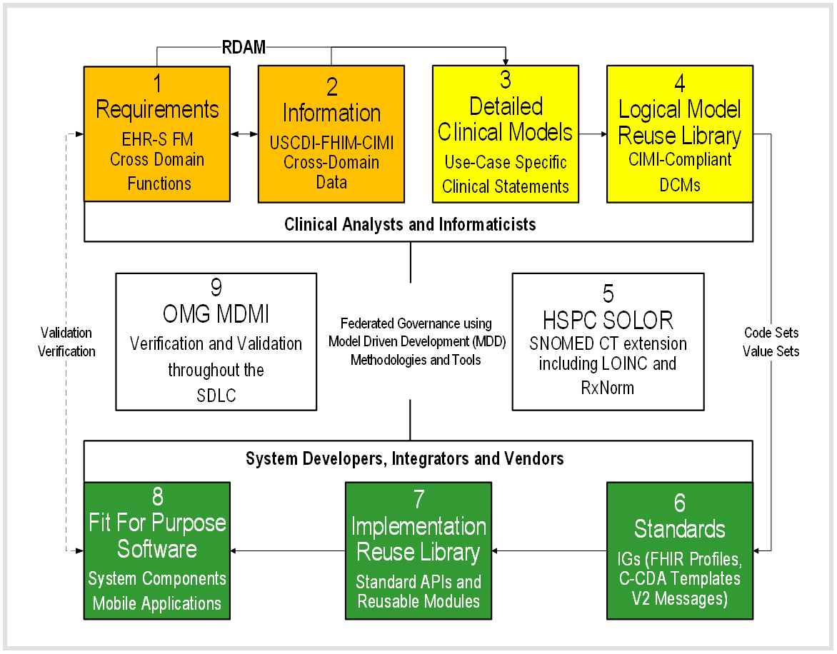
Fig 1: Emerging CIMI Compliant Software Development Lifecycle (SDLC) Methodology

The HL7 Reference Domain Analysis (RDAM) project is mapping Fig 1 steps 1-2 EHR System Functional Model (EHR-S FM) with the Federal Health Information Model (FHIM) enabling the formation of a Service Aware Interoperability Framework (SAIF) reference model for open distributed processing. RDAM domain-specific cohesive object spheres, of knowledge, activities and influence can maintain conceptual integrity within loosely coupled HIT components; where, context-specific clinical object (function, data) models can be validated by clinical domain workgroups and stakeholders. In Fig 1, a clinical analyst and informaticist can bootstrap a new project with 1: EHR-S FM clinical-requirements stated as conformance criteria, mapped to 2: FHIM domain-specific data requirements. This domain data can be constrained to 3: application-specific clinical statements specified as 4: logical CIMI-compliant Detailed Clinical Models (DCMs), which can be represented as FHIR Structure Definition (FSD). DCMs can be bound to 5: SOLOR terminology to specify consistent and requirements traceable 6: Standard Implementation Guides (IGs) for FHIR profiles, C-CDA templates and V2 artefacts.

Large scale enterprise initiatives can have rigorous development of DCMs by seasoned clinical professionals in steps 1-6, resulting in faster, better and cheaper re-usable software components by Healthcare IT developers in Steps 6-8. SDLC consistency can be verified by Model Driven Message Interface (MDMI) tools in Step 9 resulting-in improved interoperability from CIMI (FHIM, QUICK, CIMI BMM, SOLOR, EHR-FM) compliance.

Small scale site initiatives can have individual developers profile or extend 6: FHIR, CDA or V2 standards OR start with 7: Reusable Component Libraries to create 8: Fit for Purpose Software. In step 9: fit-for-purpose systems can be verified, in run-time, to have improved interoperability by maintaining CIMI compliance.

Fig 2 CIMI (FHIM, QUICK, CIMI BMM, SOLOR, EHR-S FM) STRATEGY AND VALUE PROPOSITION
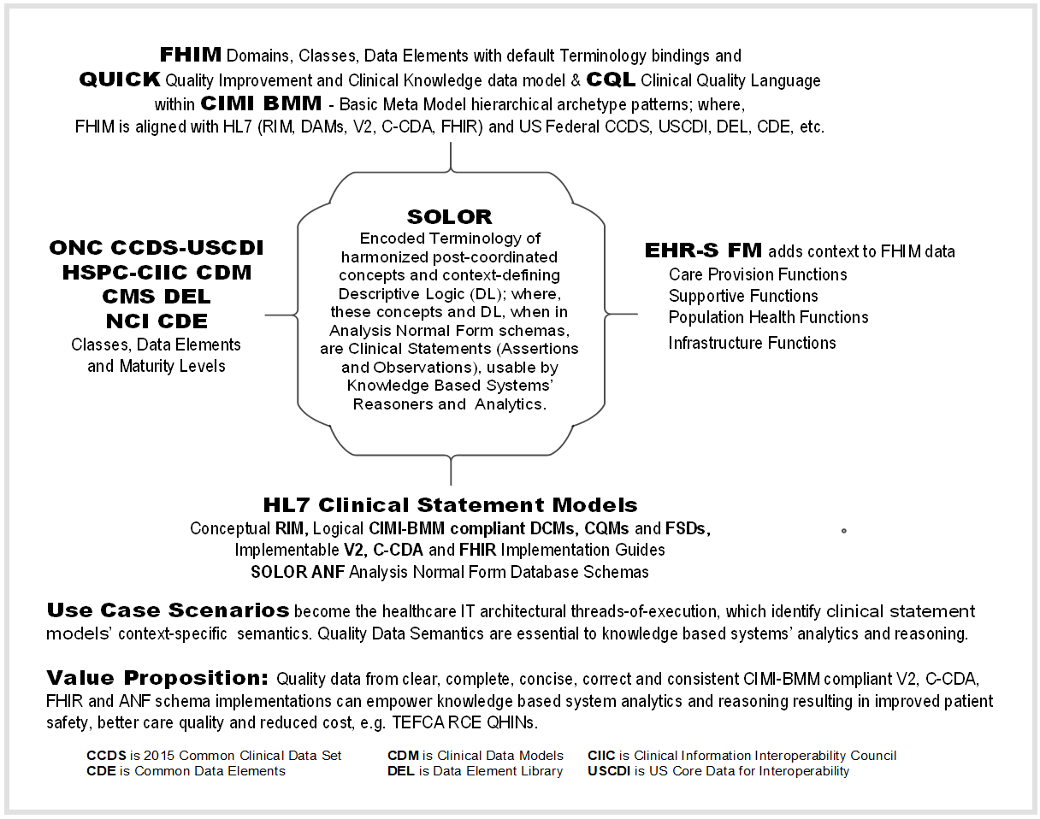
In summary, the proposed CIMI (FHIM, QUICK, CIMI BMM, SOLOR, EHR-S FM) data-quality strategy operationalizes HL7 lessons learned to simplify and improve HL7 governance, products, processes, and reduce healthcare IT costs. The collaboratively developed RDAM will take time to mature across clinical domains; where, CIMI collaboration and compliance, among workgroups, HTA, UTG and HSPC, can positively influence value (patient safety, care quality, cost) by finding inflection points; where, HL7 products and services efficiently and effectively meet HIT developer and clinical user needs.

REFERENCES <In OneNote, left of a reference click "+" symbol to open content>:
- HL7 EHR System Functional Model (EHR-S FM) R2 http://www.hl7.org/implement/standards/product_brief.cfm?product_id=269
- Federal Health Information Model (FHIM) Immunization Domain Model http://www.fhims.org/content/_420A62FD03B64295E8200076-content.html
- Immunization Functional Profile Mapping Spread Sheet http://wiki.hl7.org/index.php?title=EHR_Immunization_Functional_Profile
- Solving the Modeling Dilemma as a Foundation for Interoperability by Berndt Blobel and Frank Oemig, Intl. HL7 Interop Conference (IHIC) 2018 in Portsmouth, UK. https://www.ejbi.org/abstract/solving-the-modeling-dilemma-as-a-foundation-for-interoperability-4614.html
- CIMI Detailed Clinical Models https://CIMI.HL7.org
- FHIR Immunization Resources https://www.hl7.org/fhir/immunization.html
- HL7 May 2018 Newsletter Article http://www.hl7.org/documentcenter/public/newsletters/HL7_NEWS_20180523.pdf
- QI-Core IG http://hl7.org/FHIR/us/qicore/2016Sep/index.html

Postscript (Architectural Perspective)
For Healthcare Ontology Cats
SOLOR "Separation of Concerns" Interoperability Specification Stack
- Configuration Management (CM): Version, Object ID, STAMP (status, time, author, module, and path), etc.
- SOLOR Language and Dialect: assignment of language and dialect information to an identified object.
- SOLOR Logical Definition: OWL EL++ with concrete domains, e.g., properties like weight, name, or age, having concrete values such as integers or strings, with built-in predicates, such as ≤ or =.
- Assertional Knowledge that does not depend on a statement model. Layer 4 enables a sharable knowledge base built on a common layer 2-3 language and logic.
  - An example might be "aspirin may be used to treat headache".
  - EHR examples might include patient defined problems or clinician defined diagnoses.
  - Value and code sets, CQMs are a kinds of assertional knowledge, which also live in level 4.
  - CCDS-USCDI, DEL, CDM, CDE live here too.
- Observational Knowledge Statement Model (FHIM Domain Models, CIMI Detailed Clinical Models, FHIR Structure Definitions etc.), based on assessments and evaluations represented as V2, C-CDA or FHIR pre-coordinated Clinical (observation) Input form, which should be bi-directionally mapped to layer 2-3 post-coordinated Request-for and Performance-of Action Analysis Normal Form (ANF), to improve data quality, analytics and reasoning.
  - Descriptive logic of SOLOR concepts in an ANF schema is a DCM duality
    - e.g., DCMs, KNARTS, CQMs in ANF are statement models.
  - Use-case scenarios (EHR-S FM tasks mapped to FHIM) can be represented as an ANF sequence.
- Procedural knowledge software scripts, APIs and components, such as IF statement indicates chief complaint of condition, THEN search assertional knowledge for treatments (e.g., medications) that treat condition, and present to user. KNARTs can live here and depend on lower layers. Layer 6 is where reusable knowledge representation and problem-solving methodologies can live (episodic skeletal plan refinement), e.g., assertions with associated observations.

The engineering challenge is to efficiently and deterministically separate the layered concerns.

The Fig 1 methodology can incorporate the CIMI-SOLOR Separation of Concerns Principle within Fig 3 HL7 SAIF ECCF. It cleanly separates responsibility between a CIMI statement model and a SOLOR encoded terminology for concerns such as encoded action, subject of information (aka Evaluations), and measurement (aka Assessment). SOLOR normalizes and standardizes layers' 2-3 (below) content language, dialect and logical definitions, with a reusable knowledge representation foundation aka SNOMED extension with SNOMED, LOINC, etc. configured into an Analysis Normal Form (ANF) suitable for knowledge based systems.

To help separate the layered concerns, project architectural documentation can be organized into a Fig 3 HL7 SAIF reference model for open distributed processing called Enterprise Compliance and Conformance Framework (ECCF) used for the specification and test of components within federated network platforms; where, the ECCF can be a TEFCA RCE QHIN interoperability test-and-certification architecture.

Fig 3 CIMI (FHIM, QUICK, CIMI BMM, SOLOR, EHR-S FM) within HL7 SAIF ECCF aka ISO RM-ODP
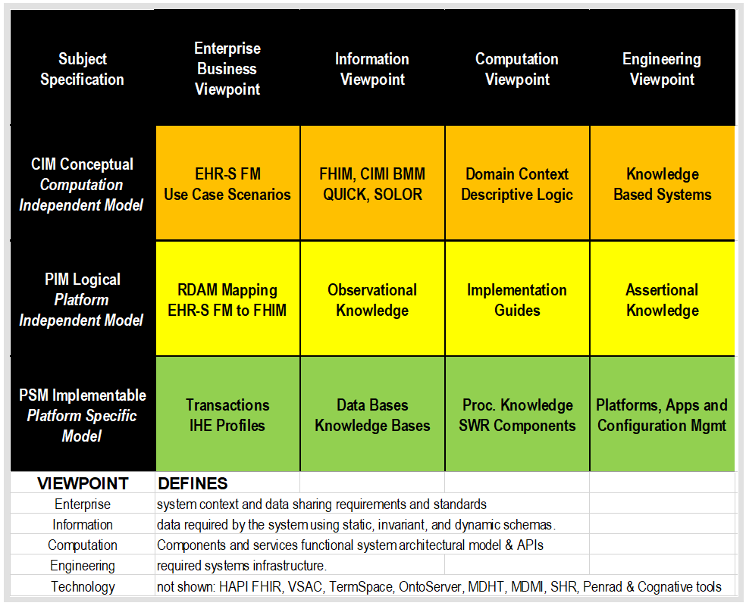

EVENTS and Notes <In OneNote, left of a date click "+" symbol to open notes>:
2018-09-29 HL7 Workgroup Meeting. Baltimore, MD, USA
2018-08-26 ~1500 word article FINAL DRAFT to stakeholders
2018-08-22 Gary Dickinson, Berndt Blobel, Thomas Beale, Gerard Frer, Mark Kramer, Keith Campbell guidence. Added SOLOR separation of concerns to CIMI (FHIM, CIMI BMM, SOLOR, EHR-S FM) in HL7 SAIF ECCF.
2018-07-16 (Nona Hall): Next article should be on projects with tangible CIMI and SOLOR accomplishments
2018-07-12 article was discussed at CIMI WG call, reduced to ~800 words.
2018-07-10 CIMI-SOLOR Map-and-Gap done with Keith Campbell's SOLOR Information Architecture Work Group
2018-07-10 Infrastructure Steering Division (ISD) approved Technical RDAM (Mapping) PSS
2018-07-09 Article due; where, publication was deferred, pending TSC-SGB RDAM Investigative study on the article's suggested CIMI methodology impact on HL7 product lines, families and procedures.
2018-06-27 TSC requested RDAM Investigative Study by Standards Governance Board's (SGB)
2018-06-24 CIMI BMM-ADL Compliance section added to article, as presented by Stan Huff at CIMI WG calls
2018-06-22 RDAM Deep Dive added to article and it was distributed to WGs for feedback
2018-06-13 Article Title and Abstract submitted to Andrea Ribick
2018-06-01 (Andrea Ribick) Call for Story Ideas for HL7 September 2018 Newsletter
2018-05-12 "Healthcare IT Computable-Interoperability Strategy --- Methodology to manage data-quality risk by standardizing data In accordance with 21st Century Cures Act, TEFCA and USCDI", HL7 Newsletter, May 2018, P16-18, http://www.hl7.org/documentcenter/public/newsletters/HL7_NEWS_20180523.pdf. The May 2018 article discussed HL7 supporting the Common Data Interoperability (USCDI) agenda across US Office of the National Coordinator (ONC) Trusted Exchange Framework Common Agreement (TEFCA) among Qualified Health Information Networks (QHINs) managed by a Recognized Coordinating Entity (RCE).

