HL7 CDS WG Conference Call
7 November 2013, 11:15am US ET

Attendees:
[ ] Tomasz Adamusiak
[X] Chad Armstrong
[X] Joe Bormel
[X] Aziz Boxwala
[X] Thompson Boyd
[ ] Sarah Corley
[ ] Lindsey Hoggle
[ ] Bob Hussey
[X] Krishna Gazula
[X] Ken Kawamoto
[X] Lester Keeper
[X] Eric Larson
[X] Victor Lee
[ ] Stacey Marovich
[X] Christy May
[X] Alicia Morton
[X] Rob McClure
[X] Claude Nanjo
[X] Jamie Parker
[X] Divya Raghavachari
[X] Bryn Rhodes
[X] Virginia Riehl
[X] Julie Scherer
[X] Atanu Sen
[ ] David Shields
[ ] Julia Skapik
[X] Howard Strasberg
[X] Serafina Versaggi

Minutes:
--------
- Reconciliation of ballot comments on vMR Logical Model
- Proposed reconciliations reviewed, discussed, edited, and voted upon
- Results of voting are in the updated ballot reconciliation spreadsheet posted at http://www.hl7.org/ctl.cfm?action=ballots.tallydetail&ballot_id=1210&ballot_cycle_id=531 under Ballot Reconciliation Package. Also available at https://docs.google.com/spreadsheet/ccc?key=0AkVg6OcD6S5NdHJEbTg4bEdiaEJtQzJpNDdsaXQtWFE#gid=1

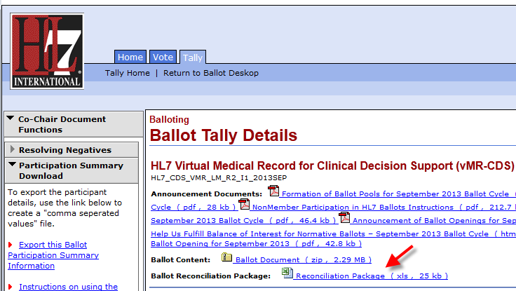

-
- The following individuals abstained from all votes:
  - Joe Bormel
  - Krishna Gazula
  - Alicia Morton
  - Jamie Parker
  - Divya Raghavachari
  - Virginia Riehl
  - Atanu Sen

- A similar reconciliation call is planned for next week at the same time. This next call will include in scope other HL7 CDS Work Group ballots from September 2013.

