Orders & Observations Conference Call

1 March 2017

+1 770 657 9270, Passcode: 398652#

WebURL: https://join.me/vernetzt.us

Attendees:

 | Name | Organization
1 | Kathy Walsh | LabCorp
2 | JD Nolen | Cerner
3 | Riki Merrick | Vernetzt, LLC / APHL
4 | Hank Mayers | ReliaTech Consulting
5 | Ron van Duyne | CDC
6 | Rob Hausam | Hausam Consulting
7 | Carolyn Knapik | CAP
8
9
10
11
12
Regrets:

Co-Chair: Riki Merrick
Scribe: Riki Merrick

Agenda/Minutes:
- Agenda Review
- Approve minutes – defer until we have completed the spreadsheet
  - from May 6, 2016: : http://wiki.hl7.org/index.php?title=File:SPM_Minutes_20160506_ConCall.docx
  - from May 27, 2016:http://wiki.hl7.org/index.php?title=File:SPM_Minutes_20160527_ConCall.docx
  - from June 3, 2016: http://wiki.hl7.org/index.php?title=File:SPM_Minutes_20160603_ConCall.docx
  - from June 10, 2016: http://wiki.hl7.org/index.php?title=File:SPM_Minutes_20160610_ConCall.docx
  - from June 17, 2016: http://wiki.hl7.org/index.php?title=File:SPM_Minutes_20160617_ConCall.docx
  - from June 24, 2016: http://wiki.hl7.org/index.php?title=File:SPM_Minutes_20160624_ConCall.docx
  - NO CALL ON July 1, 2016
  - From July 8, 2016: http://wiki.hl7.org/index.php?title=File:SPM_Minutes_20160708_ConCall.docx
  - From July 15, 2016: http://wiki.hl7.org/index.php?title=File:SPM_Minutes_20160715_ConCall.docx
  - From July 22, 2016: http://wiki.hl7.org/index.php?title=File:SPM_Minutes_20160722_ConCall.docx
  - From July 29, 2016: http://wiki.hl7.org/index.php?title=File:SPM_Minutes_20160729_ConCall.docx
  - From August 5, 2016: http://wiki.hl7.org/index.php?title=File:SPM_Minutes_20160805_ConCall.docx
  - From August 12, 2016 – NO Quorum
  - From August 19, 2016 – http://wiki.hl7.org/index.php?title=File:SPM_Minutes_20160819_ConCall.doc
  - From August 26, 2016 - http://wiki.hl7.org/index.php?title=File:SPM_Minutes_20160826_ConCall.doc
  - From September 2, 2016 – NO Quorum
  - From September 9, 2016 – No call
  - From September 16, 2016 - http://wiki.hl7.org/index.php?title=File:SPM_Minutes_20160916_ConCall.docx
  - From October 14, 2016 – NO Quorum
  - From October 28, 2016 – NO Quorum
  - From November 2, 2016 - http://wiki.hl7.org/index.php?title=File:SPM_Minutes_20161102_ConCall.docx
  - From November 9, 2016 - NO Quorum
  - From November 16, 2016 - NO Quorum
  - From December 14, 2016 - http://wiki.hl7.org/index.php?title=File:SPM_Minutes_20161214_ConCall.docx
  - From December 21, 2016 - http://wiki.hl7.org/index.php?title=File:SPM_Minutes_20161221_ConCall.docx
  - From January 4, 2017 – NO quorum
  - From January 11, 2017 - http://wiki.hl7.org/index.php?title=File:SPM_Minutes_20170111_ConCall.docx
  - From January 25, 2017 - http://wiki.hl7.org/index.php?title=File:SPM_Minutes_20170125_ConCall.docx
  - From February 1, 2017 - http://wiki.hl7.org/index.php?title=File:SPM_Minutes_20170201_ConCall.docx
  - From February 15, 2017 - http://wiki.hl7.org/index.php?title=File:SPM_Minutes_20170215_ConCall.docx
  - From February 22, 2017 - http://wiki.hl7.org/index.php?title=File:SPM_Minutes_20170222_ConCall.docx

- Compare Specimen DAM to biologic specimen model in BRIDG - map specification source is BRIDG and the map to is specimen DAM
Spreadsheet = http://www.hl7.org/documentcenter/public/wg/orders/Copy%20of%20Copy%20of%20BRIDG%20to%20Specimen%20DAM%20Mapping%20Spreadsheet%20as%20of%2020170301.xlsx

EA file is here:
http://www.hl7.org/documentcenter/public/wg/orders/V3_DAM_Specimen_R1_2014May-BRIDG_Discussions.zip
The spreadsheet:

Ballot document:
http://www.hl7.org/documentcenter/public/wg/orders/V3_DAM_Specimen_R2_INFORM_2017JAN_20161102.docx

Also Raj sent this file:
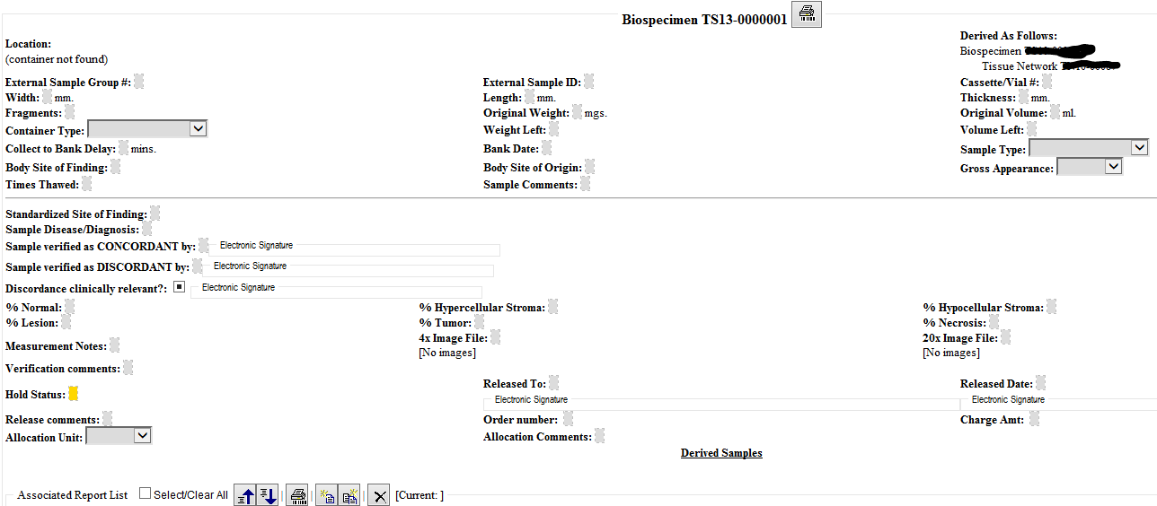

For review and approval – please review by filtering and identifying any that we need to look at next call will have block vote on these:
Filter on Draft and Supported = PULL ROWs 767, 1201 – they have questions listed!
Filter on Draft and out of scope =
Filter on Draft and impl-specific =

Filter on Draft and Source-chg:
Rows 733 and 735 and 736 = associatedOrganization mappings and definitions – approved those
Row 1201 = Product (class)
While we are here consider = Subject.performingSpecimen – how should we represent when tissue from a tissue bank is a specimen – we think it would still fall under person, only de-identified, because currently our material is ONLY from non-living subject = HOWEVER in BRIDG the product class covers tissue from bio-banking etc – do we want to allow association of product class to subject as well to cover biologics when they are being tested?
We approved adding product class – will only associate with specimen processing.
JD explains that when a tissue bank specimen is removed from storage for further testing it is basically added as additional specimen under the existing block which can be traced via the parentSpecimenId to the original specimen obtained from the subject, so it does not become a subject on its own – for research purposes the association to the subject may be masked.
Row 1204 and 1205 = Product.expirationDate and Product.lotNumber – updated definition to allow use of dash and other special charaters – approved as entered

Row 1464 = StorageEquipmentComponent – approve definition

Also open from other minutes:
Row 1418 = Specimen.containingSpecimenCollectionGroup – and related attributes
Ask Wendy about dealing with identifiers – do we need to have a separate row to map to the high level datatype or do we drop the .value element from the mapping – we want to be able to say: allow 0..* identifiers for example for subject, but was also want to say that when you have a value in identifier.value you have to have 1..1 assigning authority. – Applies here as well as rows 1247, 1248, 1253, 1254, 1684 etc. – there may be more (find all (Identifier) mappings!

Depending on the outcome of Wendy’s recommendation Riki to add a separate row for that or adjust ALL identifiers accordingly – Riki also needs to ADD rows to properly map the Specimen.containingSpecimenCollectionGroup showing the respective attributes in the DAM for the identifier datatype

Related to the items we need to review SET profile for – JD, Raj and Riki to do prior to next call:
- SpecimenMoveActivity – on hold until we Review the IHE Specimen Event Tracking (SET) profile for data elements that are required there – keeping these notes for when we get back to this topic
  - when nothing changes in the specimen – there are other processing activities that don’t result in new specimen, so need to verify in the EA model that the association between specimen and specimenProcessingActivity labeled “results in” has a cardinality of 0..*
  - since we are only concerned with the actual instance tracking, not the protocol creation should we rename this class to PerformedSpecimenMoveActivity – yes
  - cardinality should be 0..*
  - Approve this class
  - What attributes do we need: currenty BRIDGE has 3 to represent the different coordinates possible – we have a datatype that does this so have fromCoordinates and toCoordinates – hence one of our attributes maps to 3 BRIDG attributes
  - What about building location – we have geographicalLocation as a data type – currently an attribute of storageEquipment
  - Would a holder also need a geographicalLocation?
  - Would it be better to create a fromLocation and a toLocation attribute, that can use either the coordinates or the geographicalLocation dataytpes?
  - We already discussed adding SpecimenMoveActivity.TakenFromElementIdentifier, which is similar to have a fromEntity and a toEntity that can be referenced and you could reference the holder and the storageEquipment, which in turn have coordinates and geographicalLocation attributes?

Next steps:
ALL REVIEW THE DRAFT items or block vote and note ANY that need to be pulled and discussed individually for block vote next week = 3/8/2017
JD, Raj, (Riki) – Review SET profile so we can finish off the SpecimenMoveActivity related attributes on the next call
Riki - fix up the identifier related entries per feedback from Wendy for review on 3/8 call
Riki – add definition for all datatype attributes to the word document – Rob can you check if these are already in EA and we can copy from there?
Ron – copy the information (attributes / classes and definitions, data types etc) listed as source change into the word document for review on 3/8 – latest 3/15 call
Rob – copy the information (attributes / classes and definitions, data types etc) listed as source change into EA file for review on 3/8 – latest 3/15 call
Content due to OO for approval to ballot by 3/16 (worst case 3/20)!!!

- Resources:
  - Link to BRIDG model: http://bridgmodel.nci.nih.gov/files/BRIDG_Model_4.0_html/index.htm - chose VIEW:BSP - biospecimen
  - Link to Specimen DAM: http://wiki.hl7.org/index.php?title=Specimen – scroll to bottom for image

