HL7 CDS WG Conference Call
16 March 2016, 12-1pm US ET

Attendees:

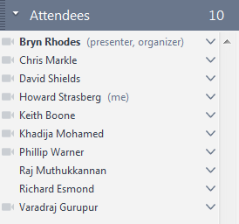

Agenda:
- - GAO ballot reconciliation
- - CQL STU comment review

Minutes:
- - Co-chair of record: Howard Strasberg
- - Bryn – CQL STU comment review
  - Published CQL May 2015
  - 24-month STU period during which comments arrive periodically
  - Reviewed comments 911, 827, 826, 824, 823 and 804.
  - Block vote: Bryn, Keith. 9-0-0.
- - Keith - GAO ballot reconciliation
  - Comment 33
    - Two levels where we could apply GAO
      - Could apply to many types of requests
      - More specific imaging use case
    - Two levels of implementation guidance
      - This is how you do it in general
      - Another – more specific to AUC, like body site, imaging orders
    - Decision: Publish more general profile. Start a new project for a US-realm, AUC-specific profile.
    - Vote: Keith/Bryn. 9-0-0.
  - Comment 41
    - Resources are contained within the original request.
    - FHIR publication doesn’t show the use of contained.
    - Keith filed this issue in GForge.
    - Vote: Keith/Richard. 9-0-0.

Next Call:
Wed 23 March 2016 12 PM ET
Agenda:
- GAO ballot reconciliation (continued)
- CQL STU comment review (continued)

