2013-10-09 Email from Eric:
Related ballot comment:
#250,
#78
#159 (partially)
#294
#91
#148
Similar issue but not covered below
#148 , #153 which I will consider withdrawing after some discussion how the producers will fill this field.

Motion to:
OPTION A: ( if want to support LOINC, SNOMED as an alternate code set)
1) remove CWE-CR
2) create and new flavor CWE_RC1
3) replace CWE_CR datatype in OM1.31 with CWE
4) replace CWE_CR datatype in OM1.34, OM1.52, OM5.2with CWE_RC1
5) replace CWE_CR datatype in CMD.1 with CWE_RC

OPTION B: ( if only want to support one code system –local or LOINC or SNOMED)
1) remove CWE-CR
2) replace CWE_CR datatype in OM1.31 with CWE
3) replace CWE_CR datatype in OM1.34, OM1.52, OM5.2, and CMD.1 with CWE_RC

see attached. note: in screenshots I wrote CWE_CR2 insteand of CWE_RC1.

Eric
Eric M Haas, DVM, MS
Health eData Inc
1566 Ash Street, Napa, CA, 94559
707.227.2608|Skype: haas.eric1
ehaas@healthedatainc.com

RE CWE_CR in eDOS

Proposed flavor of CWE_RC to allow for local and LOINC code but no original text.

CWE_RC1 – Required Components – Second Triplet Required but may be empty, original text optional
Note: Components 10-22 are pre-adopted from V2.7.1 CWE.
Table 4-4. Coded with Exceptions − Code Required But May Be Empty (CWE_CRE)

SEQ | Component Name | DT | Usage | Value Set | Comments
1 | Identifier | ST | R
2 | Text | ST | R
3 | Name of Coding System | ID | R | HL70396
4 | Alternate Identifier |  | RE
5 | Alternate Text |  | RE
6 | Name of Alternate Coding System |  | C(R/X)
7 | Coding System Version ID | ST | C(RE/X) |  | Condition Predicate: If CWE_CRE.3 (Name Of Coding System) is valued.
8 | Alternate Coding System Version ID |  | C(RE/X |  | Condition Predicate: If CWE_CRE.6 (Name Of Coding System) is valued.
9 | Original Text |  | O
10 | Second Alternate Identifier |  | O
11 | Second Alternate Text |  | O
12 | Second Name of Alternate Coding System |  | O
13 | Second Alternate Coding System Version ID |  | O
14 | Coding System OID |  | O
15 | Value Set OID |  | O
16 | Value Set Version ID |  | O
17 | Alternate Coding System OID |  | O
18 | Alternate Value Set OID |  | O
19 | Alternate Value Set Version ID |  | O
20 | Second Alternate Coding System OID |  | O
21 | Second Alternate Value Set OID |  | O
22 | Second Alternate Value Set Version ID |  | O
Usage Note
The CWE_RC data type is used in OM1-2 Producer’s Service/Test/Observation ID to support the HL7 Standard requirement that the first three components should be non-null.
The CWE_RC1 data type is used where it is necessary to communicate a code, text, or coding system and the version of the coding system the code was drawn from and alternate codes drawn from another coding system. Many coded fields in this specification identify coding systems or value set attributes that must be used for the field. The Original Text field is optional and not expected to be used by a compendium producer.

Screenshots of affected fields ( note: CWE_CR2 should read CWE_RC1)
OM1.31 and OM1.34

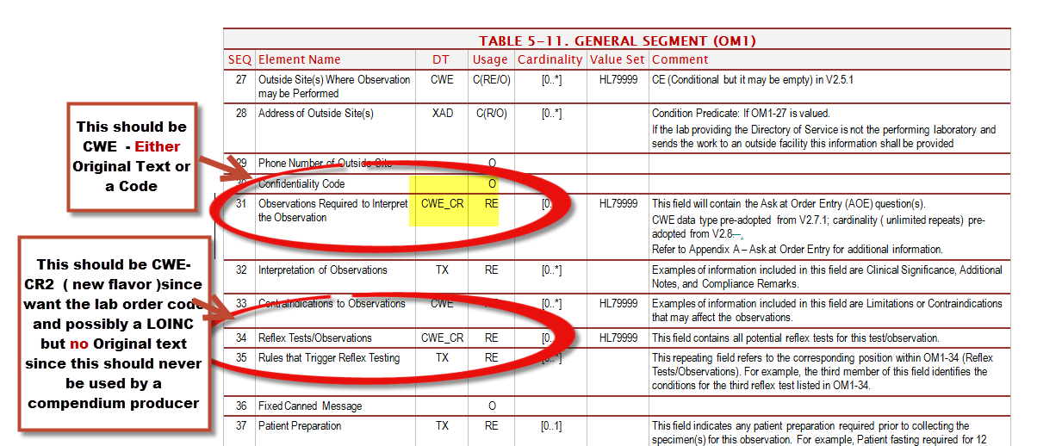
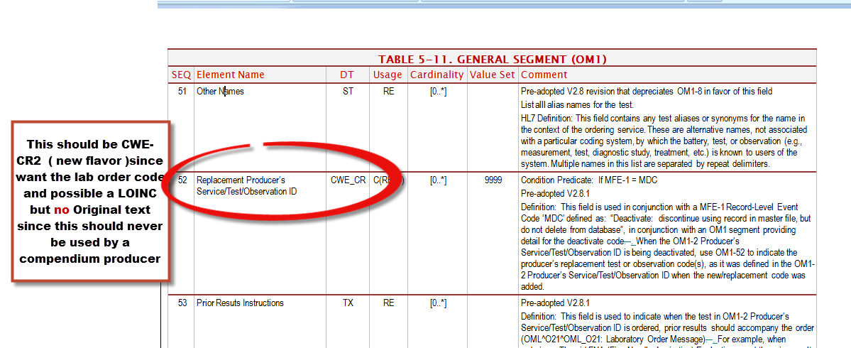

OM5.2
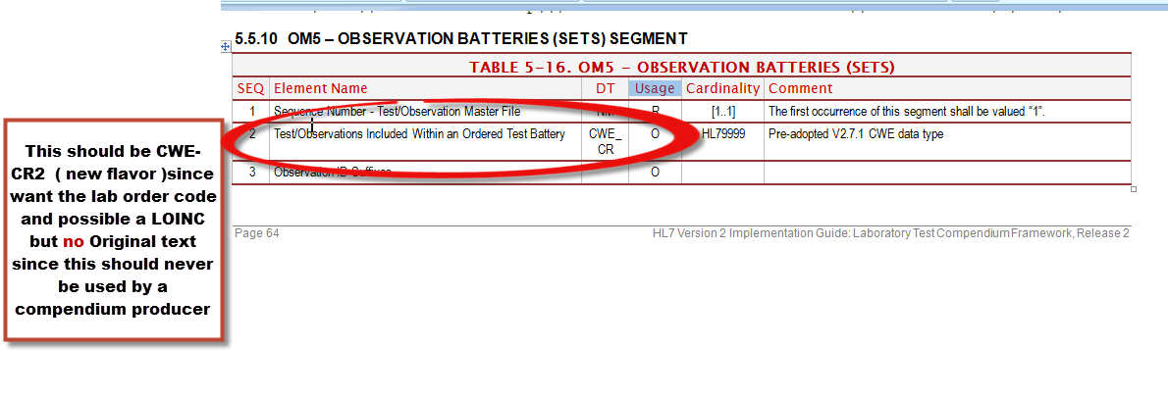
CMD.1

