Unique ID DAM

Overview and Business Case

This Domain Analysis Model covers the necessary and sufficient requirements for a unique identifier (UID) standard for anatomic pathology specimens to ensure interoperability between laboratory information systems (LIS), specimen tracking solutions (STS), and any other device that can either read or generate an UID in the anatomic pathology laboratory. The scope of the DAM is to describe the relevant attributes that are specific to the identification of an anatomic pathology specimen and its derivatives.
Beyond the critical need in pathology and laboratory medicine to uniquely identify a specimen, the challenge in anatomic pathology (where the specimen types are typically organs and sampled tissues) lies with derived portions of the specimen. Unlike other laboratory specimens (such a tube of blood), a derived portion of an anatomic pathology specimen (e.g. a subsection of tissue) is unique and distinct from other derived portions. This uniqueness must be persevered and encapsulated in the identification scheme used in the laboratory.
This need has led to the development of alphanumeric ID schemes (e.g. S-12-1234-A) to reflect both the specimen type or assigned pathology service (S for surgical pathology), case number (11-1234), and subcomponent (block A). In a modern pathology laboratory, this ID scheme is reflected in both the human readable label on the item and the barcode (either 1D or 2D).
The present state of specimen identification in anatomic pathology leverages the aforementioned identification scheme, but there is no interoperability of this scheme given the variety of implementations of specimen identification (different formats for the same information between different LIS makers) and lack of uniqueness between individual laboratories regardless of the LIS or STS in use (collision of identical IDs between two institutions). These roadblocks have generated painful workflows and workarounds to ensure the effective and safe movement of anatomic pathology cases and their components within and between institutions. The collision of IDs is a serious medical risk, which have devastating impact to patient care by promoting case or specimen mis-identification, leading to incorrect work and/or diagnoses being applied. For example, an outside case sent to an institution for consultation must be relabeled with new institutional IDs for follow-on work to prevent possibility of collision of the outside IDs with unrelated IDs generated by the institution.
By utilizing a unique ID standard, it will be possible to decode that identifier to recover meaningful, structural information about the specimen (or derived specimen component) in a manner that respects patient privacy. This meaningful, structural data includes laboratory of origin, case number, any relevant derivative information (block or slide), and any special procedure information (e.g. the item is a slide with a CD10 stain). Given that information, the ability to communicate with the originating laboratory becomes possible.
To ensure the success of this proposed unique ID standard, this unique ID must be considered a separate entity from what is currently used in laboratories today with respect to the human readable identifier in place now. Two reasons drive this separation. First, the physical space requirements present with some of the derived specimen types in anatomic pathology restrict the amount of information that can be present in the human readable part of the label. This is clearly seen in the labeling done for cassettes and slides, where the available area for a label is small given the size of the item. Another reason for the clear separation is the potential length of the unique ID so that the laboratory sub-identifier can be long enough to handle the current and future number of laboratories globally.

Unique ID Technical Schema

Workflow and Physical Requirements

- The standard must enable the creation of a globally unique identifier for both specimens and containers.
- The standard must be able to handle the relationship between specimens and containers. As stated in the glossary, every specimen is held by a container. From the perspective of the specimen, this is a one-to-one relationship. While the current majority of containers contain a single specimen, the relationship from the perspective of the container is a one-to-many. There are a growing number of scenarios in which a single container houses a number of separate, unique specimens.
- Given the one-to-many nature of the container-specimen relationship, the standard will place the unique container ID in the machine-readable component of the label. This design will allow for efficient and scalable lookup of specimens held within the container.
- This standard will allow for a distinct detection of a machine-readable ID in keeping with the standard to prevent mis-interpretation with a currently implemented schema in use.
- The length of these IDs will be amenable to current LIS storage and implementation abilities and the available technology for identification

Information Requirements
- Location ID – This is the origin of the specimen, such as the laboratory where it was accessioned. This will be contained as a prefix in the specimen and container IDs.
- Specimen ID– The alphanumeric sequence that uniquely identifies the specimen for the given location.
- Container ID – The alphanumeric sequence that uniquely identifies the container.

Unique ID Use Cases

Initial Specimen and Container Identification

This first scenario involves a single actor, a “generator”. The generator is the entity (typically an LIS) that generates the UID for the specimen or (specimen derivative) and relevant containers. Upon the accessioning of a specimen in to the laboratory or the creation of a new specimen derivative, the specimen and the container must be given unique IDs (UIDs). For the case of a specimen being added to a container that already holds a specimen only requires a specimen UID will be generated since the container has already been uniquely identified.

Intralab

This scenario introduces another actor, the “consumer”. A consumer is a separate entity from a technology perspective (such as a different vendor) in the laboratory that interrogates the container UID for specimen identification for follow-on work. Example of “follow on work” includes matching an order with patient material or querying the generating system for additional information, including the specimen UID. The obtaining of the specimen UID can open further queries for more data.
For this use case, the generator must be able to produce a standard UID that the consumer can interrogate and retrieve the correct identifiers (referenced above in the Information Requirements) for the component in hand.

Interlab

This scenario is similar to the prior “Intralab” use case, only the generator and consumer(s) are located at separate laboratories. In this case, the generator produces the UID s for all specimens and containers of the case, and the case is sent to another laboratory for further work. The consumers in this other lab must be able to interrogate the UIDs on the case and retrieve the information. The location ID is critical for this use case in that the consumer may need to query the generator via some trusted means of communication, and the location ID is the initial point of direction for the consumer to find the location of the generator. Following on the location provided by the location UID, a query based on the container ID can retrieve other specimen information, including the specimen UID. Similar to the “Intralab” scenario, the obtaining of the specimen UID can open further queries for more data.

Role-reversal

Using the same actors defined above, only with roles exchanged. A generator in a laboratory that typically produces UIDs must act as a consumer for a UID produced by another system. This use case can occur in either the intra- or interlab formats.

Backwards Compatibility

This standard will allow for the efficient detection of a compliant machine-readable ID. Such a feature will allow for the robust distinguishing IDs generated via pre-existing formats from standard-compliant IDs and ensure legacy ID functionality.

Use Cases Diagram
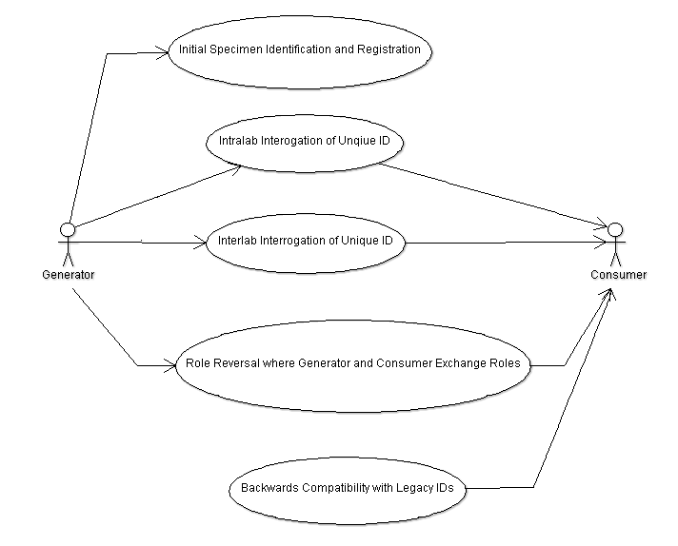

Activity Diagrams

Intralab and Interlab Use Cases

With the only difference being the location of the consumer, the intralab and interlab use cases have a similar activity diagram, with the generator accessioning and identifying the specimen prior to the consumer interrogating the unique ID.

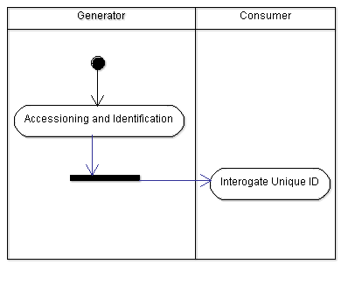

Glossary

Specimen – From DICOM Supplement 122 with minor edits
A physical object (or a collection of objects) is a specimen when the laboratory considers it a single discrete, uniquely identified unit that is the subject of one or more steps in the laboratory (diagnostic) workflow.
Specimens are sampled and processed during a laboratory’s (diagnostic) workflow. Sampling can create new (child) specimens. These child specimens are full specimens in their own right (they have unique identifiers and are direct subjects in one or more steps in the laboratory’s (diagnostic) workflow. This property of specimens (that can be created from existing specimens by sampling) extends a common definition of specimen which limits the word to the original object received for examination (e.g., from surgery).
Container – Taken from DICOM Supplement 122 with minor edits
Specimen containers (or just “containers”) play an important role in laboratory (diagnostic) processes. In most, but not all, process steps, specimens are held in containers, and a container often carries its specimen’s ID. Sometimes the container becomes intimately involved with the specimen (e.g., a paraffin block), while other times the container is simply that, a container.
Containers have identifiers that are important in laboratory operations and in some imaging processes (such as whole slide imaging). The Container ID and the Specimen ID are distinct entities, making them different data elements. In many laboratories where there is one specimen per container, the value of the specimen ID and container ID will be same. However, there are use cases in which there are more than one specimen in a container. In those situations, the value of the container ID and the specimen IDs will be different.
Containers are often made up of components. For example, a “slide” is container that is made up of the glass slide, the cover slip and the “glue” the binds them together. The Module allows each component to be described in detail.
Machine-readable identifier
An identifier that is read by a non-human device, such as a barcode or RFID tag
Accessioning
This is the act of registering a specimen in the laboratory. Typically, this involves the creation of a top-level case identifier and the detailing of the various components of the case along with data associated with patient’s clinical condition and the collection and transport of the specimen.

Processing
This is the act of manipulating a specimen via physical, chemical, or other means. Processing may result in the creation of multiple derivative specimens (such as the sectioning of a piece of tissue from surgery into smaller portions for submission in cassettes), or the act of processing may simply change the characteristics of a single specimen (such as the application of a stain to a slide).

Working Appendix

Not officially part of the DAM. This is the place for ideas, concepts, partial thoughts, and TODOs.

Implementation Issues/Scenarios

- Space constraints on Unique IDs in the field
- Deployment and maintenance of Unique ID repository
  - Locally hosted
  - Remote hosted with service
- Trusted connectivity between labs for case information exchange

Use Cases/Implementation Scenarios from John G.

- Use cases to consider are lab mergers and divestitures. These happen a lot, and there will need to be clarity on how the systems can support historical and future data with such events. May be more of an implementation detail for future, but something to keep in mind.

Use Cases/Implementation Scenarios from John G.

Use Case 1:

An institution has 8 years of barcoded slides (millions of slides). They have been barcoded using a locally unique barcode identifier and are labeled them with a locally unique human readable slide identifier (the two may not be the same).

They now want to implement the new HL7 globally unique barcode ID standard without changing the old slides. Will the new standard constructed in such a way that:

1: the LIS will be able to identify old (local) assets and deal with them appropriately.
2. the LIS will be able to hide the institution code for assets created locally (in other words, hide/ignore the part of the ID in front of the first “.”for local cases? In other words: if the institution code for MGH is “MGH”, a MGH part might have an barcoded ID of MGH.S12-1000_A, can this be part be handled, queried and displayed locally as S12-1000_A.

The standard should not define how this is done, but it should be constructed so that it is possible. So I guess this is not a use case but rather something to consider when the standard is made.

Use Case 2:

Every label on slide we (or any lab) makes has our (or their) name (MGH) or our logo on it. Anyone with the slide in his hand will know 1) that it is from MGH and 2) what the local MGH barcode identifier is and 3) what the local MGH human readable slide identifier (2 and 3 could be different).

The HL7 globally unique barcode ID standard has be balloted and implemented in many locations, but not at MGH. MGH sends a slide to Consulting Medical Center and Consulting Medical Center wants to accession the case into their LIS and use the MGH barcode ID as a foreign ID.

Will the new standard be constructed in a way that Consulting Medical Center query the central database of institution IDs, get the ID for MGH and enter the MGH slide as MGH_InstitutionID.MGH_Local_ID into its LIS?

I think a number of institutions would like this. It is a way of identifying foreign ID and foreign ID in the LIS and also identifies where it comes from.

Potential Use Cases/Implementation Issues from Victor

- In-house Specimen
- Consult Sent / Consult Received
- Consult slides & blocks received with paper requisition listing the items; (what should be listed on the paper req?)
- Cutting additional slides from outside consult blocks
- Frozen Section
- Placing one container into another container
- Additional Blocks / Slides ordered
- Splitting of accessioned part into EM, Immuno, Microtomy
- Visual identification of slides at time of sign out at the microscope; Identification of the blocks at time of cutting by the microtome
- Lab 1 sends Part 1 to Lab 2 with/without blocks; Lab 2 makes/does not make more blocks and sends blocks to Lab 3 that makes slides and does laser microdissection/DNA test (i.e. chain of 3 to 4 independent labs processing the specimen)
- Errors (What are the chances? How should they be dealt with? What requirements are needed to avoid these?):
  - Re-accessioning (will it ever occur? “Re-accession as a derm case”)
  - Incorrectly labeled part; block; slide – Human readable vs pre-printed ID error
  - Re-staining a slide
  - Discarding slides that were accidentally cut from the wrong block / Discarding labeled cassettes
- Connectivity:
  - No Internet Connection
  - No connection to the “central” “Origin ID” lookup service
  - No Connection to the remote “Origin’s” metadata server
  - No connection to the local server (while your local PC works)
- Equipment failure:
  - Barcode/RFID Reader failed
  - Barcode/RFID Reader failed AND Human misreads the label ID
  - Metadata Server failed
  - Local PC failed
- Misread:
  - Barcode/RFID Reader misreads the barcode
  - Human misreads the human readable label
- ID Damage
  - Barcode/RFID Damaged/Unreadable
  - Human Readable Label Damaged/Unreadable
- Conversion / Adoption
  - A lab with tens of thousands of already labeled specimens in freezers, on shelves, off-site, would like to adopt the new Universal Unique ID: What issues will they encounter – differentiating between old and new IDs, etc.

