**Orders & Observations Conference Call**

**22 April, 2016**

**+1 770 657 9270, Passcode: 398652#**

**WebURL:** [**https://join.me/vernetzt.us**](https://join.me/vernetzt.us)

**Attendees:**

|  |  |  |
| --- | --- | --- |
|  | Name | Organization |
| 1 | Andrea Pitkus | IMO |
| 2 | Kathy Walsh | LabCorp |
| 3 | Riki Merrick | Vernetzt, LLC |
| 4 | Ron van Duyne | CDC |
| 5 | Dale Chrismon | LabCorp |
| 6 | Wendy VerHoef | Samvit Solutions / NCI |
| 7 | Mark Jones | Orchard |
| 8 |  |  |
| 9 |  |  |
| 10 |  |  |
| 11 |  |  |
| 12 |  |  |

Regrets:

**Co-Chair**: Riki Merrick

**Scribe:** Riki Merrick

Agenda/Minutes:

1. Agenda Review
2. Approve minutes:
   1. from April 15, 2016: <http://wiki.hl7.org/index.php?title=File:SPM_Minutes_201604015_ConCall.docx>

Approve minutes Kathy Walsh, Andrea Pitkus, no further discussion, against:0, abstain: 0, in favor: 6

1. Compare Specimen DAM to biologic specimen model in BRIDG - map specification source is BRIDG and the map to is specimen – stored here: <http://www.hl7.org/documentcenter/public/wg/bridg/BRIDG%20to%20Specimen%20DAM%20Mapping%20Spreadsheet%2020160401.xls>

Discussion:

Start with StorageEquipmentComponent – see 4/1/2016 minutes

Walk in coolers are dedicated to certain holders – defined by area = geographic location

Walk in cooler has: X number of shelves, X number of holder types for a shelf – each tray can hold X number of containers

Holders can leave the storage equipment and storageEquipmentComponent remains inside the storage equipment

Temperature range – cardinality 0..1

AdjustableIndicator – Boolean – cardinality 1..1

So we need constraints on StorageEquipmentComponentType for length height and weight to be smaller than StorageEquipmentType inside values – add as note

Add GeographicLocation to the StorageEquipmentComponent as 0..1? or do we need the recursive attribute on storage equipment?

Difference storage to holder => storage = long-term vs holder = short term / transport

Container touches the specimen directly in DAM – BRIDG does not cover that distinction, but that should not make a difference

Position attribute needs to be on association between Holder and StorageEquipment – do we need to rename it to HolderStoragePosition and place it between Holder and association to either the StorageEquipment or StorageEquipmentComponent

If we add this isn’t it more the StorageActivity – have date and person for check in / check out applies both to container to holder as well as holder to storage equipment, but only holder to StorageEquipment has the constraint about component or type

Difference in DAM between the associated location vs GeographicLocation attribute in StorageEquipment – need to research (think the associated location is the larger street address)

1 container at any given time, but over time can have multiple storage actions associated with it

Container and holders can both be outside of storage

For retesting – staff will move container from storage to transport holder to go to testing

Tracking outside of storage = processing activity

Sharing specimen between labs workflow

Do we need a container move activity? – start with that with that next week

Diagram status at the end of this call:

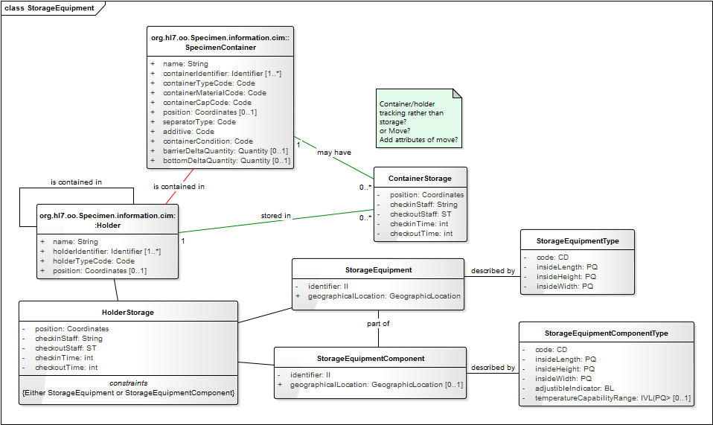

Adjourn 1:04 PM EST

**Next call, which is 4/29/2016 at 12:00 PM EST.**

Status at end of the call:

1. <http://www.hl7.org/documentcenter/public/wg/bridg/BRIDG%20to%20Specimen%20DAM%20Mapping%20Spreadsheet%2020160401.xls>
   1. Link to BRIDG model: <http://bridgmodel.nci.nih.gov/files/BRIDG_Model_4.0_html/index.htm> - chose VIEW:BSP - biospecimen
   2. Link to Specimen DAM: <http://wiki.hl7.org/index.php?title=Specimen> – scroll to bottom for image
2. Next Steps:
   1. Compare Specimen DAM to biologic specimen model in BRIDG = Identify issues, if any find resolution – doing that on our calls
   2. IHE AP domain is working on structured AP report in CDA and has some requirements, we might not yet have considered – have added the concerns identified to the spreadsheet above - Identify issues, if any find resolution