Clinfhir.com
Please see David Hay’s blog for more details –
https://fhirblog.com/2017/01/09/building-a-set-of-resources-in-fhir/
https://fhirblog.com/2017/01/09/simple-builder-library-and-documents/

Servers used:
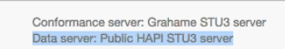

Log into clinFhir and click on the Gear
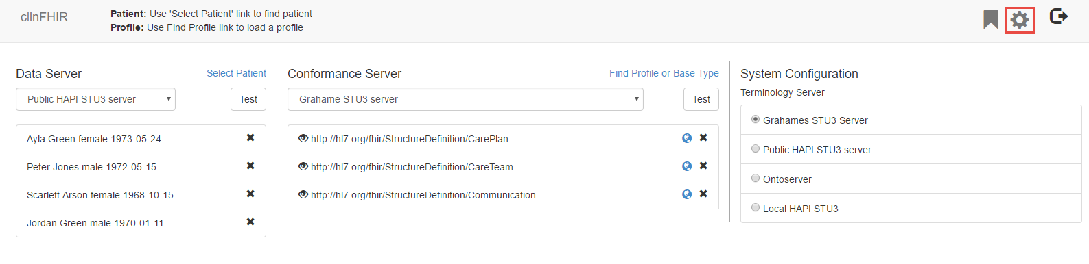
Click on simple builder - will load a new browser page
Click on New set and add Name and description
Save it

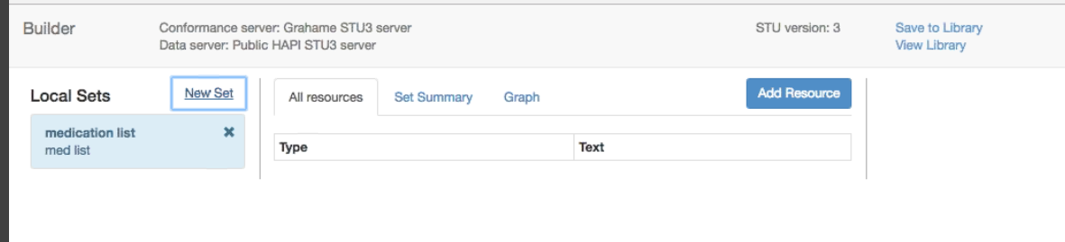

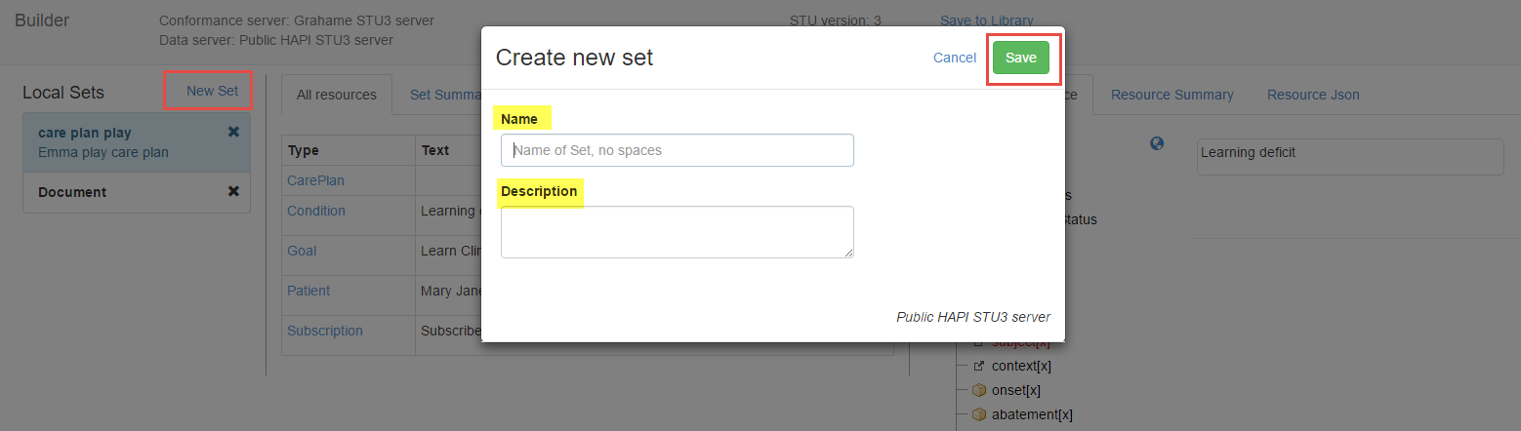

To create resources - Click on add resource and select a resource from the dropdown
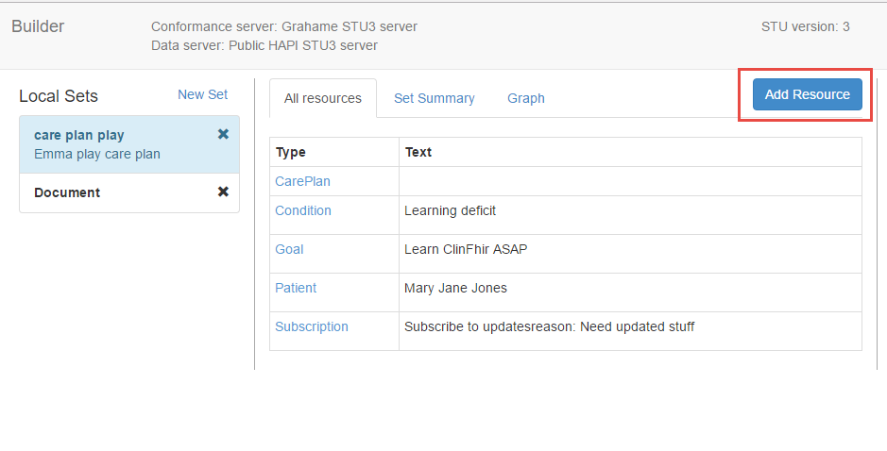

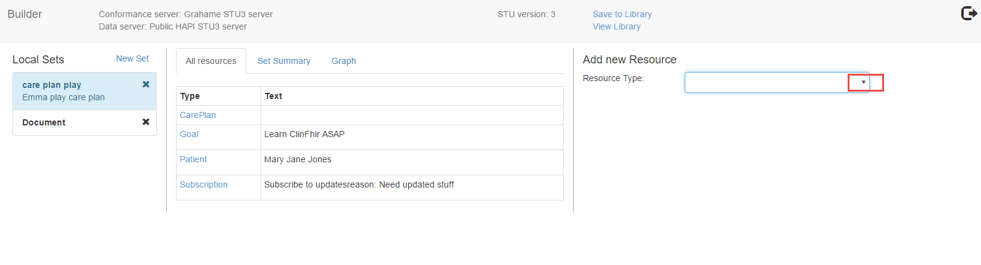
Add text and then click on Add. Create all the resources you plan on linking together.

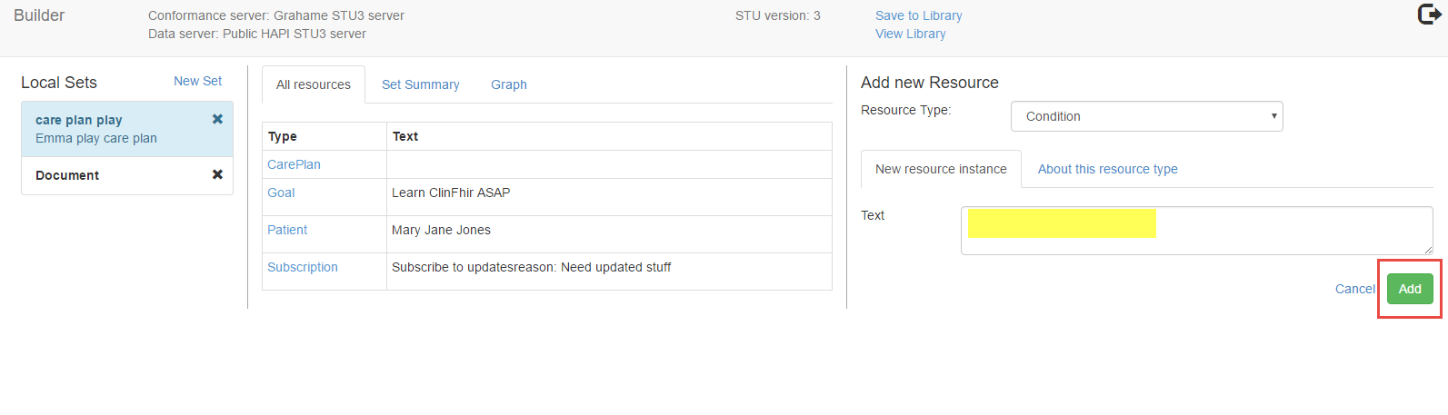

Click on the All Resources tab to see the created list of resources
Select a resource to show the resource details (Structure & Reference; Resource Summary and Resource Json tabs on right)

To link resources together - Click on the resource in the list (the resource attributes will display on the Structure & Reference tab). Select the resource to link. The selected resource will display under Potential References - click on the + to link it
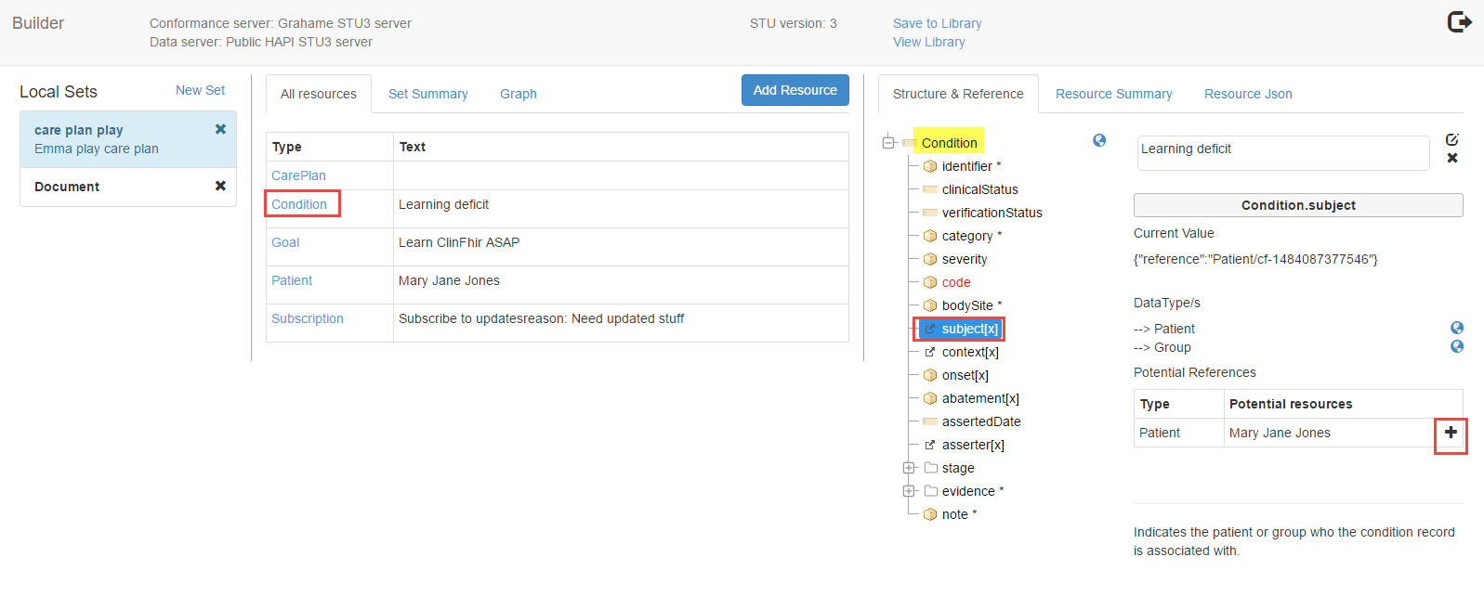

Click on graph tab to show linkages. If more linking is needed, can select the resource in the graph area to display the Structure & Reference. Select a resource to link.
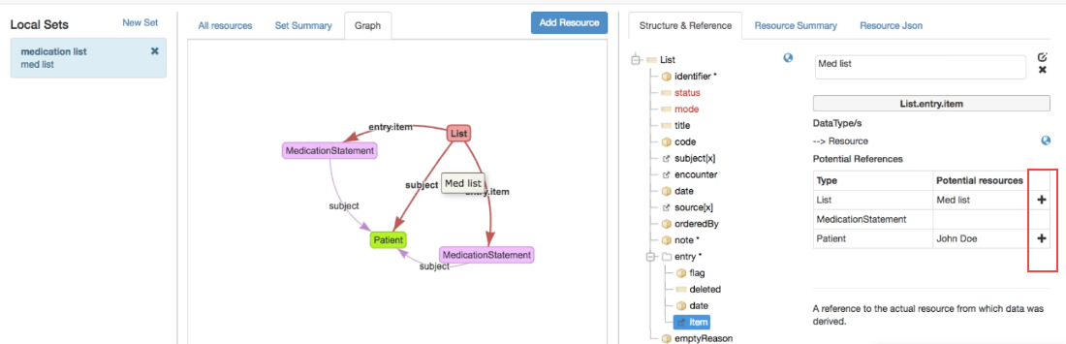

To undo the linkages, select the resource you want to unlink from (from the All resource list or from the graph display), select the resource you want to unlink and click on the X

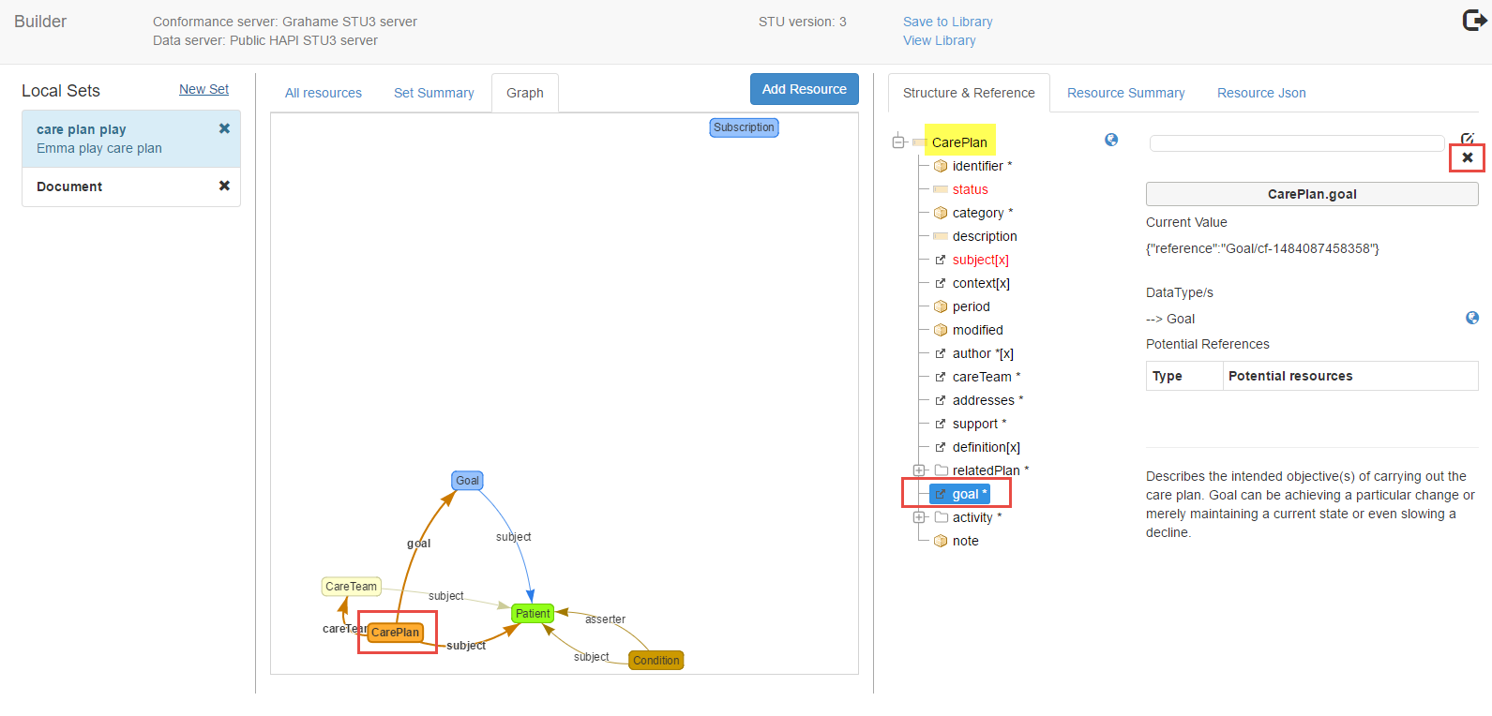

To add a code - select code, then codeableConcept.
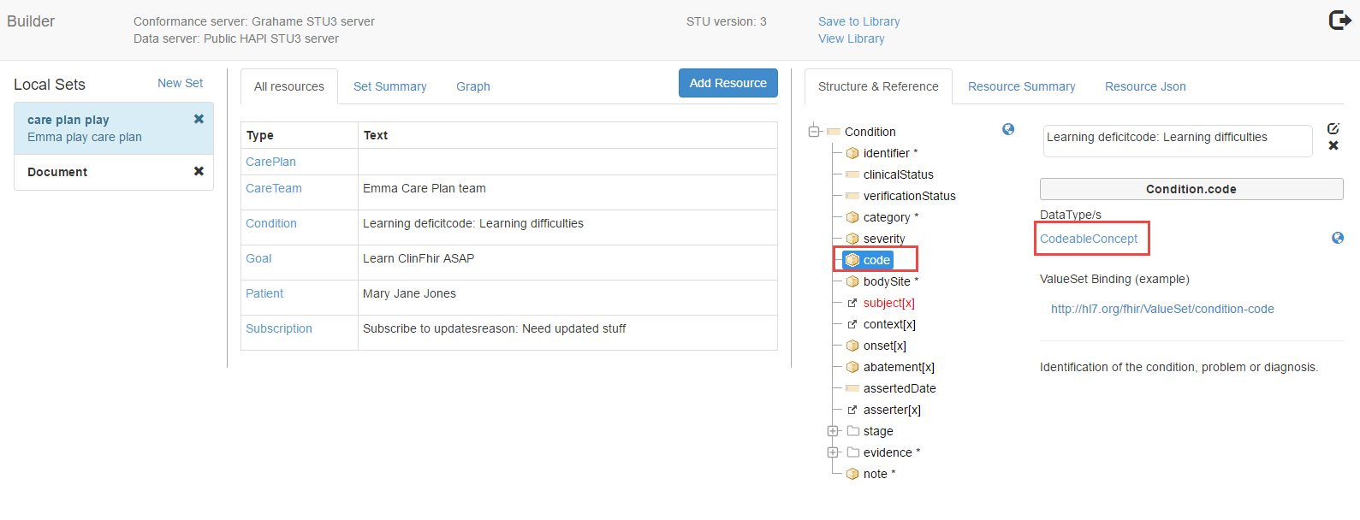
A search diaglogue will open. Search for the code, select code displayName and save. Can add text value if no code
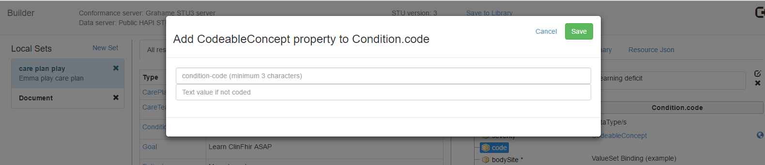

While building your resource your work is automatically saved locally. Click on Save to Library to add to the server. Currently completely open to see to be able to see what everybody has added to the library
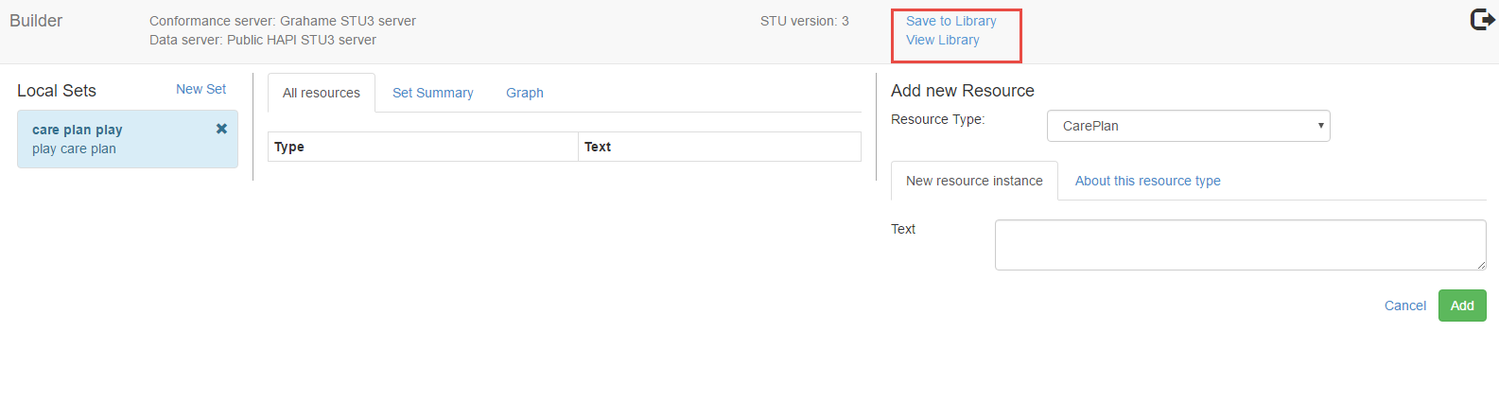
Creating Documents - A document is a bundle that returns resources. The composition resource is at the head of the bundle.

Can create a document - bundle returning resources with the composition at the head.
Add new resource and select composition and give it some text. This will create a document tab
Click on the document tab and Add to start adding section to your document

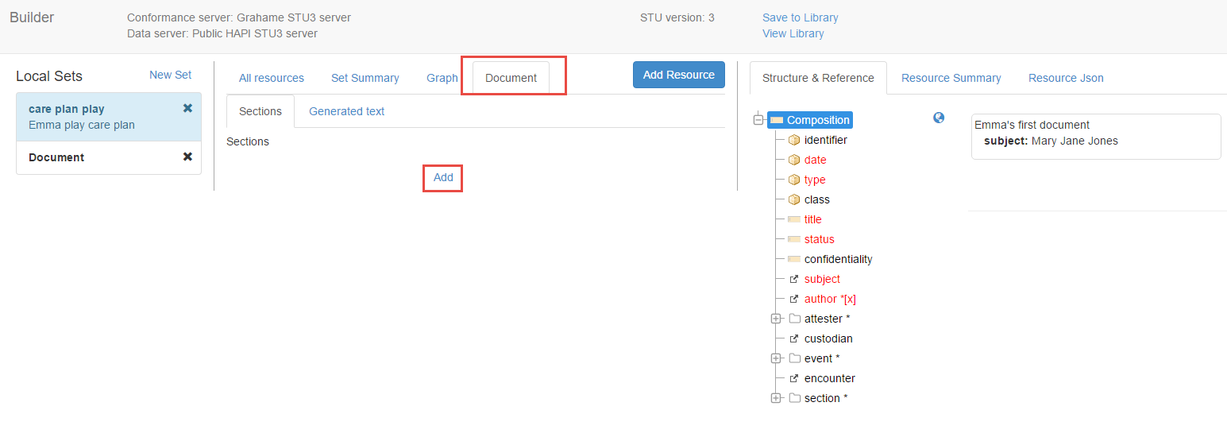
Creating Profiles:

Click on the gear (on the ClinFHIR page) and select profile then new profile. Name your profile without any spaces.

