HL7 CDS WG Conference Call
10 July 2014, 3-4pm US ET

Attendees:
[ ] Tomasz Adamusiak
[ ] Joel Amoussou
[ ] Chad Armstrong
[ ] Jennifer Barrett
[ ] Cynthia Barton
[ ] Chris Bontempi
[ ] Joe Bormel
[X] Aziz Boxwala
[ ] Thompson Boyd
[ ] Daryl Chertcoff
[ ] Sarah Corley
[ ] Clayton Curtis
[ ] Maria Esquela
[ ] Elitsa Evans
[ ] Robert Freimuth
[ ] Emory Fry
[ ] Marc Hadley
[ ] Lindsey Hoggle
[ ] Vojtech Huser
[ ] Bob Hussey
[ ] Krishna Gazula
[ ] Chris Johnson
[X] Ken Kawamoto
[ ] Rosemary Kennedy
[ ] Lester Keeper
[X] Ryan Knepp
[ ] Mark Kramer
[ ] Thomson Kuhn
[ ] Polina Kukhareva
[ ] Eric Larson
[ ] Oliver Lawless
[ ] Victor Lee
[ ] Bill Lord
[ ] Stacey Marovich
[X] Jason Matthews
[ ] Lloyd McKenzie
[ ] Christy May
[ ] Jim May
[ ] Rob McClure
[ ] Clem McDonald
[ ] Chris Melo
[ ] William Michaels
[ ] Chris Millet
[ ] Maiko Minami
[ ] Bernadette Minton
[ ] Mark Monterastelli
[ ] Alicia Morton
[X] Claude Nanjo
[ ] Lisa Nelson
[ ] Jamie Parker
[ ] Anne Pollock
[ ] Divya Raghavachari
[ ] Stan Rankins
[X] Bryn Rhodes
[ ] Mark Roche
[ ] Virginia Riehl
[ ] Martin Rosner
[ ] Julie Scherer
[ ] Atanu Sen
[ ] Mark Shafarman
[ ] David Shields
[ ] Julia Skapik
[ ] Davide Sottara
[ ] Howard Strasberg
[ ] Rita Torkzadeh
[ ] Serafina Versaggi
[ ] Phillip Warner
[ ] Ben West
[ ] Missy Willoughby
[ ] Julia Xu
[ ] Cathy Welsh
[ ] Su-Hsiu Wu
[ ] Shirin Zaidi

Minutes:
- QUICK
- Reviewed structural updates to QUICK made in QI model HL7 call
- Refactored topic and modality as it made leaf-level classes more consistent, and it made expressions cleaner. Content is the same as before.
- StatementTopic can be Observable or Act
- StatementModality can be an Observation or Action
- Discussed modeling extension considerations for QUICK. More discussions to occur in future calls. Slide set for discussion from Aziz:

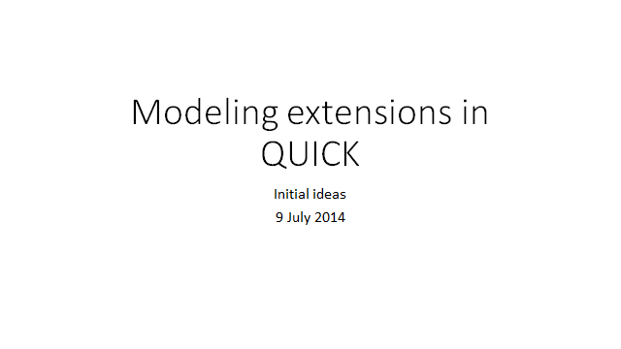
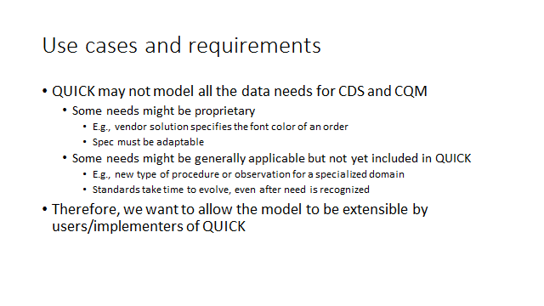
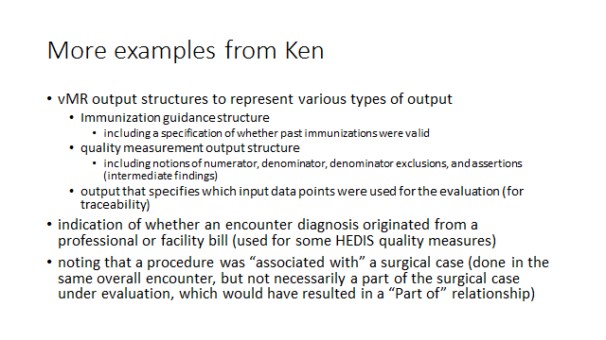
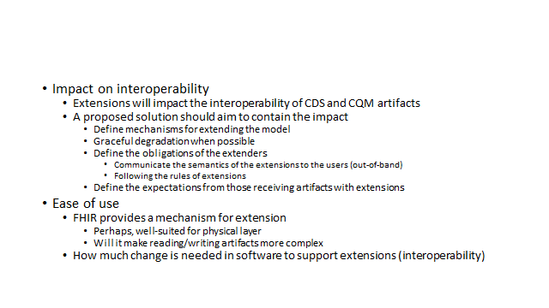
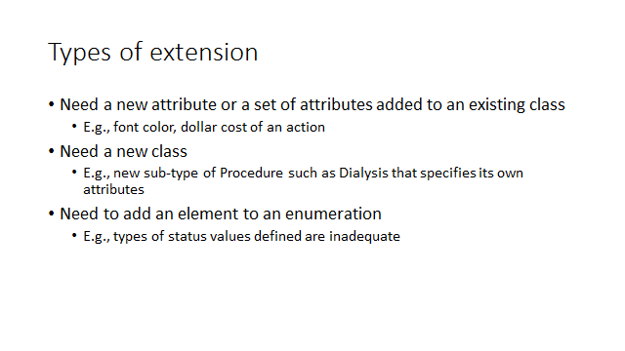
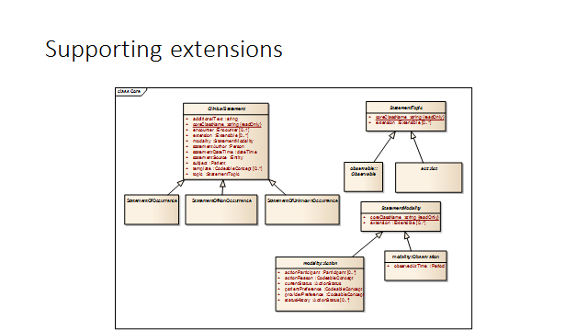
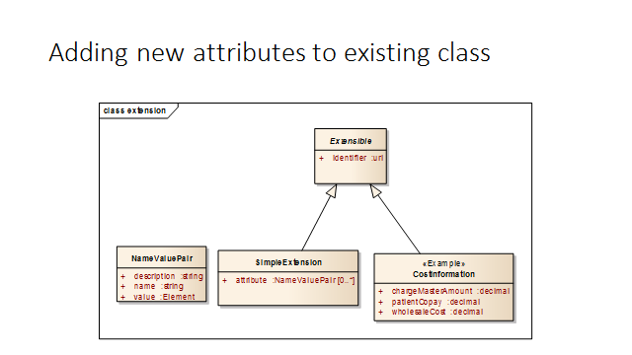
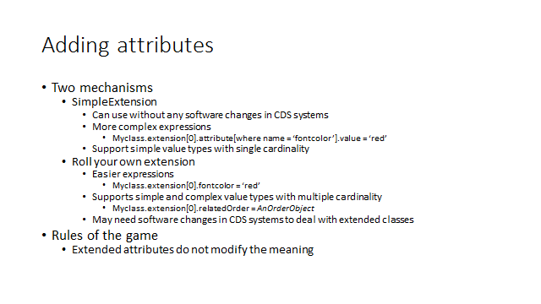
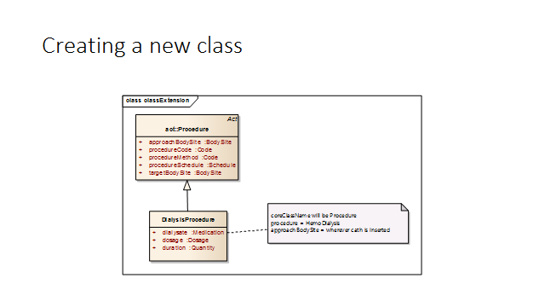
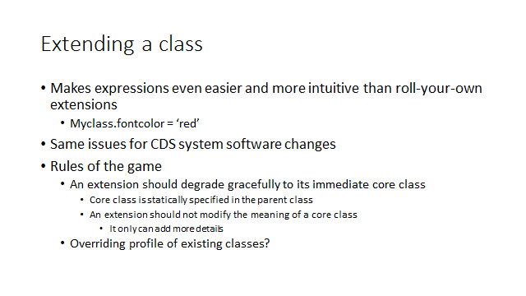
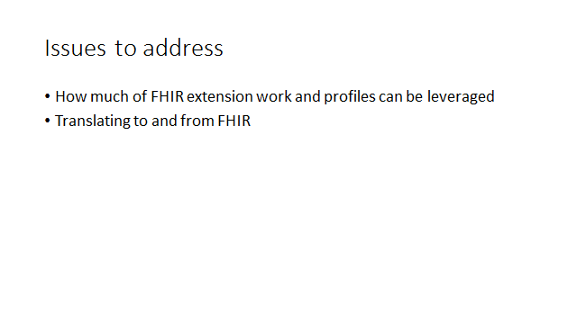

- Next call:
- 7/17 (Th) 3pm ET
Tentative Agenda:
- CQL and QI Data Model Discussion

