HL7 Patient Care WG
FHIR Resources Management
Meeting Minutes

July 16, 2015, 5-6 pm ET

Participation Information
Phone Number: +1 770-657-9270
Participant Passcode: 943377

Web Meeting Info
www.webex.com
198 139 396

Attendees:
Elaine Ayres
Marc Hadley
Michelle Miller
Russ Leftwich
Russell McDonell
Stephen Chu
Emma Jones
Mark Kramer
Rob Hausam
Eric Haas

Agenda for July 16, 2015
- Review agenda
- Approve minutes of July 9
- Review of status concepts with CQI – QDM group
- DAF ballot comment – GFORGE #8407 adding onset to root of allergy
- GFORGE Review – ballot comments
- Next call is July 23, 2015

2. Minutes for July 9, 2015 Move for approval Russ/Stephen Abstain – 1, Negative – 0, Approve - 5

List of what resources that PC owns (DSTU 2.1) – number equals priority
1 - AllergyIntolerance - *
1 - Condition - *
1 - Procedure - *
1 - CarePlan - *
1 - Goal - *
1 - Referral Request*
1 - Questionnaire - *
1 - Questionnaire Answer - *
2 - FamilyMemberHistory (genomics group)(Jonathan Holt – Vanderbilt)- interested in contributing to this resource.
2 - Procedure Request - * (more internal – less important to implementer
2 - Flag
3 - ClinicalImpression
3 - Communication
3 - CommunicationRequest
Contraindication-no (CDS)
Risk Assessment – no (CDS).

# 5546 – Condition vs. Concern – Leave open for now.

#7581 – Discussion Marc Hadley – QDM does not use status – have two concept s DX onset and DX abatement in combination with dates. Slide 1 :
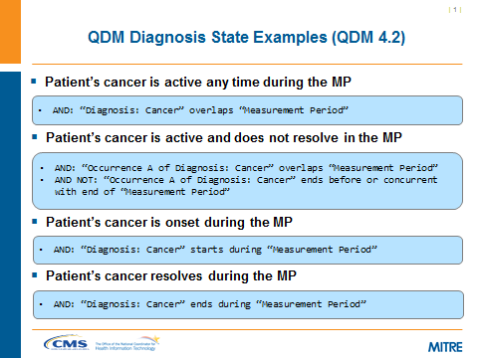

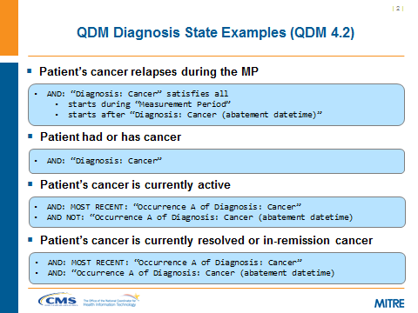

What if no dates – how is the status resolved? If no onset or abatement, or even an unknown value?

How do you deal with the period of time where there is a problem, but no diagnosis?

For quality measures, if various stages of diagnosis, may not be part of the denominator for reporting purposes. If an examples like cancer – do you have abatement or remission? What if you have historical data – and so status is unclear? Measurement period will consider active patients during that particular period (clause in rules or denominator).

This model works well in a system where the patient is tracked internally. Is there really an abatement even of a common cold.

Is there a difference between a clinical quality measure vs. clinical work flow?

In QDM more like C-CDA.

Condition resource:

Spit clinicalStatus into two attributes: verificationStatus and clinicalStatus, defined as follows:

verificationStatus: Differential, Provisional, Working, Confirmed, Refuted, Unknown, Entered In Error ADD “established”
Where do you add onset and abatement to each of these concepts. What about date asserted? On a problem list, a provisional diagnosis is then replaced with a confirmed diagnosis. Is the provisional abated?

Long Range Plan – phase out QDM and use fields in FHIR resource. Will not be in current MU.

Define relationships between clinical status and date time. Most quality measures are more temporal in nature. If no dates on a diagnosis – ruled out of scope or in scope for a measure.

How do you handle an abatement date for example for remission?

Need a table of instances and the types of dates we would see associated with these cases.

What happens with a provisional dx – once a confirmed dx is established? The provisional dx will always be maintained for traceability, and medico-legal reasons.

In the future, quality measures need to take into account the various stages of diagnosis. An inclusion of resolved date as well as abatement.

We should put in a request to include an assertion date as well – and who is the asserter? There is a date recorded in lieu of assertion.

Action – pair status dates with status conditions in a table. Group – Russ, Stephen.

**Add to Atlanta agenda for joint PC/CQI meeting. Also discuss during Clinicians on FHIR.

clinicalStatus:

Active – The subject is currently experiencing the symptoms of the condition

Relapse – The subject is re-experiencing the symptoms of the condition after a period of remission or presumed resolution

Remission – The subject is no longer experiencing the symptoms of the condition, but there is a risk of the symptoms returning

Resolved – The subject is no longer experiencing the symptoms of the condition and there is no perceived risk of the symptoms returning

Add a usage note that stage and clinical status may have interdependencies

For verificationStatus, had also considered: confirmationStatus, workflowStatus, decisionStatus, assessmentStatus

GFORGE #8407 – Found DAF ballot comment persuasive – addition of allergyintolerance.onset to allergyintolerance resource.

Agenda for July 23, 2015
- Review agenda
- Approve minutes of July 16
- Clinicians on FHIR
- GFORGE Review – ballot comments
- Next call is July 30, 2015

