**HL7 Patient Care Work Group**

**Allergy/Intolerance/Adverse Reaction Topic Sub-Group Meeting Minutes**

**Date: May 16, 2012 – Vancouver WG – Wednesday, Q3**

Co-Chairs: Stephen Chu, Hugh Leslie, Elaine Ayres Scribe: Hugh Leslie

|  |  |  |  |
| --- | --- | --- | --- |
| **Name** | **Organization** | **E-mail** | **Present on 5/16/2012** |
| Elaine Ayres | Academy of Nutrition and Dietetics/NIH | eayres@nih.gov | X |
| Andre Boudreau | Boroan, Canada | a.boudreau@boroan.ca |  |
| Stephen Chu | NEHTA | Stephen.Chu@nehta.gov.au | X |
| Kevin Coonan |  | kevin.coonan@gmail.com | X |
| Margaret Dittloff | Academy of Nutrition and Dietetics/CBORD | mkd@cbord.com | X |
| Jean Duteau | Gordon Point Informatics | jean.duteau@gpinformatics.com | X |
| Adel Ghlamallah | Canada Health Infoway | aghlamallah@infoway.ca |  |
| Maggie Gilligan | Academy of Nutrition and Dietetics | mmgilligan@gmail.com |  |
| Bill Gregory | Patient Safety |  |  |
| Nick Halsey | European Medicines Agency | Nick.halsey@ema.europa.eu | X |
| Peter Harrison | McKesson |  |  |
| Kai Heitmann | HL7 Germany | HL7@kheitmann.de |  |
| William Hess | FDA |  | X – by phone |
| Wendy Huang | Canada Infoway | whuang@infoway.ca |  |
| Steve Hufnagel | US DOD | Stephen.Hufnage.ctrl@tma.osd.mil |  |
| Gaby Jewell | Cerner | gjewell@cerner.com | X |
| Tom de Jong | HL7 Netherlands | tom@nova-pro.nl |  |
| Hugh Leslie | Ocean Informatics, Australia | Hugh.leslie@oceaninformatics.com | X |
| Russell Leftwich | Office of eHealth Initiatives, Tennessee | [Russell.Leftwich@tn.gov] | X – by phone |
| Ben Loy |  |  |  |
| Masaharu Obayashi | HL7 Japan | obayashi@metacube.jp |  |
| Richard Sakakura |  | 'richard.sakakura@stjoe.org' |  |
| Carolyn Silzle | Academy of Nutrition and Dietetics |  |  |
| John Snyder | Academy of Nutrition and Dietetics | jwsnyder@nutrioffice.biz |  |
| Lise Stevens | FDA |  | X |
| Michael Tan | Nictiz | tan@nictiz.nl | X |
| Cathy Welsh | St. Judes |  |  |
|  |  |  |  |
|  |  |  |  |

**Agenda for WGM Vancouver, Wednesday Q4 May 17, 2012**

1. Review agenda for meeting and add other issues as needed
2. Review and approve the minutes for April 26, 2012 meeting
3. Review status of Project Scope Statement - Elaine
4. Review status of DSTU Extension Withdrawal Request - Elaine
5. Review of current functional model - Jean
6. Review of allergy use case list
7. Review assigned use cases
8. Confirm ongoing meeting day and time for conference calls (currently every other Thursday at 5 PM EDT). Next call would be on May 31th.
9. Plan the agenda for the next conference call

**Minutes** –

Minutes of the *April 26, 2012* conference call – deferred until the next conference call

**Project Scope Statement –** approved by the TSC. Elaine will post on the wiki. Encouraged by the TSC to submit another scope statement after the completion of the DAM that will address the outstanding RMIM issues.

**DSTU Extension Withdrawal** - Approved by the TSC.

**Project Update:** - Relationship to other projects:

* + Care plans
  + Nutrition orders (through O & O)
  + EHR FM (through EHR WG)
  + Composite orders (through O & O)

Presentations on the project made to the O & O WG (Monday Q4) and the EHR WG (Wednesday, Q2). The O & O WG received a status update and a request for input. The group requested collaboration with the O & O project on nutrition orders. The EHR WG had an active discussion of the use cases, particularly the concept of an allergy vs. intolerance. Continued cross-mapping to the EHR-S FIM for Allergy and Intolerance was requested. The notion of failed therapy was discussed – this term has specific meaning for the US FDA – e.g. a drug is not effective, vs. the notion of a preference. A suggestion was made re preferences to note the preference but classify as “no reaction”. The group had not considered the issue of devices and will now consider for the EHR FIM for allergies.

**Review of Concept Model – Jean Duteau** –

Presentation Objectives:

* Present the last version of the conceptual information model and associated definitions developed in Canada, and enhanced with HL7 Patient care Work Group
* Collect feedback

Addition Notes to the Concept Model:

* The terms used in the concept model are the ‘right’ terms and not necessarily the terms ‘preferred’ by specific clinical groups
  + ‘Preferred’ terms can be the ones displayed to clinicians in a given setting as synonyms to the ‘right’ term
* All discussions notes behind the model and definitions can be found in meeting minutes of the HL7 PC WG on allergies and in the Canadian Standards Partnership Minutes
* A few definitions are to be completed

Jean then reviewed the model as previously discussed by the Patient Care Workgroup:

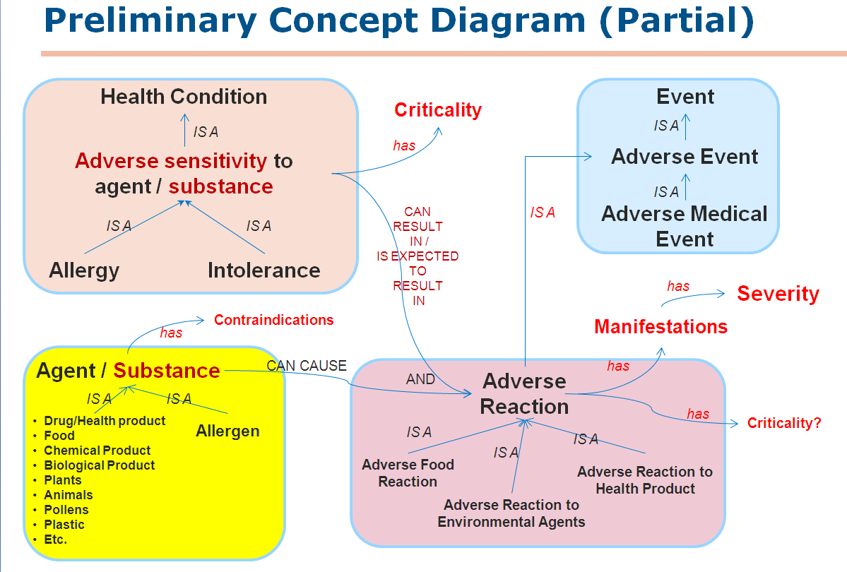

Jean then presented a series of definitions related to the concept model:

* Health Condition (ISO 13940)
  + one or more observed aspects of the health state of a subject of care at a given time
    - NOTE 1 In the perspective of health care, the term 'health condition' is often used to label a bad condition (diseases, disorders, injuries, etc.), because it may motivate certain health care activities
* Adverse sensitivity to substance or agent
  + A susceptibility to an agent or substance or category of substances, such that exposure to it is likely to result in a harmful physiological response rather than the expected (non-harmful, normal) physiological response AND where it has not been possible to determine whether the sensitivity is of the allergic type or not. Allergy
* Allergy - An immunological hypersensitivity to one or several defined antigens, called allergens, resulting in a marked increase in adverse reactivity to that antigen upon subsequent exposure, sometimes resulting in harmful immunologic consequences
* Intolerance - Adverse sensitivity caused by a mechanism other than an immunologic over-response
* Adverse Event (CDISC, NCI/NIH) - Any unfavorable and unintended sign, symptom, disease, or other medical occurrence with a temporal association with the use of a medical product, procedure or other therapy, or in conjunction with a research study, regardless of causal relationship
* Adverse Reaction (New) - Noxious (harmful or injurious to health or physical well-being) and unintended response to a substance or agent
* Adverse Effect (MedicineNet.com) - A harmful or abnormal result. An adverse effect may be caused by administration of a medication or by exposure to a chemical and be indicated by an untoward result such as by illness or death
* Adverse Drug Reaction - Use Adverse Drug Reaction to Health Product
* Adverse Drug Reaction to Health Product (Health Canada, adjusted)
  + Noxious (harmful or injurious to health or physical well-being) and unintended response to health products
  + Health products include both prescription and non-prescription medications; natural health products; biologically derived products such as therapeutic or diagnostic vaccines and fractionated blood products; cells, tissues and organs; radiopharmaceuticals; and disinfectants and sanitizers with disinfectant claims.
* Allergen (The Free Dictionary by Fairfax∕ Medical Dictionary)
  + An antigenic substance capable of producing hypersensitivity (allergy)
* Contraindication (Stedman's Medical Dictionary)
  + A factor that renders the administration of a drug or the carrying out of a medical procedure inadvisable
* Relative contraindication (MedicineNet.com)
  + A contraindication may be absolute or relative
  + A relative contraindication is a condition which makes a particular treatment or procedure somewhat inadvisable but does not rule it out
* Hypersensitivity (also called hypersensitivity reaction) refers to undesirable reactions produced by the normal immune system, including [allergies](http://en.wikipedia.org/wiki/Allergies) and [autoimmunity](http://en.wikipedia.org/wiki/Autoimmunity). These reactions may be damaging, uncomfortable, or occasionally fatal. Hypersensitivity reactions require a pre-sensitized (immune) state of the host.
  + Wikipedia: <http://en.wikipedia.org/wiki/Hypersensitivity>
  + Includes ref to Gell PGH, Coombs RRA, eds. Clinical Aspects of Immunology. 1st ed. Oxford, England: Blackwell; 1963
* Anaphylaxis (severe allergic reaction)
  + Hypersensitivity (as to foreign proteins or drugs) resulting from sensitization following prior contact with the causative agent
    - Merriam-Webster's Medical Dictionary, © 2007 Merriam-Webster, Inc.
  + Anaphylaxis refers to a rapidly developing and serious allergic reaction that affects a number of different body systems at one time
    - MedicineNet.com: <http://www.medicinenet.com/anaphylaxis/article.htm>

**Discussion**

Recommended changes to the model – it was noted that in the Agent/Substance area, that the arrow from allergen to agent/substance should be reversed. The Agent/Substance is an allergen. Jean will make this change.

In the area entitle Adverse Sensitivity - Kevin Coonan had the view that allergy and intolerance are the incorrect categories - a very long discussion followed about the theoretical view that allergy and intolerance were not the only categories that were necessary. Kevin suggested that it was better to have a more abstract view of the model so that a more fine grained approach could be constructed. This discussion also ranged around the need to actually not include reported allergies in the allergy list until they were confirmed – there was general disagreement with this idea. Kevin was asked by Stephen Chu to write up his proposal and review it with Stephen prior to the next conference all.

Michael Tan noted that in the Netherlands, allergy is a subtype of intolerance and that a note on the mechanism of the reaction is used to differentiate. However, he also noted that in terms of documentation there is no differentiation – only the concept of certainty is added as known.

The definitions were then reviewed by the group.

* Under adverse sensitivity, the suggestion was made to change the word harmful to undesirable.
* Comments were also made about adverse reaction and adverse effect related to the word harmful.

The group then reviewed the practicality of how allergies and intolerances are documented. They are often reported, not observed and noted as “unconfirmed”. Another use case was suggested – that of the patient recording their own allergies such as in a PHR/patient portal which would then become of the EHR.

It was noted that the model should also reflect a reaction history (reported vs. documented) and an evaluation of certainty based on signs and symptoms.

A use case related to failed therapy should be removed – it is a specific term for the US FDA related to drugs that are not effective (vs. a preference). A use case on preference can be retained. The provenance of the reported reaction or condition should also be included.



**Agenda for Thursday, May 31 at 5 PM EDT**

1. Review agenda for meeting
2. Review and approve the minutes for April 26, 2012 and for the Vancouver WG meeting minutes from May 16, 2012.
3. Review update to concept model - Jean
4. Review of allergy use cases
5. Plan the agenda for the next conference call on Thursday, June 14 at 5 PM EDT.