Integrating the Healthcare Enterprise


IHE Pharmacy
White Paper
2010-2012
For Public Comment

Medication Documentation
A proposal for consistent documentation and preparation of medication information from different sources to support clinical decisions

IHE Pharmacy Technical Committee
Editors: José Costa Teixeira (jose.costateixeira@agfa.com), Marc Robberecht (marc.robberecht@agfa.com), Marco Demarmels (marco.demarmels@lakegriffin.ch), Stephen Chu (stephen.chu@nehta.gov.au), Julie James (julie_james@bluewaveinformatics.co.uk), Tom De Jong (tom@nova-pro.nl)

Version 0.9
2012-01-29

Contents

IHE Pharmacy Technical Committee 1
1 Introduction 4
1.1 Purpose 4
1.2 Scope 5
1.3 Expected knowledge and references 7
2 Objective 8
2.1 Request for Feedback 9
2.2 Open Issues and Questions 10
2.3 Closed issues 10
3 Medication Processes and Data 10
3.1 Overview of the Medication Processes and Data 10
3.2 Medication information from distributed data sources 12
4 Scenarios and Use Cases 12
4.1 Scenarios 13
4.1.1 Hospital stay, physicians prescribing medication in one system 13
4.1.2 Hospital stay, physicians prescribing medication in one system, medication substituted by pharmacy 13
4.1.3 Hospital visit, no previous information available, patient reports history to physician 13
4.1.4 Hospital visit, patient has medication reported from community system 13
4.1.5 Hospital visit, patient has medication reported from community system, wrong patient checked. 13
4.1.6 Hospital visit, patient has medication reported from community system and reports additional data 13
4.1.7 Hospital visit, patient has medication reported from community system and reports verbal dose changes from requested 14
4.1.8 Hospital visit, patient has medication reported from community system in another country 14
4.1.9 Hospital visit, patient has medication reported from community system in another country where medication is considered to have different life 14
4.1.10 Emergency visit and admission 14
4.1.11 Hospital visit, patient has prescription from GP and dispense report 14
4.1.12 Hospital visit, patient has prescription from GP and dispense report dated from day after treatment start 14
4.1.13 Hospital treatment with different medication management systems 14
4.1.14 Hospital visit, radiology contrasted procedure and transfer to another hospital for follow-up 14
4.1.15 GP Follow-up visit after treatment with antibiotics, dispense report and prescription is accurate but patient mentions delay in the take of one dose. Physician investigates whether there is a reason for suspecting that the treatment may have been ineffective. 14
4.1.16 Psychiatric patient, patient reports adherence but physician suspects the opposite. 15
4.1.17 Hospital visit, physician suspects use of contraceptive but patient denies it 15
4.2 Use Cases 15
4.2.1 Emergency visit, patient’s medication history checked for current medication 15
4.2.2 Hospital visit, patient’s medication history checked for details 15
4.2.3 Finding the patients that received a defective batch of medication 15
4.2.4 Following up on patient whose therapy included counterfeit medication 15
5 Outcomes and derivative work 16
5.1 Medication Reference Data Structure 16
5.2 Queries 16
6 Data Sources 16
6.1 Pharmacy Documents and/or Messages 16
6.1.1 Prescription 16
6.1.2 Pharmaceutical Advice 16
6.1.3 Dispense Report 16
6.1.4 Preparation Report 16
6.1.5 Administration Report 16
6.2 Additional Sources 17
6.2.1 Medication Statements 17
6.2.2 Other Sources 17
6.3 Classification of Sources 17
6.4 Semantic Interoperability 18
7 Data Aspects to Consider 18
7.1 Data Granularity Available 18
7.2 Data Reliability/Information Quality 18
7.3 Data Synchronicity 19
8 Common Data Structure 19
8.1 Original Data Structure 19
8.2 Processed Data 19
9 Existing Structures and Templates 19
10 Deriving Information from Data 19
10.1 Data Collection 19
10.2 Processed Data versus Information Quality 19
10.2.1 Data Parsing 19
10.2.2 Harmonization 19
10.2.3 Compilation 20
10.2.4 Data Interpretation 20
10.2.5 Data Visualisation 20
11 Data Handling Mechanisms 20
11.1 Broadening the Scope of Medication Reconciliation 20
11.2 Local Rules 21
12 Pharmacy EHR Functional Profile 22
12.1 Medication Profile 22
12.1.1 Definition 22
12.1.2 Scope 22
12.1.3 Clinical Aspects 22
12.1.4 Medication-related data 23
12.1.5 Medical Diagnoses and Findings 24
12.1.6 Entity-Relationship Model 25
13 Appendix A: Deriving Information from Data 27
14 Appendix B: Examples of How Data Can be visualized 29
B.1 Possible visualisation of Information 29

Introduction
“Medications are the most prevalent health therapy in clinical medicine” [(Adapted from Medication Safety paper, the Australian Commission on Quality and Safety in Healthcare (http://www.safetyandquality.gov.au/internet/safety/publishing.nsf/Content/D0DABD9912D44A14CA257516000FDABB/$File/NatRep-Windows.PDF)]. Like most health therapies or interventions, there are risks of harm associated with the use of medications, such as wrong medication being prescribed or use, or the correct medication being used inappropriately. Harm may also occur because of adverse reactions to the medication used. These harms result in varying degrees of damages to life and incur heavy financial costs to the patient and society.
Ability to provide accurate and most up-to-date information concerning the patient’s medication for clinical decision is one of the critically important requirements for facilitating safe use (prescribing, dispensing and administration) of medications. Patient medication information may originate from many sources and may be expressed in various ways, with different meanings, depending on the context under which the medication information is generated, used and stored. While the every efforts will be directed to ensure the fidelity of medication is preserved when such data from disparate sources are presented to clinicians during the course of clinical care, variations in syntax/structure and semantics of data always present significant challenges during collection, preparation and presentation of the information.. In addition, difficulties in matching medication data from different phases of the medication management cycle (e.g. a prescription may not always have matching dispensing and/or administered data) increases the challenges in medication data synchronization and reconciliation.

Purpose
The data concerning a patient’s medication is registered at different times, in many sources, in different environments and systems, with different contexts. Sometimes important data is not available at all, whether due to unavailability/ unreliability of the source, or because the information is simply not stored.
The purpose of this whitepaper is to expose the known sources of information and to define the requirements for the establishment of a consistent data structure that can accommodate this information. This includes:
- Identify the information sources and their respective context (preconditions and workflows)
- Expose the requirements for exchanging information between different systems in similar or different contexts.
- Propose a reference structure that accommodates the representation of medication information of different sources
In addition to the above bottom-up approach, we complement the discussion from top-down and
- define the requirements of the Pharmacy-related part of an Electronic Health Record (Pharmacy EHR functional profile)
- assess the added value of using the above reference structure for medication documentation in a Pharmacy EHR from the point of view of clinical decision making

Scope
This whitepaper explores the following:
- Relevant medication management related concepts and terminology required for a clear documentation of medication information
- Any known and relevant data sources of patient medication data that may potentially feed into the clinical review and reconciliation processes required for the creation of the patient medication documentation / profile
- The procurement of these patient medication data from the relevant data sources including the exploration of the optimal or most appropriate technology or technical approach for the procurement of the required data
- The distributed nature of repositories of the Medication-related information, and the limitations of distributed systems with regards to availability, consistency and reliability of the data
- The viability for clinical reconcilliation (validation and consolidation) of data procured from various data sources into a consolidated record. Given the clarity and unambiguity of the documentation, some degree of automated pre-consolidation of the information is possible. It is acknowledged that this may be a manual process that requires a high level of clinical expertise.
- The identification and development of a standardised reference structure and semantics for harmonisation of medication documentation data. It is obvious that medication data from disparate data sources will have variations in syntax and semantics. Therefore standardised data structure and semantics are critically important for the harmonisation of the medication data.
- Identify how the harmonised medication information may be queried and used for processing, visualisation or other uses. Some purposes for consumption of the data:
  - Preparation for visualization in different contexts, for use by clinicians during a clinical consultation
  - Processing (e.g. creating a reduced version of a patient’s Medication Record for portability)
  - Clinical decision support mechanisms for safe use of medications (prescribing, dispensing and administration)
  - Clinical effectiveness analysis and research
  - Epidemiological and biosurveilliance analysis and decisions
  - Management and executive decision support analysis for policy decisions
- To identify persistence requirements for the data that are viewed by the clinicians to satisfy the medico-legal requirements (as clinical decisions may have been made based on the profiled view of the procured data)
- To identify any assumptions on medication management workflow that may be made during the development of this whitepaper and to assess the clinical safety risks that such assumptions may cause

Rationale:

The definition of rules for data filtering
Rationale: These rules may vary across countries,

Use cases:
Patient with same IDs
Reference data structure.

Note: we must differentiate the name versus the value of the element.
Name

Such an approach has the following benefits:
- It can be applied immediately with the currently available sources of data
- It is compatible with the fact that some data may not be available all the time
- It can be expanded to other sources of data as they are identified or become available
- It allows incremental expansion to additional sources, enriching the information for the HCP

In addition to the above the whitepaper also explores:
- The possible requirements of a Pharmacy-related Electronic Health Record containing a patient’s medication profile (Pharmacy EHR functional profile)
- Guidelines on documentation and transmission of medication information from different jurisdictions (NL, Canada, Australia) and conclusions for a generalized Pharmacy EHR functional profile
- The set of medical information on a patient (e.g. allergies) required in addition to mere medication information that best supports clinical decisions in medication therapy
- The added clinical value of the medication information represented in the above mentioned reference structure compared with the requirements of a Pharmacy EHR functional profile.

Expected knowledge and references
It is assumed that the reader has a basic knowledge of the Pharmacy workflows, both in community and institutions, as well as the pertaining terms used. An equal knowledge of the Pharmacy Content Profiles is expected (Pharmacy Dispense, Pharmacy Pharmaceutical Advise, Pharmacy Prescription)
Throughout this document, other possibly relevant works in this area are being mentioned.
- IHE Patient Care Coordination Technical Framework Supplement, Trial Implementation, September 9, 2011 – Reconciliation of Diagnoses, Allergies and Medications – (RECON) – describes a mechanism to automatically reconcile clinical information during every transfer of care, discharge or admission of Diagnoses, Allergies and Medications Profile.
- IHE IT Infrastructure Profile Revision 8.0 – Final Text, August 19, 2011- Retrieve Information for Display (RID) - provides simple and rapid read-only access to patient-centric clinical information that is located outside the user’s current application.
- IHE Patient Care Coordination (PCC) Technical Framework, Volume 2, Transactions and Content Profiles, Revision 7.0 - Final Text - September 09, 2011 - 6.3.3.3 Medications Section.
- IHE Patient Care Coordination (PCC) Technical Framework Supplement, CDA Content Modules, Trial Implementation, September 2, 2011 – Medications information.
- All IHE Pharmacy Documentation
- HL7 Common Product Model Domain, HL7 Pharmacy Domain - The information present in the Pharmacy D-MIM, RMIMs, Common Product Model and the associated available components, as it pertains to the subjects discussed.

MUST DISCUSS NEXT: hierarchical OR Flat? My feeling: Flat, to prevent contamination of data with business flows (e.g. prescription has same potential data value as Dispense, it would be better if there’s no assumption that a dispense is attached to a prescription)

Objective
The whitepaper explores how a harmonized reference data structure and the associated procurement processes, such as query, compilation and rendering, supports or enables any processes that require the medication information, be it administrative or clinical, like the medication reconciliation processes.
Reconciliation is the process of applying clinical adjudication to satisfactorily and safely resolve conflicts among medication data procured from disparate data sources.
The medication data can then be collated and harmonized into the standardised reference data structure with preservation of the context and clinical semantics. Any additional constructs on this data can also be projected onto the structure under which the source data were created and used.

The key Objectives of this whitepaper include:

- A glossary of terms relevant to patient medication documentation/profile concepts is created. This glossary is kept in synchronization with the common IHE and HL7 Pharmacy Glossary. Examples of such terms include:
  - Medication List
  - Medication Record
  - Medication Profile
  - Medication Statement
  - Prescription Record
  - Medication Order
  - Dispense Record
  - Administration Record
- The description of data sources and the types of data relevant for the documentation of tmedication-related information – i.e. a superset of attributes that allow the original information to be preserved throughout additional constructs and downstream processes.
- The processes and query services required to procure relevant medication data from the identified data sources are determined/established
- Identification of techniques/methods (technical/automated and manual) for collection and reconciliation of medication data procured from various data sources
- a reference medication data structure and semantics for harmonisation of medication profile are developed and validated to be suitable for construction of harmonized patient medication documentation repository

- Any assumptions made on medication management workflow during the development of this whitepaper are clearly documented together with the clinical risk that may arise from such assumptions.

Medication data structure

- the original sources
- filtered data
- local, interpreted data.
- ready-to-display version, with filtered and possibly some interpreted data, for display in situations like emergency, mobile applications, etc.

Further objectives are:
- A list of requirements for a Medication Profile extracted from existing guidelines from different jurisdictions (Canada, NL, AU) and practical examples (CH)
- Blueprint of a Pharmacy EHR Functional Profile that may serve as a complement to the on-going work in the HL7 EHR WG (http://www.hl7.org/implement/standards/product_section.cfm?section=4)

Request for Feedback
The IHE Pharmacy Domain requests feedback on the concepts described in this White Paper. Comments can be submitted until the period of Public Comments to the mailing list. As soon as there is a new version containing considerable changes, it must be published on the IHE International ftp, and the mailing list must be notified. Comments received will be incorporated in the following releases.

Open Issues and Questions
- Can one disregard the original data once the information is filtered and presented to the end user, provided that the traceability is kept and the link between the presented data and the original data is clearly kept?

Closed issues
- If information concerning the allergies and contraindications for medication is present, this must be preserved with the medication details.

Medication Processes and Data
Several possible areas of interest where medication reconciliation may be examined are listed below.
- Hospital basic in-patient scenario, with documentation of the different steps
- Community dispense (including several dispenses for one prescription), with documentation of the different steps
- Medication history collected by a physician as per the patient’s statement
- Substitution – documented or not documented
- Non-synchronized systems
- Community pharmacy prescription and dispense, no treatment start/end time
- Community dispense, no prescription
- Community dispense, several dispenses
- Hospital outpatient dispense, several dispenses
- Community pharmacy prescription and dispense, dispense starts after treatment start time
- Inpatient, administration reported by nurse (this would include the PRN cases as well)
- Patient in elderly care, personal medication dispenser
- Psychiatric patient, self-reporting during follow-up visit
- Patient statement (including negations)
- No patient statement, suspected use
- Non-documented changes in therapy
- ER aggregation collection and reconciliation, local reuse by OR colleague

Overview of the Medication Processes and Data
The medication processes are described in Figure 1, below:

Figure 3-1. Medication Processes

The most commonly reported data can be found in the dispense report which can contain the administration instructions
- as provided by an HCP
- or, like with over the counter (OTC) medication, the administration pattern can be determined from the medication itself.
- However, it must be noted that using the dispense report isn’t but one of the artefacts produced and represents one part of the workflow, from which data may be absent – e.g. it’s not known whether the patient took the medication, or medication orders that are not reflected in a dispense report can be lost).
Note on the preparation report: It musts be noted that although it is uncommon for a preparation report to be produced, this can be seen in the cases of the preparation of individual doses in systems such as individual medication dispensers. In a hospital environment, when a nurse administers a medication, it can be either simple or complex. For a simple administration such as taking a pill out of the pack, there is no preparation information being captured. For complex preparation (e.g. the tablet needs to be crushed and dissolved in sodium bicarbonate solution before administered, or reconstitute power into infusion solution for IV infusion) it is useful to have the preparation information captured; however it is seldom (or almost never) done.
In the case of individual dose repackaging (from bottles or packs) in hospital, this is usually done before dispensing. From the workflow perspective, this step will be before dispensing. Hence the diagram in Section 3.2 will need to be updated.
There is another use case that supports the “preparation”:
In community pharmacy, a pharmacist may receive prescription which requires the prescribed medications to be packaged into packaged pill box (dosette box) for senior patients. Again, preparation reports are seldom done, but the availability of electronic devices that support such repackaging can be based upon this information.

Medication information from distributed data sources

Brewer's theorem, states that it is impossible for a distributed computer system to simultaneously provide all three of the following guarantees:
- Consistency (all nodes see the same data at the same time)
- Availability (a guarantee that every request receives a response about whether it was successful or failed)
- Partition tolerance (the system continues to operate despite arbitrary message loss)
According to the theorem, a distributed system can satisfy any two of these guarantees at the same time, but not all three.[3]

This can also apply when dealing with various medication documentation repositories as distributed systems.

Brewer’s theorem was proven by Gilbert and Lynch in Brewer’s Conjecture and the Feasibility of Consistent, Available, Partition-Tolerant Web Services

Scenarios and Use Cases

To help in the analysis, this section is structured in Scenarios and Use Cases.

Scenarios are seen as events that happened, a static snapshot of the situation. These represent “what is the data available at a given moment”. It is more related to describe the data available at the input of a data repository, and its various configurations.

Use Cases are representing the required actions, the functions that a system would provide to a user, based on the data available. It is more related to the data available at the output of the repository.

Scenarios

Hospital stay, physicians prescribing medication in one system
(simple one, all should be registered – will never happen but a good place to start. Exposes concepts of cardinality - 1 prescription, N dispenses, M administrations; also data concurrence)

Hospital stay, physicians prescribing medication in one system, medication substituted by pharmacy
(medication IDs)

Hospital visit, no previous information available, patient reports history to physician
(information is tagged as “as reported by physician X”)

Hospital visit, patient has medication reported from community system
(information is collected from CMPD repositories; this introduces SVS or lookup for patient ID checks – patient ID may not be the same)

Hospital visit, patient has medication reported from community system, wrong patient checked.
(information is collected from CMPD repositories; this introduces SVS or lookup for patient ID checks – patient ID may not be the same)

Hospital visit, patient has medication reported from community system and reports additional data
(available data can be complemented with the report from the patient at that context. This scenario introduces notion of context and validity of information)

Hospital visit, patient has medication reported from community system and reports verbal dose changes from requested
(available data can be complemented with the report from the patient at that context. This scenario introduces notion of context and validity of information, many users providing information of the same type (medication order))

Hospital visit, patient has medication reported from community system in another country
This introduces SVS, references and IDs lookup… time sync

Hospital visit, patient has medication reported from community system in another country where medication is considered to have different life
Antidepressive and anesthesia
This introduces SVS, references and IDs lookup… time sync

Emergency visit and admission
This introduces the “reuse” of the documentation. After information collected and prepared once, the second users don’t need to recollect and recompile everything. Unless they want to

Hospital visit, patient has prescription from GP and dispense report
(normal)

Hospital visit, patient has prescription from GP and dispense report dated from day after treatment start
(here two different assumptions or even different visualizations are possible – it’s impossible for a computer system to make assumptions)

Hospital treatment with different medication management systems
(different product IDs, concurrent workflows)

Hospital visit, radiology contrasted procedure and transfer to another hospital for follow-up
(better keep track of this…)

GP Follow-up visit after treatment with antibiotics, dispense report and prescription is accurate but patient mentions delay in the take of one dose. Physician investigates whether there is a reason for suspecting that the treatment may have been ineffective.
(here, medication is prescribed and administered, but for some medication it’s different “administered” and “correctly administered”).

Psychiatric patient, patient reports adherence but physician suspects the opposite.

Hospital visit, physician suspects use of contraceptive but patient denies it
(cultural aspects + negative statement)

Use Cases
Clinical

Emergency visit, patient’s medication history checked for current medication

Hospital visit, patient’s medication history checked for details
Patient sees physician with chief complaint of recurrent gastritis symptoms. Physician reviews treatment/medication record - which indicates previous course of H. Pylori eradication therapy completed.
Physician suspects recurrence.
Physician wants to investigate whether the patient did not comply to previous therapy as advised, i.e. whether he skipped taking tablets on some days.

Finding the patients that received a defective batch of medication

Following up on patient whose therapy included counterfeit medication
- The health authorities decide to investigate the long-term effects of a counterfeit medication. Using unique medication item identification (see ePedigree), the patients that took the counterfeit medication are identified, and this is checked with the condition that was being treated with the medication. The patients are identified and called for a consultation.

Outcomes and derivative work

Medication Reference Data Structure

Queries

Data Sources
PART 1 – Let’s see what is there – this is the part that needs work upfront.

Pharmacy Documents and/or Messages
The most obvious medication data sources are found in documents and/or messages directly related to Pharmacy, listed below, with illustrative but not exhaustive lists of data elements.

Prescription
Data elements and other details present in Pharmacy in the Community and Hospital Pharmacy:
- Patient
- Medication
- Dose
- Treatment expected start date
- Treatment expected end date
- Total quantity
- Administration pattern

Pharmaceutical Advice

Dispense Report
- Patient
- Medication
- Date Dispensed
- Quantity Dispensed
- Usual administration pattern associated with the product and dispense circumstances (e.g. times of administration are determined by ward)

Preparation Report

Administration Report
After dispensing, the concept of “pattern” evolves into administration events, for the preparation and administration reports.

Additional Sources

Medication Statements

Other Sources
Other clinical sources of information are possible, containing information about the medication taken and/or administered to the patient such as Discharge Summary, Emergency Department Encounter Summary, Labor and Delivery Profiles, Radiology (e.g. contrasts) and other profiles from other domains.

(To be detailed here if found)

Classification of Sources
Medical data are generated, stored and interpreted by different actors that work on disparate documentation systems. A possible classification of medical data sources or systems is the following:
- Primary data sources or systems:
Systems that are used directly by HCPs, like EMRs in a general practice or a HIS or Pharmacy Information Systems. These are the systems on which data are generated in the first place.
- Secondary data sources or systems:
Systems meant for storing documents that originate from primary systems representing meaningful and significant information on patients directed to other HCPs who treat the same patient and to the patient itself. Repositories as actors in the IHE XDS profile that store CDA documents are an example. Such documents may be discharge letters, lab reports, Continuity of Care Documents (CCD) and other types including the PRE, PADV and DIS documents as defined in the IHE Pharmacy Domain.
- Tertiary data sources or systems:
The totality of documents that reside on secondary systems are the raw material for higher-order information aggregations like Electronic Health Records (EHR) that are supposed to span a patient’s lifetime, or for a Medication Record which is also meant to cover all treatment episodes that include medication therapy.
Thus, a Medication Record provides a view on already existing information and does not generate any additional new information. A Medication Record is a concept, a virtual entity, and according to the classification above it represents a tertiary data source instantiated on a tertiary system.

Semantic Interoperability
In order to be able to correctly interpret data present across distributed systems the concepts and terms must be used and interpreted in an ambiguous manner, in their context of use. The contexts of use are various – just to name a few: prescribing, dispensing, discharge medication, ceased medication. In order to assure a common understanding throughout the present whitepaper, the reader is guided to consult the IHE Pharmacy Glossary.
In a real-case scenario where a concept might have variants in the code systems used in their different attributes, for example (ASPIRIN® versus acetylsalicylic acid), it is possible to manually or automatically look up a nationally or regionally established formulary and assessing how the two concepts are linked to each other. This is part of the manual reconciliation or automatic collection and its implementation is considered out of scope for this white paper – it is assumed that there is a mechanism for this and this whitepaper may influence the later procurement or implementation of such a mechanism.

Data Aspects to Consider
PART 3 – we see what else may hit us.

Data Granularity Available
The data needed might not be stored as separate fields both due to a human factor – being used to prescribe medication a certain way and also due to the data structure itself. For example, 3x day for 5 days is usually all there is present in a prescription, instead of having discrete fields indicating frequency and length of treatment. In an administration, the data is much more granular –

Data Reliability/Information Quality
The data reliability and the quality of information must be considered when collecting data and associated with the data itself. While not possible to quantify this quality, it is intrinsic to the collection of the data and any factors that affect the quality should be documented – for example who reports the data, date of this report, any assumptions known at the data source…

- A possibly unreliable patient stating that the he or she took the medication and no verification can be done
- Conflicting reports from different sources
- Not being able to understand the patient information concerning the medication due to cultural barriers
- Differences between information present in different systems due to asynchronous systems.

Data Synchronicity
There are some cases when the patient has a prescription for five days, starting Monday, ending Friday, but only goes to the pharmacy on Tuesday. Several scenarios are possible, such as he or she took the medication only for four days, that he or she took the medication a day late and stopped on Saturday, or that they had some medication left over at home and they started on time, on Monday.

Common Data Structure
Part 4 – we document the data superset

The data retrieved by means discussed later on in the paper can be available to the end user in various forms, either in its original format or as a result of a processing operation.

Original Data Structure

Processed Data

Existing Structures and Templates

Part 5 – we project the superset into existing structures.

Across the IHE content profiles, CDA-based templates exist concerning medication.

Deriving Information from Data

Data Collection

Processed Data versus Information Quality

Data Parsing
Data may need to be parsed. For example, transforming an administration pattern description (3x day for 5 days) into a discrete series of events.

Harmonization
The data of interest must be presented according to a certain format. The transformation of the original data into a harmonized format must be discussed.

Compilation
Compilation is understood as aligning and combining any information concerning the same medication item. The first step is determining whether the information refers to the same medication. For example, in the case where a prescription mentions an active substance and the corresponding dispense report mentions a commercial name, it may be possible to determine that this dispense corresponds to the prescription, because the prescription item ID is the same. However, this depends on the scope of practice of the dispensing pharmacy. In Canada, a pharmacist may be able to change the prescription and dispense a different drug. In such cases, it must not be assumed that what is dispensed is the same as what is prescribed because the prescription ID in the two records are the same. In this case one can say that the prescription line is dispensed, although with a different product.
Specific business rules need to be set up for such cases. In this case the rule for combining data be of type: if “Prescription line ID in the prescription = Prescription line ID in the dispense report”, then…

Data Interpretation
Since the original information is still available, it is possible to rely on the fact that the data after “filtering” does not contain any local or regional transformation. The information has the same quality as in the source.

Data Visualisation
The display of a patient’s medication can be done in a way to summarize the information present, or allow the HCP to visualize the full details if needed. The synthetic presentation form may exist as a presentation layer, which does not mean that the details are lost. This white paper looks at a proposal that supports both simple or complex data visualization.

Data Handling Mechanisms

Broadening the Scope of Medication Reconciliation
As mentioned before, reconciliation is described in the PCC RECON profile as the process of merging and adjudicating conflicts between electronically accessed clinical information from multiple sources. It occurs during transfers or transitions of care from one healthcare practice setting or level of care to another, and can occur at other times as needed. The information reconciled is diagnosis, medications and allergies. The Pharmacy Domain delves into the medication reconciliation process, which is considered to be the formal process of obtaining and verifying a complete and accurate list of a patient's medicines and matching the medicines the patient should be prescribed to those they are actually prescribed. Any discrepancies are discussed with the prescriber and/or the healthcare providers and the reasons for changes in therapy are then documented. This may also include matching of prescribed to dispensed medicines and ideally to the administered medicines.

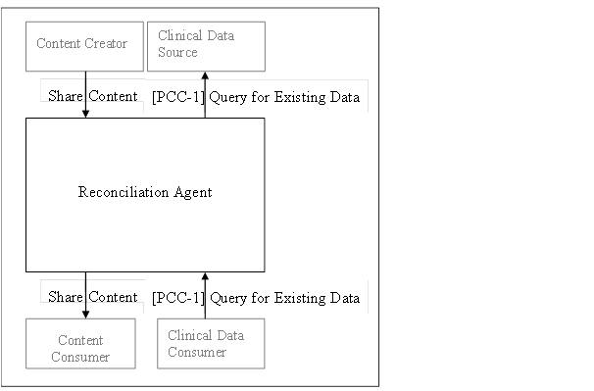
Figure 11-1. Reconciliation Actor Diagram

As defined in the profile RECON PCC, the Reconciliation Agent actor accesses clinical information in structured form, automatically identifies potentially duplicated information based upon application knowledge, presents it to a clinician and accepts clinician input to finalize the reconciliation, and stores the resulting data for future use.

Local Rules
Local rules apply, e.g. regulations on a minimal time range (e.g. Austria: min. 6 months) or even detailed directions on the content of a medication record (e.g. NL).

Pharmacy EHR Functional Profile
Add explanation on relation of “Medcation Profile” to “Pharmacy EHR Functional Profile” here, and a distinction from “Medication Record”.

Medication Profile

Definition
A Medication Record is seen as one patient’s record of all medication treatment plans, applied in the past and eventually representing an on-going treatment, enriched with medical findings and conditions that are relevant for decisions on medication therapy.
There are, though, certain specialities in medicine that have their own very specific medication schemes and that require distinct laboratory tests for their medication therapy decisions, e.g. oncology, pediatrics or neonatology. It is assumed that those clinical decisions are usually made during an inpatient treatment and mainly rely on direct observations and measurements and less on a medication history. Therefore, only medication statements in treatment plans that cover the majority of cases are considered to be part of a Medication Record.

Scope
Any medication data that has the structure proposed in this white paper can be combined and the resulting combined information also respects the same structure. The purpose of a Medication Record is to serve as an information source for clinical decision making. This includes human actors as decision makers as well as Clinical Decision Support (CDS) software systems as information consumers. This implies the need for highly structured and machine-readable data. Human actors are HCPs like physicians, nurses, caregivers and pharmacists and pharmacologists for pharmaceutical advice, according to local regulations.

Clinical Aspects
The purpose of this section is to describe the information needs of a HCP when making decisions on medication therapy. It is deliberately done in a qualitative manner without detailed consideration of existing definitions or exact reuse of information elements from IHE PCC and HL7 like CDA content modules. It is about the view of a HCP as a Clinical Data Consumer and is meant to spawn the discussion on the possible contribution of medication data out of the prescription and delivery workflow to therapeutic decision making.
Information on a patient’s medication, be it about medication taken in the past or medication that a patient is currently taking, may be retrieved from different sources, including records of medical treatment and records of medication prescription and delivery. A common misconception is that a patient’s medication history may be accurately reconstructed from medication documentation out of the prescription and delivery workflow. Quite often a HCP’s decision on medication therapy does not result in a prescription and the delivery workflow is not triggered, e.g. if the therapeutic decision is to stop a medication, or if the general practitioner provides medication out of an in-house stock directly to the patient (self-dispensation).
This therapeutic decision is usually documented as a medication statement in a treatment plan. Thus, the most accurate source of information on a patient’s past and current medication, apart from the patient itself, are the past and current medication treatment plans. These medication treatment plans are important components of a Medication Record as it is conceived here.
(Title: )Versions
Assuming that the medication data that has the structure proposed in this white paper and that is can be combined, with the resulting combined information respecting the same structure, with no impact on the quality of the information, it possible to create flexible and comprehensive records of a patient’s medication.
This Medication Record can be presented as:
- A global version with a repository of all the original sources
- A global or local version with filtered data
- A local version, with local, interpreted data
- A local, ready-to-display version, with filtered and possibly some interpreted data, for display in situations like emergency, mobile applications, etc.
Given the context preservation and integrity of the solution proposed, it is possible to cascade and combine data sources.
Therefore, a Medication Record that respects this layering can also feed other Medication records – each medication record would consistently know and understand the flavors that each other Medication Record can provide and consume.

Medication-related data
This is an enumeration of possible information elements of a Medication Record.

- Medication Statement
  - Product Name
  - Prouct Identification (e.g. GS1 GTIN)
  - Active Ingredient (e.g. ATC)
  - Dosage
  - Administration Schema
  - Route of Administration
  - Start and End Dates

- Prescribing Event (Codes):
  - New Prescription
  - Dosage Adjustment
  - Change of Product
  - Medication Stop

- Outcome / Observed Drug Effect
possible coding systems:
  - SNOMED CT 3
  - MeSH (Medline)
  - ICPC2

- Special Medication
  - E.g. medication with maximum cumulative dose

- Self-medication
  - Dietary supplements
  - Other active substances

Medical Diagnoses and Findings
- List of Diagnoses
  - E.g. ICD-10 Codes

- Vital Signs
  - Age (Date of birth)
  - Gender
  - Weight
  - Body height
  - Circumferences of head, abdomen and hips
  - Pulse
  - Blood pressure
  - Temperature
  - Breathing frequency
  - Breathing type

- Loss of renal or liver function
  - Creatinine level
  - Extrarenal elimination fraction

- Special Conditions
  - Pregnancy
  - Lactation
  - Anticoagulation

Entity-Relationship Model
This is a rough linear model to describe how a Medication Profile could be structured and to indicate the positions where additional information out of the prescription and delivery workflows might come in.
1 Medication Record
1 Patient Demographics
1 List of Risks
0..n Allergies
0..n Intolerances
0..n Medication with maximum cumulative dose
1 List of Diagnoses
1..n Diagnoses with dates
0..1 List of self-medication
0..n Dietary supplements
0..n Other active substances
1..n Visits
0..1 Medication treatment plan
0..n Medication statement
0..1 Prescribing event
1 Medication
0..1 Outcome
0..1 List of findings
0..n Vital signs
0..n Renal and liver dysfunction
0..n Special conditions

Similarities to the Continuity of Care Document remain to be examined.

Appendix A: Deriving Information from Data
Decision: How does this related to Chapter 10 and 11 and to what extent we want to describe each process. Need to clarify whether “reconciliation agent” is a software agent or a human actor. The rules may be implemented by the reconciliation agent – human or appliance. We simply describe the available sources of data, how they can be harmonized, and what mechanisms exist – not the rules. We can instantiate a few cases, for demonstration of the concept.
Suggestion:
Articulate clearly the scope in the introduction.
Identify the concepts / flavours as variable intents and data quality…

To be redrawn and/or placed next to RECON

Figure A-1. Data Handling Mechanisms

Figure A-2. Data Handling Mechanisms

Appendix B: Examples of How Data Can be visualized
This is a hypothetical representation for the local definition of current medication. Naturally, each agent can define its own flavor of current, and we should not aim at one universal definition of current.

In practice, this could mean that if a hospital asks another for the patient’s medication, it can be 2 things:
- Collected data (information quality is preserved, objective data) is obtained
- Hospital B replies “here is the patient’s current medication, according to our definition of current” and hospital A may trust more or less in this information, since the definition of “current” may vary between those hospitals.

B.1 Possible visualisation of Information
The data concerning a particular event can be presented in various formats: tabular, simple graph, graph with associated information concerning the steps present in the workflow as seen underneath.

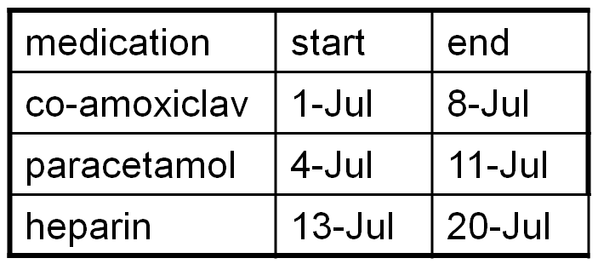

Figure B-1. Tabular Presentation of Current Medication

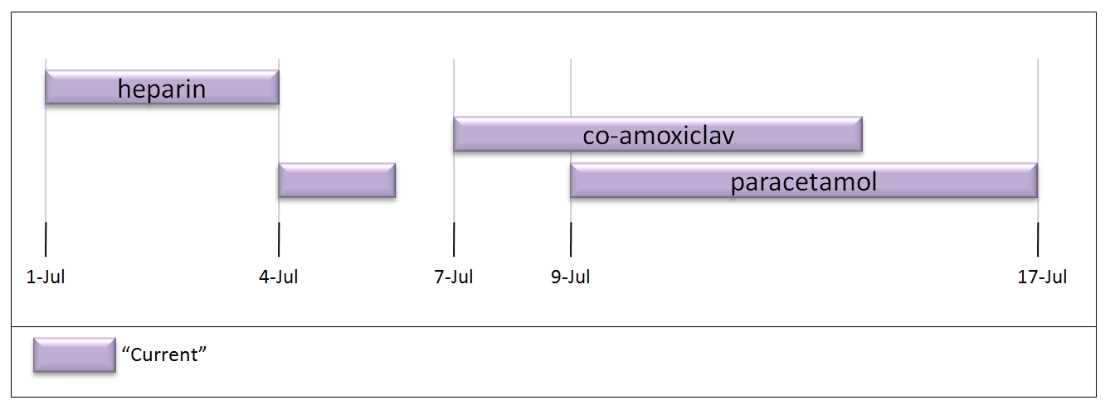

Figure B-1. Graph Presentation of Current Medication
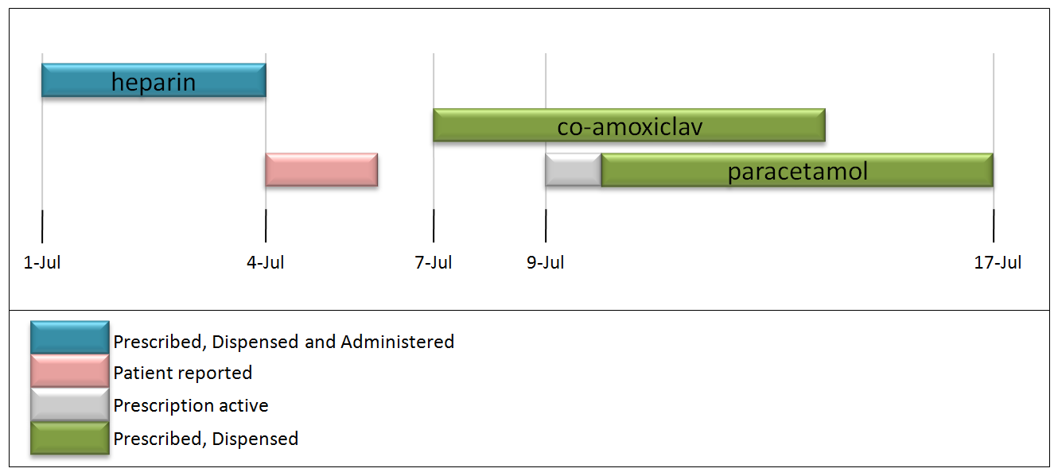
Figure B-1. Graph Presentation of Current Medication with medication status information

http://www.ihe.net/Technical_Framework/upload/IHE_PCC_Suppl_Reconciliation_Rev1-1_TI_2011-09-09.pdf
http://www.ihe.net/Technical_Framework/upload/IHE_ITI_TF_Rev8-0_Vol1_FT_2011-08-19.pdf
http://www.ihe.net/Technical_Framework/upload/IHE_PCC_TF_Rev7-0_Vol_2_2011-09-09.pdf
http://www.ihe.net/Technical_Framework/index.cfm#pcc
http://wiki.ihe.net/index.php?title=Pharmacy
http://www.hl7.org/v3ballot/html/domains/uvrx/uvrx.html
https://bit.ly/sdk2u7
http://lpd.epfl.ch/sgilbert/pubs/BrewersConjecture-SigAct.pdf
https://bit.ly/sdk2u7

