Web Meeting
- Every Friday noon EST to 1PM EST
- Phone Number: +1 770-657-9270
- Participant Passcode: 310940
- https://intuitcorp.webex.com/intuitcorp/j.php?J=595268449
Agenda for 04/26/2013 Meeting

  - Update to group on ballot reconciliation session with SWG on 04/25 (10AM EST Weekly Call)
    - 2 Comments were voted on
    - 10 Comments in a block vote
  - 15 min update added to the SWG Atlanta agenda on Tuesday Q1
    - Update on where we are
    - Next step and process to get next version of the IG
    - PGD consolidation into c-cda dstu
      - We would like to be integrated with c-cda in the evolution
- We have completed and reconciled all 95 Ballot comments
  - CONGRATULATIONS and Thank you for a concerted effort
  - It is time to celebrate!
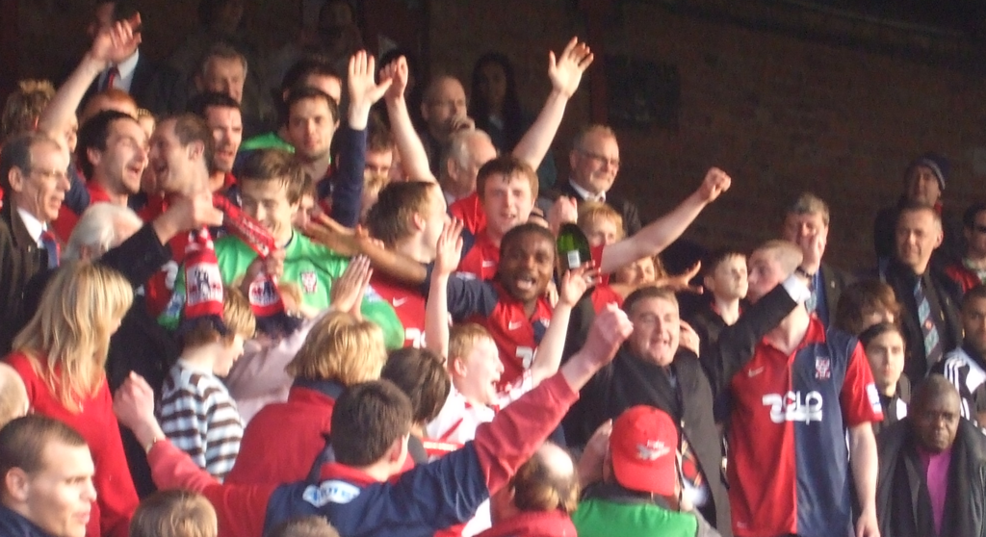

  - Next steps to get the reconciled version of the Implementation Guide
    - IG Update: Lisa, Jessi, and Virinder work together in 2 or three two hour sessions to get a define a new version of the implementation guide which incorporates all the comment dispositions
    - Updated IG Content Review / QA : Gordy/Shawn/Brian go thru the Updated IG to make sure the comments have been addressed as voted and written in the comment dispositions
    - Updated IG Style Review : Team C TBD will go thru the updated guide for style and give comments
- Meeting cancelled on May 3rd and May 10th. Next meeting on May 17th

