Initiative



Intersectoral communication

**ADDENDUM**

**LETTER TO THE DOCTOR V1.50**

**BASED ON THE**

**HL7 Clinical Document Architecture RELEASE 2**

**FOR THE GERMAN HEALTH**

**OF LABOR**

- Implementation Guide -

Version 1.00

As of 02.07.2007

Documents OID: 1.2.276.0.76.3.1.13.7.21

VHitG

**IMPLEMENTATION GUIDE**

**ADDENDUM TO THE MEDICAL LETTER V1.50**

**BASED ON THE**

**HL7 Clinical Document Architecture RELEASE 2**

**FOR THE GERMAN HEALTH OF LABOR**

presented by

**VHitG**

Office:

Association of producers of IT solutions for the healthcare VHitG Neustädtische Kirchstr. 6

10117 Berlin

*Contact*

Andrew Kassner (email: andreas.kassner @ vhitg.de) VHitG office

Kai U. Heitmann (email: hl7@kheitmann.nl) Heitmann Consulting and Services

SCIPHOX Arbeitsgemeinschaft GbR mbH eV HL7 user group in Germany

The content of this document is public. It should be noted that parts of this document on the voting package 11 and the Normative Edi-tion 2005 of HL7 version 3 is based, applies to HL7 Inc ©.

Disclaimer

Although this publication has been compiled with great care, the VHitG can not accept any liability for direct or indirect damage that may arise from the content of this specification.

**Document information**

**Status**

Final version

**Revision list**

|  |  |  |  |
| --- | --- | --- | --- |
| Version | Author | Content | Date |
| 12:10 | KH | Draft | 27-09-2006 |
| 00:20 | KH | Main portions | 29-09-2006 |
| 12:30 | KH | Graphics inserted finalized example fragments vervollstän-aged, text | 14-11-2006 |
| 00:50 | KH | Incorporated comments received intermediate | 05-12-2006 |
| 0.90 | KH | Comments incorporated, recommended supplements added to final document | 27-12-2006 |
| 0.95 | KH | Incorporation of the internal VHitG comments | 07-03-2007 |
| 0.97 | KH | Added Introduction | 12-04-2007 |
| 1:00 | KH | Final version | 02-07-2007 |
|  |  |  |  |
|  |  |  |  |
|  |  |  |  |
|  |  |  |  |
|  |  |  |  |
|  |  |  |  |
|  |  |  |  |
|  |  |  |  |
|  |  |  |  |
|  |  |  |  |
|  |  |  |  |
|  |  |  |  |
|  |  |  |  |
|  |  |  |  |
|  |  |  |  |

**Editors**

Kai U. Heitmann (KH), Heitmann Consulting and Services

Andrew Kassner (AK), VHitG e.V.

**Authors**

Kai U. Heitmann (KH), Heitmann Consulting and Services

**With contributions by**

René Spronk, Ringholm GmbH Erich Gehlen, Duria eG

Frank Oemig, Agfa HealthCare

**Authors and Copyright Notice, Terms of Use**

**Nachnutzungs or publication claims**

This document was developed by the Association of manufacturers of IT for the healthcare Industry (). The Nachnutzungs or publication rights are not limited.

The content of this specification is public.

It is based on the specifications of the working community SCIPHOX GbR mbH and the nationally adapted HL7 standard of "Clinical Document Architecture (CDA)".

Reader [http://www.sciphox.de,](http://www.sciphox.de/) [http://www.hl7.de](http://www.hl7.de/) and [http://www.hl7.org.](http://www.hl7.org/)

The extension or discharge of the specification, in whole or in part, the executive management of the Association and VHitG SCIPHOX GbR mbH is written Gen. anzuzei-

Also applies to all of the Arbeitsgemeinschaft GbR mbH SCIPHOX published CDA files with a reference:

All agreed and published by the Association SCIPHOX specifi-cations such as implementation guides, style sheets, and sample files are available for free and subject to any limitations, as the authors of all rights, which can be derived from the authorship of the documents without.

For details, see [http://www.sciphox.de,](http://www.sciphox.de/) [http://www.hl7.de](http://www.hl7.de/) and [http://www.hl7.org.](http://www.hl7.org/)

All adapted to national conditions and published SCIPHOX / CDA schemas can is used without license and usage fees in any type of application software.

From the use, no further claim against the VHitG and SCIPHOX GbR mbH results, for example, a liability for any damages arising from the use of specifications or the files provided.

**Table of Contents**

**Document information ................................................. ............... 4**

Status ................................................. .................................. 4

Revision History ................................................. ........................ 4

Authors ................................................. ................................ 5

With contributions by ............................................... .................... 5

**Authors and copyright notice, terms of use ...................... 6**

Nachnutzungs or publication claims ........................ 6

**Table of Contents ................................................. ........................ 7**

|  |  |  |
| --- | --- | --- |
| **1** | **Laboratory** | **values ​​................................................. .............................. 9** |
|  | 1.1 | Introduction ................................................. .................... 10 |
|  | 1.2 | Laboratory findings and results ........................................ 10 |

1.2.1 Laboratory findings in CDA Level 1/2 ........................................... .... 11

1.2.2 Laboratory results to CDA Level 3 ............................................ .... 14

1.2.3 Relationship between levels 2 and 3 in laboratory findings .......... 15

1.2.4 Class Observation ................................................ .................. 19

1.2.5 Grouping / array of laboratory values ​​.................................. 24

1.2.6 Reference values ​​(Class Observation Range) .................................. 25

1.2.7 Previous results ................................................ ......... 26

**2 Supporting documents ................................................ .... 27**

2.1 Sample Documents ................................................ ....... 28

2.2 LOINC codes for laboratory results ....................................... 28

2.3 Common laboratory findings Ucúm units ............... 28

**3 Appendix ................................................. .................................. 29**

3.1 References ................................................. .................. 30

3.1.1 Doctor's letter HL7 CDA Release 2 ............................................. ........ 30

3.1.2 General and HL7 ............................................... .................... 30

3.1.3 International specifications and generally to CDA Release 2 .... 30

3.1.4 Classification / terminology ............................................... . 30

**1Laborwerte**

**1.1 Introduction**

Focus of a medical laboratory activities include the clinics cal chemistry, microbiology, hematology and immunochemistry.

This Addendum "laboratory" is used for illustration of the laboratory results of the context of the electronic medical letter, for example, laboratory values ​​embedded in the inpatient discharge letters or specialist report structured to represent [cdar2arztbrief]. It allows to extend the existing doctor's letter Guidance on display on Level 3, so that a corresponding analysis of individual data on the receiver side is possible.

This description can serve as a basis for further concepts for La bordatenübermittlung, but is not suitable for the transmission of the so-called laboratory findings, such as those produced in laboratories.

In the following, the term "laboratory results" as a representation of an individual or a collection of several individual measurements used. The "assessment" under fachlichem point contains the subjectively collected by the physician physical and mental symptoms of a patient. As the quantitative results of the technical devices or microscopic analysis but also without a qualitative interpretation created by the doctor to make a diagnosis or other ärztli-chemical interventions, increasingly, the term "finding" is colloquially used synonymously with laboratory results.

**1.2 Laboratory findings and results**

Laboratory findings in terms of result summaries and ASSESSMENT-tions for in vitro analyzes, including microbiology samples are in the electronic discharge letter ideally

• tabulated in Level 1 & 2,

• coded to Level 3 and the corresponding result value and

Result unit specified.

As a rule, lab results, ie the individual measured values, even in highly structured form in the application system before, the narrative portion (eg, tabular representation) is therefore usually derived from the structured information. This is indicated by the @ type code DRIV (derived from) the entry element.

**<component>**

**<section>**

**<Code code = ... code system = ... />**

**<text>**

***Laboratory results in free text (eg, in tabular form)***

**</ Text>**

**<entry> typeCode="DRIV">**

**<observation> *structured laboratory values ​​(code and measuring value with unit, etc.)***

**...**

**</ Observation>**

**</ Entry>**

**</ Section>**

**</ Component>**

Laboratory results (individual values) are special forms of observations made (observation), so the corresponding RIM class from the CDA model is used for playback of Level 3 laboratory results.

***1.2.1 Laboratory findings in CDA Level 1/2***

Basically all the possibilities of textual design in level 1 and 2 are also available for lab results or findings are available. Since most laboratory values ​​already present in a structured form, they are frequently given in table form. Are common, in addition to the description of the tests, the laboratory measured value and its unit shall also include a standard value ranges with.

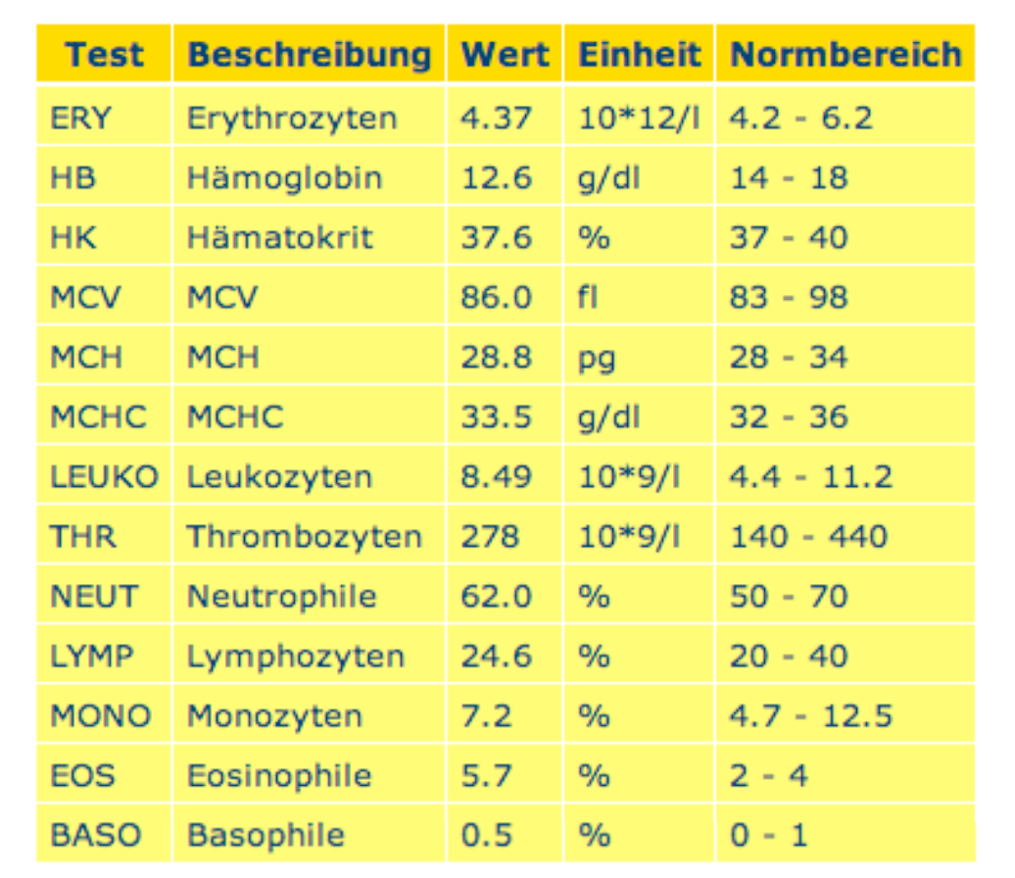

*Figure 1: Example of a tabular summary of laboratory values ​​with standard value ranges.*

**<section>**

**<code code="18723-7" codeSystem="2.16.840.1.113883.6.1" codeSystemName="LOINC"/>**

**<title> 24/09/2006: laboratory values ​​</ title>**

**<text>**

**<paragraph> We report briefly summarizes the**

**Laboratory results of the above patients. </ Paragraph>**

**<table border="1">**

**<thead>**

**<tr>**

**<th> test </ th>**

**<th> Description </ th>**

**<th> value </ th>**

**<th> unit </ th>**

**<th> normal range </ th>**

**</ Tr>**

**</ Thead>**

**<tbody>**

**<tr>**

**<td> ERY </ td>**

**<td> erythrocyte </ td>**

**<td> 4:37 </ td>**

**<td> 10 * 12 / l </ td>**

**<td> 4.2 - 6.2 </ td>**

**</ Tr>**

**<tr>**

**<td> HB </ td>**

**<td> hemoglobin </ td>**

**<td> 12.6 </ td>**

**<td> g / dl </ td>**

**<td> 14-18 </ td>**

**</ Tr>**

**...**

**</ Tbody>**

**</ Table>**

**</ Text>**

**...**

**</ Section>**

Also for the textual representation of laboratory values ​​in the course of which a table is good.

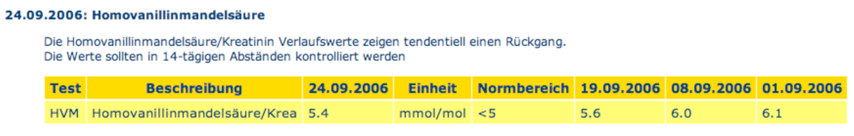

*Figure 2: Table showing the course of a laboratory value with*

*Standard value ranges.*

**<section>**

**<code code="18723-7" codeSystem="2.16.840.1.113883.6.1" codeSystemName="LOINC"/>**

**<title> 24/09/2006: Homovanillinmandelsäure </ title>**

**<text>**

**The <paragraph> Homovanillinmandelsäure / creatinine values ​​during a show tends to decrease. <br/> The values ​​should be in**

**14-day intervals are controlled </ paragraph>**

**<table border="1">**

**<thead>**

**<tr>**

**<th> test </ th>**

**<th> Description </ th>**

**<th> 24/09/2006 </ th>**

**<th> unit </ th>**

**<th> normal range </ th>**

**<th> 19.09.2006 </ th>**

**<th> 08.09.2006 </ th>**

**<th> 01.09.2006 </ th>**

**</ Tr>**

**</ Thead>**

**<tbody>**

**<tr>**

**<td> HVM </ td>**

**<td> Homovanillinmandelsäure / creatinine </ td>**

**<td> <content ID="LAB20060924090"> 5.4 </ content> </ td>**

**<td> mmol / mol </ td>**

**<td> <5 </ td>**

**<td> <content ID="LAB20060924089"> 5.6 </ content> </ td>**

**<td> <content ID="LAB20060924056"> 6.0 </ content> </ td>**

**<td> <content ID="LAB20060924045"> 6.1 </ content> </ td>**

**</ Tr>**

**</ Tbody>**

**</ Table>**

**</ Text>**

**</ Section>**

Reference should be made to the Level 3 constructs (see next section), is a referencing on the content element possible (see Letter physician Guide [cdar2arztbrief] and the next section in this document). Here, the actual measured value should be provided with the markup. In this way it is also possible to provide a plurality of measured values ​​in a table with the reference.

When used as a type of linking between text entry and driv - and that's in laboratory values ​​usually the case - this Verlinkun-tions are not strictly necessary, since the text is indeed derived from the decision-factories. Basically, the text enclosed by the element content should be able to act as a Level 3 original observation.

***1.2.2 Laboratory results to CDA Level 3***

Laboratory results are special forms of observations (observation), so the corresponding RIM class from the CDA model is used for playback of Level 3 laboratory results.

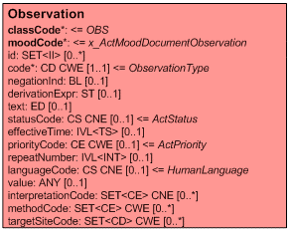

*Figure 3: Observation of the CDA class model for specifying structured laboratory results.*

Unlike the doctor diagnoses described in letter-Guide [cdar2arztbrief] is not only the class observation of importance when it comes to the representation of laboratory tests. Rather, together arrangements and associated test sets (batteries) me-aning of laboratory results, which will also be played back using the Level 3 constructs.

These can be combined in a corresponding manner. There are three

States are distinguished:

• A battery of test results, such as "blood count"

or "Clinical Chemistry",

• An individual test, such as "glucose tolerance test",

• A full investigation / analysis of the sample as in microbiology found.

For hierarchical "organization" of the findings, the organizer of the class CDA Entries serves.

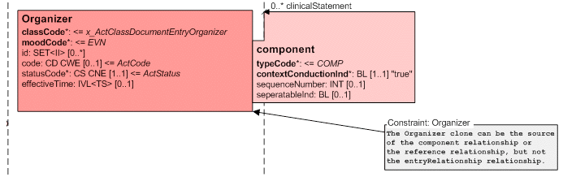

*Figure 4: Organizer of the CDA class model for structuring*

*Laboratory values.*

It may also be necessary, for example, reference ranges (normal malwerte etc.) can specify. The required classes are described in connection below.

***1.2.3 Relationship between Level 2 and 3 in laboratory findings***

As described for level 2 (see above), sections can at level 1 or 2, either whole series of specialized results include or be but itself hierarchically arranged. Level 1 or 2 contains the free text with the finding, while Level 3 structures the measured values ​​and are coded again. To classify the results at level 3 LOINC codes are used.

In the Entry section then is the collection of batteries (Organizer)

or individual values.

The following figure shows the relationship between Level 1/2 and the corresponding level 3 classes.

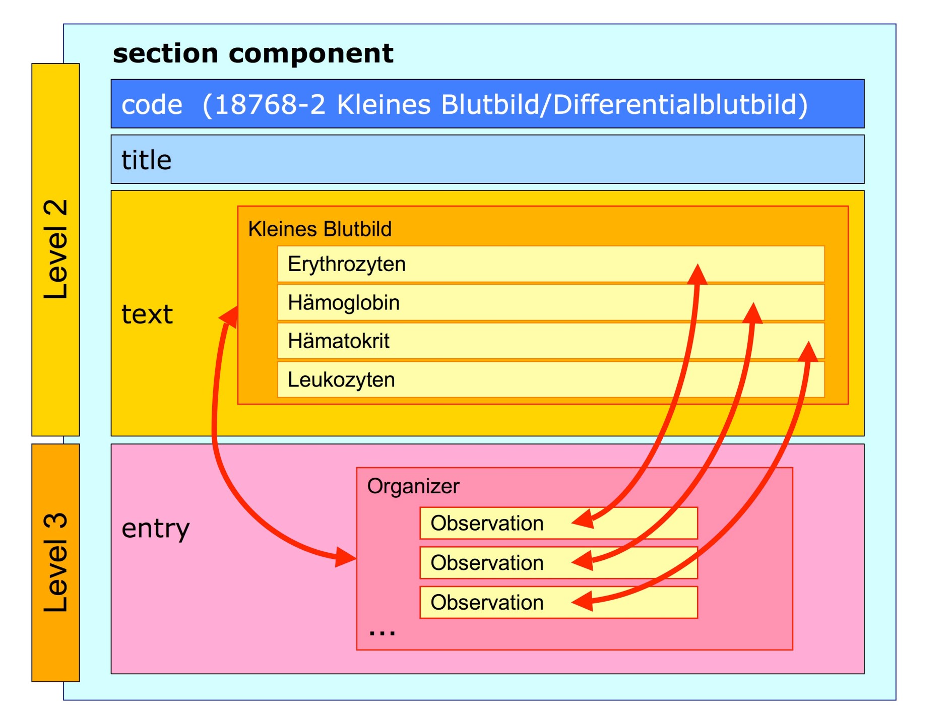

*Figure 5: Relationship between Level 2 and Level 3 laboratory ventilation found, here is a "battery" complete blood count and some of the individual result-se the entry of all levels are listed three elements, ie the collection of batteries (Organizer) or individual values .*

In XML, the level 3 shown above provides Entry example, as follows. This is manufactured from the nesting of classes Organizer and observation. For completeness, each also with a reference range specified, which is explained in Section 1.2.6.

**<entry>**

**<organizer classCode="BATTERY" moodCode="EVN">**

**<code code="24317-2" codeSystem="2.16.840.1.113883.6.1" codeSystemName="LOINC" displayName="Vollständiges Blutbild"/>**

**<statusCode code="completed"/>**

**<effectiveTime value="200609241025"/>**

**<component>**

**<observation classCode="OBS" moodCode="EVN">**

**<code code="789-8" codeSystem="2.16.840.1.113883.6.1" codeSystemName="LOINC" displayName="ERY Erythrozyten"/>**

**<statusCode code="completed"/>**

**<effectiveTime>**

**<Center value="200609241025"/>**

**</ Effective time>**

**<value xsi:type="PQ" value="4.37" unit="10*12/l"/>**

**<interpretationCode code="N" codeSystem="2.16.840.1.113883.5.83"/>**

**<referenceRange>**

**<observationRange>**

**<value xsi:type="IVL_PQ">**

**<LOW value="4.2" unit="10*12/l"/>**

**<high ​​value="6.2" unit="10*12/l"/>**

**</ Value>**

**<interpretationCode code="N" codeSystem="2.16.840.1.113883.5.83"/>**

**</ Observation range>**

**</ Reference range>**

**</ Observation>**

**</ Component>**

**<component>**

**<observation classCode="OBS" moodCode="EVN">**

**<code code="718-7" codeSystem="2.16.840.1.113883.6.1" codeSystemName="LOINC" displayName="HB Hämoglobin"/>**

**<statusCode code="completed"/>**

**<effectiveTime>**

**<Center value="200609241025"/>**

**</ Effective time>**

**<value xsi:type="PQ" value="12.6" unit="g/dl"/>**

**<interpretationCode code="N" codeSystem="2.16.840.1.113883.5.83"/>**

**<referenceRange>**

**<observationRange>**

**<value xsi:type="IVL_PQ">**

**<LOW value="14" unit="g/dl"/>**

**<high ​​value="18" unit="g/dl"/>**

**</ Value>**

**<interpretationCode code="N" codeSystem="2.16.840.1.113883.5.83"/>**

**</ Observation range>**

**</ Reference range>**

**</ Observation>**

**</ Component>**

**<component>**

**<observation classCode="OBS" moodCode="EVN">**

**<code code="4544-3" codeSystem="2.16.840.1.113883.6.1" codeSystemName="LOINC" displayName="HK Hämatokrit"/>**

**<statusCode code="completed"/>**

**<effectiveTime>**

**<Center value="200609241025"/>**

**</ Effective time>**

**<value xsi:type="PQ" value="37.6" unit="%"/>**

**<referenceRange>**

**<observationRange>**

**<value xsi:type="IVL_PQ">**

**<LOW value="37" unit="%"/>**

**<high ​​value="40" unit="%"/>**

**</ Value>**

**<interpretationCode code="N" codeSystem="2.16.840.1.113883.5.83"/>**

**</ Observation range>**

**</ Reference range>**

**</ Observation>**

**</ Component>**

**<component>**

**<observation classCode="OBS" moodCode="EVN">**

**<id extension="LAB200609241234.6520.GPT" root="2.16.840.1.113883.2.6.234.93345"/>**

**<code code="11156-7" codeSystem="2.16.840.1.113883.6.1" codeSystemName="LOINC" displayName="LEUKO Leukozyten"/>**

**<statusCode code="completed"/>**

**<effectiveTime>**

**<Center value="200609241025"/>**

**</ Effective time>**

**<value xsi:type="PQ" value="8.49" unit="10*9/l"/>**

**<interpretationCode code="N" codeSystem="2.16.840.1.113883.5.83"/>**

**<referenceRange>**

**<observationRange>**

**<value xsi:type="IVL_PQ">**

**<LOW value="4.4" unit="10*9/l"/>**

**<high ​​value="11.2" unit="10*9/l"/>**

**</ Value>**

**<Code code interpretation = "N"**

**code system = "2.16.840.1.113883.5.83" />**

**</ Observation range>**

**</ Reference range>**

**</ Observation>**

**</ Component>**

**</ Organizer>**

**</ Entry>**

***1.2.4 Class Observation***

The class observation carries the actual laboratory results (individual readings). The following attributes are of importance.

*class code ................................................. ........... Class code <= OBS*

The @ class code specified here is always lab results OBS (observation), as it always is an event observation.

*mood code ................................................. Mood ........... Code <= EVN*

@ The mood code of specified herein laboratory results is always EVN (Event), since it is always an observation event. (Laboratory requirements, for example, are not the subject of a CDA document.)

*id ............................................... Laboratory result identification number*

*SET <II> [0. *]*

It is recommended to assign each individual findings of a laboratory result in a system tele-identification (II). For a specific individual laboratory findings communication is possible, for example, the unambiguous assignment of individual results.

*code ................................................. Laboratory findings ........ classification*

*CD CWE [1 .1]*

This type of laboratory results is classified. LOINC codes are used to identify the individual findings. A small compilation can be found in the following table, an overall overview of the LOINC codes for Laboratory can be found in the "Suppor-ting Documents" (see the Appendix).

|  |  |  |  |
| --- | --- | --- | --- |
| **Code** | **LOINC identifiers** | **System / method** | **Explanation** |
| 789-8 | ERYTHROCYTES | Blood / Machine | Erythrocytes |
| 4544-3 | Hematocrit | Blood / Machine | Hematocrit |
| 718-7 | HEMOGLOBIN | Blood / Machine | Hemoglobin |
| 11156-7 | Leukocytes | Blood / Machine | Leukocytes |
| 731-0 | LYMPHOCYTES | Blood / Machine | Lymphocytes |
| 777-3 | PLATELETS | Blood / Machine | Platelets |
| 6298-4 | POTASSIUM | Blood | Potassium |
| 2947-0 | SODIUM | Blood | Sodium |
| 22664-7 | UREA | Serum / plasma | Urea |
| 13951-9 | HEPATITIS A VIRUS AB | Serum | Hepatitis A Virus Antibody |
| 5187-0 | HEPATITIS B VIRUS CORE AB | Serum / Micro  EIA | Hepatitis A virus core anti-body |

*Table 1: LOINC codes (excerpt as an example) for laboratory findings*

*negationInd ................................................. negation indicator .........*

*BL [0 to 1]*

The @ negationInd shows when it is set to true to indicate that the observa-tion is denied / denied. In the context of laboratory results, this means that the laboratory examination was not carried out and about this on this way testimony is to be stored. The model attribute

@ NegationInd than structural attributes in the root element of the observation

found (see below). The default value is false.

*text ................................ Supplementary Notes to the laboratory result*

*ED [0 to 1]*

This additional (more detailed) explanation of the laboratory result can be specified, if any.

Please note: This is not a free text to the Labor Code (see above). This is found in the displayName attribute of the @ lab code again.

*status code ............................. status code <= active | completed | aborted*

*CS CNE [0 to 1]*

The status code of laboratory results can take on the following states to reflect what degree completion, the laboratory examination. Not all status information is necessary in the context of the doctor's letter, usually laboratory results are only communicated when they are completed and released, ie as a summary of a pre-viously received laboratory results. But it can Kurzentlassbriefe

Make sense to specify that a single laboratory result is required, but there is no result (and this is replenished).

|  |  |  |
| --- | --- | --- |
| **Code** | **Meaning** | **Explanation** |
| active | active, even in editing | when a measured value is indicated, this means that this is provisionally |
| completed | completed | Laboratory result is available and is released (end-valid), complete, completed |
| aborted | canceled | Laboratory investigation was terminated |

*Table 2: valid status codes for laboratory results*

Note 1: If a measurement has not yet been determined, the status code can be set to active and the element value is indicated that the value is unknown (zero flavor @ = NAV value see below).

Note 2: The status code is obsolete, as nullfied, not used in the letter context because it always represent snapshots. These are only necessary eg for process control laboratory.

Note 3: The status of all laboratory findings arises from the fact that all individual values ​​must have the status completed, even before all the findings as a whole is completed. While the findings are preliminary, as some laboratory results are incomplete. A preliminary finding is the overall status code = active in the Clinical Document class expressed, because yes, the entire document is still in the editing.

*effective time ................................................. Time specified laboratory findings*

*TS [0 to 1]*

Time indicating the clinical relevance of laboratory findings. This should be in the

Its usually the time of collection of the sample.

*value ................................................. ................................ laboratory value*

*ANY [0 to 1]*

The actual measured value and the laboratory results are communicated in e-lement value. In general, it will be here by physical measurements, the corresponding HL7 V3 data type is PQ (physical quanti-ty). In other cases, textual description, code (susceptibility ity / sensitivity in microbiology findings) or combinations thereof are required.

If it is a physical measure, for example'm hemoglobin value 13.4 g / dl, this will be in HL7 V3 with the PQ data type specified. To the original data type (ANY) is demoted type moderately

(Demotion) by the xsi: type statement. Here, the value element contains a @ value attribute for the measured value and a @ unit attribute. The above example looks like this in XML.

**<observation classCode="OBS" moodCode="EVN">**

**...**

**<value xsi:type="PQ" value="13.4" unit="g/dl"/>**

**...**

**</ Observation>**

Special feature here is the specification of the unit (unit). In HL7 V3, the Unified Code of Units of Measure (Ucúm) here mandatory system must be used (see also [hl7mcg], [ucumau], [ucumjamia]). The Ucúm system offers a unique spelling of units and conversion of units with each invoice. It represents a code system for all units in science, technology, business and management, which are currently used in practice. The focus is by electronic data exchange and processing of applications - not necessarily on communication between people. It is a one-integral, complete and unique code system for all units with defined associated semantics and consists of basic units-derived units, prefixes and the associated rules for the production of units including opportunities for multiplication, division, exponentiation tion and bracketing .

To simplify the handling of Ucúm Ucúm are the most important units in the "Supporting Documents" summarized (see Appendix).

Missing values, for example because they have not yet determined this must be made explicit and the value element with the

*@ Null flavor* Attribute (NAV temporarily unavailable) are expressed ge-introduced.

**<observation classCode="OBS" moodCode="EVN">**

**...**

**<statusCode code="active"/>**

**...**

**<value nullFlavor="NAV"/>**

**...**

**</ Observation>**

*interpretation code ..................................... Assessment of Outcomes*

*CE CNE [0. *]*

Interpretation of the code contains information on the evaluation of laboratory results Nisses, for example whether it is a normal value too low or too high. This is reacted with the HL7 vocabulary ObservationIn-interpretation expression shown in the following table.

|  |  |  |  |
| --- | --- | --- | --- |
| **Code** | **Meaning** | **German** | **Explanation** |
| Laboratory values | | | |
| N | Normal | Normal | Normal value (all scale levels) |
| H | High | High | too high (for quantitative measurement values) |
| L | Low | Low | too low (for quantitative measurement values) |
| A | Abnormal | Abnormal | For all nominal values |
| Sensitivity information Microbiology | | | |
| I | intermediate | intermediate |  |
| MS | moderately sus-ceptible | moderate sensitivity |  |
| R | resistant | resistant |  |
| S | susceptible | sensitive |  |
| VS | very susceptible | highly sensitive |  |

*Table 3: Vocabulary domain (excerpt as an example) for ObservationInterpre-tion (OID: 2.16.840.1.113883.5.83) for laboratory and Mikrobiologiebefun de-*

**<observation classCode="OBS" moodCode="EVN">**

**<code code="787-2" codeSystem="2.16.840.1.113883.6.1" codeSystemName="LOINC" displayName="MCV">**

**<originalText>**

**<reference value="#LAB20060924004"/>**

**</ Original>**

**</ Code>**

**<statusCode code="completed"/>**

**<effectiveTime>**

**<Center value="200609241025"/>**

**</ Effective time>**

**<value xsi:type="PQ" value="86.0" unit="fl"/>**

**<interpretationCode code="N" codeSystem="2.16.840.1.113883.5.83"/>**

**</ Observation>**

*method code .............................................. Classification of the method*

*CE CWE [0. *]*

If necessary, the method for laboratory testing can be speci-fied in the coding method code. The corresponding HL7 vocabulary domain is ob-servationMethod. With LOINC codes, the method is usually included in the code Ten.

***1.2.5 Grouping / array of laboratory values***

For example grouping of laboratory values Batteries for the Organizer class is used.

*class code ................................................. ... Class code <= BATTERY mood code ............................................. Mood ............... Code <= EVN* The @ class code specified here is always BATTERY laboratory findings,

@ mood of the code always EVN (Event).

*code ................................................. Laboratory findings ........ classification*

*CD CWE [1 .1]*

This type of grouping of results is classified, for example,

"Blood count" or "Clinical Chemistry". It will be used to identify LOINC codes. An overview of the LOINC codes for Laboratory can be found in the "Supporting Documents" (see section in Appendix).

*status code ............................. status code <= active | completed | aborted*

*CS CNE [0 to 1]*

The status code of laboratory results can take on the following states to reflect what degree completion, the laboratory examination.

*effective time ................................................. Time specified laboratory findings*

*TS [0 to 1]*

Time indicating the clinical relevance of laboratory findings. This should be in the

Its usually the time of collection of the sample.

*component ................................................. Act-Relationship ...... [0. *]*

The actual lab result and its reference value are connected via the referential renceRange with @ typeCode REFV (reference value) connected to.

***1.2.6 Reference Values ​​(Class Observation Range)***

To specify reference values ​​that reflect, for example, standard value ranges che, class observation range is used, which depends directly on the Observation class. With its standard value ranges are given as intervals of physical measurements.

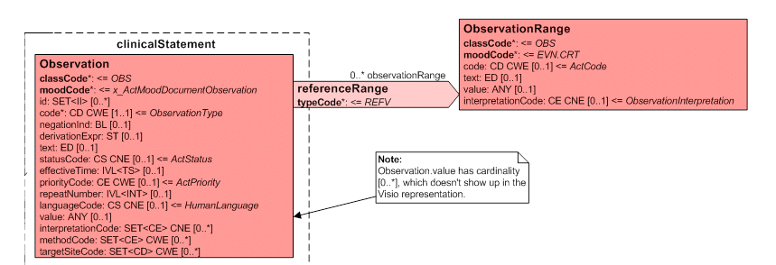

*Figure 6: Observation of the CDA class model with respect to re-fenz laboratory values.*

*reference range ................................................. Relationship Act [0. *]*

The actual lab result and its reference value are connected via the referential renceRange with @ typeCode REFV (reference value) connected to.

*class code ................................................. .......... Class code <= OBS*

*mood code ................................................. .... Mood Code <= EVN.CRT*

As @ class code here is constant OBS (observation) indicated. The

*@ Mood code* an observation as a reference value is always EVN.CRT (Criterion E-vent), because it is always a criterion for a monitoring event.

*value ................................................. ................................ laboratory value*

*ANY [0 to 1]*

In the value of the reference range is indicated, for example, an interval of physical measurement variables (IVL_PQ). In this case, even if only to the upper or lower limits corresponding un-reproduced in order, for example,

To bring "<5" as a reference region for expression.

*interpretation code ............................. assessment of the result <= N CE [1 .1]*

Interpretation of the code is required to set constant to "N" for normal here, because it is always to normal values ​​at reference values.

**<observation classCode="OBS" moodCode="EVN">**

**<code code="787-2" codeSystem="2.16.840.1.113883.6.1" codeSystemName="LOINC" displayName="MCV MCV">**

**<originalText>**

**<reference value="#LAB20060924004"/>**

**</ Original>**

**</ Code>**

**<statusCode code="completed"/>**

**<effectiveTime>**

**<Center value="200609241025"/>**

**</ Effective time>**

**<value xsi:type="PQ" value="86.0" unit="fl"/>**

**<interpretationCode code="N" codeSystem="2.16.840.1.113883.5.83"/>**

**<referenceRange>**

**<observationRange>**

**<value xsi:type="IVL_PQ">**

**<LOW value="83" unit="fl"/>**

**<high ​​value="98" unit="fl"/>**

**</ Value>**

**<interpretationCode code="N" codeSystem="2.16.840.1.113883.5.83"/>**

**</ Observation range>**

**</ Reference range>**

**</ Observation>**

***1.2.7 Previous results***

In a medical report relating to previous laboratory results is not provided.

**2Unterstützende**

**Documents**

This section is not normative.

**2.1 Sample Documents**

To the example presented in this guide fragments laboratory and

Medication, there are sample XML instance documents as CDA.

• **VHitG POCD_EX000007.xml,** contains information in accordance with the guidelines set out in Chapter laboratory.

Each with the style sheet (see below) rendered version is e-likewise attached to the suffix. Html.

**2.2 LOINC codes for laboratory results**

It is a Microsoft Excel Spreadsheet **LOINCLabcodes200611.xls** annexed to the main LOINC codes used in Germany contains.

**2.3 Common Ucúm units for laboratory findings**

There is a list of the most important Ucúm units for use in healthcare Germans in Ucúm folder attached (CommonlyUsedUCUM- **Codes).**

**3Anhang**

This section is not normative.

**3.1 References**

***3.1.1 Doctor's letter HL7 CDA Release 2***

[Cdar2arztbrief]

Doctor's letter based on the HL7 Clinical Document Architecture Release 2 for the German health care, Version 1.50 from 12.05.2006, issued by VHitG, HL7 German country and the Working Group SCIPHOX

***3.1.2 General and HL7***

[Dtcmetv3-hl7de]

HL7 version 3 data types and for the German CMETS the health sector, [www.hl7.de](http://www.hl7.de/) (Publications)

***3.1.3 International specifications and generally CDA re-lease 2***

[Ihelab] IHE Laboratory Technical Framework Supplement "Sharing Laboratory Reports (XDS-LAB)" dated 14 September 2006. http:// [www.ihe.net](http://www.ihe.net/)

***3.1.4 Classifications / terminologies***

[Hl7mcg] C. Gessner: Coding of units of physical measurement variables with Ucúm (Unified Code for Units of Measure). With HL7 departments 21/2006, 6-17.

[Ucumau] definition: <http://aurora.rg.iupui.edu/UCUM/ucum.html><http://aurora.regenstrief.org/UCUM/><http://aurora.regenstrief.org/UCUM/UCUM.pdf>(Old version

1.4b)

[Ucumjamia] Schadow G, McDonald CJ, Suico J, Föhring U, T Tolxdorff: Units of Measure in Clinical Information Systems. J Am Med Inform Assoc.1999, 6: 151-161.<http://www.jamia.org/cgi/content/abstract/6/2/151>