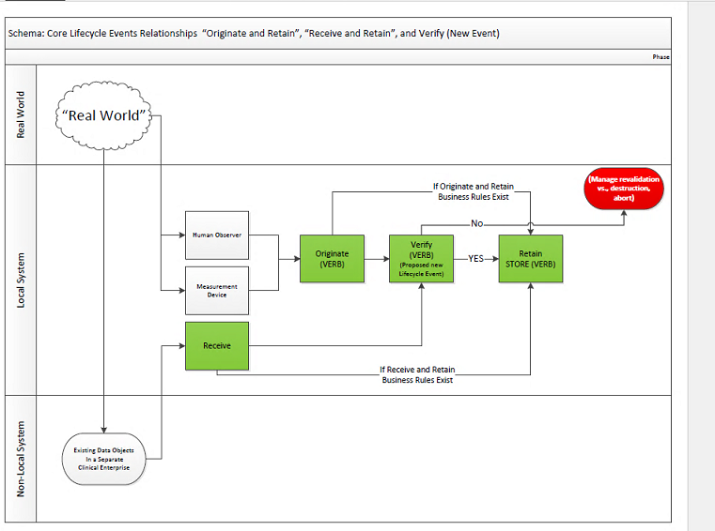

Originate
Originate (v) | Definition:  To initiate entry of data objects as potential content for an EHR record. Contrast with "To Receive." | Pre-Conditions:  - Originator has logged into the EHR system.  - Agent has “Create” Permission  Process:  - At T_{0,} Agent selects “create.”  - The object is defined, iterated.  - At T₁, iteration is complete (0)  Post-event Options  - Discard object 0  - Verify and/or Validate object 0  - Retain object 0  Key:  0 represents a transient object.  A represents an object that has been retained in the system.  A’ represents iterations of A. | "To Originate" is an action within EHR Records Management. "To Originate" includes the option of an interim state that permits an intermediate assessment of new data or data objects prior to commitment to long-term management. That intermediate assessment is intended to determine whether to store the initially captured data or data objects or to destroy them as ephemera or a rejected draft. "To Originate" may include the use of volatile memory or other means which offer a temporary cache or cache-like status for the interim state.  Properties:  1. New data object  2. Potential, interim status (or State)
Ontological View:
1.2.2 Class: <provisional> EHR Records Management
1.2.3 Class differentiating characteristics are "new" and "potential" content, an interim state to be acted on (ex: To Verify or To Store or To Dispose/Destroy)

*See Notes, Item 1. The text is included to provisionally identify a Class termed "EHR Records Management" to which the verb action belongs, in conformance with our draft style sheet and guidelines for definitions.

Receive

Receive (v) | Definition:  To acquire data objects that existed elsewhere for potential inclusion in an EHR record. Contrast with Originate.  The act of reproducing at one point either exactly or approximately a message selected at another point. [Derived from a quote from Claude Shannon] | Pre-conditions:  - Communications channels between sender and receiver are open and available  Process:  - At T₀, object M is presented to receiver.  - At T₁ Object M is copied into the message space as M’.  - At T₁, copy is complete and temporary object 0 is available in receiver’s address space.  Post-event options  - Discard Object M’  - Copy M’ into receiver’s address space as O.  - Verify and/or Validate object O.  - Retain O.  - Send return receipt. | Extended Definition:  "To Receive" is an action within EHR Records Management "To Receive" includes the option of an interim state that permits an intermediate assessment of data or data objects that existed elsewhere and is conveyed for consideration for commitment to long-term management. That intermediate assessment is intended to determine whether to store the initially captured data or data objects or to destroy them as ephemera or a rejected data or data object. "To Receive" may include the use of volatile memory or other other means which offer a temporary cache or cache-like status for the interim state.  Properties:  1. Existing data object from sender is used in a message.  2. Object received resides exclusively in the receiver’s message space as M’.  3. Data object M’ is opened and introduced into the receiver's temporary address space as object O.  Question: is M considered “received” once it reaches the receiver’s message space or does it need to be opened and introduced into the receiver’s temporary address space? Once it is opened, it could then be considered an O. Is it possible that M’ only exists within the “Receive” function (inside the box) and is not the final output? If yes, then at T_{1,} the object should be O.
Ontological View:
1.2.2 Provisional Class: <EHR> Records Management
1.2.3 Differentiating characteristics are "existing" and "potential" content, an interim state to be acted on (ex: To Verify or To Store or To Dispose/Destroy)
*See Notes, Item 1. The text is included to identify a Class to which the verb belongs, in conformance with our draft style sheet and guidelines for definitions.

Verify
Verify (v) | Definitions:  - To evaluate the compliance of data objects with regulations, requirements, specifications, or other internally imposed conditions based on organizational policy. Contrast with validate.  - To affirm the compliance of data or data objects with specified trust qualifications. Contrast with To Attest | Pre-Conditions:  - Data object has been originated/received (0) or retained (A)  Process:  - At T₀, an object is selected for verification.  - Object parameters are compared with internal specifications.  - At T₁, a result is returned that if comparison is successful, object(s) is verified, else verification failed.  Post-event Options  - Discard Object 0  - Retain object A | Extended Definition  Properties:  - Can be performed on an interim or retained object.  - Uses internally imposed criteria.  - Returns a result that shows success or failure of verification.  Note: How the verification attribute is bound to the object is a business decision.
 | Ontological View

Validate
Validate (v): | Definitions:  to confirm that the contents of data objects meet the needs of identified stakeholders (i.e., healthcare providers, patients). Contrast with verify. [Derived from PMBOK definition of validation.] | Pre-Conditions:  - Data object has been originated/received (0) or retained (A)  Process:  - At T₀, an object is selected for verification.  - Object parameters are compared with external specifications.  - At T₁, a results are returned that if comparison is successful, object(s) is validated, else validation failed.  Post-event Options  - Discard Object 0  - Retain object A | Extended Definition  Properties:  - Can be performed on an interim or retained object.  - Uses externally imposed criteria.  - Returns a result that shows success or failure of validation.  Note: How the validation attribute is bound to the object is a business decision.
 | Ontological View

Retain

Retain (v) | Definition:  To persist data or data objects by saving onto electronically accessible devices. | Pre-Conditions:  - An object 0 exists or an object A exists which needs to be re-saved.  Process:  - At T₀, object is selected and space is opened in memory.  - Object is written to and manipulated in memory.  - Object is placed in a permanent storage location.  - At T₁, data object has been persisted as a new EHR information object with a designation, object A’.  Post-event Options  - Object A’ available for use | Extended Definition  Properties:  - Can be performed on any object, whether previously retained or not.  - Multiple actions can be performed on attributes of the object during the retention process, such as:  - Change of name  - Updates to provenance (eg: last agent who saved/modified object)  - Change of storage location  - Change of time stamp  - Is performed on objects in memory.  - Final results are written to designated storage location.
 | Ontological View

