**HL7 Patient Care Work Group**

**Allergy/Intolerance/Adverse Reaction Topic Sub-Group Meeting Minutes**

**Date: June 28, 2012**

Co-Chairs: Stephen Chu, Hugh Leslie, Elaine Ayres Scribe: Elaine Ayres

|  |  |  |  |
| --- | --- | --- | --- |
| **Name** | **Organization** | **E-mail** | **Present on 6/28/12** |
| Elaine Ayres | Academy of Nutrition and Dietetics/NIH | eayres@nih.gov | X |
| Andre Boudreau | Boroan, Canada | a.boudreau@boroan.ca |  |
| Stephen Chu | NEHTA | Stephen.Chu@nehta.gov.au | X |
| Kevin Coonan |  | kevin.coonan@gmail.com | X |
| Margaret Dittloff | Academy of Nutrition and Dietetics/CBORD | mkd@cbord.com |  |
| Jean Duteau | Gordon Point Informatics | jean.duteau@gpinformatics.com | X |
| Adel Ghlamallah | Canada Health Infoway | aghlamallah@infoway.ca |  |
| Maggie Gilligan | Academy of Nutrition and Dietetics | mmgilligan@gmail.com |  |
| Peter Harrison | McKesson |  |  |
| Kai Heitmann | HL7 Germany | HL7@kheitmann.de |  |
| Wendy Huang | Canada Infoway | whuang@infoway.ca |  |
| Steve Hufnagel | US DOD | Stephen.Hufnage.ctrl@tma.osd.mil |  |
| Tom de Jong | HL7 Netherlands | tom@nova-pro.nl |  |
| Hugh Leslie | Ocean Informatics, Australia | Hugh.leslie@oceaninformatics.com |  |
| Russell Leftwich | Office of eHealth Initiatives, Tennessee | [Russell.Leftwich@tn.gov] |  |
| Masaharu Obayashi | HL7 Japan | obayashi@metacube.jp |  |
| Richard Sakakura |  | 'richard.sakakura@stjoe.org' |  |
| Carolyn Silzle | Academy of Nutrition and Dietetics | Carolyn.silzle@choa.org |  |
| John Snyder | Academy of Nutrition and Dietetics | jwsnyder@nutrioffice.biz |  |
| Lise Stephens | US FDA | Lise.stevens@fda.hhs.gov | X |
| Michael Tan | Nictiz | tan@nictiz.nl |  |
| Cathy Welsh | St. Judes |  |  |
| Ben Loy |  |  |  |
| Bill Gregory | Patient Safety | grego@pfizer.com |  |
| Erin Fields | FDA |  | X |
| Leslie Tompkins | FDA |  | X |
| Terrie Reed | FDA |  |  |
|  |  |  |  |

**Agenda for Thursday, June 28, 2012**

1. Review agenda for meeting and add other issues as needed
2. Review and approve the minutes for June 14, 2012 meeting
3. Allergy/Intolerance categorization - Kevin
4. Review of current concept model - Jean
5. Review assigned use cases
6. Plan the agenda for the next conference call on July 12.

**Minutes** –

Minutes of the *June 14, 2012* conference call –

Motion: Stephen/Jean Abstain –0 , No – 0 , Yes - 6

**Review Allergy/Intolerance analysis– Kevin Coonan**

Kevin outlined a number of mechanisms that can trigger an allergic or non-allergic reaction.



He noted that an exposure to a substance has the propensity to create a clinical manifestation. These triggers can be tracked via the health concern. It was also noted that diagnostic studies are needed to further evaluate the observed manifestation. This type of model also makes classification by the propensity to a reaction possible with subclasses of mechanisms and the potential reactions possible.

**Review update to conceptual model - Jean Duteau**

Jean noted that Kevin’s work informs the current conceptual model. The conceptual model has been reworked by Jean into the format below:

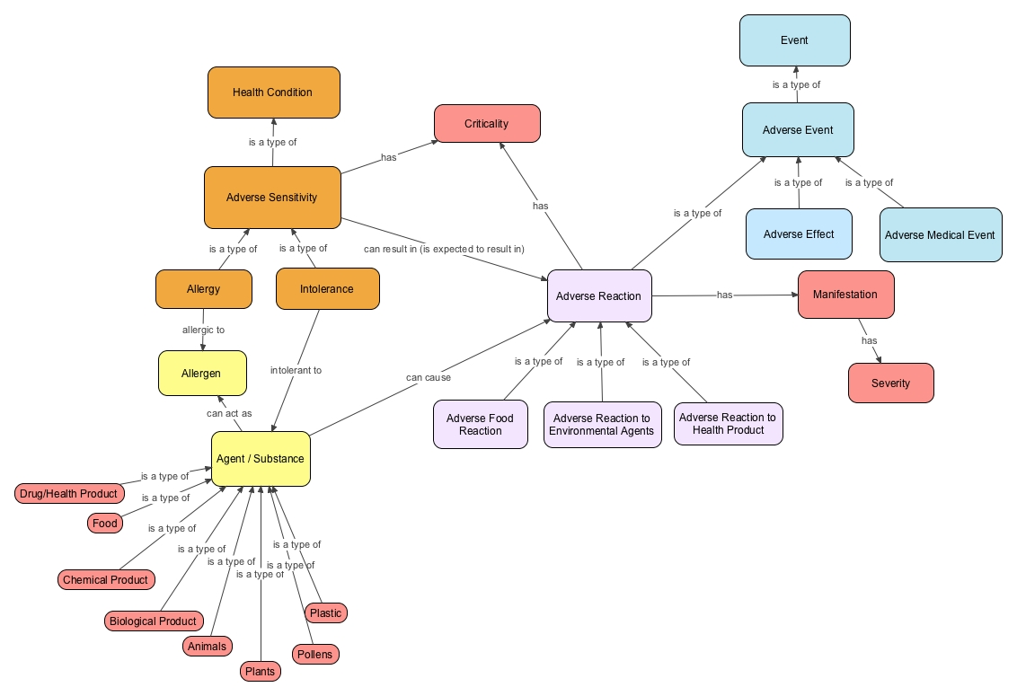

Note the addition adverse effect under “Events” based on terminology used in the US for quality measures reporting. The group agreed that the concept of “mechanism” should also be included if known based on Kevin’s work. The addition of sensitivity tests (challenges) or confirmation by direct challenge

will help define if the reaction is allergic or non-allergic. It was also decided to include the reaction type as extensions. The group also discussed the concept of an allergy as a contraindication to a substance as absolute or non-absolute. Jean will add the concept of an “absolute contraindication” vs. a managed contraindication.

**Review of Use Cases**

1. Query EHR – Elaine reported that she will work with Pat VanDyke in the EHR WG to come up with a “Query EHR” use case.
2. Device Allergy – FDA. Erin Fields and Leslie Tompkins presented a use case culled from the FDA database of reported adverse events with implanted devices (MAUDE). The use case chosen was for nylon sutures used for a cataract extraction procedure. The group discussed the use case and offered suggestions for adding additional details. Erin also agreed to draft a use case on an implanted joint.
3. The group then reviewed the list of use cases. Elaine will post the completed use cases to the wiki.



**Agenda for Thursday, July 12 , 2012**

1. Review agenda for meeting and add other issues as needed
2. Review and approve the minutes for June 28, 2012 meeting
3. Jean – modelling minute
4. Review assigned use cases
   1. Devices
   2. Criticality
   3. Immunization
5. Plan the agenda for the next conference call on July 26.