Unique_Ballot_id_V3DAM_HealthConcern_R2_I1_2015JAN



**Health Concern Domain Analysis Model Release 2**

January 2015

**Informative Ballot**

**Sponsored by: Patient Care**

Copyright © 2014 Health Level Seven International ® ALL RIGHTS RESERVED. The reproduction of this material in any form is strictly forbidden without the written permission of the publisher. HL7 and Health Level Seven are registered trademarks of Health Level Seven International. Reg. U.S. Pat & TM Off**.**

Use of this material is governed by HL7's [**IP Compliance Policy**](http://www.hl7.org/legal/ippolicy.cfm?ref=nav).

**Acknowledgements:**

**Project Leads:**

Michael Tan

Stephen Chu

Elaine Ayres

**Editors and Key Contributors**

Michael Tan

Stephen Chu

Jay Lyle

Elaine Ayres

Kevin Coonan

Lisa Nelson

Lawrence McKnight

**Other Participants/Contributors:**

Russ Leftwich

Laura Heermann Langford

Becky Angeles

Emma Jones

**HL7 Project ID -- 929**

**Content**

1 Revision History 2

2 Introduction 2

3 The Domain Analysis Model Artifact 2

4 Health Concern – The Clinical Perspective 2

5 Health Concern – The Engineering Perspective 2

6 Health Concern: Harmonizing the Clinical and Engineering Perspectives 2

7 A Typical Use Case for Health Concern and Health Concern Tracking 2

8 Health Concern Domain Analysis Model 2

8.1 Actors 2

8.2 Health Concern Use Case Diagram 2

8.2.1 ConcernIdentifier 2

8.2.2 ConcernModifier 2

8.2.3 ConcernViewer 2

8.2.4 HealthcareProvider 2

8.2.5 Patient 2

8.2.6 RelatedPerson 2

8.3 Use Cases 2

8.3.1 Add Component 2

8.3.2 Associate Components 2

8.3.3 Associate Concern 2

8.3.4 Disassociate Concern 2

8.3.5 Dissociate Components 2

8.3.6 Identify Health Concern 2

8.3.7 Monitor health concern 2

8.3.8 Promote Component 2

8.3.9 Record Health Concern 2

8.3.10 Remove Component 2

8.3.11 Supersede Component 2

8.3.12 Update Health Concern 2

8.3.13 View Health Concern 2

8.4 Health Concern Class Diagram 2

8.4.1 CarePlan 2

8.4.2 Patient 2

8.4.3 Provider 2

8.4.4 ComponentRelationship 2

8.4.5 ComponentRelationshipKind 2

8.4.6 ConcernIdentifier 2

8.4.7 ConcernRelationship 2

8.4.8 ConcernRelationshipKind 2

8.4.9 HealthConcern 2

8.4.10 HealthConcernComponent 2

8.4.11 HealthConcernName 2

8.4.12 HealthConcernTracker 2

8.4.13 Provider 2

8.5 Heatlh Concern Example 2

8.6 System Interaction Diagram 2

9 APPENDIX I – Additional Clinical Scenarios 2

9.1 Clinical Scenario 1 - Health Concern Observations 2

9.2 Clinical Scenario 2 – Health Concern Observations and Tracking: Head Trauma 2

9.3 Clinical Scenario 3 – Nutrition Focus 2

10 APPENDIX II – Patient Journey Scenarios 2

10.1 Patient Journey Scenario 1 - Abdominal Pain 2

10.2 Patient Journey Scenario 2 - Concern for Cancer with Tracking to Observations of Others (Jolie, 2013) 2

10.3 Patient Journey Scenario 3 - Conflicting Interventions 2

10.4 Patient Journey Scenario 4 - Structured Primacy Care Approach 2

11 APPENDIX III – Comparison of Use of “Health Concern” Concept 2

# Revision History

|  |  |  |  |
| --- | --- | --- | --- |
| **Version** | **Date** | **Name** | **Comment** |
| 1.0 | August 2, 2014 | Patient Care WG | First Informative Ballot |
| 2.0 | December 7, 2014 | Patient Care WG | Second revised Informative Ballot |

# Introduction

Healthcare delivery is becoming more complex. Patients, especially those with complex health issues are now treated by multi-disciplinary teams of providers within a care setting, across different care settings or care network. Institutions may specialize in one limited clinical specialty or super-specialty care. The gaps in care provision to patients with a long history of multiple complex health issues require to be picked up by different institutions. Providers need a robust mechanism to disambiguate clinical findings, keep track of how the comorbidities relate to and impact on one another and the ability to monitor the impact of different interventions on the progress of the patient’s various conditions.

The Health Concern Domain Analysis Model is intended to:

* Identify how the health concern concept is related to patient’s complaints, signs, symptoms, issues, conditions, problems, and diagnoses.
* Identify how related health concerns and associated events are linked and monitored to support more efficient and comprehensive review and monitoring of patient treatments, outcomes and progression or prognosis.
* Views into the health concern(s) may be built using the concern as the common reference to show the longitudinal history of the patient, concerns by system, by cause, or any other relationship of interest. Health concerns articulate a solution to make these goals possible.

This document also attempts to discern how the Health Concern concept is related to the health concern, problem concern and reaction concern concepts and templates defined in the C-CDA Release 2 as well as the ISO/DIS 13940 (Systems of Concepts to support continuity of care) to facilitate harmonization of concepts between projects.

# The Domain Analysis Model Artifact

A Domain Analysis Model (DAM) is UML representation of a “domain,” or area of business requirements. It is a requirements artifact—also known as a “problem domain,” “conceptual” or “business” artifact. It is designed to articulate clearly the needs of the business community as that community understands them. It tells you about the domain information, but it doesn’t tell you how to represent it in an information system.

In the words of the *HL7 Development Framework* (HDF), “During requirements documentation the problem domain is defined, a model of the domain (or problem space) is produced as the Domain Analysis Model (DAM) consisting of static and dynamic model artifacts. Domain, in this case, refers to the problem space for the requirements.” The critical distinction is that the DAM does not specify patterns for representing the data. It does not conform to the HL7 Reference Information Model (RIM), or to openEHR, or to any other logical pattern, as it must represent the problem domain with sufficient clarity to support development in any of those patterns.

The HDF clarifies: “A DAM defines what needs to be done, not how to do it. It is important to separate the description of requirements from the design of the solution. Prematurely including technical and implementation details will compromise the clarity of the original problem and will result in standards that fall short of the business needs. The DAM is [*subsequently*] used to create standard specifications by harmonizing it with HL7 references including the Reference Information Model (RIM), structural vocabulary, and application roles.”

The DAM contains both a dynamic part—with definitions for actors and the use cases they participate in—and a static part—illustrating the structure of the concepts used in those use cases. The use cases are abstracted from a set of concrete scenarios identified by domain experts.

# Health Concern – The Clinical Perspective

* A health concern is a health related matter that is of interest, importance or worry to someone. This may be the patient, the patient's family or a patient's healthcare provider.
* Health concerns are volitional and intentional. They represent the conscious deliberation and determination by an individual (provider or patient/patient family member) that a specific health condition or issue may require monitoring and intervention at certain point in time (now and/or future). The intent is then manifested as the creation and monitoring of a health concern. This intent also differentiates the concern(s) in question from simply noting a condition in the patient’s health record.
* Health concerns represent variations from a desired health status or a condition that place the patient at risk for an undesirable health status, and thus may need management or attention. A pregnancy is an example of a condition which may or may not be desired in and of itself, but at minimum requires management because it places special risks on the patient and fetus that could create an undesirable outcome if not properly managed. Health concerns are not always biologic in nature. Variations in social factors, family dynamics or relationships (e.g. loss of family members, domestic violence), economic stress, etc, may be identified as health concerns.
* A health concern is identified from the perspective of a person or group. This may be:
  + The patient.
  + A family member or care giver.
  + A provider such as a physician, surgeon, physical therapist, respiratory therapist, nutritionist, health educator, social worker, etc.
  + A group of providers or care givers that share a particular perspective of that concern such as orthopedic surgeons, or ‘the family’.
* Health concerns could be initiated by different persons in different systems without knowing about each other. Therefore there is no conclusive ownership of health concerns. The existence of other health concerns becomes apparent when information is exchanged.
* From a clinical care/management perspective, the health concern in question may be labeled with the condition, issue or risk identified at a particular point in time. The condition as noted at a point in time may prompt action(s). This may be specified order(s), a set of complex management strategies/plans, a decision to follow up at a later point in time to observe for changes (e.g. watch this) or a decision to do nothing. A concern at a time point may also imply one or more explicitly stated (prioritized) goals or desired outcomes for a future time point indicating a target that can be measures at that future time point (i.e. goal =met/partially met/not met). Concerns span time and by their nature evolve over time. As recorded by the computer these are represented as discrete, related observation events. Together these events form a history of the concern which approximates the clinicians understanding of a pathologic processes or risk in the patient (separate from other processes of the patient which may also be evolving, but at different course, and at different rate, or of different importance). Because this history records not only a point observation, but a series, a concern is useful in the prediction of future events and management plans (i.e. a diagnostic order is not needed because it was already performed recently, or more urgent action is required because of the speed of decline in function).
* Health concerns are broader than just “problems” on the "problem lists" in health records. Health concerns are typically recorded on problem lists, and in the "assessment" or "impression" section of notes. They may also be the "problem" part of a multidisciplinary plan of care. The time course and perspective of these recordings are different, so care should be taken to ensure that the evolving nature and "intentional" aspect of a concern can be managed correctly. A concern represented as a problem on a problem list or in a multidisciplinary plan of care typically represents the concern aspect will be followed up at a future point in time. It is 'active' to mean that it should remain on the list to check on again. A concern represented as a line in the assessment part of a note however has a much shorter timeframe, typically represented as a single point in time. This note observation may update aspects of a concern represented on a problem list. However the use cases are distinct because the same observation may indicate different follow up (and therefore "active" state) to different people. For example, a nurse in the hospital may wish to clear a concern at discharge from the hospital, while a physician may consider the concern ongoing because they want to follow up in the office. It is possible to generate a problem list which includes any health concerns that meet certain utility criteria of a health provider or organization.

Figure 1 Example of back pain concern tracking

Figure 1 represents the identification and continuous tracking of a set of related health concerns. The patient initially noted pain shooting down the left leg. Two weeks later, the patient began to feel lower back pain in addition to the leg pain and decided to seek consultation with the Primary Care Provider (PCP). After conducting a set of initial clinical assessments (not shown), the PCP made a diagnosis of sciatica. Diagnostic imaging tests were ordered and the results led to the revision of the diagnosis to herniated intervertebral discs (at Lumbar 2 and Lumbar 3 Levels).

The PCP decided to track the health concern when making the diagnosis of sciatica. The health concerns were traced back to the date when the first symptom (leg pain) appeared. At each point in time, the name of the health concern changed as the condition evolved.

The PCP discussed management options with the patient, who rejected surgical intervention and opted for conservative management. The PCP discussed with the patient a plan to monitor the condition (as a health concern) and the potential risk of subluxation of the affected vertebrae.

# Health Concern – The Engineering Perspective

From information management or engineering perspective, a "health concern" can be considered to encompass two sub-concepts:

* + Health Concern Events
  + Health Concern Thread or Tracking

**Health Concern Events:**

1. Health concern events are activities relevant to the specific health concern(s) that occur at a discrete point in time that may be monitored as the condition evolves over time. For example, a problem as listed on a problem list represents the ongoing concern (e.g. the concern for hypertension is ongoing should be followed up over time), where the problem is recorded in a note is a concern event (e.g. On June 25th the patient’s hypertension is assessed as controlled with current medication). Similarly, the concern about an allergy is followed to ensure that exposure to the allergen in question is avoided.
2. Other requirements for health concern events:
   * A concerned person (see Figure 4 for designation of actors) should be able to designate a recorded fact as a health concern.
   * A concerned person should be able to associate further recorded facts with a health concern.
   * A concerned person should be able to change associated facts, including the one that designates the health concern.
   * A concerned person should be able to view the facts associated with a health concern, including previous designations, sorted and presented by any paradigm they can specify (including, e.g., a time series).

**Health Concern Thread or Tracking:**

1. The health concern thread is a temporal concept which is akin to the logical linkage of events pertinent to the health concern in the health records. Events like observations, interventions (such as medications), diagnosis and such are grouped under the concern thread. This could mean that health concern is used to personalize views on the medical records.
2. Monitoring or tracking health concern events through time allows the patient history to be filtered by time, or a subset of related events (which include observations, assessments, interventions), and filtering out other events which are unrelated to the existing concern.

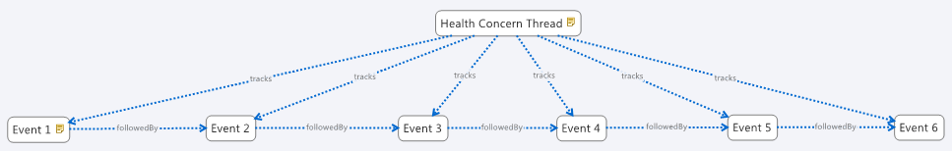

Figure 2 Example of Health Concern Tracking

# Health Concern: Harmonizing the Clinical and Engineering Perspectives

There have been numerous discussions and attempts to differentiate and disambiguate the clinical and technical perspectives of health concern. A harmonized approach to view these two perspectives is required to address the semantic confusion.

The clinical perspective of “health concern” is represented by any health condition assessed to be a health concern (by the provider or patient). A patient’s health condition may evolve over time, for example, from a cough to an upper respiratory tract infection, to bronchopneumonia to acute respiratory failure. As the health condition evolves over time, the health concern name takes on the name of the condition as assigned by the provider/patient at the time of the observation and evaluation. Health concern events may include identification of relevant health goals and associated interventions formulated to manage the health conditions as they evolve over time. The related health concerns, their associated health goals and interventions are “connected” (and hence trackable) by the “health concern”.

It is important to note that any risks identified in relation to the health condition (e.g. risk of pneumonia from upper respiratory tract infection in susceptible patient) and/or intervention (e.g. risk of adverse drug reactions to medications) may be assessed as health concern(s) that need to be monitored and mitigation strategies planned/implemented.

The technical perspective of “health concern” is represented by the mechanism to link the evolving health condition and the associated health event details such that all related information can be queried, viewed, and navigated to facilitate effective assessment of patient clinical status and forward planning of management strategies or plans.

# A Typical Use Case for Health Concern and Health Concern Tracking

To help clarify the abstract nature of health concern tracking, an example patient history may be used.

A 55 year old patient with known Type I Diabetes presented to his Primary Care Physician (PCP) with chief complaints of cough and slight shortness of breath. There was no wheezing on examination.

A week later, he returned to see his PCP with presenting symptoms of cough, shortness of breath and fever.

Two days later, he presented himself at the Emergency Department of local hospital with cough, severe shortness of breath, wheezing and fever.

In the Emergency Department he was diagnosed with asthma and pneumonia, was admitted, and treated in the hospital for 2 days. During this hospitalization he is noted to have problems with his diabetes control and a new allergy is noted. After the hospitalization, the patient is discharged back to the care of his PCP, and sees that provider a week later.

The example will illustrate communication between two systems which share similar event structure. Each of the above events is recorded in the electronic health records as individual health concern events. The sum of all recorded events represents the patients’ medical history as understood by the computers.

System A – Ambulatory Office System

|  |  |
| --- | --- |
| .... |  |
| 11/20/2013, 10:17am | Encounter Note.Assement:Diabetes, Type 1, Controlled |
| ... |  |
| 3/4/2014, 2:45pm | Registration Complaint: Cough & Dyspnea |
| 3/4/2014, 2:50pm | Encounter Note.Exam:No Wheeze |
| 3/4/2014, 2:50pm | Encounter Note. Assessment: Probable Viral URI |
| 3/11/2014,9:23am | Registration Complaint: Cough, Dyspnea , Fever |
| 3/11/2014 , 9:38am | EncounterNote.Exam: Crackles, No Wheeze |
| 3/11/2014, 9:38am | EncounterNote.Exam:Assessment: Possible CAP |
| 3/11/2014, 9:38am | EncounterNote.Order:Azithromycin |
| 3/11/2014, 9:38am | EncounterNote.Order:CXR, CBC, Chem 7 |
| 3/11/2014, 12:10pm | Lab.WBC: 17.3 |
| 3/11/2014, 12:11pm | Lab.Glucose:258 |
| 3/12/2014, 1:20pm | Result.CXR:Patchy Infiltrate |
| 3/12/2014, 4:32pm | TelephoneNote:Patient advised to go to ED. |

System B – the ED/Hospital System

|  |  |
| --- | --- |
| 3/13/2014, 7:32am | ED Triage Complaint: Cough/SOB/Fever |
| 3/13/2014, 7:45am | ED Physician Note Exam: Wheeze Crackles, Fever |
| 3/13/2014, 7:50am | ED.Order: Rocephin |
| 3/13/2014, 8:15am | ED Disposition: Admit to Floor |
| 3/13/2014, 8:15am | ED AdmittingDx: Pneumonia |
| ... |  |
| 3/13/2014, 10:30am | Admit H&P.Assessment: Pneumonia |
| 3/13/2014, 10:30am | Admit H&P.Assessement:Diabetes, Type 1 |
| ... |  |
| 3/14/2014, 5:40am | POC.Glucose:456 |
| 3/14/2014, 5:50am | Order:Insulin Regular |
| ... |  |
| 3/14/2014, 9:13am | Lab.Sputum.Gramstain. Gram Pos Cocci in Pairs |
| ... |  |
| 3/14/2014,10:10am | SOAP.SubjComplaint:Rash / Itch |
| 3/14/2014,10:10am | SOAP.Exam – Salmon colored maculopapular Rash |
| 3/14/2014, 10:10am | SOAP.Assessment: Diabetes, Type 1, Uncontrolled |
| 3/14/2014, 10:10am | Order: Increase Lantus |
| 3/14/2014, 10:10am | SOAP.Assessment: Rash - Likely Drug Reaction |
| 3/14/2014, 10:10am | Order: discontinue Rocephin |
| 3/14/2014, 10:10am | Order: Levaquin |
| 3/14/2014, 10:10am | Allergy: Rocephin, Reaction Rash |
| ... |  |
| 3/15/2014, 11:15am | DischargeDx: Pneumococcal Pneumonia |
| 3/15/2014, 11:15am | DischargeDx: Asthma |
| 3/15/2014, 11:15am | DischargeDx: Diabetes, Type 1 |
| 3/15/2014, 11:15am | Discharge Summary.Allergies: Rocephin, reaction: rash. |
| 3/15/2014, 11:15am | Discharge Medication: Levaquin |
| 3/15/2014, 11:20am | Hospital Disposition: Discharge |

System A – Ambulatory Office System

|  |  |
| --- | --- |
| 3/20/2014, 9:40am | RegistrationComplaint: Hospital F/U |
| 3/20/2014, 10:00 am | Office Spirometry: <report> |
| 3/20/2014, 10:12am | Allergy: Rocephin, reaction Rash |
| 3/20/2014, 10:15am | EncounterNote.Exam: Wheeze |
| 3/20/2014, 10:15am | EncounterNote.Assessment:Recent Pneumococcal Pneumonia. |
| 3/20/2014, 10:15am | EncounterNote.Assessment:Asthma |
| ... |  |
| 4/20/2014, 3:45pm | EncounterNote.Assessment:Pneumococcal Pneumonia - resolved |

Without concern tracking, all of these events simply record the history of the patient as seen within the EHR. The patient’s diabetes, asthma, and pneumonia are documented together in a chronological manner. However, it is not possible to match up that elevated glucose on 3/14 is related to diabetes, or that the Rocephin was related to the ED admitting Dx: pneumonia, but unrelated to problem of diabetes. Any problem list entry or allergy list maintenance is unrelated.

With concern tracking, the events are typically entered based on a concern identifier as a starting point. For example, in this case, the physician might order the CXR (chest x-ray) in the context of a concern that started with the registration event cough and dyspnea (later renamed possible pneumonia and finally winding up as S/P pneumococcal pneumonia). Furthermore, the EHR may allow for additional tagging or correction of relationships within a concern history, however the implementation details may vary significantly from system to system, where some systems only track major name changes, others might only record that a particular note exists related to the concern, and others might use sophisticated inference to automatically bind concerns and orders and results based on known relationships like the fact that glucose results are generally relevant for diabetes so any observation of a concern recently named “Diabetes Type 1, uncontrolled” might automatically include glucose results.

In our example, let us examine where and how these concern identifiers are established.

System A – Ambulatory Office System

* 11/20/2013, 10:17am – Encounter Note - Assessment: Diabetes, Type 1, Controlled,
  + Concern id A.1 previously recorded with additional history.
* …
* 3/4/2014, 2:45pm – Registration Complaint: Cough & Dyspnea
  + Concern id A.2 – start of a new concern on system A, and current name of the concern.
* 3/4/2014, 2:50pm – Encounter Note.Exam: No Wheeze
  + Concern id A.2 - because the exam finding was recorded in the complaint context “Cough/Dyspnea”. Some systems may merge all exam into on consolidated exam in which case the exam findings may not necessarily be shown related to the concern, or it might be bound based on static known associations (respiratory exam findings are relevant for complaints of cough/dyspnea). Alternatively the exam findings may be related because they are included in a note that included an assessment related to the concern. Exam findings would generally be used as naming observations.
* 3/4/2014, 2:50pm – Encounter Note. Assessment: Probable Viral URI
  + Concern id A.2 - because of complaint context of encounter. In the note, the Assessment/Plan section, the “Assessment” (sometimes called “Impression”) is an observation event that names the concern at a point in time. The name of the concern is now “Probable Viral URI”
* 3/11/2014, 9:23am – Registration Complaint: Cough, Dyspnea , Fever
  + Concern id A.3 – At the triage desk, a nurse may not know that the patient had just been seen, and might without being aware of the existing concern, create a new concern. That can be corrected by merging with concern id A.2 after it is realized this represents the same complaint / concern. As the concern is merged, the name of the concern is selected from one or the other.
* 3/11/2014 , 9:38am – EncounterNote.Exam: Crackles, No Wheeze
  + Concern id A.2 because of the complaint context
* 3/11/2014, 9:38am – EncounterNote.Exam:Assessment: Possible CAP
  + Concern id A.2 because of the complaint context. This is the new name of the concern A.2
* 3/11/2014, 9:38am –Order:Azithromycin
  + Concern id A.2 - placed from the context
* 3/11/2014, 9:38am –Orders: CXR, CBC, Chem 7
  + Concern id A.2 – placed from the context
* 3/11/2014, 12:10pm –Lab.WBC: 17.3
  + Concern id A.2 because result is from ordered under this context
* 3/11/2014, 12:11pm –Lab.Glucose:258
  + Concern id A.2 because of the order there is the context of Chem7. It might later be tagged as part of Concern id A.1 because known relationship that Glucose is relevant for Diabetes, and concern A.1 is named as a child of this term. Alternatively it might be manually tagged as relevant for concern A.1 (Type I Diabetes). The same event may be tagged to multiple concerns.
* 3/12/2014, 1:20pm – Result CXR:Patchy Infiltrate
  + Concern id A.2 because of order
* 3/12/2014, 4:32pm – TelephoneNote:Patient advised to go to ED.
  + Concern Id A.2 because of complaint context

For sake of edification, the hospital/ED is a separate system, thus concerns are prefixed B. The patient arrives without an electronic transmission from the ambulatory system so a new concern is started. If this was the same system, then concern ids could/would be just carried forward. If an electronic transmission were received the history would merged and reconciled. This is shown later in the example.

System B – the ED/Hospital System

* 3/13/2014, 7:32am – ED Triage Complaint: Cough/SOB/Fever
  + Concern id B.1 – start of new concern in ED.
* 3/13/2014, 7:45am – ED Physician Note.Exam:Wheeze, Crackles, Fever
  + Concern id B.1 because of complaint context of the encounter
* 3/13/2014, 7:50am – ED.Order: Rocephin
  + Concern id B.1 because of complaint context of the encounter
* 3/13/2014, 8:15am – ED Disposition: Admit to Floor
  + Concern id B.1 because of complaint context
* 3/13/2014, 8:15am – ED AdmittingDx: Pneumonia
  + Concern id B.1 because of complaint context. This is the new naming observation of the concern
* …
* 3/13/2014, 10:30am – Admit H&P.Assessment: Pneumonia
  + Concern id B.1 - Carried forward from ED because this is the same system.
* 3/13/2014, 10:30am – Admit H&P.Assessement:Diabetes, Type 1
  + Concern id B.2 – started new because Inpatient Resident asked the patient.
* ...
* 3/14/2014, 5:40am – POC Lab.Glucose:456
  + Concern id B.2 –Lab was ordered under complaint context of inpatient stay “Diabetes, type 1”
* 3/14/2014, 5:50am – Order:Insulin Regular
  + Concern id B.2 – ordered under complaint context
* …
* 3/14/2014, 9:13am – Lab.Sputum.Gramstain. Gram Pos Cocci in Pairs
  + Concern ID B.1 because of order context.
* …
* 3/14/2014,10:10am – SOAP.SubjComplaint:Rash / Itch
  + Concern id B.3
* 3/14/2014,10:10am – SOAP.Exam: Salmon colored maculopapular Rash
  + Concern id B.3 - because recorded in context of new complaint
* 3/14/2014, 10:10am – SOAP.Assessment: Rash - Likely Drug Reaction
  + Concern id B.3 renames the concern.
* 3/14/2014, 10:10am – Order: discontinue Rocephin
  + Concern id B.3 & B.1. Discontinue is from B.3, but Start was from B.1
* 3/14/2014, 10:10am – Allergy: Rocephin, Reaction Rash
  + Concern id B.3 & B.4. Allergies are concerns of themselves, so a new allergy concern is created in this event. In this case the same observation history relevant to both an active problem “Likely Drug Reaction” and the allergy “Rocephin”.
* 3/14/2014, 10:10am – SOAP.Assessment: Diabetes, Type 1, Uncontrolled
  + Concern id B.2 - renamed. In the problem list this now reads “Diabetes, type 1, Uncontrolled”
* 3/14/2014, 10:10am – Order: Increase Lantus
  + Concern id B.2 - because place in context of concern.
* 3/14/2014, 10:10am – SOAP.Assessment: Pneumonia, likely Pneumococcal, Improving
  + Concern id B.1 – renamed.
* 3/14/2014, 10:10am - Order: Levaquin
  + Concern id B.1
* …
* 3/15/2014, 11:15am – DischargeDx: Pneumococcal Pneumonia –
  + Concern id B.1
* 3/15/2014, 11:15am – DischargeDx: Probable Asthma
  + Concern id B.5
* 3/15/2014, 11:15am – DischargeDx: Diabetes, Type 1
  + Concern id B.2
* 3/15/2014, 11:15am – DischargeSummary.Allergies: Rocephin
  + Concern id B.4
* 3/15/2014, 11:15am – Discharge Medication: Levaquin
  + Concern id B.1
* 3/15/2014, 11:20am – Hospital Disposition: Discharge
  + Concern id B.1 - because admitted under this concern.

For sake of edification, assume the ambulatory system now receives electronic summary of ED and hospital stay documentation with concern tracking identifications.

System A – Ambulatory Office System

* 3/20/2014, 9:40am – RegistrationComplaint: Hospital F/U
  + Concern id A.4 – new. But, the physician reads the electronic discharge documentation from hospital and merges that history. He recognizes the hospital Discharge Dx “Pneumococcal Pneumonia” (concern ID B.1) represents the item on his problem list called “Possible CAP” (Concern ID A.2). He drags the “Pneumococcal Pneumonia” onto “Possbile CAP” and gets a dialog “Would you like merge these problems? Y/N”. His problem list item is now named “Pneumococcal Pneumonia” because that is the more recent naming observation.
  + Similarly, he recognizes that the hospitals “Diabetes Type 1” (Concern ID B.2) is his “Diabetes Type 1” (Concern id A.1) and merges these.
  + He adds the problems B.5 as a new problem. In his system this is concern id A.5. This history from the hospital is already there.
* 3/20/2014, 10:15 am – Office Spirometry: <report>
  + Concern id A.5. Note that the reference to observations/events may be discrete data, or very often large blobs such as pictures, or scanned documentation.
* 3/20/2014, 10:15am – EncounterNote.Exam: Wheeze
  + Concern id A.2 &/or A.5, depending on how /where he records this, provides additional problem (concern) tagging and system function to automatically bind known relevant relationships.
* 3/20/2014, 10:15am – EncounterNote.Assessment:Recent Pneumococcal Pneumonia.
  + Concern id A.2 – The naming observation looks the same as the hospital, but this is an additional time point where this is known state /name of this concern. The observation timing and verification is important for decision support systems to know if the problem is stale or not.
* 3/20/2014, 10:15am – EncounterNote.Assessment:Asthma
  + Concern id A.5
* …
* 4/20/2014, 3:45pm – EncounterNote.Assessment:Pneumococcal Pneumonia – resolved
  + Concern id A.2 now marked ‘inactive’. Additionally, the PCP may wish to create a new concern A.6 in the patients ‘Past Medical History’ representing the fact that this may affect his risk of pulmonary issues in the future. In this case the PCP might click on the item “Pneumococcal Pneumonia – resolved” and select “add to Past Medical History”, which makes a reference of the concern A.2, including all it’s history.

This is a very simple example – much more simple than exists in real patients where the history of events is hard to follow because problems/concerns are dynamic and the thinking about the concern evolves over time. But the benefits of a health concern system are evident because a history can now be constructed for each concern separately. For example, if the PCP is interested in what has been happening with Diabetes, and how/why the Lantus was increased in the hospital – he can easily see the history of only events that are associated with concern id A.1. This might look like:

|  |  |
| --- | --- |
| 11/20/2013, 10:17am | Encounter Note.Assement:Diabetes, Type 1, Controlled |
| 3/13/2014, 10:30am | Admit H&P.Assessement:Diabetes, Type 1 |
| 3/14/2014, 5:40am | POC.Glucose:456 |
| 3/14/2014, 5:50am | Order:Insulin Regular |
| 3/14/2014, 9:13am | Lab.Sputum.Gramstain. Gram Pos Cocci in Pairs |
| 3/14/2014, 10:10am | SOAP.Assessment: Diabetes, Type 1, Uncontrolled |
| 3/14/2014, 10:10am | Order: Increase Lantus |
| 3/15/2014, 11:15am | DischargeDx: Diabetes, Type 1 |

# Health Concern Domain Analysis Model

## Actors

Any person may be a ConcernIdentifier, but only Caregivers have access to the record.



Figure: 3

## Health Concern Use Case Diagram

The Concern Identifier will typically be a healthcare provider, but may in some patient-centric systems be a patient or patient proxy. The identifier may create, modify, or view concerns. Only one specific paradigm for viewing a concern is shown; others may be suggested.

### ConcernIdentifier

A patient, caregiver, family member, or other person who identifies a Health Concern.

### ConcernModifier

A person who modifies a concern.

### ConcernViewer

A person who views a concern.

### HealthcareProvider

A healthcare professional with authority to modify a patient's health record.

### Patient

The subject of health care provision.

### RelatedPerson

A family member, home caregiver, significant other, or other person concerned with the health of the patient.

## Use Cases



Figure: 4

### Add Component

Associate a component fact with a HealthConcern.

### Associate Components

Assert that two HealthConcern components have a relationship.

### Associate Concern

Associate an existing HealthConcern with another HealthConcern.

### Disassociate Concern

Remove an associated HealthConcern from a HealthConcern.

### Dissociate Components

Remove an asserted relationship between two components.

### Identify Health Concern

Designate an identifying component for a HealthConcern.

### Monitor health concern

View information about a HealthConcern at points in time determined by a specific care plan or by clinical protocol (e.g., "weekly," "when the patient comes in") .

### Promote Component

Create a HealthConcern out of an existing component fact.

### Record Health Concern

Create a new HealthConcern, whether by identifying an existing component fact as a concern or creating a component fact that is itself a concern.

### Remove Component

Disassociate a component fact from a HealthConcern.

### Supersede Component

Replace an existing component fact with one that corrects it.

### Update Health Concern

Change the information constituting an existing HealthConcern.

### View Health Concern

View the information about a HealthConcern.

This may involve a variety of information architectures, including time series, causal network, recent events, etc.

## Health Concern Class Diagram

This diagram represents the HealthConcern aggregation and its relationships to other classes. The HealthConcern domain is placed in the context of the CarePlan in order to illustrate the close relationship between the two.



Figure: 5

### CarePlan

A set of goals and planned interventions designed to treat a particular health concern.

Care Plan is not part of the Health Concern domain, but it is closely related, so it is shown here for reference.

A care plan is specific to an institution, so a patient might have different care plans for the same condition in different places. However, concern tracking assumes a single record context, in which these organizational boundaries are out of scope. If a record has no method of representing plans at other institutions, then their existence if moot; if it does, then they should be reconciled into a single plan.

Forward-looking actions (e.g., noting that a concern should be re-evaluated in 6 months and making an appointment to do so) are part of the plan domain and are not elaborated here, though the Concern concept does support the association of such actions with a concern via the plan and goal.

### Patient

The subject of health care provision.

### Provider

If a concern identifier is a provider, other providers will need to know who it is in order to address disagreements.

### ComponentRelationship

The manner in which one component is relevant to another.

One condition may be suspected of causing another, or an observation may provide evidence for a finding.

This relationship may also obtain for components that define (name) HealhtConcerns. E.g., a diabetes concern may be related to a risk of retinal detachment. Different clinicians may desire different views; e.g., an ophthalmologist needing to view the retinal detachment concern without having to sort through other diabetes-related conditions.

Attributes

|  |  |  |  |
| --- | --- | --- | --- |
| **Name** | **Scope** | **Multiplicity** | **Notes** |
| relationshipKind | *Private* |  | The set of relationships that may obtain among HealthConcernComponents |

### ComponentRelationshipKind

Kinds of relationships that concern components may have with each other.

### ConcernIdentifier

A patient, clinician, caregiver, family member, or other person who identifies a Health Concern, or who identifies a new name or focal concept for an existing concern.

Note that different persons may identify different focal components for a concern at the same time. This should eventuate in those who disagree recognizing that there is disagreement and taking steps to ensure both parties are in full command of the facts.

### ConcernRelationship

Relationships among health concerns.

### ConcernRelationshipKind

Kinds of association among HealthConcerns.

Attributes

|  |  |
| --- | --- |
| **Name** | **Notes** |
| causedBy | The target concern is deemed to precipitate the source concern |
| hasComplication | The source concern is problematized by another that, e.g., worsens it or contraindicates a treatment |
| evidenceFor | The source concern provides evidence for another concern |
| subconcernOf | The source concern is a specific subset of the target. E.g., a patient may have two cancer diagnoses, both subconcerns of a general cancer concern |
| subsequentTo | The source concern occurred after the target concern |
| inPatientWithKnown | The source concern occurs in a patient with the confirmed target concern  Is this the same as a comorbidity? |
| merge | Multiple source concerns are deemed to be a single target concern |
| split | The source concern is deemed to be multiple target concerns |
| comorbidity |  |

### HealthConcern

A Health Concern is a health related matter that is of interest, importance or worry to someone, who may be the patient, patient's family or patient's health care provider.

Health Concern properties may be derived from the focal component (e.g., current diagnosis).

Usage note: This is typically a variation from a desired health status or a condition that may harm the patient or place the patient at risk for harm, and thus may need management or attention, but it may include social, financial, or other issues.

A pregnancy is an example of a condition which may or may not be desired in and of itself, but at minimum requires management because it places special risks on the patient and fetus that could create an undesirable outcome if not properly managed.

Concerns span time and by their nature evolve over time. As recorded by the computer, these are represented as discrete, related observation events. Together these events form a history of the concern which approximates the clinicians' understanding of a pathologic processes or risk in the patient (separate from other processes of the patient which may also be evolving, but at different course, and at different rate, or of different importance). Because this history records not only a point observation, but a series, a concern is useful in the prediction of future events and management plans (i.e. a diagnostic order is not needed because it was already performed recently, or more urgent action is required because of the speed of decline in function).

The condition as noted at a point in time may prompt action(s). These may be specified order(s), a set of complex management strategies/plans, a decision to follow up at a later point in time to observe for changes (e.g. watch this) or a decision to do nothing. A concern at a point in time may also imply one or more explicitly stated (prioritized) goals or desired outcomes for a future point in time indicating a target that can be measures at that future time point (i.e. goal =met/partially met/not met). However, these relationships are in the scope of the Care Plan domain.

Attributes

|  |  |
| --- | --- |
| **Name** | **Notes** |
| likelihood | An evaluation of the probability that a concern is real. |
| clinicalStatus | The state of the concern, e.g., new, worsening, resolved. |
| severity | The extent of organ system derangement or physiologic decompensation. |
| confidentiality | Level of clearance necessary to view this information.  Privacy labeling may supersede the confidentiality property. |
| concernTime | The time (start & end or duration) during which the concern is recognized. This is analogous to the V3 "activity time." |

### HealthConcernComponent

A fact that may be of concern, or that may be related to a concern.

A HealthConcernComponent will typically be a problem (such as diabetes or hypertension), but could be a risk, a complaint or clinical observation that has not yet been diagnosed, a procedure (e.g. a coronary bypass graft operation), or any other fact that has been designated as a concern that requires attention, whether for treatment or monitoring for possible indication of treatment.

HealthConcernComponents may have many attributes that will be useful in filtering and displaying a concern to a clinician; at this time "time" is the only one that has been identified.

Attributes

|  |  |
| --- | --- |
| **Name** | **Notes** |
| clinicalTime | The effective clinical time at which the phenomenon occurs . |
| componentKind | The classification of the component, e.g., a diagnosis, complaint, or procedure name. In V3 terms, this is equivalent to Act.code. |
| clinicalStatus | For conditions, the state of the condition, e.g., new, worsening, resolved. |
| confidentiality | Level of clearance necessary to view this information.  Privacy labeling may supersede the confidentiality property. |
| likelihood | Probability that a concern is or may be real.  This property may be split into epistemological values (suspected, confirmed) and ontological values (at risk, goal, present). |
| value | The assessed value of a property.  This property is used for measurements and other question & answer form facts. Assertions of unary concepts use only the "component kind" property. |

### HealthConcernName

A HealthConcernComponent that names the concern. A HealthConcern may have many component facts, but only one of them--e.g., the latest diagnosis--identifies the current understanding of what the concern is at any given time. A HealthConcern may have more than one name over time, and a clinician should be able to review the history of name changes.

Attributes

|  |  |
| --- | --- |
| **Name** | **Notes** |
| concernNameBeginDate | The time at which the component becomes the name of the concern. |
| concernNameEndDate | The time at which this component is superseded by another as the name of the concern. |

### HealthConcernTracker

The activity of desiring to stay current on a health concern.

This activity may be fulfilled by a "monitoring" activity in a health plan, but a health concern does not always have a health plan.

Attributes

|  |  |
| --- | --- |
| **Name** | **Notes** |
| frequency | How often a concern flagged for monitoring or notification should be checked. This parameter may simply be a record of intent, or it may support automated reminders. |

### Provider

If a concern identifier is a provider, other providers will need to know who it is in order to address disagreements.

## Heatlh Concern Example



Figure: 6

Several related facts are recorded about a patient over time. At one point, someone identifies Sciatica as a concern and uses the concern to group the leg and back pain complaints. Dr. Smith monitors the concern. He then orders an image, and on review, he revises the concern identification to Herniated IVD, indicating that the back pain is caused by that diagnosis.

## System Interaction Diagram

This diagram is reverse-engineered from the HL7 V3 ballot topic. It provides a way to transition from the clinically focused use cases to system boundary definitions.



Figure: 7

# APPENDIX I – Additional Clinical Scenarios

These scenarios were developed to support the concepts in the DAM and will be used to ensure future work in this domain reflects the varied nature of how a health concern might be presented to the health care community.

## Clinical Scenario 1 - Health Concern Observations

This scenario illustrates related problems and a hierarchical structure of the concerns.

**GP Encounter: First visit/consultation:**

A 48 year-old male patient was seen by a primary care provider (PCP) on 20 June 2012.

*Clinical History*: presenting signs and symptoms:

He presented to the PCP with complaints of lethargy, polydipsia, polyuria, difficulty in concentration, and recent weight loss. Spot blood glucose level revealed a reading of 11mmol/litre (198.2 mg/dl). Patient has no family history of Type 1 or Type 2 Diabetes Mellitus.

*Clinical observation*:

Patient’s spot blood pressure was 156/90 (hypertensive) .

Body weight was 88 kg, height 170cm, BMI = 30.4 (obese).

Based on medical history and physical assessment, the GP made a provisional diagnosis of type 2 diabetes mellitus.

The GP requested fasting blood glucose and glucose challenge, HbA1C, serum lipid profile tests.

**GP Encounter: Second visit/consultation**:

Patient was seen again by his GP on 25 June to discuss the test results.

Glucose challenge test result:

* Fasting blood glucose = [10.3 mmol/L]; [(185 mg/dl)]
* 2 hours post glucose load (75 gm) = [13.9 mmol/L]; [(230mg/dl)]

The GP made a diagnosis of Type 2 diabetes taking into consideration clinical history, physical examination and diagnostic test results.

**Hospital Encounter**:

*Clinical observation*: presenting signs and symptoms:

On 30 June, patient presented at the ED of his local hospital with the following presenting signs and symptoms: fever, productive cough, dyspnea for 3 days, severe thirst, muscle weakness and increasing lethargy since onset of respiratory symptoms, warm dry skin, dry oral mucosa, blurred vision and mental confusion.

*Clinical observation*: diagnostic tests

Diagnostic tests showed: chest x-ray lateral view showed lobar pneumonia left lower lobe, spot blood glucose level 30 mmol/L (540.5 mg/dl), serum osmolality = 325 mOsm/kg, serum pH = 7.40.

Based on the clinical history, presentation and diagnostic tests, the treating physician diagnosed the patient to be suffering from (a) lobar pneumonia, (b) hyperosmolar hyperglycemic nonketotic syndrome.

The patient was treated in the hospital and discharged back to the care of his PCP. An electronic discharge summary was sent to the PCP.

*Health Concerns and Tracking:*

The PCP determined that the patient’s health conditions/issues (including actual complications and assessed prognosis) identified since the first visit are of significant concern and should be tracked continuously. Health concern tracking allows related health issues including problems, diagnosis, interventions, outcomes to be linked and tracked over time. The holistic view enables better management of the conditions over time.

From June 2012, the health concern tracker application of the PCP medical record system continues to track the patient’s diabetes problem and related issues:

* Presenting signs, symptoms, clinical evaluation, problems, diagnoses identified at each encounter/visit
* Outcomes of interventions.
* Risks for complications: cardiovascular, neurological, renal, ophthalmic, etc .
* Prognosis of the condition(s).

## Clinical Scenario 2 – Health Concern Observations and Tracking: Head Trauma

This scenario illustrates the tracking and monitoring principle.

**Health Concern Observations:**

A 57 year-old female patient was brought into the Emergency Department of the local hospital suffering from concussion. The car she was travelling in collided sideway with a light post. Her head hit the B pillar of the car. She lost consciousness (LOC) for approximately 7-8 minutes.

Imaging studies (CT/MRI) showed no organic lesions such as skull fracture or intracranial hemorrhage.

She was hospitalized for 2 days and was discharged to the care of her primary care physician (PCP).

*Problem concern observation*: presenting signs and symptoms:

Her chief complaints/presenting signs/symptoms include: severe headache; dizziness; nausea; LOC for 7-8 minutes prior to arrival at ED.

*Problem concern observation*: discharge problem/diagnosis

The hospital discharge summary contains a discharge diagnosis: concussion.

Three weeks later, the patient presents at her PCP office with a number of complaints which are documented by the PCP in the patient’s EMR.

Health/Problem concern observation: presenting signs and symptoms:

* Fatigue; insomnia; increased sensitivity to noise and light.
* Cognitive problems: deteriorated memory, concentration and thought processes.

The PCP advises patient to take adequate rest and prescribes amitriptyline for post-traumatic injury; **dihydroergotamine combined with metoclopramide** for [chronic] headache; refers patient for cognitive and relaxation therapy, recommends supportive care and use of diary to help with memory problem.

The PCP organises follow up visits for the patient to continue monitor and manage the condition.

Health/Problem concern observation: problem/diagnosis

* The PCP associates the continuing problems with the head injury/concussion event and makes a diagnosis: post traumatic injury/disorder; post-concussion syndrome.

The follow-up visits continue until 4 months later the patient presents with a set of new complaints.

Health/Problem concern observation: presenting symptoms/problems

* Irritability; anxiety; mood changes; depression mood.
* The PCP prescribes anti-depressant and refers patient for psychotherapy.

**Health Concern Tracking:**

The PCP discusses with the patient the importance of tracking the health/problem concern observations to monitor the clinical status and progress in relation to treatment/management. The following are tracked under post-concussion syndrome Health Concern Tracker:

* Presenting signs, symptoms, clinical evaluation at each encounter/visit.
* Medication and therapy treatment, patient compliance and outcomes.
* Assesment of the condition including risks of organic brain lesions.

## Clinical Scenario 3 – Nutrition Focus

This scenario illustrates a scenario with multiple concerns.

A 50-Year-Old Hispanic Man With Metabolic Syndrome:

**Background**

The patient works in maintenance for the apartment building where he lives. He has been overweight since childhood and has been unable to lose weight despite many attempts. Several fad diets have resulted in as much as a 15-lb weight loss, but eventually he regains all the lost weight and rebounds past his baseline weight, becoming even heavier. The patient does not exercise except for walking associated with his job. His family has expressed concern about his risk of developing type 2 diabetes mellitus or heart disease, and they have convinced him to seek medical consultation. The patient states he has not seen a physician in 2 years, and he has not adhered to his cholesterol-lowering therapy because of the cost of the drug.

**Physical Examination**

* Height 6 ft 1 in.
* Weight 350 lb.
* Body mass index (BMI) 46.2 kg/m2.
* Waist circumference 50 in.
* Blood pressure 150/100 mm Hg.

**Assessment**

Morbidly obese male, alert and oriented, in no acute distress.

Laboratory Values:

* Fasting plasma glucose 115 mg/dL.
* High-density lipoprotein cholesterol (HDL-C) 41 mg/dL.
* Triglycerides 220 mg/dL.
* Total cholesterol 250 mg/dL.
* Low-density lipoprotein cholesterol (LDL-C) 171 mg/dL.

**Lifestyle/Family History**

* + Exercise status - Patient does not exercise.
  + Smoking status - Nonsmoker.
  + Alcohol consumption - None.
  + Drug history - Denies drug abuse.
  + Past medical history - Hypertension, hypercholesterolemia.
  + Diet - Patient does not adhere to a sodium-modified (4 g/day) diet.
* Family history - Significant for hypertension and type II diabetes diagnosed in father at 40 years of age; history of hypertension in mother.

**Medications**

• Lisinopril 10 mg daily.

**Health Concerns:**

1. Morbid Obesity (provider).
2. Atherogenic dyslipidemia (provider).
3. Hypertension (provider).
4. Risks;
   1. Type 2 Diabetes (provider and family).
   2. Stroke (provider).
   3. Myocardial Infarction (provider and family).
   4. Cost of medications (family).

# APPENDIX II – Patient Journey Scenarios

The following scenarios describe different patient journeys and how health concern concept is related to structuring information between care providers and their electronic health care systems.

## Patient Journey Scenario 1 - Abdominal Pain

This scenario describes the flow of a patient through various health institutions in which the diagnosis changes over time.

Ricardo D.: healthy young mechanic 22 years old has pain in the abdomen. He cannot digest his meals and vomits all the food he eats. Ricardo complains about his ache to his mother.

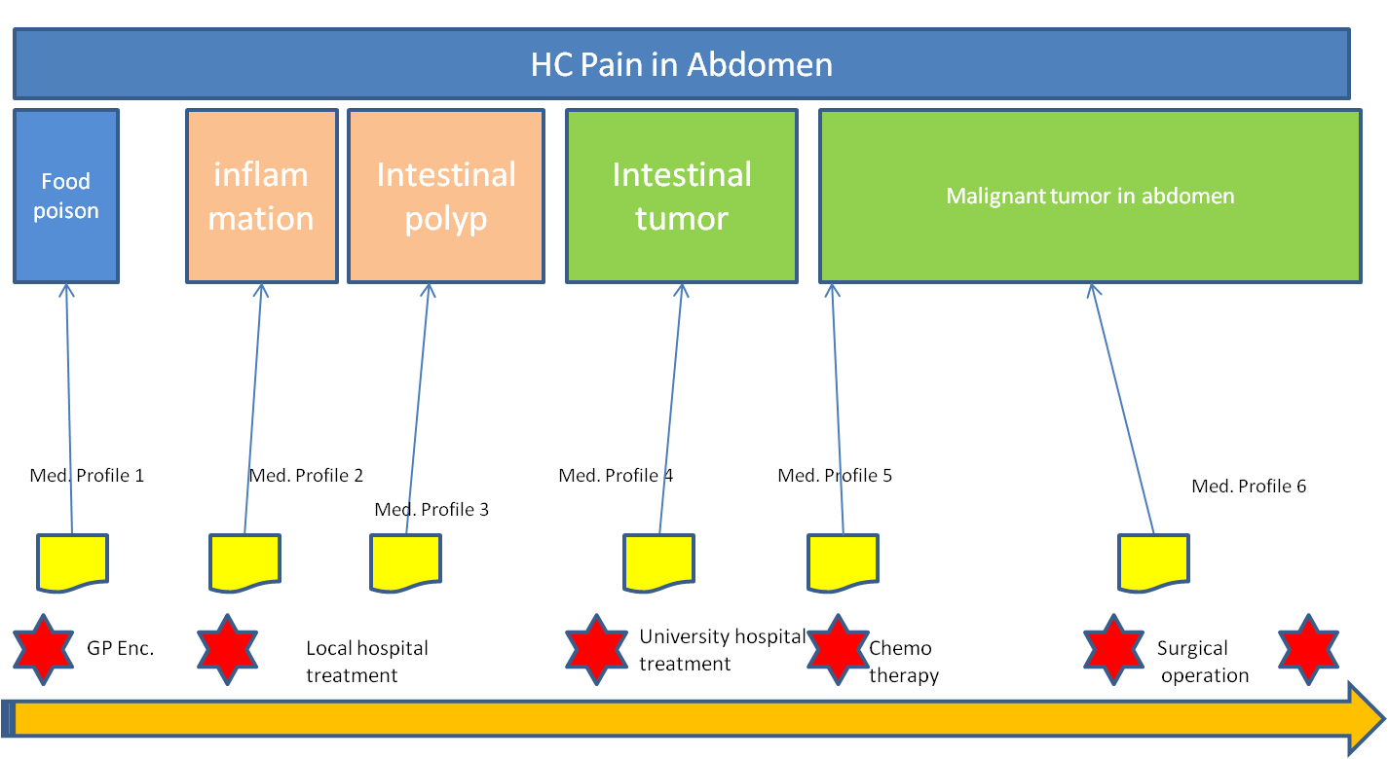

Figure 7 - Longitudinal view health concerns

The first diagnosis of the GP is food poisoning. Medication is given for diarrhea and food poisoning. The vomiting and pain still remain after 3 weeks. The GP suspects some inflammation in the abdomen. New medication is given and meanwhile the boy is referred to the general hospital.

If health concerns were track across the GP visits/encounters:

The initial diagnosis (abdominal pain for investigations or food poisoning) will be flagged in the GP EMR as health concerns and linked to supporting data such as presenting complaints, physical examination findings (signs, symptoms) and treatment data.

The changed diagnosis (e.g. inflammatory bowel disease) would also be flagged and linked to support data identified during the second visit.

The health concern data from both visits will be linked and can then be tracked.

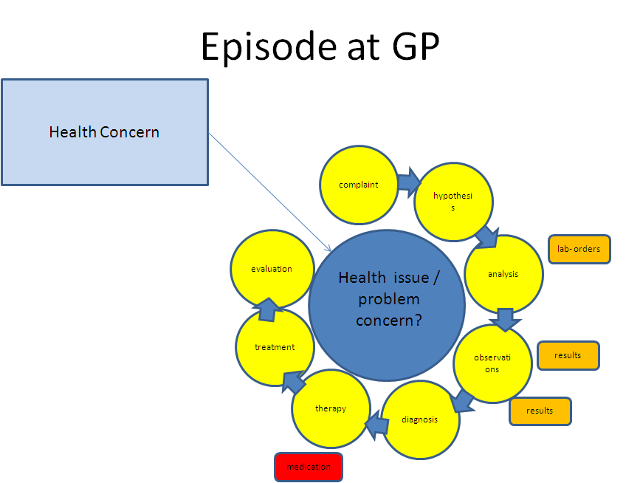

Figure 8 - Events and flow primary care

The general hospital investigates a possible inflammation, but does not find the cause. The hypothesis changes to a possible polyp in the intestines. Meanwhile Ricardo is severely weakened and is put on tube feeding. The scans are showing no results. Six months have passed since the initial complaints.

Figure 9 - Events and flow general hospital, while reflecting back at concerns within the primary care

The parents have no confidence in the general hospital and consult their GP. The GP updates his records and concerns. The GP advices them to consult the university hospital and helps them with the referral. The medical records with the suspected concerns are submitted to the university hospital. The physician suspects an intestinal tumor, but the scans show no results. Finally after 8 months they find the cause of the problems: a malignant tumor in the abdomen.

Figure 10 - Events and flow in University hospital, while reflecting back at concerns in the past

Ricardo is being treated with chemo therapy, but the therapy is not successful. The physician decides for surgery to remove the malignant tumor. The surgery showed that the cancer has spread over a large part of the abdomen. The physician removes as much malignant tissue, but concludes that the situation is too grave to be saved. Ricardo is brought home and the doctors give him 2 months to live. A transfer of care document is sent to the GP to support Ricardo with the palliative care. The GP updates his records and concerns. Ricardo celebrates his last birthday (23d) with his family and friends. On the 14th of June 2013 he passes away.

**Health Concern Tracking – the chronological events**:

* The starting health concern is ***pain in abdomen***. This is the view from the patient and is retrospective from the time the condition is flagged as a health concern and when a decision to track the health concern is made.
* The GP thinks it is food poisoning. The *problem concern* would then be identified or assigned as ***food poisoning***.
* The treating physician at general hospital suspects at first an inflammation of the abdomen. The *concern* could be changed to abdominal ***inflammation or inflammatory bowel disease***.
* After investigation the treating physician revised their findings and suspects an intestinal polyp in the large intestine. The problem concern would then be changed to ***intestinal polyp***.
* The university hospital physician reviewed the results and are convinced that the problem is an intestinal tumor. The problem concern is then ***intestinal tumor.***
* An endoscopic procedure identifies the location of the tumor and the histo-pathology test result leads problem concern to be set to ***malignant tumor in upper region of abdomen.***
* The overarching health concern (pain in abdomen) is the view from a patient. The patient does not have a system to enter this input.
* Most probably the care providers will define the problems like inflammation as their health concerns.

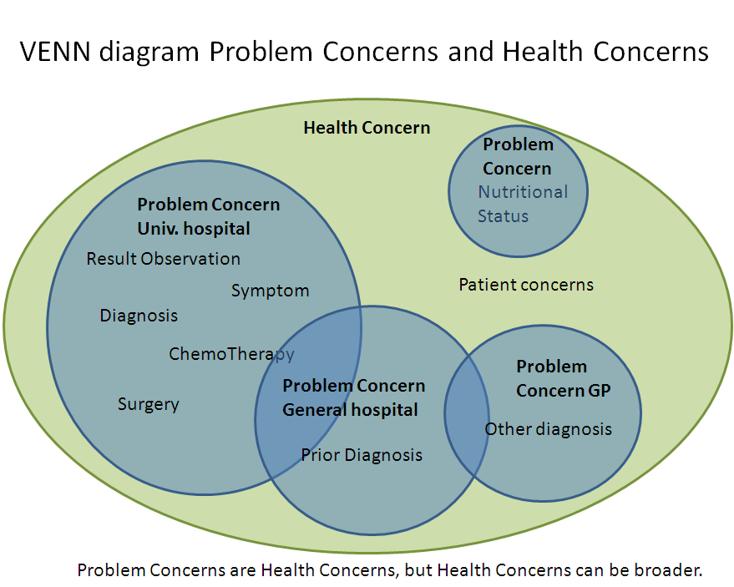

Figure 11 – Venn diagram of health concern and problem concern

## Patient Journey Scenario 2 - Concern for Cancer with Tracking to Observations of Others (Jolie, 2013)

This scenario describes a story in which concerns link to the medical history of another patient.

**Background**

* Healthy 38 year old actress.
* Observation 1: Mother diagnosed and died of cancer
* Observation 2: BRCA-1 gene positive.
* Patient is concerned of the high risk of cancer.

**The Article**

My mother fought cancer for almost a decade and died at 56. She held out long enough to meet the first of her grandchildren and to hold them in her arms. But my other children will never have the chance to know her and experience how loving and gracious she was.

We often speak of “Mommy’s mommy,” and I find myself trying to explain the illness that took her away from us. They have asked if the same could happen to me. I have always told them not to worry, but the truth is I carry a “faulty” gene, BRCA1, which sharply increases my risk of developing breast cancer and ovarian cancer.

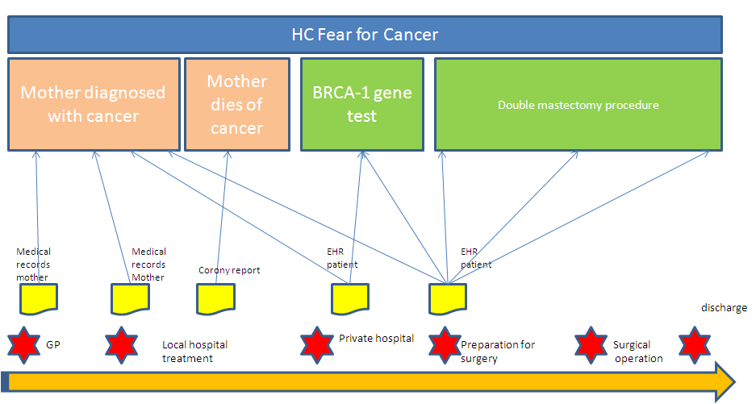

Figure 12 - Time line with reference to other medical records

My doctors estimated that I had an 87 percent risk of breast cancer and a 50 percent risk of ovarian cancer, although the risk is different in the case of each woman. Only a fraction of breast cancers result from an inherited gene mutation. Those with a defect in BRCA1 have a [65 percent](http://cancer.stanford.edu/information/geneticsAndCancer/types/herbocs.html) risk of getting it, on average. Once I knew that this was my reality, I decided to be proactive and to minimize the risk as much I could. I made a decision to have a [preventive double mastectomy](http://www.cancer.gov/cancertopics/factsheet/Therapy/preventive-mastectomy). I started with the breasts, as my risk of breast cancer is higher than my risk of ovarian cancer, and the surgery is more complex.

On April 27, I finished the three months of medical procedures that the mastectomies involved. During that time I have been able to keep this private and to carry on with my work. But I am writing about it now because I hope that other women can benefit from my experience. Cancer is still a word that strikes fear into people’s hearts, producing a deep sense of powerlessness. But today it is possible to find out through a blood test whether you are highly susceptible to breast and ovarian cancer, and then take action.

My own process began on Feb. 2 with a procedure known as a “nipple delay,” which rules out disease in the breast ducts behind the nipple and draws extra blood flow to the area. This causes some pain and a lot of bruising, but it increases the chance of saving the nipple.

Two weeks later I had the major surgery, where the breast tissue is removed and temporary fillers are put in place. The operation can take eight hours. You wake up with drain tubes and expanders in your breasts. It does feel like a scene out of a science-fiction film. But days after surgery you can be back to a normal life.

Nine weeks later, the final surgery is completed with the reconstruction of the breasts with an implant. There have been many advances in this procedure in the last few years, and the results can be beautiful.

I wanted to write this to tell other women that the decision to have a mastectomy was not easy. But it is one I am very happy that I made. My chances of developing breast cancer have dropped from 87 percent to under 5 percent. I can tell my children that they don’t need to fear they will lose me to breast cancer.

It is reassuring that they see nothing that makes them uncomfortable. They can see my small scars and that’s it. Everything else is just Mommy, the same as she always was. And they know that I love them and will do anything to be with them as long as I can. On a personal note, I do not feel any less of a woman. I feel empowered that I made a strong choice that in no way diminishes my femininity.

I am fortunate to have a partner, Brad Pitt, who is so loving and supportive. So to anyone who has a wife or girlfriend going through this, know that you are a very important part of the transition. Brad was at the [Pink Lotus Breast Center](http://www.pinklotusbreastcenter.com/), where I was treated, for every minute of the surgeries. We managed to find moments to laugh together. We knew this was the right thing to do for our family and that it would bring us closer. And it has.

**Health Concerns**

* Fear of cancer

**Problem concerns**

* Fear for breast cancer.
* Fear for ovarian cancer.

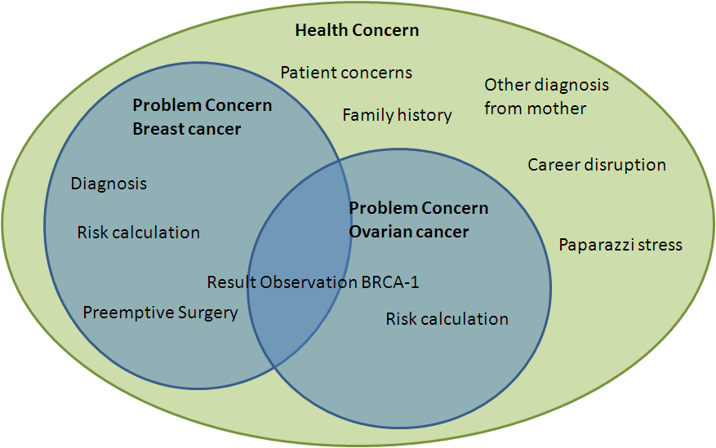

Figure 13 - Venn Diagram breast cancer concern

## Patient Journey Scenario 3 - Conflicting Interventions

This scenario illustrates multiple concerns with conflicting interventions.

My Father is 87 years old. He lives in a Memory Care Center because he has vascular dementia. He also has congestive heart failure, has had quadruple by-pass surgery (in 2007), and now has a pace maker (in 2011). I am his legal guardian and his healthcare power of attorney.

Dad has very bad back pain. It keeps him from moving around much, and consequently he spends a lot of time sitting in his room by himself. This is not good for his quality of life. He is much happier when he is up and about and participating in activities with other residents. His PCP prescribed Celebrex for his back pain. After taking this medication for four weeks, he was getting noticeable relief and was spending more time walking outside of his room and partaking in activities. At his 6-month check-up with his Cardiologist, the Celebrex was discontinued due to concomitant risks of use. Dad takes Warfarin, so the Cardiologist was concerned the Celebrex could increase Dad’s risk of bleeding complications. The

Cardiologist was also concerned that the Celebrex could decrease the effectiveness of the ACE Inhibitor medication that Dad takes. When the nurses at the Memory Center got the order to discontinue Celebrex, they destroyed the remaining 2-month’s supply of the medication. (Dad’s insurance company requires that all medications are filled via mail-order with a 3-month’s supply.)

At the 6-week follow-up visit with his PCP, Dad said his back was feeling better for a while and he was happy about doing a few more activities, but explained that lately he was feeling more pain again. The PCP explained the risks to me (I take Dad to all his appointments). We agreed that concerns about Dad’s pain and low enjoyment of life, outweighed the concerns about the risks associated with the potential complications. The PCP provided orders for Dad to go back on the Celebrex. The nurses at the Memory Care Center ordered another 3-month’s supply.

Two weeks later, when the Cardiologist reviewed Dad’s medical record to check on the recent lab results and INR levels, he noticed that Dad’s medication list included Celebrex and he ordered it to be discontinued. The nurses destroyed the supply of Celebrex a second time.

A week later when I came to visit, Dad’s back was really bothering him. I checked his medication log and noticed that he was not being given any Celebrex. I asked the nurses why and they told me the Celebrex order had been discontinued.

I’m concerned. I don’t know how to communicate effectively about our choices regarding these trade-offs. I need a way to explain to the whole care team our decision to accept the risks associated with taking this medication, so that Dad’s life can be more enjoyable, even if that means it might be shorter. What point is there for Dad to live longer, if he can’t engage in activities and be free from pain? I am concerned about how to resolve the doctor’s conflicting points of view. I am also concerned about the cost of the medications that are being wasted.

## Patient Journey Scenario 4 - Structured Primacy Care Approach

This scenario is to illustrate how Primary Care providers in the Netherlands organize their information.

The General Practitioners in the Netherlands work according to a highly structured method which is set as guideline for the practitioners for working with their EHR. IT systems for the GP's are certified against the reference information model of the GP association. Using the same reference information model makes access to an EHR more transparent and transfer from one system to another more simple.

The structure of the information model reflect a problem oriented approach. This is called the Problem Oriented Registration ( POR) . The characteristics of this POR is very much similar to the health concern topic. Another word frequently used in this context is the Episode Oriented Registration. Somewhere along the line this last word seemed to be preferred above a POR and the GP's often talk about the episode list of a patient, probably because the GP's first screen should give a quick dashboard view of the patients episodes in time from which you can drill down to retrieve more detailed information. Let run through a use case which took place in January 2014 of John Doe visiting his general practitioner.

John visits his GP dr. Pil because he has trouble breathing and coughing. The GP looks at John's medical records, which displays episodes of concerns. John has a long medical history and on the active health concerns are displayed on the top part of the screen, while health concerns that are no longer open are displayed under the category: terminated episodes.

The active health concerns are gastritis, problems with work, malaria prophylaxis and tuberculosis. The heading of the health concerns contain a description of the problem, and also an ICPC code ( International Classification of Primary Care) . John Doe has been on holiday in Tanzania and has been coughing since he returned. John has been referred to the pneumonologist Dr. Lung from the hospital where he has been diagnosed for tuberculosis and has been treated with Rifinah.



**The consult is also registered under this episode. To speed up the analysis Dr. Pil has written an order to the radiologist of the X-ray Diagnostic Centre to make a n X-ray of John's lungs. The result was also sent to Dr. Lung. Dr. Pil instructs the X-ray centre to include the health concern reference number in the identity of the results.**

**The diagnosis of Dr. Lung was this was not an open TBC and a six month cure should relief John from his TBC. In November John complained about gastritis to Dr. Pil. This could be caused by the Refinah medication and therefore Dr. Pil decided to adjust the medication and change to a different brand.**

**Although the gastritis might be linked to the episode of TBC Dr. Pil decided to register it under a separate concern identifier.**

**The last note from the pulmonologist is from November 2013 from the regular check-up of John. It showed that the situation of TBC was under control.**

**The cold and windy winter months were now heading and Dr. Pil decided to give John an influenza vaccine to prevent John from getting the flu. The main reason is John has been diagnosed for TBC and influenza could be disastrous for John. The vaccine is therefore also noted under the episode of TBC.**

**Health concerns can contain a attention flag. This flag can be seen as a reminder even if an episode has been terminated. The fact that Jan Janssen has had TBC has already been flagged since his first encounter with TBC.**

# ****APPENDIX III – Comparison of Use of “Health Concern” Concept****

| **Concept** | **HL7 Health Concern DAM** | **HL7 C-CDA R2** | **ISO/CEN** |
| --- | --- | --- | --- |
| **Health Concern Definition** | A Health Concern is a health related matter that is of interest, importance or worry to someone. This may be the patient, the patient's family or a patient's health care provider. | Note – there is a Health Concern Section containing a Health Concern Act – *The Health Concern Section* is a wrapper for a single health concern which may be derived from a variety of sources within an EHR (such as Problem List, Family History, Social History, Social Worker Note, etc.). | ISO Contsys defines “Health Issue” (synonym: “health concern”) (Section 6.1.3 )as:  health issue which defines and labels associations between specific health issue  included with this obscure definition are additional notes:  NOTE 3 In other standards the concept of ―concern‖ is used. A concern is said to have a focus of attention. The concept ― “interest” in this standard is equivalent to the concept ― “concern” in those other standards. |
| **Health Concern Event/Observation** | *Health Concern Event*  The identification of a health concern or a risk. The event may involve observation, risk assessment, risk monitoring, or assessment of a condition, an intervention or a goal. | A *Health Concern Act* is used to track non-optimal physical or psychological situations drawing the patient to the health care system. These may be from the perspective of the care team or from the perspective of the patient. Has multiple entry level templates including problem concern act and problem observation. Risk is documented in a separate template. |  |
| **Health Concern Tracking** | A Health Concern or a set of related health concerns (expressed as issue(s), condition(s), problem(s), diagnosis/diagnoses, risk(s), barrier(s)) are linked to a set of supporting information including complaints (by patient and/or patient family), signs, symptoms, diagnostic findings through health concern tracking  Other related topics such as goal(s), preference(s) and intervention(s) [and their related observations/evaluations] may also be linked to health concern(s) through the health concern tracking. | **A** C-CDA document is by definition a snapshot in time – the health concern act is not dynamic. Health concerns may have relationships. | “Health Issue Thread” (Section 6.2):  defined association between *health issues* and/or *health issue treads*, as decided and labelled by one or several *health care actors* |
| **Health Concern Risk** | A type of health concern event (considered to be equivalent to a condition that is a health concern event. A risk can be assessed, may have an intervention and can be monitored – but is not on the problem list. | Risk concern act – It is a wrapper for a single risk concern which may be derived from a variety of sources within an EHR (such as Problem List, Family History, Social History, Social Worker Note, etc.).  A Risk Concern Act represents a health concern that is a risk. A risk is a clinical or socioeconomic condition that the patient does not currently have, but the probability of developing that condition rises to the level of concern such that an intervention and/or monitoring is needed. | “Risk Condition” (Section 6.1.2.2.4):  “*possible health condition* representing an undesirable future *health state*” |
| **Relationship of problem** | Not all health concerns are problems. Not all conditions or problems are considered health concerns. A health concern may be an item/entry on a problem list. A health risk is not be included a problem list (e.g. risk of diabetic retinopathy is not included on patient’s problem list). | The Problem section lists and describes all relevant clinical problems at the time the document is generated. At a minimum, all pertinent current and historical problems should be listed. Overall health status may be represented in this section. Entry level templates associated with the problem section include problem concern and health status observation. |  |
| **Relationship of Problem Concern Act** | No equivalent concept | The Problem Concern Act template reflects an ongoing concern on *behalf of the provider* that placed the concern on a patient’s problem list. So long as the underlying condition is of concern to the provider (i.e. as long as the condition, whether active or resolved, is of ongoing concern and interest to the provider), the statusCode is “active”. Only when the underlying condition is no longer of concern is the statusCode set to “completed”. |  |
| **Problem Observation** |  | The problem observation template reflects a discrete observation about a patient's problem. Because it is a discrete observation, it will have a statusCode of "completed". The effectiveTime, also referred to as the “biologically relevant time” is the time at which the observation holds for the patient. For a provider seeing a patient in the clinic today, observing a history of heart attack that occurred five years ago, the effectiveTime is five years ago. |  |