greenCDA.xml
v0.4 January 13, 2010

A White Paper from Alschuler Associates, LLC and Semantically Yours, LLC
for Discussion within the CDA Community of Users and Developers

Introduction 1
What does it mean to be green? And who is the target audience? 2
greenCDA using the CCD Problem Act 2
Process flow 4
Method for designing greenCDA schema modules 5
CCD Problem Act: Full CDA 7
Schema for a “Problem Report” document type 9
Discussion topics/Next steps 11

Queries and requests for the working files can be sent to: greenCDA@alschulerassociates.com

Introduction
The full specification of CDA XML addresses universal requirements for exchange and management of structured clinical documents. This project maintains the full utility of the current CDA.xml while exploring one method of working with an implementation-specific XML.
The approach we describe here simplifies instance creation while it asserts as a primary principle that any simplification must also deliver valid, normative CDA.
Our experience so far is that every person with an interest in the topics of easier or simpler CDA has at least a few concrete ideas and assumptions about what easier and simpler mean and how to achieve them. For good discussion, it’s important to make the assumptions explicit. Alschuler Associates, LLC, and Semantically Yours, LLC offer this White Paper in this spirit and hope that it stimulates discussion and further experimentation.
We call this “green CDA” because it’s good for the environment!

What does it mean to be green? And who is the target audience?
For a first demonstration we adopted and documented specific premises about who is to benefit and what it means to be green. To begin with, we assert that:
- A greenCDA schema will
  - have a shorter learning curve and yet can deliver valid CDA.
  - be easier to work with for instance generation
- The beneficiaries – the people who get the shorter learning curve and the easier model to work with – are developers who must accept or generate CDA, and who do not know CDA or the RIM.
In creating a small sample we ran into some big-picture questions about goals and approaches, which we document in the final section of this paper.
Please keep in mind the audience definition – people who don’t know CDA or the RIM. This effort will be evaluated in the first instance by people who do know CDA and CCD very well indeed, and to this first audience, the approach may seem unusual at first blush.

greenCDA using the CCD Problem Act
The schema and sample document today demonstrate these characteristics of green:

1. Rigorous
Premise: Automated conversion to normative CDA must be a core capability.
Resolution: (1) Establish a methodology for simplification. (2) Accompany the model with a transform to full CDA that reverses the simplification operations.

2. Modular
Premise: Implementers need schemas specific to a document type.
Premise: The re-useable unit in a CDA IG is a template for a clinical statement.
Resolution: Express templated clinical statements as schema modules; create section and document schemas ( “Problems Report”, “Discharge Summary” schema) that call in these schema modules.

3. 80% solution
Premise: To have all CDA features, use CDA! A greenCDA is an 80% solution.
Resolution: (1) Address what we believe is in common usage. (2) Gather data on what is 80%.
Mitigation: Extensibility must be a core capability.
Mitigation: Keep working on the methodology with the CDA community of users.

4. Clinical/localization
Premise: Element and attribute names should reflect content semantics not the CDA RMIM class.
Resolution: Name elements and attributes for specific clinical meaning not the abstract model (e.g., “condition” not “problem”, “physician” not “performer”).
Mitigation: The architecture may use types for common patterns (id, code, name, time).
Mitigation: The architecture must support localization

5. Documented
(Actually we’re not demonstrating this yet....) The schema must be self-documenting. There are commercial and open-source tools to create linked HTML documentation pages from schema documentation elements. It’s even possible to include transform segments in the schema documentation element.
The schema documentation will record the relationship between a greenCDA module and the full-CDA template from which it was derived, and be able to produce indexes, e.g.,
ProblemSet ... CCD Problem Act (2.16.840.1.113883.10.20.1.27)

6. Gentle learning curve
Some aspects of green, such as having a single schema to work with all its parts in plain view, are addressed above. Technical aspects of green include rules such as collapsing nesting levels that carry no distinguishing data after the 80% rule has been applied. The approach includes ordinary normalization techniques from data modeling practice. Some principles are illustrated in “Designer’s methodology” below. A completed design methodology will articulate them.

7. No burden on others
It is not OK for green to place a burden, such as transformation to full CDA, on others.

Process flow
The diagram below shows the design process which combines implementation-specific requirements with the normative CDA and a repository of CDA templates. The result are implementation-specific (green) instances, samples, transforms and schemas. Note that this is the same process used today to create implementation specific Schematron rule sets. The green process combines the implementation-specific *.sch rules with a simplified CDA xsd.

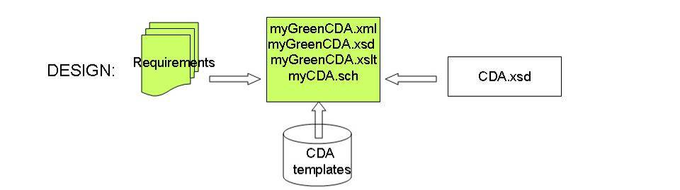

The following diagram shows how the green artifacts work locally to produce a normative CDA (myCDA.xml) that is conformant with CDA R2 and can be validated against the implementation-specific rules (myCDA.sch), as is commonly done today. Or, the recipient in a pre-negotiated exchange might choose to accept the sender’s greenCDA.

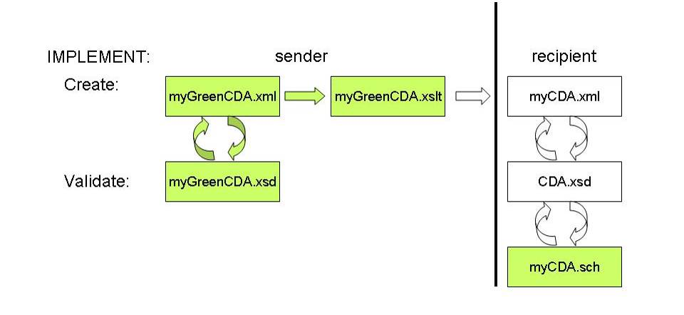

Method for designing greenCDA schema modules

Start with a clinical statement. We used “CCD Problem Act”.
- Mark up the template – Identify what the transform will generate automatically:
  - Fixed characteristics: the transform can generate these
  - Required but typically no data available, two kinds:
    - the transform should generate with nullFlavors or equivalent
    - the transform should generate with nullFlavor IF not present
  - Optional and typically absent: exclude from model
- What remains unmarked is data that the greenCDA model needs to support.
- Name elements for their meaning (semantics) not for their derivation from the RIM. Example: ProblemAct → ProblemSet.
- Identify singleton elements that have no element children, and make them attributes.

Marking up CCD: This greenCDA Module supports Problem Observations in a Problem Section.
Blue = fixed = the transform can generate
Pink = required but typically nullFlavored in our environment
Yellow = an option not to be supported in the greenCDA Model for our environment

A problem act (templateId 2.16.840.1.113883.10.20.1.27) SHALL be represented with Act.
The value for “Act / @classCode” in a problem act SHALL be “ACT” 2.16.840.1.113883.5.6 ActClass STATIC.
The value for “Act / @moodCode” in a problem act SHALL be “EVN” 2.16.840.1.113883.5.1001 ActMood STATIC.
A problem act SHALL contain at least one Act / id.
The value for “Act / code / @NullFlavor” in a problem act SHALL be “NA” “Not applicable” 2.16.840.1.113883.5.1008 NullFlavor STATIC.
A problem act MAY contain exactly one Act / effectiveTime, to indicate the timing of the concern (e.g. the interval of time for which the problem is a concern).
A problem act SHALL contain one or more Act / entryRelationship.
A problem act MAY reference a problem observation, alert observation (see section Error: Reference source not found) or other clinical statement that is the subject of concern, by setting the value for “Act / entryRelationship / @typeCode” to be “SUBJ” 2.16.840.1.113883.5.1002 ActRelationshipType STATIC.
The target of a problem act with Act / entryRelationship / @typeCode=”SUBJ” SHOULD be a problem observation (in the Problem section) or alert observation (in the Alert section, see section ...), but MAY be some other clinical statement.

With those principles & methodology, you get something like this –
<ProblemReport>
<!-- DocumentInformation here ... -->

<PatientInformation>
<Patient birthDate="197304030454-0800" gender="M">
<Id idAuthority="patientIdAuthority"
idValue="patientIdValue"/>
<Name>
<Given>Henry</Given>
<Family>Levin</Family>
<Suffix>the 7th</Suffix>
</Name>
</Patient>
</PatientInformation>

<!-- EncounterInformation here ... -->

<ProblemSet>
<TimeRange start="20091124" end="20091126"/>
<Problem status=”55561003”
healthStatus=”271593001”
age=”27” ageUnit=”y”>
<TimeRange start="20091125" end="20091126"/>
<Topic codeSystem="2.16.840.1.113883.6.96"
code="233604007"/>
</Problem>
</ProblemSet>

</ProblemReport>

The corresponding full-CDA Problem Act is shown on the next pages. The data shown in the greenCDA example above is marked in bold.

CCD Problem Act: Full CDA

<!-- Problem Act -->
<act classCode="ACT" moodCode="EVN">
<templateId root="2.16.840.1.113883.10.20.1.27"/>
<id nullFlavor=”NA”/>
<code nullFlavor="NA"/>
<effectiveTime>
<low value="20091124"/>
<high value="20091126"/>
</effectiveTime>
<!--Problem-->
<entryRelationship typeCode="SUBJ">
<observation classCode="OBS" moodCode="EVN">
<templateId root="2.16.840.1.113883.10.20.1.28"/>
<code code="ASSERTION" codeSystem="2.16.840.1.113883.5.4"/>
<statusCode code="completed"/>
<effectiveTime>
<low value="20091125"/>
<high value="20091126"/>
</effectiveTime>
<value xmlns:xsi="http://www.w3.org/2001/XMLSchema-instance"
xsi:type="CD"
codeSystem="2.16.840.1.113883.6.96"
codeSystemName="SNOMED CT"
code="233604007"
displayName="Pneumonia"/>
<!--Problem Status-->
<entryRelationship typeCode="REFR">
<observation classCode="OBS" moodCode="EVN">
<templateId root="2.16.840.1.113883.10.20.1.50"/>
<code codeSystem="2.16.840.1.113883.6.1"
codeSystemName="LOINC" code="33999-4"/>
<statusCode code="completed"/>
<value xmlns:xsi="http://www.w3.org/2001/XMLSchema-instance"
xsi:type="CE"
codeSystem="2.16.840.1.113883.6.96"
codeSystemName="SNOMED" code="55561003"/>
</observation>
</entryRelationship>
<!--Health Status-->
<entryRelationship typeCode="REFR">
<observation classCode="OBS" moodCode="EVN">
<templateId root="2.16.840.1.113883.10.20.1.57"/>
<code codeSystem="2.16.840.1.113883.6.1"
codeSystemName="LOINC"
code="33999-4"/>
<statusCode code="completed"/>
<value xmlns:xsi="http://www.w3.org/2001/XMLSchema-instance"
xsi:type="CE"
codeSystem="2.16.840.1.113883.6.96"
codeSystemName="SNOMED CT"
code="271593001"/>
</observation>
</entryRelationship>
<!--Age-->
<entryRelationship typeCode="SUBJ">
<observation classCode="OBS" moodCode="EVN">
<templateId root="2.16.840.1.113883.10.20.1.38"/>
<code codeSystem="2.16.840.1.113883.6.96"
codeSystemName="SNOMED CT"
code="397659008"/>
<statusCode code="completed"/>
<value xmlns:xsi="http://www.w3.org/2001/XMLSchema-instance"
xsi:type="PQ"
codeSystem="2.16.840.1.113883.6.96"
codeSystemName="SNOMED"
value="27"
unit=”y”/>
</observation>
</entryRelationship>
</observation>
</entryRelationship>
</act>

Schema for a “Problem Report” document type
To explore this approach and methodology, we created a schema, a valid document instance, and a transform to full CDA. We ran into a few big-picture questions that need discussion, so some parts of the transform are hard-coded at the moment.
The top-level ProblemReport has only a few lines, shown below.
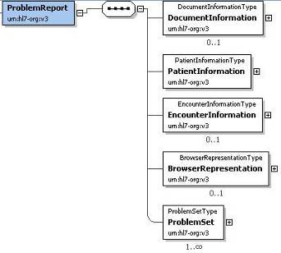

Note 1: In a completed schema, DocumentInformation would not be optional. This element includes the document id, document code, author, custodian, and other document-level information.
Note 2: This model corresponds to a CDA document that contains a single problem section. The section is thus a fixed characteristic of the model and so can be generated by the transform to enclose the BrowserRepresentation and ProblemSet.
The top-level schema could instead call on modules for named section types – ProblemSection, VitalSignsSection, and so on, which in turn call on the appropriate clinical statements (entries).

<?xml version="1.0" encoding="UTF-8"?>
<xs:schema xmlns:xs="http://www.w3.org/2001/XMLSchema"
xmlns="urn:hl7-org:v3"
targetNamespace="urn:hl7-org:v3"
elementFormDefault="qualified">

<xs:include schemaLocation="modules/greenCDA_datatypes.xsd"/>
<xs:include schemaLocation="modules/greenCDA_header.xsd"/>
<xs:include schemaLocation="modules/greenCDA_browserRepresentation.xsd"/>
<xs:include schemaLocation="modules/myGreenCDA_problemSet.xsd"/>

<xs:element name="ProblemReport">
<xs:complexType>
<xs:sequence>
<xs:element name="DocumentInformation"
type="DocumentInformationType"
minOccurs="0" maxOccurs="1"/>
<xs:element name="PatientInformation"
type="PatientInformationType"
minOccurs="1" maxOccurs="1"/>
<xs:element name="EncounterInformation"
type="EncounterInformationType"
minOccurs="0" maxOccurs="1"/>
<xs:element name="BrowserRepresentation"
type="BrowserRepresentationType"
minOccurs="0" maxOccurs="1"/>
<xs:element name="ProblemSet"
type="ProblemSetType"
minOccurs="1" maxOccurs="unbounded"/>
</xs:sequence>
</xs:complexType>
</xs:element>

</xs:schema>

Discussion topics/Next steps
- Methodology and module design.
    - Bringing more modules into scope will refine and articulate the design methodology. What should be done next?
    - Must everyone in the world use the same greenCDA module for a template?
      - There’s no obvious requirement for that so far – the key requirement is that the module is documented and the simplification reversible such that valid full-CDA can reliably be generated from an instance.
      - User requirements differ – the best design for data entry might capture data as element content, whereas the best design for export from a database might capture data as attribute values. Also, database table designs differ – goes to the question of optimal design for local use also.

- 80% solution. Extensibility allows us to define modules that cover the most common usages while local needs can be handled by conformant localization. How can we identify which parts of a CCD template are the 80% solution and which parts were special-needs requirements?

    - How much of what’s implicit from base CDA also is normally needed by a template? e.g., the optional substanceAdministration/routeCode is not constrained by a CCD template, but it’s likely to be used in document instances.
    - Which templates were created in an IG for historical reasons but are not currently common cases?

- Modularity. What is the need exactly – a schema for a generic CCD document that can handle anything that any CCD document could ever contain, or schema modules corresponding to trimmed-down CCD templates that can be assembled into report types?

    - Could modules be automatically generated from a template definition?
    - Would it be sufficiently green to include every detail of a published template – all the CDA requirements, as constrained by the template, even fixed values and values not locally needed – using CDA elements? Is this a different use case?

- Sample documents. We need to work with actual samples.

- When (if ever) would sending greenCDA be acceptable? –
    - under what pre-conditions?
    - what benefit if any would accrue to the receiver?

- Extent of auto-generation from Tdb
    - where does integration of local requirements fit
    - requires modules

- Feasibility of uni- and bi-directional transform between green & fullCDA

