**NBS HL7 Workgroup Meeting Call Notes**

**June 27 2017**

**Attendees:** Riki Merrick, Ashleigh Ragsdale, Susan Downer, Brendan Reilly, Kaitlin Houlihan, Emily Hopkins, Rhoda West, Careema Yusuf

* Reviewed ballot comments and responses from states for both the [LOI](https://www.aphlweb.org/cmt/nbsgph/NSSC/HL7/Shared%20Documents/V251_IG_LABORDERS_R1_D3_2017MAY_Consolidated_NBS_20170627.xlsx) and [LRI](https://www.aphlweb.org/cmt/nbsgph/NSSC/HL7/Shared%20Documents/V251_IG_LABORDERS_R1_D3_2017MAY_Consolidated_NBS_20170627.xlsx) documents
* There was a question specific to the CLIA requirement on the information required for the ordering provider and how NBS programs are currently using these fields (see CLIA requirement below). Riki, Brendan and Kaitlin will join the July 11 HL7 ballot reconciliation call to discuss this further.

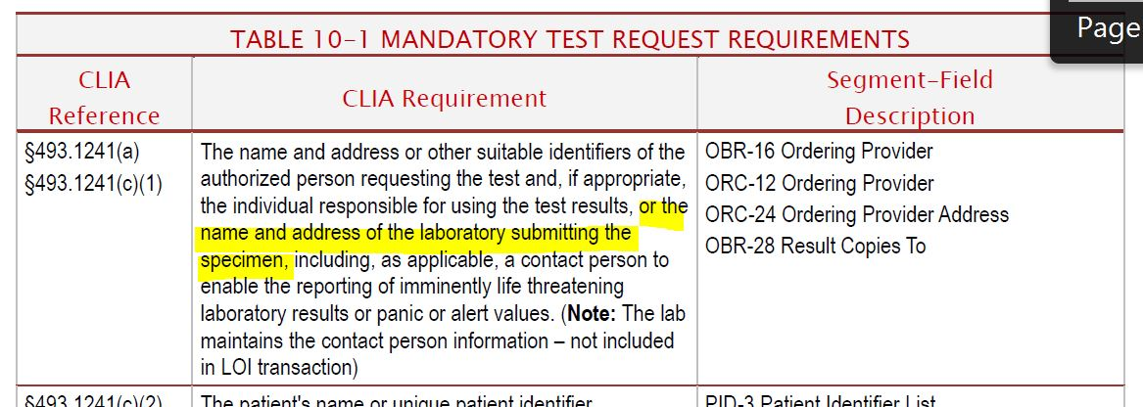

* Next call: July 11 2017 at 2pm ET.