Orders & Observations Conference Call

11 January 2017

+1 770 657 9270, Passcode: 398652#

WebURL: https://join.me/vernetzt.us

Attendees:

 | Name | Organization
1 | Kathy Walsh | LabCorp
2 | Riki Merrick | Vernetzt, LLC / APHL
3 | JD Nolen | Cerner
4 | Andrea Pitkus | IMO
5 | Rob Hausam | Hausam Consulting
6
7
8
9
10
11
12
Regrets:

Co-Chair: Riki Merrick
Scribe: Riki Merrick

Agenda/Minutes:
- Agenda Review
- Approve minutes – defer until we have completed the spreadsheet
  - from May 6, 2016: : http://wiki.hl7.org/index.php?title=File:SPM_Minutes_20160506_ConCall.docx
  - from May 27, 2016:http://wiki.hl7.org/index.php?title=File:SPM_Minutes_20160527_ConCall.docx
  - from June 3, 2016: http://wiki.hl7.org/index.php?title=File:SPM_Minutes_20160603_ConCall.docx
  - from June 10, 2016: http://wiki.hl7.org/index.php?title=File:SPM_Minutes_20160610_ConCall.docx
  - from June 17, 2016: http://wiki.hl7.org/index.php?title=File:SPM_Minutes_20160617_ConCall.docx
  - from June 24, 2016: http://wiki.hl7.org/index.php?title=File:SPM_Minutes_20160624_ConCall.docx
  - NO CALL ON July 1, 2016
  - From July 8, 2016: http://wiki.hl7.org/index.php?title=File:SPM_Minutes_20160708_ConCall.docx
  - From July 15, 2016: http://wiki.hl7.org/index.php?title=File:SPM_Minutes_20160715_ConCall.docx
  - From July 22, 2016: http://wiki.hl7.org/index.php?title=File:SPM_Minutes_20160722_ConCall.docx
  - From July 29, 2016: http://wiki.hl7.org/index.php?title=File:SPM_Minutes_20160729_ConCall.docx
  - From August 5, 2016: http://wiki.hl7.org/index.php?title=File:SPM_Minutes_20160805_ConCall.docx
  - From August 12, 2016 – NO Quorum
  - From August 19, 2016 – http://wiki.hl7.org/index.php?title=File:SPM_Minutes_20160819_ConCall.doc
  - From August 26, 2016 - http://wiki.hl7.org/index.php?title=File:SPM_Minutes_20160826_ConCall.doc
  - From September 2, 2016 – NO Quorum
  - From September 9, 2016 – No call
  - From September 16, 2016 - http://wiki.hl7.org/index.php?title=File:SPM_Minutes_20160916_ConCall.docx
  - From October 14, 2016 – NO Quorum
  - From October 28, 2016 – NO Quorum
  - From November 2, 2016 - http://wiki.hl7.org/index.php?title=File:SPM_Minutes_20161102_ConCall.docx
  - From November 9, 2016 - NO Quorum
  - From November 16, 2016 - NO Quorum
  - From December 14, 2016 - http://wiki.hl7.org/index.php?title=File:SPM_Minutes_20161214_ConCall.docx
  - From December 21, 2016 - http://wiki.hl7.org/index.php?title=File:SPM_Minutes_20161221_ConCall.docx

- Compare Specimen DAM to biologic specimen model in BRIDG - map specification source is BRIDG and the map to is specimen DAM
Spreadsheet http://www.hl7.org/documentcenter/public/wg/orders/Copy%20of%20Copy%20of%20BRIDG%20to%20Specimen%20DAM%20Mapping%20Spreadsheet%20as%20of%2020170111.xlsx

EA file is here:
http://www.hl7.org/documentcenter/public/wg/orders/V3_DAM_Specimen_R1_2014May-BRIDG_Discussions.zip
The spreadsheet:

Ballot document:
http://www.hl7.org/documentcenter/public/wg/orders/V3_DAM_Specimen_R2_INFORM_2017JAN_20161102.docx

Also Raj sent this file:
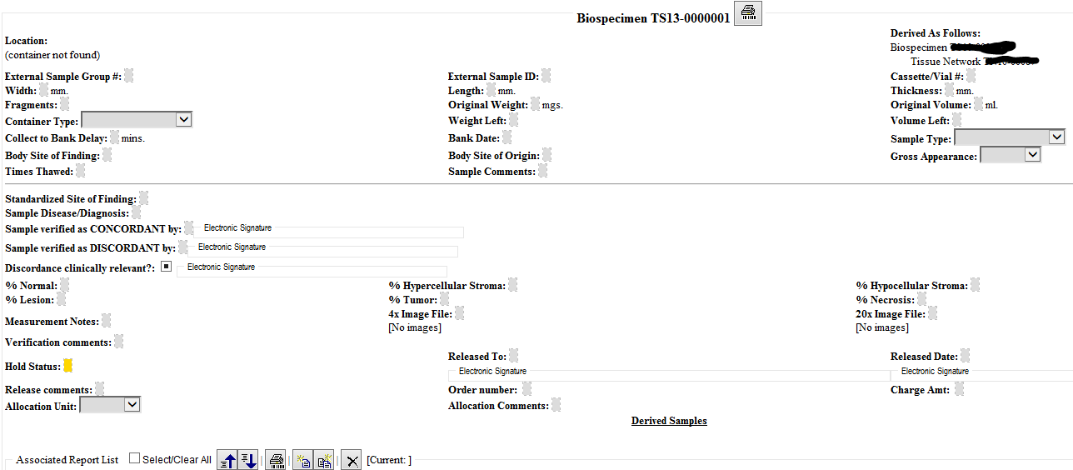

We have these items left in these classes:
- SpecimenCollectionProcedure
  - Accepted the mapping for Specimen Collection Procedure
  - Added elements for the previously approved SpecimenCollectionProcedure.targetAnatomicSitePortionCode
    - Issue with pre-coordinated terms in the qualifier hierarchy vs in the body structure hierarchy
    - Need to provide guidance how to approach this element together with the SpecimenCollectionProcedure.targetAnatomicSiteCode and SpecimenCollectionProcedure.targetAnatomicSiteQualifierCode,
as the notion of entire and part of are captured in the body structure concepts, but other elements potentially useful here like single or many are not – it would be beneficial to provide some suggestions for value sets here, but a thorough analysis of some complex target anatomic sites would have to be performed – not a priority prior to completing this document – so need to create good Notes highlighting the implementation decisions to consider here:
      - need to be specific about where the collection takes place
      - the qualifiers of many or single are more quantifiers vs giving more specific locations which seems to be needed for scoring – or do we need more a 4/5 kind of notation here?
      - For Prostate important which quadrant they are from => SpecimenCollectionProcedure.targetAnatomicSiteQualifierCode = topographical hierarchy
      - Is this here in order to define the protocol for the procedure? No it’s under performedProcedure in BRIDG, so is meant to record instances
      - Approve changes per spreadsheet entry
- Performer
  - Add attribute to the performer that allows designation of an associated organization to cover specimen collecting organization – maps to BRDIG collectingLaboratory element by associating it to specimenCollectionProcedure
  - Where in v2 would this be covered – This it is in OBR-10 in v2.5.1 and got moved to PRT segment in v2.7, which has been added following OBR, OBX and SPM (in ORU also after PV1, ORC)
- SpecimenMoveActivity
  - when nothing changes in the specimen – there are other processing activities that don’t result in new specimen, so need to verify in the EA model that the association between specimen and specimenProcessingActivity labeled “results in” has a cardinality of 0..*
  - since we are only concerned with the actual instance tracking, not the protocol creation should we rename this class to PerformedSpecimenMoveActivity – yes
  - cardinality should be 0..*
  - Approve this class
  - What attributes do we need: currenty BRIDGE has 3 to represent the different coordinates possible – we have a datatype that does this so have fromCoordinates and toCoordinates – hence one of our attributes maps to 3 BRIDG attributes
  - What about building location – we have geographicalLocation as a data type – currently an attribute of storageEquipment
  - Would a holder also need a geographicalLocation?
  - Would it be better to create a fromLocation and a toLocation attribute, that can use either the coordinates or the geographicalLocation dataytpes?
  - We already discussed adding SpecimenMoveActivity.TakenFromElementIdentifier, which is similar to have a fromEntity and a toEntity that can be referenced and you could reference the holder and the storageEquipment, which in turn have coordinates and geographicalLocation attributes?
  - Review the IHE Specimen Event Tracking (SET) profile for data elements that are required there, so but the attributes on hold for now
No call next week – next call 1/25/2017
Call adjourned 5:00 PM ET
- Specimen
- Datatype change for identifier (add type code into the datatype)
- StorageEquipment Parameter = Kathy working on this one – she said descriptions all there, so need to check if anything left

Some items from prior minutes, so check on these:
PerformedAdministrativeActivityVarianceReasonCode – proposed source change to add to SpecimenProcessingActivity and

specimenCollectionProcedure, IF we have a protocolReference (or SOP reference) there as well – yes will add that

PerformedAdministrativeActivityVarianceTypeCode - – proposed source change to add to SpecimenProcessingActivity and

specimenCollectionProcedure, IF we have a protocolReference (or SOP reference) there as well

TargetAnatomicSiteConditionCode – do we need this?

Subject.performingSpecimen – how should we represent when tissue from a tissue bank is a specimen – we think it would still fall under person, only de-identified, because currently our material is ONLY from non-living subject

Subject.performingSpecimen: find out if we need this

Specimen.containingSpecimenCollectionGroup – and related attributes

- Resources:
  - Link to BRIDG model: http://bridgmodel.nci.nih.gov/files/BRIDG_Model_4.0_html/index.htm - chose VIEW:BSP - biospecimen
  - Link to Specimen DAM: http://wiki.hl7.org/index.php?title=Specimen – scroll to bottom for image

