HL7 CDS WG Conference Call
25 April 2018, noon-1pm US ET

Attendees:
[ ] Denisha Abrams
[ ] Tomasz Adamusiak
[ ] Kurt Allen
[ ] Brian Alper
[ ] Rita Altamore
[ ] Michael Altmann
[ ] Joel Amoussou
[X] Lisa Anderson
[ ] Chad Armstrong
[ ] Noam Arzt
[X] Rebecca Baker
[ ] Kimberly Balliet
[ ] Jennifer Barrett
[ ] Cynthia Barton
[ ] Bilal Baydoun
[ ] Louis Bedor
[ ] Anna Bentler
[ ] Swapna Bhatia
[ ] Jaspreet Birk
[ ] Bridget Blake
[ ] Mike Bohl
[ ] Chris Bontempi
[ ] Keith Boone
[ ] Joe Bormel
[ ] Aziz Boxwala
[ ] Richard Boyce
[ ] Thompson Boyd
[ ] Bruce Bray
[ ] Jennifer Brush
[ ] Yiscah Bracha
[ ] Bruce Bray
[ ] Jennifer Brush
[ ] Russell Buchanan
[ ] Nathan Bunker
[ ] Anna Burchfield
[ ] Susan Campbell
[ ] Hector Cariello
[ ] Bob Carmichael
[ ] Lizzie Charbonneau
[ ] Daryl Chertcoff
[ ] Julia Chan
[ ] Quinn Chen
[ ] Myung Choi
[ ] Alex Connor
[X] Lorraine Constable
[ ] Sarah Corley
[ ] Angela Crovetti
[ ] Jacob Crump
[ ] Clayton Curtis
[ ] Nathan Davis
[X] Guilherme Del Fiol
[ ] John C. DeLong
[ ] Paul Denning
[ ] Gay Dolin
[ ] Karen Eberhardt
[X] Floyd Eisenberg
[ ] Richard Esmond
[ ] Maria Esquela
[ ] Elitsa Evans
[ ] Seena Farzaneh
[ ] Pavla Frazier
[ ] Robert Freimuth
[ ] Emory Fry
[ ] Krishna Gazula
[ ] Guy Ginton
[ ] Carol Graham
[ ] Matthew Greene
[ ] Michael Guarnaccia
[ ] Varadraj Gurupur
[ ] Marc Hadley
[ ] Shirin Haider-Zaidi
[ ] Claudia Hall
[ ] Steven Hardy
[ ] Peter Haug
[ ] Yan Heras
[ ] Bas van den Heuvel
[ ] Brent Hill
[ ] Lindsey Hoggle
[ ] Yanyan Hu
[ ] Stan Huff
[ ] Steve Hufnagel
[ ] Vojtech Huser
[ ] Bob Hussey
[ ] Andrew Iskander
[ ] Jesse James
[ ] Lenel James
[ ] Robert Jenders
[ ] Allen Johnson
[ ] Chris Johnson
[ ] Ken Kawamoto
[ ] Rosemary Kennedy
[ ] Lester Keeper
[ ] Jae Kim
[ ] Bill Kleinebecker
[ ] Stephanie Klepacki
[ ] Paul Knapp
[ ] Ryan Knepp
[ ] Mark Kramer
[ ] Adam Kroetsch
[X] Thomson Kuhn
[ ] Polina Kukhareva
[ ] Tammy Kuschel (LaFavor)
[ ] Sweta Ladwa
[ ] Peter Lamb
[ ] Robert Lario
[ ] Cindy Larson
[ ] Eric Larson
[ ] Oliver Lawless
[ ] Preston Lee
[ ] Victor Lee
[ ] David Lobach
[ ] Bill Lord
[ ] Genny Luensman
[ ] Rick Maguire
[ ] Josh Mandel
[ ] Chris Markle
[ ] Stacey Marovich
[ ] Brett Marquard
[ ] Jason Mathews
[ ] Christy May
[ ] Jim May
[ ] Zachary May
[ ] Henry Mayers
[ ] Rob McClure
[ ] Ashley McCrea
[ ] Lloyd McKenzie
[ ] Clem McDonald
[ ] Charlie Mead
[ ] Chris Melo
[ ] William Michaels
[ ] Linda Michaelson
[ ] Chris Millet
[ ] Maiko Minami
[ ] Bernadette Minton
[ ] Sue Mitchell
[ ] Chris Moesel
[ ] Khadija Mohamed
[ ] Mark Monterastelli
[ ] Alicia Morton
[ ] Raj Muthukkannan
[ ] Claude Nanjo
[X] Lisa Nelson
[ ] Jared Nichols
[ ] Tom Oniki
[ ] M’Lynda Owens
[ ] Varsha Parekh
[ ] Jamie Parker
[X] Birju Patel
[ ] Reshma Patel
[ ] Branis Pesich
[ ] Anne Pollock
[ ] Dennis Polling
[ ] Vadim Polyakov
[ ] Diana L. Proud-Madruga
[ ] Chris Pugliese
[ ] Joseph (Joe) Quinn
[ ] Divya Raghavachari
[ ] Nadia Ramey
[ ] Stan Rankins
[ ] Lori Reed-Fourquet
[X] Thomas Reese
[X] Bryn Rhodes
[ ] Virginia Riehl
[ ] Mark Roche
[ ] Salvador Rodriguez
[ ] Martin Rosner
[ ] Juliet Rubini
[ ] Sarah Ryan
[ ] Deidre Sacra
[ ] Brian Scheller
[ ] Julie Scherer
[ ] Chris Schuler
[ ] Rayna Scott
[ ] Atanu Sen
[ ] Mark Shafarman
[ ] David Shields
[ ] Andrew Simms
[ ] Julia Skapik
[ ] Andrey Soares
[ ] Sharon Solomon
[ ] Davide Sottara
[X] Travis Stenerson
[ ] Michael Sterly
[ ] Greg Stevens
[ ] Eileen Storey
[X] Howard Strasberg
[ ] Lee Surprenant
[ ] Ashley Swain
[ ] Elaine Taylor
[ ] Rob Thomas
[ ] Aldo Tinoco
[ ] Sarah Tonn
[ ] Rita Torkzadeh
[X] Bas van den Heuvel
[ ] Matt Varghese
[ ] Serafina Versaggi
[ ] Isaac Vetter
[ ] Mary Visceglia
[ ] Kavishwar (Kavi) Wagholikar
[ ] Jason Walonski
[ ] Yunwei Wang
[X] Phillip Warner
[ ] Adam Wendt
[ ] Ben West
[ ] Robin Williams
[ ] Missy Willoughby
[ ] Darrell Woelk
[ ] Tyler Woelk
[ ] Cathy Welsh
[ ] Su-Hsiu Wu
[X] Patrick Yep
[ ] Julia Xu
[ ] Shirin Zaidi
[ ] Ning Zh
[ ] Andrew McIntyre
[ ] Tatyana Sandler
[ ] Richard Plow
[ ] Peter Scott
[ ] Srikarthikeyan Dritharashtrar
[ ] Kathleen Connor
[X] Elizabeth Fitzwater

Minutes:
- Potential CDS project: FHIR-based knowledge resources describing evidence and guidance for healthcare – Brian Alper led the discussion. Brian’s full documentation along with meeting notes is provided below.

Agenda for next week – Wed May 2nd 4pm ET:
- Review first draft of the PSS for the proposed project above. Target is to vote on PSS at the May WGM in Germany.

EBM Community Developments
Guidelines International Network (G-I-N)
Cochrane
Grading of Recommendations Assessment, Development and Evaluaton (GRADE) Working Group
International Society of Evidence-based Health Care (ISEHC)

”Knowledge Resources” to these groups include
- summaries of research results (evidence)
- summaries of appraisal of reliability of research results
- synthesis of research results
- certainty of evidence for a body of evidence
- recommendations
- strength of recommendations

”Knowledge Resources” represent societal knowledge to answer questions like What do we know? What should we do? How certain are we in these answers?
These concepts are the precursors to decision rules (the L1 knolwedge artifacts), and there is substantial global activity in development and refinement of this knowledge

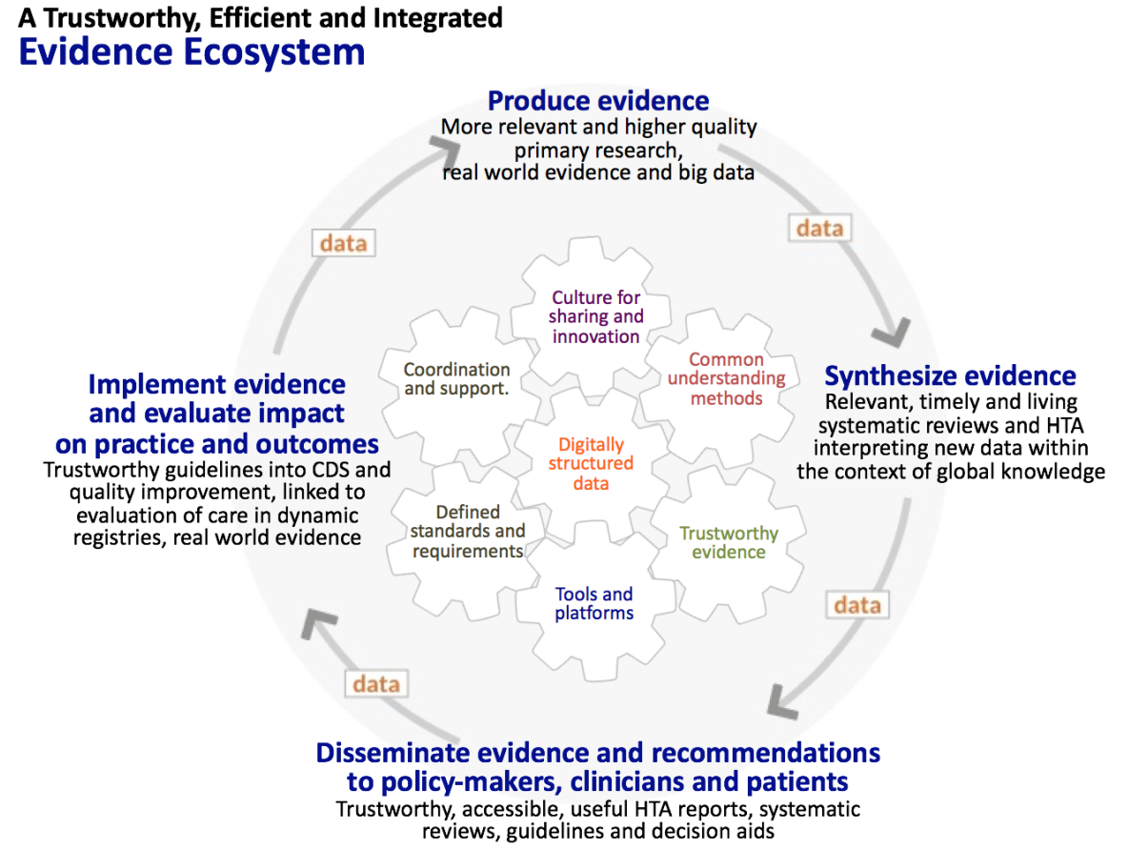
CDS Community Developments

Knowledge Artifact Specification (KNART)
CDS Hooks
FHIR Clinical Reasoning Module

The Clinical Reasoning module focuses on enabling two primary use cases:
- Sharing - The ability to represent clinical knowledge artifacts such as decision support rules, order sets, protocols, and quality measures, and to do so in a way that enables those artifacts to be shared across organizations.
- Evaluation - The ability to evaluate clinical knowledge artifacts in the context of a specific patient or population, including the ability to request decision support guidance, impact clinical workflow, and retrospectively assess quality metrics.

To enable these use cases, the module defines several components that can each be used independently, or combined to enable more complex functionality. These components are:
- Expression Logic - the representation of logic using languages such as FHIRPath and Clinical Quality Language (CQL).
- Definitional Resources - resources that are not defined on any specific patient, but are used to define the actions to be performed as part of a clinical knowledge artifact such as an order set or decision support rule. These resources can be used directly, or with profiles to provide intended structure for specific types of resources.
- Knowledge Artifacts - representation of clinical knowledge such as decision support rules and clinical quality measures.

FHIR Clinical Reasoning Module

Resources
Resource | Description
ActivityDefinition | A resource to represent definitional resources.
DataRequirement | A data type that represents a general data requirement for a knowledge asset such as a decision support rule or quality measure.
GuidanceResponse | Represents the response to a specific guidance request returned by the $evaluate operation.
Library | Provides a container for knowledge artifacts that includes logic libraries, model definitions, and asset collections.
Measure | Represents a clinical quality measure and provides evaluation through the $evaluate-measure operation.
MeasureReport | Represents the response to a specific measure evaluation request returned by the $evaluate-measure operation.
PlanDefinition | Represents the description of a plan for accomplishing a particular goal. This resource is used to represent a broad variety of clinical knowledge artifacts including decision support rules, order sets, and protocols.
RequestGroup | Represents a group of options for a particular subject that can be used to accomplish a particular goal. This resource is often, but not always, the result of applying a PlanDefinition to a particular patient.
ServiceDefinition | Describes a specific clinical decision support service and supports evaluation using the $evaluate operation.

”Knowledge Resources” represent the coordination of the decision rules with individual patient data (to reach executable guidance)

Some efforts perhaps getting closer to capturing the knowledge of evidence and guidance (societal knowledge, evidence-based medicine)

CDC project mapping guideline recommendations to CDS knowledge artifacts
--CDC Kaizan
--Guideline Preparation
--challenge – how to deal with missing evidence, how to represent best known consensus

CDS WG discussion with Pharmacy WG about Assertion Resource (eg. ”aspirin treats headache”)
--draft in current FHIR build, focused on medication (? Indication)

EBMonFHIR – Advancing from Interoperable Electronic Health Records to an Interoperable Evidence Ecosystem

B. Alper ¹, I. Kunnamo ².

¹EBSCO Health - Ipswich (United States), ²Duodecim Medical Publications Ltd - Helsinki (Finland)

Background & Introduction

GINtech has long sought optimal use of technology for guideline developers and implementers. The Evidence Ecosystem image visualizes evidence production and application across interdependent systems, but scalable methods to enable data flow between systems do not yet exist. Electronic Health Record (EHR) developers and implementers coordinated global collaboration to facilitate scalable data exchange methods using Fast Healthcare Interoperability Resources (FHIR). FHIR could be adapted to make evidence and guideline knowledge components interoperable (EBMonFHIR) and easily usable for clinical decision support (CDS).

Objectives / Goal
Involve evidence and guideline producers and implementers in a collaborative process for developing a standard for evidence interoperability that has the potential to be used globally.
Methods
We will introduce FHIR and how it rapidly developed into a highly used international standard. Participants can contribute directly to FHIR adaptations for evidence synthesizers and guideline developers, and join a group for continuing effort to develop EBMonFHIR.

Results & Discussion
The result will be a refined listing of the data elements that evidence processers need to receive or transmit for an interoperable ecosystem.

The material and results of the workshop are available here: http://bit.ly/2JCg3A3

Implications for guideline developers / users
Guideline developers and tool developers can get engaged using the EBMonFHIR method to develop interoperability solutions for the guideline and CDS communities.

Conclusion
EBMonFHIR can be a standard for structured representation of medical knowledge. Coordination with the FHIR standard for interoperable patient data will greatly facilitate implementation of evidence and guidelines through CDS.

Description of the workshop
An informative introduction followed by group work where participants directly engage in refining data standards for interoperable communication across the Evidence Ecosystem.

Target Group
Guideline developers and tool developers with an interest in digitization of content and learning how this will help in integrating guidelines with EHRs.

Some basic steps to extend FHIR to support EBM:

FHIR is fundamentally an exchange specification.

What systems do we envision needing to exchange the data?

What data needs to be exchanged? How will it be used?

Are the data concepts to be exchanged discrete shareable reusable units (resources) or facets of shareable units (attributes)?

Structured data = metadata about the evidence (and guidance)
Limited uses in FHIR today but some data elements that could be built off of – need to determien what they are and if they fit well as this develops
Lost structure when mapping supporting evidence resources to FHIR for order sets. Too much generalization. Extensions to close the gaps not defined yet.
Consider CIMI modeling effort
Is there a role for Domain Analysis Model? Role as/with Implementation Guide? Start with conceptual model vs. Adapt when implementing or defining use cases? Parallel approach to avoid paralysis analysis

Draft Framework:

- Foundational Resources – Population, Exposure, Outcome
  - The building blocks
  - TBD: are they ”Resources” or ”Attributes”?
- HealthKnowledge Resources -- Assertions
  - What do we know?
  - The expression of effect estimates (What is likely to occur? What is the likelihood of it occurring?)
- Evidence Resources
  - How do we know?
  - The expression of the evidence supporting HealthKnowledge Resources
- Recommendation Resources
  - What should we do?
  - The expression of judgments of others regarding the desirability or obligation of actions
- Certainty Resources
  - How well do we know?
  - The expression of how certain we are in the accuracy of the HealthKnowledge Resources

- Foundational Resources -- PICO
  - Population Resource
    - Describes a group of entities that could individually be represented as patients in FHIR Resource
    - Includes 0-n Conditions
    - Excludes 0-n Conditions
    - Need to determine if age, gender, setting, etc map to Conditions or are other included/exclude factors
    - Similar to “Group” Resource in FHIR (or Cohort in quality measures)
  - Exposure Resource
    - Describes state of being or exposure
    - Types can include ExternalCondition (Intentional or Unintentional) and InternalCondition
      - Look at Occupational Health Project (under Public Health WG) for defining Unintentional (or environmental) exposures
  - Outcome Resource
    - Describes the effects
    - May be classified as Patient-Important, Surrogate (believed to represent patient-important), or Non-patient-important
    - May be continuous or categorical
    - May be Comparative or Descriptive

- HealthKnowledge Resources
  - Assertion Resource
    - Influence Type – effect of Exposure on Outcome in Population
    - Prediction Type – likelihood of Population/Exposure/Outcome in Population
      - may be past, present or future
      - may be diagnostic or prognostic
      - may be compound (exposure predicting the influence of different exposure)

- Recommendation Resource
  - Includes who is making the recommendation (typically an Organization)
  - Intended target = Population Resource
  - Recommended Action = Exposure Resource
  - StrengthofRecommendation
  - Future considerations to manage conflicts and multiple conditoins/prioritization

- Evidence Resources
  - DirectResearchResults Resource
    - Citation Resource – where the evidence report is published
    - ResearchType
    - Population
    - Exposure
    - Outcome (Comparative among ResearchGroups)
    - ResearchGroups – used to describe subgroups (cohorts) within the study
      - Population
      - Exposure
      - Outcome (Descriptive)
      - SampleSizeIntended
      - SampleSizeInvited
      - SampleSizeEnrolled
      - SampleSizeReported
      - (learn from and perhaps contribute to clinicaltrials.gov)

  - ?? Extensions to DirectResearchResults Resource or distinct resources to cover:
    - CuratedResearchResults Resource – when the direct research result is a systematic synopsis of a direct research result
    - AdditionalAnalysisResults Resource – perhaps attributes if desire to distinguish primary from secondary analyses, or to distinguish analyses by individuals other than the original investigators
    - MetaAnalysisResults Resource – when the direct research results is a synthesis of multiple instances of direct research results
    - IndividualPatientDataMetaAnalysis Resource
  - IndirectEvidence Resource
    - Source – may be DirectResearchResults, Assertion, Explanation

- Certainty Resources
  - CertaintyRating
  - RiskofBias Resources – mapped out by ResearchType
  - ConsistencyRating
  - PrecisionRating
  - PublicationBiasRating
  - DirectnessRating

Action Steps to Progress: -- Continue discussion and draf tPSS for next Wed at 4 pm

- Complete a Project Scope Statement (Guilherme to send example, find latest version)
- Submit the Project Scope Statement – draft for May 16 meeting
  - –What groups to cosponsor? BR+R (the Research people), CQI
  - Plan to reach out to many (but not cosponsor externally)
  - Intent to ballot? When? August 17 due for Sept ballot (if ballot to comment); STU for January
- Create a project website page for shared discussion
- Reframe the discussion in terms of ”data elements” instead of ”resources” – mapping to resources or datatypes is part of mapping it as we go
- Plan agenda for May 16 meeting in Germany (to approve PSS)
- Establish a regular time for project meetings
- Schedule webmeeting events for project meetings
- Invite interested parties to participate
  - Invite HL7 members
  - Invite non-HL7 members (? NLM, Cochrane, GIN, etc.)

Subprojects:
- Identify list of data constructs with desire to share (eg recommendations, summary of findings tables, risk of bias assessments, quality measure)
- Map Population Resource for terminology coding
- Map selected data constructs to the schema
  - Map Summary of Findings Table to this schema
  - Map primary study summaries (body of evidence) to this schema
  - Map quality measure to this schema
- Coordinate with CDS Hooks (and CDS overall)

