Orders & Observations Conference Call

1 February 2017

+1 770 657 9270, Passcode: 398652#

WebURL: https://join.me/vernetzt.us

Attendees:

 | Name | Organization
1 | Riki Merrick | Vernetzt, LLC / APHL
2 | MariBeth Gagnon | CDC
3 | JD Nolen | Cerner
4 | Ron van Duyne | CDC
5 | Rob Hausam | Hausam Consulting
6 | Raj Dash | Duke
7
8
9
10
11
12
Regrets: Kathy Walsh

Co-Chair: Riki Merrick
Scribe: Riki Merrick

Agenda/Minutes:
- Agenda Review
- Approve minutes – defer until we have completed the spreadsheet
  - from May 6, 2016: : http://wiki.hl7.org/index.php?title=File:SPM_Minutes_20160506_ConCall.docx
  - from May 27, 2016:http://wiki.hl7.org/index.php?title=File:SPM_Minutes_20160527_ConCall.docx
  - from June 3, 2016: http://wiki.hl7.org/index.php?title=File:SPM_Minutes_20160603_ConCall.docx
  - from June 10, 2016: http://wiki.hl7.org/index.php?title=File:SPM_Minutes_20160610_ConCall.docx
  - from June 17, 2016: http://wiki.hl7.org/index.php?title=File:SPM_Minutes_20160617_ConCall.docx
  - from June 24, 2016: http://wiki.hl7.org/index.php?title=File:SPM_Minutes_20160624_ConCall.docx
  - NO CALL ON July 1, 2016
  - From July 8, 2016: http://wiki.hl7.org/index.php?title=File:SPM_Minutes_20160708_ConCall.docx
  - From July 15, 2016: http://wiki.hl7.org/index.php?title=File:SPM_Minutes_20160715_ConCall.docx
  - From July 22, 2016: http://wiki.hl7.org/index.php?title=File:SPM_Minutes_20160722_ConCall.docx
  - From July 29, 2016: http://wiki.hl7.org/index.php?title=File:SPM_Minutes_20160729_ConCall.docx
  - From August 5, 2016: http://wiki.hl7.org/index.php?title=File:SPM_Minutes_20160805_ConCall.docx
  - From August 12, 2016 – NO Quorum
  - From August 19, 2016 – http://wiki.hl7.org/index.php?title=File:SPM_Minutes_20160819_ConCall.doc
  - From August 26, 2016 - http://wiki.hl7.org/index.php?title=File:SPM_Minutes_20160826_ConCall.doc
  - From September 2, 2016 – NO Quorum
  - From September 9, 2016 – No call
  - From September 16, 2016 - http://wiki.hl7.org/index.php?title=File:SPM_Minutes_20160916_ConCall.docx
  - From October 14, 2016 – NO Quorum
  - From October 28, 2016 – NO Quorum
  - From November 2, 2016 - http://wiki.hl7.org/index.php?title=File:SPM_Minutes_20161102_ConCall.docx
  - From November 9, 2016 - NO Quorum
  - From November 16, 2016 - NO Quorum
  - From December 14, 2016 - http://wiki.hl7.org/index.php?title=File:SPM_Minutes_20161214_ConCall.docx
  - From December 21, 2016 - http://wiki.hl7.org/index.php?title=File:SPM_Minutes_20161221_ConCall.docx
  - From January 4, 2017 – NO quorum
  - From January 11, 2017 - http://wiki.hl7.org/index.php?title=File:SPM_Minutes_20170111_ConCall.docx
  - From January 25, 2017 - http://wiki.hl7.org/index.php?title=File:SPM_Minutes_20170125_ConCall.docx

- Compare Specimen DAM to biologic specimen model in BRIDG - map specification source is BRIDG and the map to is specimen DAM
Spreadsheet = http://www.hl7.org/documentcenter/public/wg/orders/Copy%20of%20Copy%20of%20BRIDG%20to%20Specimen%20DAM%20Mapping%20Spreadsheet%20as%20of%2020170201.xlsx

EA file is here:
http://www.hl7.org/documentcenter/public/wg/orders/V3_DAM_Specimen_R1_2014May-BRIDG_Discussions.zip
The spreadsheet:

Ballot document:
http://www.hl7.org/documentcenter/public/wg/orders/V3_DAM_Specimen_R2_INFORM_2017JAN_20161102.docx

Also Raj sent this file:
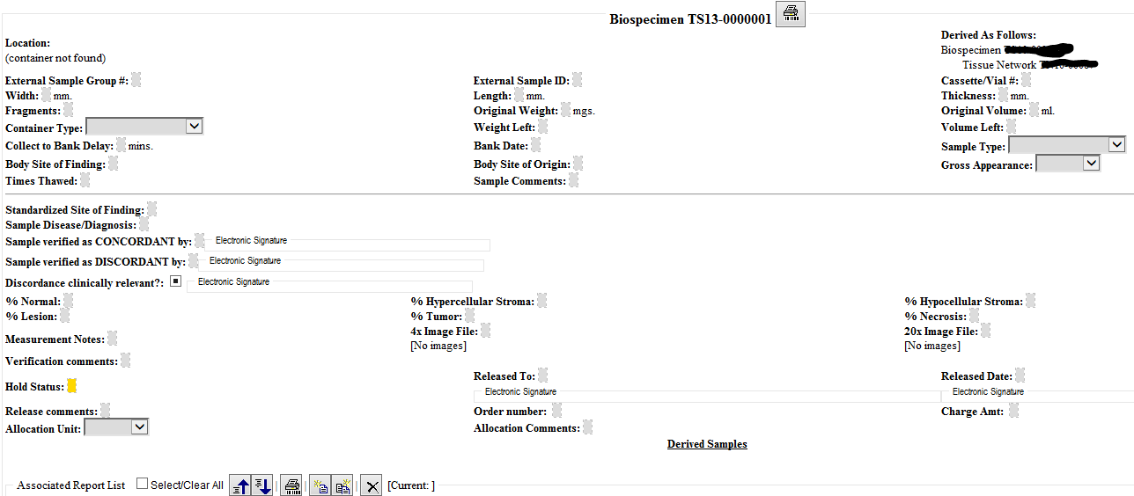

We have these items left in these classes:
TargetAnatomicSiteConditionCode – do we need this? – currently marked as out of scope; seems like this would be the narrative description during the collection procedure or grossing of specimen – leave as out of scope

Specimentesting is not covered in the DAM here – however from a chain of custody perspective should it be, for example, a tissue is stained for antibodies, but it is negative, so then the same tissue may be used in a different antibody stain – could we consider the testing to be a special kind of processing step? We do not want to model observations in this DAM, so that would be an exist ppoint to another model

Since we have quorum reviewing the items marked as source change and draft:
Row 136 – Subject.identifier(Identifier)typeCode – approve to add with cardinality 0..1, using example values from HL70203
Row137 - Subject.identifier(Identifier).assigningAuthority – approve to add with cardinality 1..1
Row 172 – approve to add associated organization to performer; this also needs to be done for performer on processingActivity – Riki to do and mark additions in yellow, so they can be reviewed next call (Row 171)
Row 214 - SpecimenCollectionProcedure.procedureCode – approve to add and make a note to balloters to find out, if method code in addition to procedureCode is useful here

NEXT CALL IS 2/15/2017 – no call next week!

Subject.performingSpecimen – how should we represent when tissue from a tissue bank is a specimen – we think it would still fall under person, only de-identified, because currently our material is ONLY from non-living subject

Subject.performingSpecimen: find out if we need this

Specimen.containingSpecimenCollectionGroup – and related attributes

- SpecimenMoveActivity – on hold until we Review the IHE Specimen Event Tracking (SET) profile for data elements that are required there – keeping these notes for when we get back to this topic
  - when nothing changes in the specimen – there are other processing activities that don’t result in new specimen, so need to verify in the EA model that the association between specimen and specimenProcessingActivity labeled “results in” has a cardinality of 0..*
  - since we are only concerned with the actual instance tracking, not the protocol creation should we rename this class to PerformedSpecimenMoveActivity – yes
  - cardinality should be 0..*
  - Approve this class
  - What attributes do we need: currenty BRIDGE has 3 to represent the different coordinates possible – we have a datatype that does this so have fromCoordinates and toCoordinates – hence one of our attributes maps to 3 BRIDG attributes
  - What about building location – we have geographicalLocation as a data type – currently an attribute of storageEquipment
  - Would a holder also need a geographicalLocation?
  - Would it be better to create a fromLocation and a toLocation attribute, that can use either the coordinates or the geographicalLocation dataytpes?
  - We already discussed adding SpecimenMoveActivity.TakenFromElementIdentifier, which is similar to have a fromEntity and a toEntity that can be referenced and you could reference the holder and the storageEquipment, which in turn have coordinates and geographicalLocation attributes?

- Resources:
  - Link to BRIDG model: http://bridgmodel.nci.nih.gov/files/BRIDG_Model_4.0_html/index.htm - chose VIEW:BSP - biospecimen
  - Link to Specimen DAM: http://wiki.hl7.org/index.php?title=Specimen – scroll to bottom for image

