Comment: The cCDA example given for tapering medication dosing should not be the example for the major use of cCDA, which is, namely, to convey to the patient or the next caregiver the discharge prescriptions or reconciled medications (prescriptions) from a preceding hospital or clinic encounter.
At the HL7 Joint session of Pharmacy and Structured documents in Phoenix, I argued that the way the example presents tapering dose “sigs” (which might be appropriate for some circumstances) is not appropriate for discharge prescriptions from health care organizations, including hospitals and physician’s offices. And the committee agreed that in the meantime, my criticism could be posted juxtaposed with the example until a final resolution is reached.
The specific example is for Azithromycin (an antibiotic) that is used widely for bacterial respiratory infections. The recommended dosing is two 250 mg tablets on day one and one 250 mg tablet on days 2-5 of therapy. It is commonly prescribed as a Z-pack which includes the dosing and instructions in a bubble pack, with either a 500 mg tablet or two 250 mg tablets in the bubble marked day one, and a single 250 mg tablet in each of the bubbles marked day 2 through 5. It can also be prescribed as individual pills where the Sig (prescriber’s instructions) says take 2 tabs on day one and 1 tab on days 2 through 5 (there are lots of variants on that theme).
So physicians write one prescription that includes the name the drug once and then say how to take it (the sig). Their prescription appears on one line in the patient’s profile with one date, and pharmacies will dispense one item to the patient (either a bottle of pills or a pack) with one instruction (usually a direct translation into patient-understandable language) and one date (the date the prescription was filled).
The problem with the example (See Figure 1) is that it shows what looks like two azithromycin prescriptions, each with its own drug name (identifier), date and instructions, one for the first day of the prescription and another for the next four days. These look like two separate prescriptions. At the meeting I learned that the two records were part of one prescription and each of what looked like a prescription was considered a separate Sig. But in the message, these two things are described as “components” within a “grouper”. There is nothing in the XML that says they are both sigs. Nor do they appear to be subservient (nested) under one drug. The drug name appears again in each component. And it would be legal to include a different drug in the 2nd component. Further confounding things is the ill-defined mechanism for specifying the “text sig” which literally is the instructions but is variously used to carry full text of all prescriptions, or the full text of the given prescription? Moreover the medication structure can be used variously for recording dispensing in hospital or other setting, prescribing, etc., without clear signal as what is intended in a specific cCDA.
Care providers would pick a drug and write the declining dose as one sig. For example, Azithromycin 250m tabs, take 2 tabs on day one and 1 tab on days 2-5, as described above. That text would likely be tied to the drug and the prescriber could enter it with a single click. It would take a lot more effort for the prescriber to break it into what would be the equivalent of two prescriptions (the work would multiply further with tapering doses of prednisone). At the meeting, the proponents of this structure asserted that the cCDA structure does not require prescribers to write them this way. However, if prescribers are doing the entry who else would be responsible for creating the example structure? Consider the confusion and/or extra cognitive work to reconcile medication lists with two “prescription like” entries.
The specification of the prescribing with fixed dates presents another problem. For example, the patient is seen in the Emergency Department at 8PM on June 1. Their CDA prescription record says to take the 2 pills on June 1 and one pill starting June 2. However, the patient doesn’t get to the pharmacy until June 2 in the AM. What are they supposed to do? The example structure might make some sense for patient dispensing, but not for provider or patient record keeping.

So I plead for recording this as one medication with a single sig that explains the tapering dose (see figure 2). It will be easier for prescribers, easier for pharmacies to generate labels (where will they find the room to say the drug name twice and the date twice?), easier for reconciliation. Of course this implies a free text sig. But that has been agreed to.
We came across the disadvantages of this exemplified approach while developing a function to import cCDA medications into a personal health record. The challenges of reconciling what they have in their PHR medication profile are difficult enough (considering brand names, duplicate classes, etc.). But if the patient can count on having a one-to-one relationship between the drug names in their active medication list and their medication bottles, it is at least tractable.

Figure 1 (Source: https://github.com/jddamore/HL7-Task-Force-Examples/blob/master/MED_Med_Dose_Change.xml)
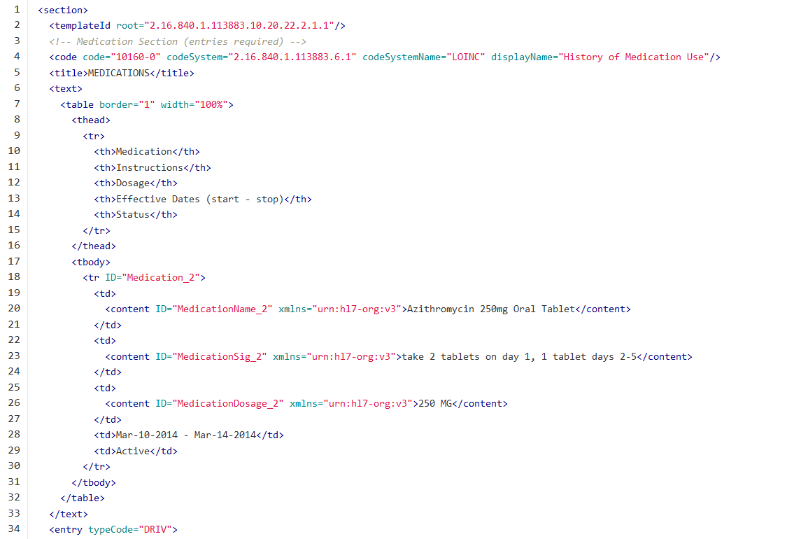
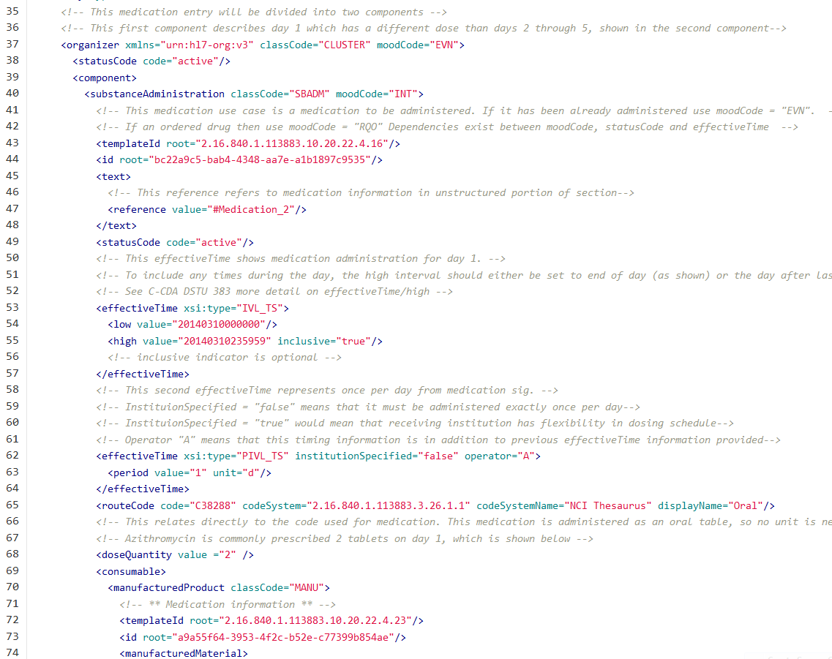

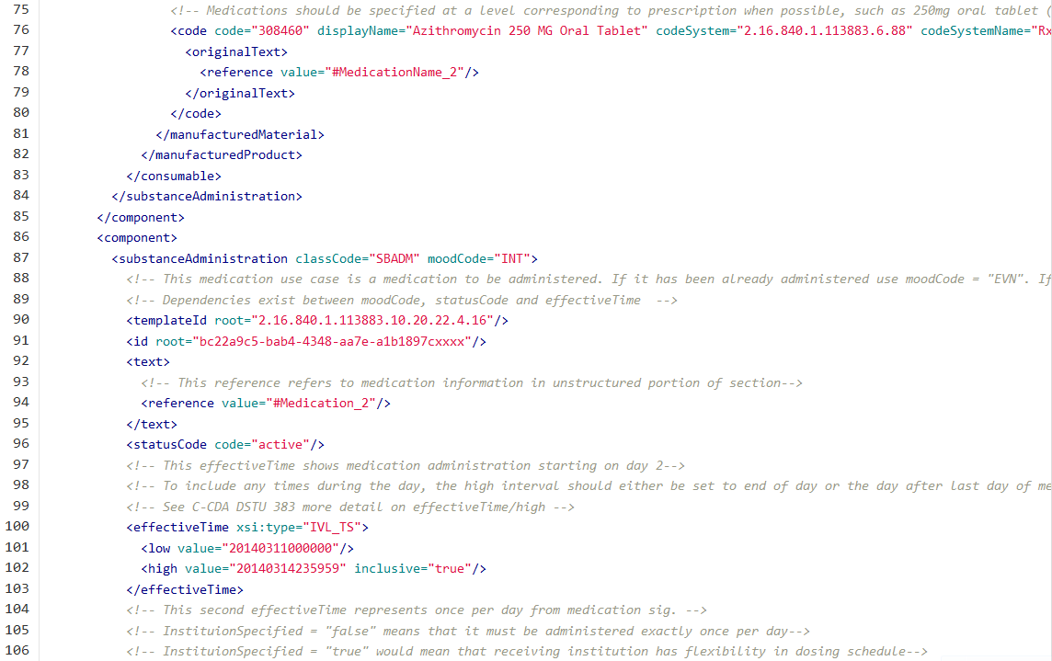
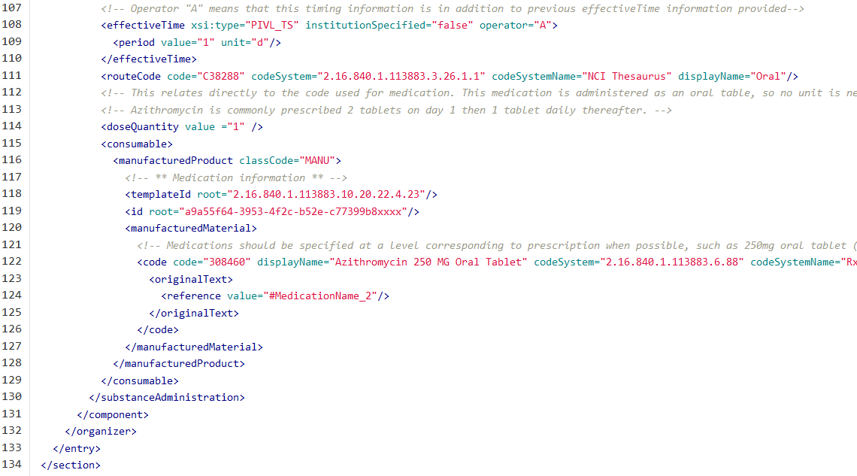

Figure 2:

<section>
<templateId root="2.16.840.1.113883.10.20.22.2.1.1"/>
<!-- Medication Section (entries required) -->
<code code="10160-0" codeSystem="2.16.840.1.113883.6.1" codeSystemName="LOINC" displayName="History of Medication Use"/>
<title>MEDICATIONS</title>
<text>
<table border="1" width="100%">
<thead>
<tr>
<th>Medication</th>
<th>Instructions</th>
<th>Dosage</th>
<th>Effective Dates (start - stop)</th>
<th>Status</th>
</tr>
</thead>
<tbody>
<tr ID="Medication_2">
<td>
<content ID="MedicationName_2" xmlns="urn:hl7-org:v3">Azithromycin 250mg Oral Tablet</content>
</td>
<td>
<content ID="MedicationSig_2" xmlns="urn:hl7-org:v3">Take 2 tabs the first day and 1 tab daily the next four days.</content>
</td>
<td>
<content ID="MedicationDosage_2" xmlns="urn:hl7-org:v3">250 MG</content>
</td>
<td>Mar-10-2014 - Mar-14-2014</td>
<td>Active</td>
</tr>
</tbody>
</table>
</text>
<entry typeCode="DRIV">
<substanceAdministration classCode="SBADM" moodCode="INT">
<templateId root="2.16.840.1.113883.10.20.22.4.16"/>
<id root="bc22a9c5-bab4-4348-aa7e-a1b1897c9535"/>
<text>
<reference value="#Medication_2"/>
</text>
<statusCode code="active"/>
<effectiveTime xsi:type="IVL_TS">
<low value="20140310000000"/>
<high value="20140314235959" inclusive="true"/>
</effectiveTime>
<effectiveTime xsi:type="PIVL_TS" institutionSpecified="false" operator="A">
<period value="1" unit="d"/>
</effectiveTime>

<routeCode code="C38288" codeSystem="2.16.840.1.113883.3.26.1.1" codeSystemName="NCI Thesaurus" displayName="Oral"/>
<consumable>
<manufacturedProduct classCode="MANU">
<!-- ** Medication information ** -->
<templateId root="2.16.840.1.113883.10.20.22.4.23"/>
<id root="a9a55f64-3953-4f2c-b52e-c77399b854ae"/>
<manufacturedMaterial>
<!-- Medications should be specified at a level corresponding to prescription when possible, such as 250mg oral tablet (non-branded)-->
<code code="308460" displayName="Azithromycin 250 MG Oral Tablet" codeSystem="2.16.840.1.113883.6.88" codeSystemName="RxNorm">
<originalText>
<reference value="#MedicationName_2"/>
</originalText>
</code>
</manufacturedMaterial>
</manufacturedProduct>
</consumable>
</substanceAdministration>
</entry>
</section>

