9/4/2013

Discussion regarding Supersets*(profiles) in EDOS
Section in HL7 2.7.1 standard that outlines how to deal with Supersets*(profiles) in OM10 messages:
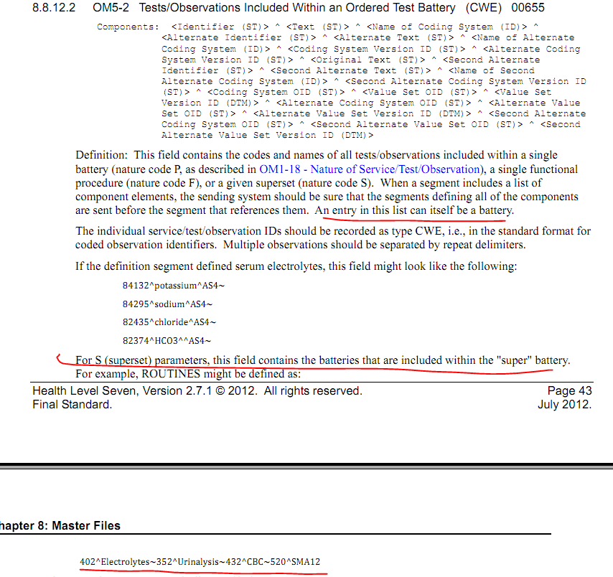
So if you have a profile that contains both panels and individual tests as the profile components. For example: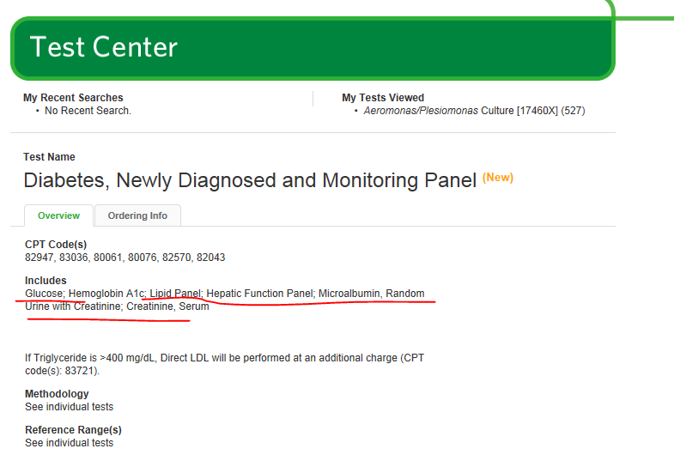
Your OM10 message would look something like this containing both panels and individual tests…
MSH...
MFI...
MFE|MAD|2||123^Diabetes, Newly Diagnosed and Monitoring Panel^99USI^^^^20140421|CWE
OM1|2|123^Diabetes, Newly Diagnosed and Monitoring Panel^99USI...|S|...
OM5|1|234^Glucose^99USI~345^Hemoglobin A1c^99USI~456^Lipid Panel^99USI~5667^Hepatic Function Panel^99USI~678^Microalbumin, Random^99USI~789^Urine with Creatinine~102^Creatinine,serum^99USI...
OM4|...
The individual tests identifier listed above ( e.g. 234^Glucose^99USI ) would key to OM1.2 (Producer's Service/Test/Observation ID) and/or MFE.4 (Primary Key Value – MFE) in an M08 message and the panel identifier ( e.g. 5667^Hepatic Function Panel~99USI) keys to the same fields in a M10 message. The panel components then in turn key these fields in an M08 message. Both the panels and individual tests listed would also key to CDM 1(Primary Key Value – CDM) and/or MFE.4 (Primary Key Value – MFE)
Note: They may also key to MFE.4 (Primary Key Value – MFE) in all message types, but I am still unclear on the guidance on how this field will be implemented in EDOS. And am awaiting my ballot comments on this issue.
How the receiver handles these linkages is out of scope of the guide, but I think the use case exists and is not forbidden by the EDOS IG or the standard.

