V2_LVSCG_R1.2_2018APR

HL7 Version 2 Implementation Guide: Laboratory Value Set Companion Guide, Release 1, STU 2 - US Realm
April 2018

Publication of this draft standard for trial use and comment has been approved by Health Level Seven International (HL7). This draft standard is not an accredited American National Standard. The comment period for use of this draft standard shall end 24 months from the date of publication. Suggestions for revision should be submitted at http://www.hl7.org/dstucomments/index.cfm.
Following this 24 month evaluation period, this draft standard, revised as necessary, will be submitted to a normative ballot in preparation for approval by ANSI as an American National Standard. Implementations of this draft standard shall be viable throughout the normative ballot process and for up to six months after publication of the relevant normative standard.

Copyright © 2018 Health Level Seven International ® ALL RIGHTS RESERVED. The reproduction of this material in any form is strictly forbidden without the written permission of the publisher. HL7 International and Health Level Seven are registered trademarks of Health Level Seven International. Reg. U.S. Pat & TM Off.
IMPORTANT NOTES:
HL7 licenses its standards and select IP free of charge. If you did not acquire a free license from HL7 for this document, you are not authorized to access or make any use of it. To obtain a free license, please visit http://www.HL7.org/implement/standards/index.cfm.
If you are the individual that obtained the license for this HL7 Standard, specification or other freely licensed work (in each and every instance "Specified Material"), the following describes the permitted uses of the Material.
A. HL7 INDIVIDUAL, STUDENT AND HEALTH PROFESSIONAL MEMBERS, who register and agree to the terms of HL7’s license, are authorized, without additional charge, to read, and to use Specified Material to develop and sell products and services that implement, but do not directly incorporate, the Specified Material in whole or in part without paying license fees to HL7.
INDIVIDUAL, STUDENT AND HEALTH PROFESSIONAL MEMBERS wishing to incorporate additional items of Special Material in whole or part, into products and services, or to enjoy additional authorizations granted to HL7 ORGANIZATIONAL MEMBERS as noted below, must become ORGANIZATIONAL MEMBERS of HL7.
B. HL7 ORGANIZATION MEMBERS, who register and agree to the terms of HL7's License, are authorized, without additional charge, on a perpetual (except as provided for in the full license terms governing the Material), non-exclusive and worldwide basis, the right to (a) download, copy (for internal purposes only) and share this Material with your employees and consultants for study purposes, and (b) utilize the Material for the purpose of developing, making, having made, using, marketing, importing, offering to sell or license, and selling or licensing, and to otherwise distribute, Compliant Products, in all cases subject to the conditions set forth in this Agreement and any relevant patent and other intellectual property rights of third parties (which may include members of HL7). No other license, sublicense, or other rights of any kind are granted under this Agreement.
C. NON-MEMBERS, who register and agree to the terms of HL7’s IP policy for Specified Material, are authorized, without additional charge, to read and use the Specified Material for evaluating whether to implement, or in implementing, the Specified Material, and to use Specified Material to develop and sell products and services that implement, but do not directly incorporate, the Specified Material in whole or in part.
NON-MEMBERS wishing to incorporate additional items of Specified Material in whole or part, into products and services, or to enjoy the additional authorizations granted to HL7 ORGANIZATIONAL MEMBERS, as noted above, must become ORGANIZATIONAL MEMBERS of HL7.
Please see http://www.HL7.org/legal/ippolicy.cfm for the full license terms governing the Material.
Ownership. Licensee agrees and acknowledges that HL7 owns all right, title, and interest, in and to the Trademark. Licensee shall take no action contrary to, or inconsistent with, the foregoing.
Licensee agrees and acknowledges that HL7 may not own all right, title, and interest, in and to the Materials and that the Materials may contain and/or reference intellectual property owned by third parties (“Third Party IP”). Acceptance of these License Terms does not grant Licensee any rights with respect to Third Party IP. Licensee alone is responsible for identifying and obtaining any necessary licenses or authorizations to utilize Third Party IP in connection with the Materials or otherwise. Any actions, claims or suits brought by a third party resulting from a breach of any Third Party IP right by the Licensee remains the Licensee’s liability.
Following is a non-exhaustive list of third-party terminologies that may require a separate license:
Terminology | Owner/Contact
Current Procedures Terminology (CPT) code set | American Medical Association  http://www.ama-assn.org/ama/pub/physician-resources/solutions-managing-your-practice/coding-billing-insurance/cpt/cpt-products-services/licensing.page?
SNOMED CT | International Healthcare Terminology Standards Development Organization (IHTSDO) http://www.ihtsdo.org/snomed-ct/get-snomed-ct or info@ihtsdo.org
Logical Observation Identifiers Names & Codes (LOINC) | Regenstrief Institute
International Classification of Diseases (ICD) codes | World Health Organization (WHO)
NUCC Health Care Provider Taxonomy code set | American Medical Association. Please see 222.nucc.org. AMA licensing contact: 312-464-5022 (AMA IP services)

Acknowledgments
This work has been sponsored by the HL7 Orders and Observations Work Group in collaboration with the Health and Human Services Standards and Interoperability Framework Laboratory Result Interface Working Group.
Questions or comments regarding this document should be directed to the Orders and Observations Workgroup (ord@lists.hl7.org)
The authors of this document wish to recognize the following participants who contributed their time and expertise to the development of this guide.
Name | Organization | Role
Hans Buitendijk | Cerner Corporation | LRI Work Group Co-chair
Ken McCaslin | Accenture | LRI Work Group Co-chair
Cindy Johns | LabCorp | LRI Vocabulary Work Group Co-chair
Virginia Sturmfels | Quest Diagnostics | LRI Vocabulary Work Group Co-chair
Riki Merrick | Vernetzt, LLC | LRI Vocabulary and EHR-FR Work Group Co-chair
Robert Dieterle | EnableCare, LLC | EHR-FR Work Group Co-chair
Freida Hall | Quest Diagnostics | eDOS WG Co-Chair
Mark Jones | Orchard Software | eDOS WG Co-chair
Austin Kreisler | Leidos | Contributor
Bill Ormerod | Cerner Corporation | Contributor
Bob Yencha | RTY LLC | Contributor
Bonnie McAllister | Iatric Systems | Contributor
Craig Newman | Northrop Grumman | Contributor
Daniel Rutz | Epic | Contributor
David Burgess | LabCorp | Contributor
Eric Haas | Health eData INC | Contributor
Ernest Grove | SHAPE HITECH, LLC | Contributor
Farrah Darbouze | Office of the National Coordinator/Health and Human Services | Contributor
Kathy Walsh | Lab Corp | Contributor
Lester Keepper | SHAPE HITECH, LLC | Contributor
Maggie Wright | McKesson | Contributor
MariBeth Gagnon | Centers for Disease Control and Prevention | Contributor
Megan Sawchuk | Centers for Disease Control and Prevention | Contributor
Pam Banning | 3M | Contributor
Rob Hausam | Hausam Consulting | Contributor
Robert Snelick | National Institute of Standards and Technology | Contributor
Sheryl Taylor | National Institute of Standards and Technology | Contributor
Copyrights
This material includes SNOMED Clinical Terms ® (SNOMED CT®) which is used by permission of the International Health Terminology Standards Development Organization (IHTSDO). All rights reserved. SNOMED CT was originally created by The College of American Pathologists. "SNOMED ®" and "SNOMED CT ®" are registered trademarks of the IHTSDO.
This material contains content from LOINC® (http://loinc.org). The LOINC table, LOINC codes, and LOINC panels and forms file are copyright (c) 1995-2011, Regenstrief Institute, Inc. and the Logical Observation Identifiers Names and Codes (LOINC) Committee and available at no cost under the license at http://loinc.org/terms-of-use.
This material contains references and citations to various publications from the Health Level Seven International (HL7). Members may obtain a copy of the referenced materials without charge in the Members-only area of the site. Non-members are referred to the HL7 Intellectual Property Policy to determine if a no-cost license is available, otherwise a copy can be obtained for a nominal fee via the HL7 Store at www.hl7.org.

TABLE OF CONTENTS
1 Introduction 7
1.1 Purpose 7
1.2 Audience 7
1.2.1 Relevant Documentation 7
1.2.2 Requisite Knowledge 8
1.3 Organization of this Guide and Related Artifacts 8
1.3.1 Conventions 9
2 Overview 10
2.1 Value Set Creation Guidance 10
2.2 Binding and Binding Strength 10
2.2.1 Options for Binding Strength in Constrainable Profiles 12
2.3 Value Set Attributes: Implementation Considerations 12
2.4 Usage Definitions 14
3 Value Set Spreadsheets 15
3.1 File Name Conventions 15
3.2 Value Set Artifact Hierarchy 15
3.3 Primary Navigation – Full Index 15
3.4 Individual Value Set Spreadsheet 16
3.4.1 Value Set - Metadata Tab 16
3.4.2 Value Set - Value Tab 17
3.4.3 Value Set - Location Tab 18
3.5 Handling Values of type <ANY> 18
4 Implementation Considerations 20

INDEX OF TABLES
Table 2-1. Usage Definitions 14
Table 3-1. US Lab Domain Tab 16
Table 3-2. Metadata Tab 16
Table 3-3. Values Tab 17

INDEX OF FIGURES
Figure 1-1. Value Set Organization 8
Figure 3-1. Main Navigation Spreadsheet 15
Figure 3-2. Value Set - Metadata Tab 16
Figure 3-3. Value Set - Value Tab 17
Figure 3-4. Value Set - Location Tab 18

Introduction
The HL7 Version 2 Implementation Guide: Laboratory Value Set Companion Guide, Release 1- US Realm is the result of collaborative efforts between HL7 and the Office of the National Coordinator (ONC) Standards and Interoperability (S&I) Framework Laboratory Results Interface (LRI), Laboratory Orders (LOI) and the electronic Directory of Service (eDOS) Initiatives. By consensus this guide documents the definition, management and use of code systems and their contents (i.e., a value set) to meet the requirements of the US Realm Laboratory suite of Implementation Guides.

Purpose
This Companion Guide documents the requirements for the development, management and use of references to a collection of codes commonly referred to as a Value Set in the context of the suite of US Realm Laboratory Implementation Guides.
The Laboratory Results Interface Initiative identifies the requirements, defines specifications and standards to provide implementation guidance for electronic communication of a laboratory’s electronic Directory of Services to an EHR, the electronic ordering of a laboratory test, and the reporting of laboratory test results in the US Realm. These guides have been designed and developed to offer an end-to-end process for “out of the box” interoperability with minimum pre-coordination between trading partners.
This companion guide and value set package is designed to facilitate updates outside the cycle of the Implementation Guide balloting process allowing for the use of new terms and corrections within the sets without constantly revising the IGs. This is covered in more detail within each Implementation Guide in the section titled “Value Sets” under the main heading of “Conformance to this Guide”.

Audience
This guide is designed for use by analysts and developers who require guidance on value sets relative to the documents in Section 1.2.1 Relevant Documentation. Users of this guide must be familiar with the details of HL7 message construction and processing starting with HL7 Version 2.5.1 through HL7 Version 2.8.2. This guide is not intended to be a tutorial on that subject.

Relevant Documentation
There are multiple Implementation Guides that have been developed under the Office of the National Coordinator's (ONC) Standards and Interoperability Framework Initiative (S&I Framework). These guides have been created using the same processes, are stylistically similar and designed to work together. This release is based on the requirements of the following Implementation Guides:
- This publication: HL7 Version 2 Implementation Guide: Laboratory Value Set Companion Guide, Release 1, STU 2- US Realm (LVSCG), April 2018;
- HL7 Version 2.5.1 Implementation Guide: S&I Framework Lab Results Interface, Release 1, DSTU Release 3 - US Realm – US Realm (LRI), April 2018, in support of the lab result reporting;
- HL7 Version 2.5.1 Implementation Guide: S&I Framework Laboratory Orders (LOI) from EHR, Release 1, DSTU Release 3, US Realm (LOI), April 2018 in support of the lab test ordering and to provide data needed for reporting to Public Health;
- HL7 Version 2.5.1 Implementation Guide: S&I Framework Laboratory Test Compendium Framework, R2 DSTU Release 2 US Realm (eDOS), April 2018, in support of the electronic exchange of a laboratory’s directory of services.
- HL7 Version 2.5.1 Implementation Guide: Electronic Laboratory Reporting to Public Health, Release 2 (US Realm) (ELR), ???? ????, as a constrained profile of the LRI Implementation Guide.
Future releases or other Implementation Guides may result in revisions to these Value Sets.

Requisite Knowledge
- HL7 V2.5.1 through V2.8.2 Messaging (www.HL7.org)
- HL7 Characteristics of a Formal Value Set Definition, Draft, 2014 (www.HL7.org)

Organization of this Guide and Related Artifacts
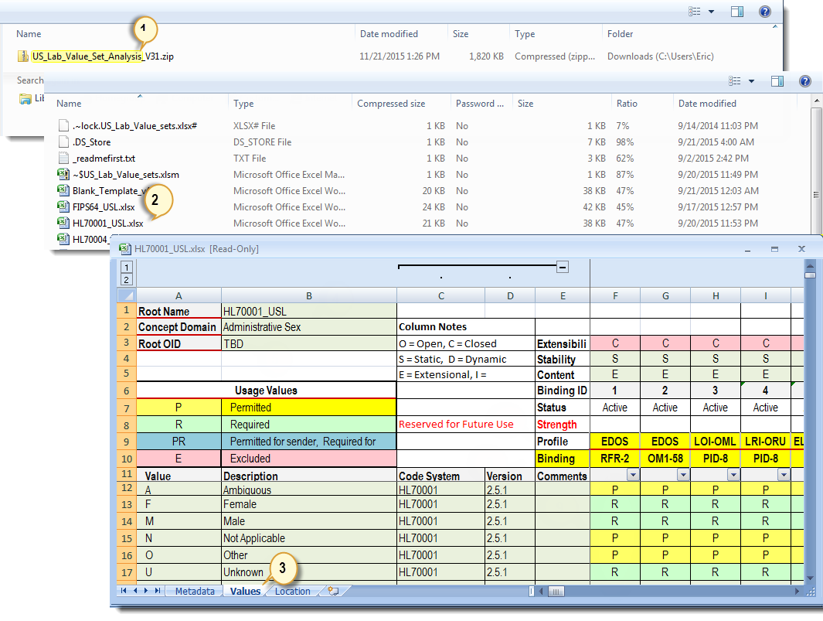
Figure 1-1. Value Set Organization

Conventions
Note: Refer to Figure 1-1. Value Set Organization for references (#) in this section.
The guide is constructed assuming the implementer has access to the HL7 Tables as defined in the referenced versions of the HL7 Standard as well as other code systems in scope per section 1.2.1 Relevant Documentation. Where there are variations from HL7 V2.5.1 the alternate version is referenced.
Value Set Package (1) – The package of Spreadsheets for a use case domain (US LAB in this case). One spreadsheet file is created for a concept domain (e.g., Administrative Sex).
Value Set Collection (2) – The set of value sets for a concept domain organized in a single spreadsheet file. Contains the value set “global” metadata and a collection of value set definitions, see section 3.4 Individual Value Set Spreadsheet.
Value Set Details (3) – A value set collection defines the detailed usage for the use case domain, i.e., for every message profile in which a message element is bound to a coded concept domain.
Value Set Library – The set of value sets that pertain to a given message profile. For example, all the value sets that are referenced (i.e., there is a value set binding to a message element) in the LRI GU-RU message profile. This guide does not provide library indexes by profile, but does provide a Value Set Library at the Implementation Guide level, see section 3.3 Primary Navigation – Full Index.

Overview
Note: Refer to Figure 3-3. Value Set - Value Tab for (#) references in this section.
Coded message elements, including those using the CE, CNE, CWE, CX, ID, IS and XCN data types, draw their values from a set of controlled strings defined elsewhere. While often used interchangeably when discussing coded elements, the terms “coding systems” and “value sets” represent distinct concepts.
As defined by HL7, “A code system is a collection of uniquely identifiable concepts with associated representations, designations, associations, and meanings.” A coding system tends to be a very broad list and not all values are appropriate to use in a specific context of a given message element. A single coding system may be relevant to a number of different parts of a single message.
For example, HL7 Table 0203 contains a list of Identifier (ID) Types. This table is called out as part of the CX data type (used in PID-3) as well as the XCN data type (used in ORC-12). HL7 Table 0203 defines the ID types of MR (Medical Record Number) and NPI (National Provider Identifier), which are appropriate for use in PID-3 and ORC-12 respectively but not vice versa.
In contrast, a value set is a more refined list of values, taken from one or more coding systems, applied at a more granular level of the message and which contains only values appropriate for that specific context of a message element.
The attributes of the value set supersede those of the underlying coding system (be it an HL7 or User table, external value set, etc.) from which it was derived. A value set is a view on the underlying code system or code systems. For most value sets in the HL7 V2 space, value sets will be views on the HL7 tables. Also note that a given coding system, such as HL7 Table 0203, may be the basis of multiple value sets (e.g. one value set for PID-3 and one value set for ORC-13).

Value Set Creation Guidance
The HL7 V2 standard provides minimal guidance on how value sets should be specified and the implications of such specifications. This causes users and developers to implement the requirements inconsistently, leading to interoperability issues. Therefore, an implementation guide must clearly describe the full complement of value sets required by the relevant use cases described in the guide. This is critical as the content of some value sets require significant and specific functionality on the part of a sending or receiving system.

Value Set Identification

Use of OIDs
Each concept domain is assigned a root OID – this information is captured on the Metadata tab for the respective group of value sets. Each column on the values tab represents one (1) value set. Its binding to the field in which it is used, is described in row 10 labeled “Binding”. Each column is also assigned a “Binding ID”; the combination of the “Root OID” (row 5 on the metadata tab) and the “Binding ID” (row on the values tab) create the unique identification for each value set that is part of this implementation guide group.
Example using the HL70074_USL Value Set
Metadata tab:

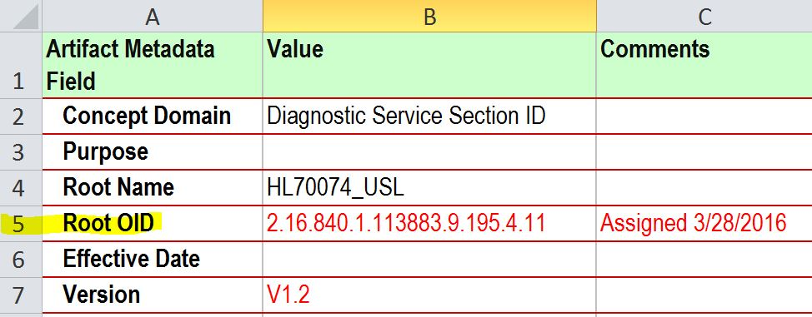
Values tab:
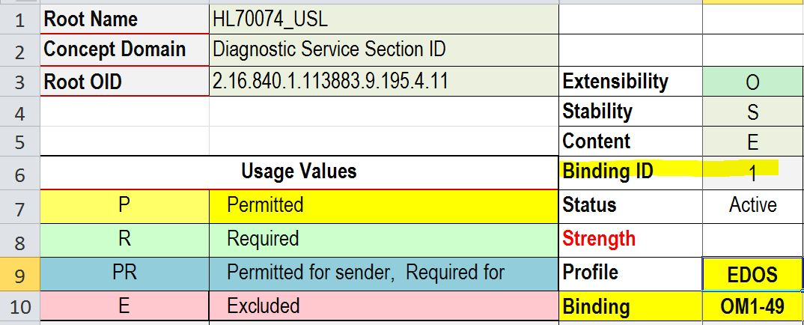
There is a unique set of values for the OM1-49 Field in the EDOS IG that is uniquely identified by the combination of the [Root OID]+’.’ +[Binding ID].
2.16.840.1.113883.9.195.4.11.1
In essence, the Binding ID is the last octet of the VS OID. Collections at this level are not versioned, if changes occur a new column and new binding ID is added, the older set can then be phased out as appropriate.
Table X is an example of the members of the collection identified by [VS Root OID]+[Binding ID].
There are 39 values from the source code system (HL7 Table 0074) that appear in the HL70074_USL set. The full set is filtered to EXCLUDE all values where the requirement for this Binding is “E” (or blank). All remaining values are members of the defined value set. Note that the set is defined as Extensibility “O” (Open), so it can be extended at any time.
Table X
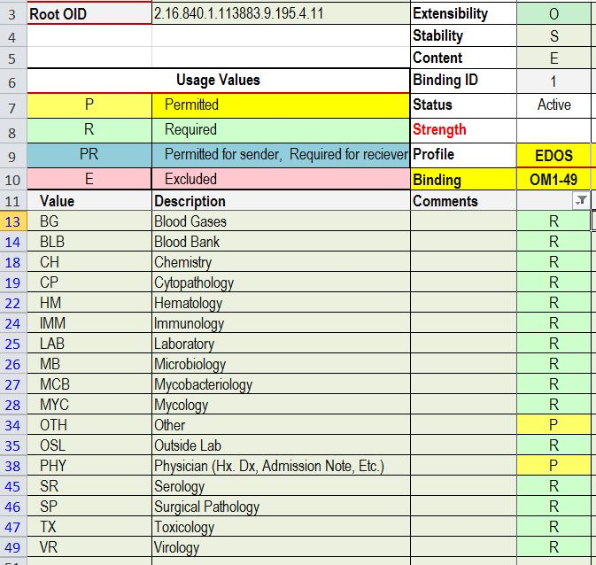

Binding and Binding Strength
Note: The concepts in this section are presented for consideration and future adoption and have not been implemented in this initial release.

Options for Binding Strength in Constrainable Profiles
Within an implementation guide, a given value set is bound to one or more message elements (i.e. a field, component or sub-component). The binding strength (6) can either be Required or Suggested. Required value sets must be supported by a compliant system. Suggested value sets are not required of a compliant system but should be discussed between trading partners for a specific implementation.
- Required (R) - The system SHALL support the value set
- Suggested (S) - The system SHOULD support the value set.
For implementation profiles all value sets that are bound to a message element shall be specified as Required. Suggested can only be specified in constrainable profiles and have no conformance implications (i.e., there are no requirements associated with these bindings).

Value Set Attributes: Implementation Considerations
All value sets have attributes that have implementation implications.
Extensibility (1): indicates whether a value set can be extended in a particular implementation of the guide. Extensibility has two states, Open and Closed. In the case of Open Extensibility, trading partners have the latitude to extend the value set to meet local needs that are not covered in the value set. In the case of Closed Extensibility, the value set can not be extended even by local agreement. Closed does not mean that a value set cannot be extended or modified in a revision or errata to the implementation guide.
Stability (2): indicates whether the value set is bound to data elements statically or dynamically. Static indicates use is fixed to a specific version of the value set. Dynamic indicates a base version is set but newer versions may also be used without requiring an update to the IG.
Content Definition (3): indicates how the values in the value set are defined:
- Intensional value sets contain rules, which allow values to be dynamically derived from the underlying coding systems. Intensional values sets are often dynamically bound.
- Extensional value sets contained an enumerated list of set values. Extensional value sets are typically statically bound.
There are occasions where a value set can be considered both an intensional and extensional set. In these cases, there is often an algorithmic means of obtaining any valid code from the code system and the general usage is “P”. However, out of that universe of possibilities there may be a known set of values that are “R”. In these cases, the value set may contain both the algorithm for accessing the entire set but also enumerate a smaller set that is required.
When statically bound, an intensional value set must specify the version of the code system being used before the members of the value set can be computed.
When a code is sent within a message, the receiving system must be able to unambiguously interpret the meaning of the coded value. This requires that the value in the message be unique within the value set used by the message element and the value set or code system be unambiguously identified.
When a value set is drawn from only a single coding system, uniqueness of the codes is an aspect of the underlying coding system. However, when a value set is drawn from multiple coding systems, it is possible for a code to be repeated, meaning that only the combination of a code plus associated coding system identifier is unique. When a message element uses a complex data type that includes elements for both a code and a coding system (e.g., CWE, CNE), the value set is allowed to contain the same code multiple times from different coding systems because the message content will specify the appropriate coding system to use to interpret the code in the message.
For complex coded data types, it is important for the Name of Coding System element (CWE.3, CWE.6, etc.) to reference the coding system (11), not the value set. However when other data types (e.g. ID, IS, CX) are used, the value set must be constructed carefully so as to not contain the same code multiple times as there is no provision to communicate a coding system in these data types and the receiving system will not be able to unambiguously interpret the code in the message.
To maximize uniqueness, the version of the coding system (12) should also be specified in the value set definition where possible, even if the version will not be included as part of the message content. Open value sets have the latitude to expand the list of coding systems to include other standard or locally defined coding systems but these same considerations surrounding data type and value uniqueness must be addressed. When extending a value set the concept of an existing code cannot be changed, nor can an additional value for an existing concept be added.
The primary content of the value set is the list of values themselves (9) and the usage requirements for each specific to where it is used (14). Each coded value is accompanied by a description, coding system, an optional coding system version and a usage. Only values drawn from coding systems and versions associated with the value set should be included in the value set. The usage requirement indicators (Usage Values) for a code are defined in Table 2-1. Usage Definitions.

Usage Definitions
Each member of a value set may independently convey its usage requirements within one or more locations where the value set is required to be used.
Table 2-1. Usage Definitions
Usage | Name | Description | Implementation Requirement
[blank] | Out of scope | Out of scope at time of publication | None
C | Conditional | Use of one or more values within the value set is conditional, e.g., at least one of the codes must be supported. | The conditions may be unique to the nature of the concept domain for the value set, therefore the conditions are stated in each value set.
E | Excluded | The code is excluded from the value set. | The integrated systems SHALL NOT support the code.
P | Permitted | The code can be included in an implementation specific value set that is derived from this existing value set. | Each individual implementation will have to define each P-Permitted, value as either R-Required or E-Excluded. Use of a Permitted value is by trading partner agreement only.
PR | Permitted for Sender/Required for Receiver | See Permitted and Required definitions. | See Permitted and Required definitions.
R | Required | The code is included in the value set. | The integrated systems SHALL support the code.
SR |  | Sender is required to support at least one value from the set; Receivers are required to support all SR values in the set. | SR - R (Required) for the receiver; The sender must support (S) a least one in the set mark as SR. SR means one in the set marked as SR is required to be supported by the sender and required by the receiver.
Usage Note
For an open value set, all values not explicitly listed in the value set have a Usage of Permitted (P). For a closed value set, all values not explicitly listed in the value set have a Usage of Excluded (X).

Value Set Spreadsheets

File Name Conventions
Main Index: _US_Lab_Value_Set[_Ballot].xlsx where:
_US_Lab_Value_Set indicates the realm and domain scope of the value sets
_Ballot Optional - indicates if this set is released for ballot review
.xlsx indicates this is a Microsoft Excel file
Individual Value Sets are named [Source]_USL.xlsx (see (2) in Figure 1-1. Value Set Organization) where:
[Source]_ String that indicates the Code System or source of the value set, e.g. HL70001, SNOMED_CT, USPS
_USL Indicates this is a value set defined for use in the US Realm for Laboratory
.xlsx indicates this is a Microsoft Excel file
Examples
HL70125_USL.xlsx indicates this value set is a representation of the HL7 Table 0125 as constrained for use in the US Laboratory Implementation Guides.
SNOMED_CT_USL.xlsx indicates that this value set is a representation of values drawn from the SNOMED CT vocabulary.

Value Set Artifact Hierarchy
As shown in Figure 1-1. Value Set Organization, the value set artifacts are a series of spreadsheets with a simple relationship:
Index _US_Lab_Value_Sets.xlsx – master list with links to:
File HL70001_USL.xlsx – contains details on the usage of HL7 Table 0001
File HL70203_USL.xlsx – contains details on the usage of HL7 Table 0203
File SNOMED_CT_USL.xlsx – contains details on the usage of SNOMED CT

Primary Navigation – Full Index
This file contains a master index of the active value sets and contains the following information:
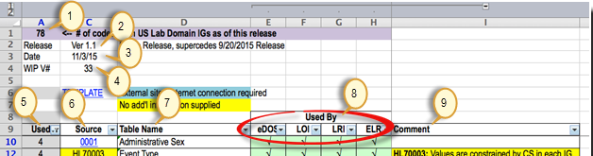
Figure 3-1. Main Navigation Spreadsheet

Table 3-1. US Lab Domain Tab
# | Field | Description
1 | Cell A1 | The number of currently active code systems in use by the Lab US Realm IGs.
2 | Release | The release number of this collection of Value Sets.
3 | Date | Date of release.
4 | WIP V# | The Work In Process version that was the basis for this release.
5 | Use | Counts the number of IGs the Value Set is referenced in.
6 | Source | Short name that is a link to the individual spreadsheet for the value set.
7 | Table Name | Name of the HL7 Table or external Value Set.
8 | Usage (e.g., eDOS, LOI, LRI, ELR) | These note the use of a table in a specific IG. Sort on the column to see only the code systems used in that IG.
9 | Comment | Additional Guidance to the implementer.

Individual Value Set Spreadsheet
This file contains a number of tabs that contain the metadata about a single value set, the allowable values and detailed binding information.

Value Set - Metadata Tab
Figure 3-2. Value Set - Metadata Tab

Table 3-2. Metadata Tab
Field | Description
Concept Domain | Identifies the context for the values in the set.
Purpose | Brief description of the purpose / intention of the value set.
Root Name | Mnemonic for identification of the value set, typically this is the source appended with _USL, see section 3.1 File Name Conventions.
Root OID | A unique OID for the set. Note: Root OID is not implemented in this release.
Effective Date | The date the value set is effective for use.
Version | The version of this release of the value set.

Value Set - Value Tab
The Values tab of a spreadsheet contains the detailed requirements for each value in each position in a message. Given the nature of a value set to broadly cover a concept domain, in practice their use is not universal at all positions in the same message at the same time. A value that is valid in a message at point A may be invalid at point B in the same message based on the context of the segment, profile, etc.
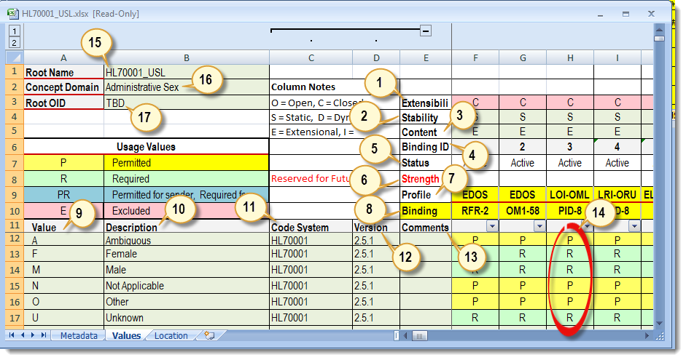
Figure 3-3. Value Set - Value Tab
Table 3-3. Values Tab
(#) | Field | Description
1 | Extensibility | The value set may be Open or Closed.
2 | Stability | The value set is either Static or Dynamic.
3 | Content | Extensional or Intensional.
4 | Binding ID | Individual ID that, when added to the binding root name or value set root OID, provides a unique value set identifier.
5 | Status | Active or inactive.
6 | Binding Strength | Required (R) or Suggested (S). Note: Not implemented in this release.
7 | Profile | Indicates the profile or profile component to which the value set is applicable. This can be identified as a profile, profile component, or a combination of both.
8 | Binding | In combination with the profile, binding indicates the message element (segment and field number) to which the value set applies. The actual binding may be at the field or data type component level.
9 | Value | The code or value that is a member of the set.
10 | Description | Text that describes the meaning of the code or value.
11 | Code System | The source of the value that provides the contextual concept; this string will also be conveyed in the message if the field uses a complex data type, e.g., CWE.3.
12 | Version | The version of the source code system where the value is originally defined.
13 | Comments | Any comments that will aid implementers or that provide further guidance on use of the value.
14 | Usage | The actual usage for a value in a specific binding – see Table 2-1. Usage Definitions.
15 | Root Name | Mnemonic for identification of the value set, typically this is the source appended with _USL, see section 3.1 File Name Conventions. This information is “pulled” from the metadata tab.
16 | Concept Domain | Identifies the context for the values in the set.
17 | Root OID | A unique OID for the collection. Note: Root OID is not implemented in this release.

Value Set - Location Tab
Figure 3-4. Value Set - Location Tab
This tab provides an alternate view of the relationship of the profile, the location of the binding, the refined binding, and the binding ID intended to be traceable to an OID. This tab is currently present to support test tool development at the National Institute of Standards and Technology (NIST), an example can be seen here: http://hl7v2-loi-r1-testing.nist.gov.

Handling Values of type <ANY>
In some instances a code system is required to be supported for a particular element(s) but the specific context (use case) can’t be sufficiently defined at this specification level—i.e., national profile intended to be further constrained for implementations in specific contexts.
In such cases, the value set specification uses the <ANY> value (indicated in the Values column) to represent a subset of values in the code system (indicated in the Code System column).
Once a specific context (use case) is defined, an exact subset of values from the code system can be identified. This is an expected profiling activity at the local level.
Use of the <ANY> value set specifications should only be used in cases where the values can be “generically” processed (i.e., the values don’t imply functional requirements on the receiver).
Example
LOINC is the required code system and specific value sets are to be created based on the context of use.
This means that implementations do not have to support all LOINC codes.
Senders shall support a subset of LOINC that pertains to their uses. The value set may be extended only in the event that a concept needing to be conveyed is not covered in LOINC.
Receivers shall support (at minimum) the superset of LOINC codes needed for data exchange with all its trading partners.

Implementation Considerations
Implementation Guides describe value sets that form the basis of specific integrations between trading partners. The IGs define lists of required, permitted, and excluded values for use in coded data elements throughout the specific messages within defined exchange scenarios. As part of the implementation process, several tasks must be performed to explicitly define values that will be exchanged between systems before testing and production messaging can begin.
For values which are not required or excluded by the constrainable profile, it is imperative that both systems agree on whether or not specific values will be include as part of the integration. This is particularly vital for fields containing clinically relevant information as unexpected values in a message can lead to a patient safety issue. This process requires close cooperation and clear communication between the sending and receiving systems and is essential to the safe and robust exchange of health care data.
- Review the binding strengths associated with all coded values in the messages and identify all value sets that need to be included as part of the integration.
- Value sets with a binding of Required (R) must be supported by all implementations. For message elements that have a usage of R/RE/C, values sets with a binding of Suggested (S) must be evaluated per implementation and either adopted or replaced by a different value set. For optional message elements, values sets with a binding of Suggested (S) can be adopted, replaced or removed from scope.
- Review all value sets and confirm the ability of both systems to exchange all Required (R) values.
  - Supporting specific values may require particular functions or workflows to be implemented for end users.
- Review all value sets and evaluate all Permitted (P) values and set the usage to either Excluded (E) or Required (R) depending on the need to support agreed upon functionality and workflows.
  - A complete integration may require different value sets be used by the same message element across different message types or profiles. This is particularly relevant where one system manages data across multiple areas before incorporating the data into a message. For example, a clinic EHR may send orders to an LIS which then returns solicited results for those orders as well as unsolicited results from an affiliated hospital or an Immunization Information System (IIS) may accept vaccination data from multiple EHRs and then transmit a complete patient history to one or more of them. In these scenarios, the value set used to submit data to one system (an order or a vaccination administration) may only be a subset of data being returned from that same system in a different message type (an unsolicited result or a patient complete immunization history).
- Review all open value sets and determine if any local additions are required to support agreed upon functionality and workflows.
  - This step is particularly important for value sets with no values included in the value set. This can be the case even for required elements such those in MSH-3 through MSH-6.
  - When making local additions to a value set keep in mind the following:
    - If the concept being added to the value set is already represented by a Permitted (P) value in the value set that permitted value must be used.
    - A local code cannot be added to an open value set to represent an explicitly Excluded concept already listed in the value set.
    - Once a value is included in a value set, it cannot be redefined. For instance, once B is defined as Blue, it cannot be redefined as Baby Blue. A new code must be created for the new concept.
    - For data types which include a Coding System component, such as CWE, make sure the Coding System value is agreed upon and sent as part of the message. “L” and “99zzz” (where z is an alphanumeric character) are valid values for a local Coding System.
- Develop comprehensive test cases for required values
  - All required values should be tested (no permitted values should remain by this stage).
- Define a process whereby both the sending and receiving system can update value sets as the needs of the integration evolve or as the underlying coding system(s) are updated.
A communication plan is critical to ensure that both systems are kept in sync to prevent a delay in processing critical data.

Errata Applied
March 2016
LRI DSTU
- 809
- 862
- 863
- 864
- 865
- 902
August 13, 2016
- 1030

Open LRI DSTU
- DSTU 866 – monitor status of V2.9 ballot

See: HL7 publication: Characteristics of a Formal Value Set Definition, Release 1 September 2014 HL7 DSTU Ballot

