Orders & Observations Conference Call

15 March 2017

+1 770 657 9270, Passcode: 398652#

WebURL: https://join.me/vernetzt.us

Attendees:

 | Name | Organization
1 | Riki Merrick | Vernetzt, LLC / APHL
2 | Kathy Walsh | LabCorp
3 | Ron van Duyne | CDC
4 | JD Nolen | Cerner
5 | Rob Hausam | Hausam Consulting
6 | Andrea Pitkus | IMO
7
8
9
10
11
12
Regrets:

Co-Chair: Riki Merrick
Scribe: Riki Merrick

Agenda/Minutes:
- Agenda Review
- Approve minutes – defer until we have completed the spreadsheet
  - from May 6, 2016: : http://wiki.hl7.org/index.php?title=File:SPM_Minutes_20160506_ConCall.docx
  - from May 27, 2016:http://wiki.hl7.org/index.php?title=File:SPM_Minutes_20160527_ConCall.docx
  - from June 3, 2016: http://wiki.hl7.org/index.php?title=File:SPM_Minutes_20160603_ConCall.docx
  - from June 10, 2016: http://wiki.hl7.org/index.php?title=File:SPM_Minutes_20160610_ConCall.docx
  - from June 17, 2016: http://wiki.hl7.org/index.php?title=File:SPM_Minutes_20160617_ConCall.docx
  - from June 24, 2016: http://wiki.hl7.org/index.php?title=File:SPM_Minutes_20160624_ConCall.docx
  - NO CALL ON July 1, 2016
  - From July 8, 2016: http://wiki.hl7.org/index.php?title=File:SPM_Minutes_20160708_ConCall.docx
  - From July 15, 2016: http://wiki.hl7.org/index.php?title=File:SPM_Minutes_20160715_ConCall.docx
  - From July 22, 2016: http://wiki.hl7.org/index.php?title=File:SPM_Minutes_20160722_ConCall.docx
  - From July 29, 2016: http://wiki.hl7.org/index.php?title=File:SPM_Minutes_20160729_ConCall.docx
  - From August 5, 2016: http://wiki.hl7.org/index.php?title=File:SPM_Minutes_20160805_ConCall.docx
  - From August 12, 2016 – NO Quorum
  - From August 19, 2016 – http://wiki.hl7.org/index.php?title=File:SPM_Minutes_20160819_ConCall.doc
  - From August 26, 2016 - http://wiki.hl7.org/index.php?title=File:SPM_Minutes_20160826_ConCall.doc
  - From September 2, 2016 – NO Quorum
  - From September 9, 2016 – No call
  - From September 16, 2016 - http://wiki.hl7.org/index.php?title=File:SPM_Minutes_20160916_ConCall.docx
  - From October 14, 2016 – NO Quorum
  - From October 28, 2016 – NO Quorum
  - From November 2, 2016 - http://wiki.hl7.org/index.php?title=File:SPM_Minutes_20161102_ConCall.docx
  - From November 9, 2016 - NO Quorum
  - From November 16, 2016 - NO Quorum
  - From December 14, 2016 - http://wiki.hl7.org/index.php?title=File:SPM_Minutes_20161214_ConCall.docx
  - From December 21, 2016 - http://wiki.hl7.org/index.php?title=File:SPM_Minutes_20161221_ConCall.docx
  - From January 4, 2017 – NO quorum
  - From January 11, 2017 - http://wiki.hl7.org/index.php?title=File:SPM_Minutes_20170111_ConCall.docx
  - From January 25, 2017 - http://wiki.hl7.org/index.php?title=File:SPM_Minutes_20170125_ConCall.docx
  - From February 1, 2017 - http://wiki.hl7.org/index.php?title=File:SPM_Minutes_20170201_ConCall.docx
  - From February 15, 2017 - http://wiki.hl7.org/index.php?title=File:SPM_Minutes_20170215_ConCall.docx
  - From February 22, 2017 - http://wiki.hl7.org/index.php?title=File:SPM_Minutes_20170222_ConCall.docx
  - From March 1, 2017 - http://wiki.hl7.org/index.php?title=File:SPM_Minutes_20170301_ConCall.docx
  - From March 8, 2017 - http://wiki.hl7.org/index.php?title=File:SPM_Minutes_20170308_ConCall.docx

- Compare Specimen DAM to biologic specimen model in BRIDG - map specification source is BRIDG and the map to is specimen DAM
Spreadsheet = http://www.hl7.org/documentcenter/public/wg/orders/Copy%20of%20Copy%20of%20BRIDG%20to%20Specimen%20DAM%20Mapping%20Spreadsheet%20as%20of%2020170315.xlsx

EA file is here:
http://www.hl7.org/documentcenter/public/wg/orders/V3_DAM_Specimen_R1_2014May-BRIDG_Discussions.zip
The spreadsheet:

Ballot document:
http://www.hl7.org/documentcenter/public/wg/orders/V3_DAM_Specimen_R2_INFORM_2017JAN_20161214%20A.docx

Also Raj sent this file:
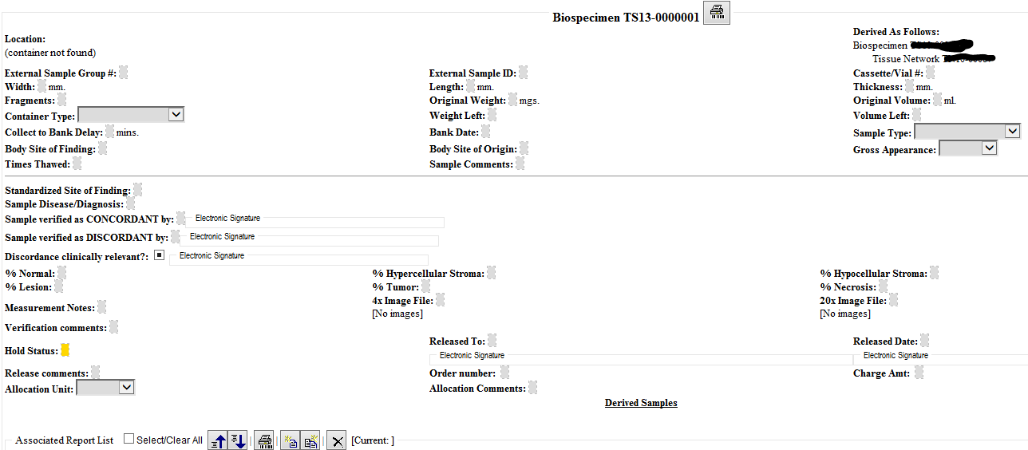

REVIEW:
FILTER ON ALL DRAFT ITEMS = 49 rows
SpecimenGroup number – will not add as its own row in the attribute definition table, but will add a note to specimen identifier, that it can be used to identify all specimen in a set
Since most changes were related to adding attributes for identifier elements, we managed to approve them all
Also approved product.manufaturerName

Review the EA file:
Definitions for all datatype attribute – these need to be migrated into the word document
Rob will send image of current status by COB tonight, so we can stick into

Content due to OO for approval to ballot by 3/16 – will share what we have at point in time, with some comments – notes as to what might still change.
Next week’s call will look at final document and may be approve all those minutes
Call adjourned 5:03 PM ET

- Resources:
  - Link to BRIDG model: http://bridgmodel.nci.nih.gov/files/BRIDG_Model_4.0_html/index.htm - chose VIEW:BSP - biospecimen
  - Link to Specimen DAM: http://wiki.hl7.org/index.php?title=Specimen – scroll to bottom for image

