Orders & Observations Conference Call

14 December 2016

+1 770 657 9270, Passcode: 398652#

WebURL: https://join.me/vernetzt.us

Attendees:

 | Name | Organization
1 | Andrea Pitkus | IMO
2 | Kathy Walsh | LabCorp
3 | Carolyn Knapik | CAP
4 | Riki Merrick | Vernetzt, LLC / APHL
5 | JD Nolen | Cerner
6 | Raj Dash | Duke
7
8
9
10
11
12
Regrets: Rob Hausam

Co-Chair: Riki Merrick
Scribe: Riki Merrick

Agenda/Minutes:
- Agenda Review
- Call next week – will have it – even if we don’t have quorum, we will continue and complete the spreadsheet review and edit the document – then we will bring to OO for review and vote
- Approve minutes – defer until we have completed the spreadsheet
  - from May 6, 2016: : http://wiki.hl7.org/index.php?title=File:SPM_Minutes_20160506_ConCall.docx
  - from May 27, 2016:http://wiki.hl7.org/index.php?title=File:SPM_Minutes_20160527_ConCall.docx
  - from June 3, 2016: http://wiki.hl7.org/index.php?title=File:SPM_Minutes_20160603_ConCall.docx
  - from June 10, 2016: http://wiki.hl7.org/index.php?title=File:SPM_Minutes_20160610_ConCall.docx
  - from June 17, 2016: http://wiki.hl7.org/index.php?title=File:SPM_Minutes_20160617_ConCall.docx
  - from June 24, 2016: http://wiki.hl7.org/index.php?title=File:SPM_Minutes_20160624_ConCall.docx
  - NO CALL ON July 1, 2016
  - From July 8, 2016: http://wiki.hl7.org/index.php?title=File:SPM_Minutes_20160708_ConCall.docx
  - From July 15, 2016: http://wiki.hl7.org/index.php?title=File:SPM_Minutes_20160715_ConCall.docx
  - From July 22, 2016: http://wiki.hl7.org/index.php?title=File:SPM_Minutes_20160722_ConCall.docx
  - From July 29, 2016: http://wiki.hl7.org/index.php?title=File:SPM_Minutes_20160729_ConCall.docx
  - From August 5, 2016: http://wiki.hl7.org/index.php?title=File:SPM_Minutes_20160805_ConCall.docx
  - From August 12, 2016 – NO Quorum
  - From August 19, 2016 – http://wiki.hl7.org/index.php?title=File:SPM_Minutes_20160819_ConCall.doc
  - From August 26, 2016 - http://wiki.hl7.org/index.php?title=File:SPM_Minutes_20160826_ConCall.doc
  - From September 2, 2016 – NO Quorum
  - From September 9, 2016 – No call
  - From September 16, 2016 - http://wiki.hl7.org/index.php?title=File:SPM_Minutes_20160916_ConCall.docx
  - From October 14, 2016 – NO Quorum
  - From October 28, 2016 – NO Quorum
  - From November 2, 2016 - http://wiki.hl7.org/index.php?title=File:SPM_Minutes_20161102_ConCall.docx
  - From November 9, 2016 - NO Quorum
  - From November 169, 2016 - NO Quorum

- Compare Specimen DAM to biologic specimen model in BRIDG - map specification source is BRIDG and the map to is specimen DAM
Spreadsheet

EA file is here:
http://www.hl7.org/documentcenter/public/wg/orders/V3_DAM_Specimen_R1_2014May-BRIDG_Discussions.zip
The spreadsheet: http://www.hl7.org/documentcenter/public/wg/orders/Copy%20of%20BRIDG%20to%20Specimen%20DAM%20Mapping%20Spreadsheet%20as%20of%20Nov%202%202016.xlsx

Ballot document:
http://www.hl7.org/documentcenter/public/wg/orders/V3_DAM_Specimen_R2_INFORM_2017JAN_20161102.docx

Also Raj sent this file:
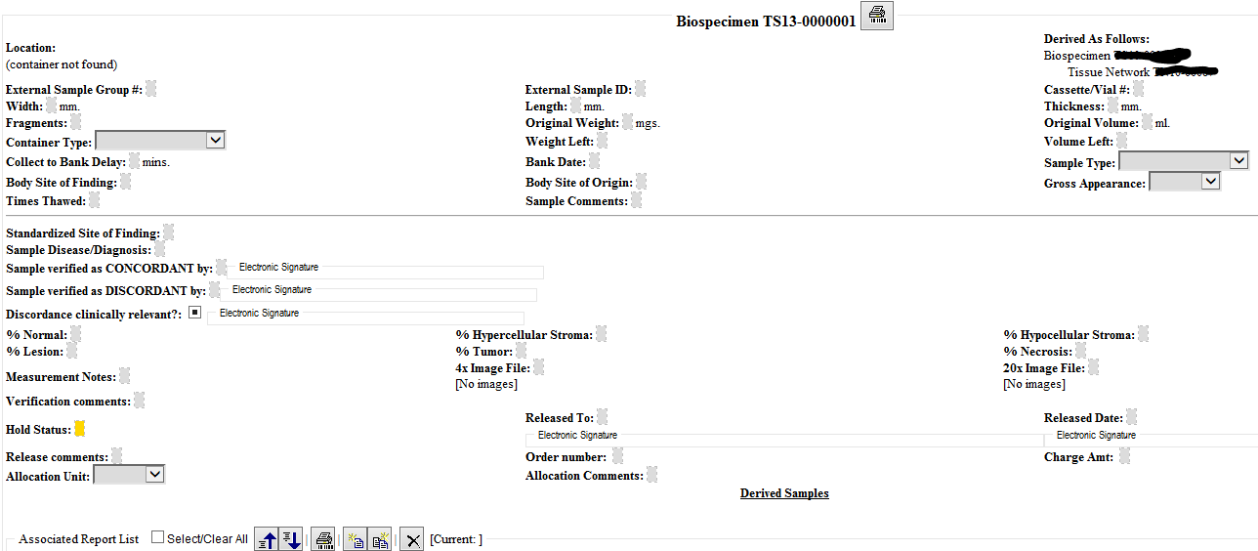

We have these items left in these classes:
- SpecimenProcessingProtocol
  - Add referencedProtocolIdentifier to specimenCollectionProcedure as O 0..1
  - Add referencedProtocolIdentifier to specimenProcessingActivity as O 0..1
  - For biospecimen best practices generally recommends referencing SOP
  - On last call we discussed that we also want to document when there was deviation from the referenced protocol, what it was and possibly why – will need to find the elements for that:
      - referencedProtocolDeviationComment as text, O 0..* - this could hole the reason for the deviation type or any other information not captured by referencedProtocolDeviationType - TO ADD TO SPREADSHEET to both specimenCollectionProcedure and specimenProcessingActivity
    - do we need to document the reason for the specific comment it belongs
      - may be start just with comment – since free text, it could include the reason as well for starters
      - over time we can add a coded element for referencedProtocolDeviationType as code O 0..* - TO ADD TO SPREADSHEET to both specimenCollectionProcedure and specimenProcessingActivity
      - Raj can request the top 10 reasons seen today to create starter set

- Subject – with related considerations for attributes in Material, Person, Non-human-living entity, Biologic entity
    - we decided to keep ONLY the ID for linkage, so that all information related to subject is in one place – no need for reconciliation between 2 locations etc
    - capture the type of specimen (environmental, human, animal, food, etc) using the specimen.ClassCode aas that may be quite important to know without linking to the subject
    - keep SubjectCharacteristicsAtTimeOfCollection that would allow additional elements to be recorded, should the link need to be broken for de-identification
      - Do we need to remove the “atTimeOfCollection” specifier, so we can track subjectCharacteristics at different times?
      - Can that include a picture for forensic purposes? Should be allowed – is normal observation, so don’t see why not support for image
      - Do we need specimenCharacteristics attribute to describe:
        - taking images of the culture plate daily during specimenProcessingActivity?
        - would that not be a ProcessingActivity in its own right and the resulting image is a derived specimen?
        - it would be more like an analysis or observation on the specimen – we will need to add a reference from specimen to separate class of testing / observation so the specimen can be linked that way
          - prefer to capture the image
          - amount of extracted DNA etc that way
          - lab test result
        - do we need a specimenProcessingActiivityIdentifier to reference specimen events?
      - How would you document that you dropped a specimen?
        - Assume specimenProcessingActivity per SOP #x and then record the DeviationType and a comment?
- Specimen
  - Accession number – is used very variable across organizations, or even inside organizations, in BRIDG is defined as the goupID for the same specimen collection – would that be the specimenCollectionProcedureIdentifier? No could use multiple collection methods during same accession – is more often linking to the ordered tests for the visit – so may be create this element: specimen.RelatedOrderIdentifier as Attribute, with datatype string, cardinality 0..*, definition: The alphanumeric sequence that defines the specimen that are collected to fulfill a specific order = mark as approved
  - Specimen.Condition – should be able to record more than one condition, so change cardinality to 0..* and add the following text: For example hemolyzed, thawed, lipemic etc This is specifically allowed to repeat, in case more than one condition needs to be captured. = mark as approved
Call adjourned 5:01 PM ET
- StorageEquipment Parameter = Kathy working on this one – she said descriptions all there, so need to check if anything left
- SpecimenProcessingActivity
- SpecimenCollectionProcedure
- Performer
- Specimen
- SpecimenProcessingActivity
- SpecimenCollectionProcedure
- Performer
- Datatype change for identifier (add type code into the datatype)

Some items from prior minutes, so check on these:
PerformedAdministrativeActivityVarianceReasonCode – proposed source change to add to SpecimenProcessingActivity and

specimenCollectionProcedure, IF we have a protocolReference (or SOP reference) there as well – yes will add that

PerformedAdministrativeActivityVarianceTypeCode - – proposed source change to add to SpecimenProcessingActivity and

specimenCollectionProcedure, IF we have a protocolReference (or SOP reference) there as well

TargetAnatomicSiteConditionCode – do we need this?

Subject.performingSpecimen – how should we represent when tissue from a tissue bank is a specimen – we think it would still fall under person, only de-identified, because currently our material is ONLY from non-living subject

Subject.performingSpecimen: find out if we need this

Specimen.containingSpecimenCollectionGroup – and related attributes

- Resources:
  - Link to BRIDG model: http://bridgmodel.nci.nih.gov/files/BRIDG_Model_4.0_html/index.htm - chose VIEW:BSP - biospecimen
  - Link to Specimen DAM: http://wiki.hl7.org/index.php?title=Specimen – scroll to bottom for image

