Content
Introduction 3
Definitions 4
Health Concern Observation 11
Tracking: 11
Illustrative Example: 12
Analogy 17
Use Case examples 18
Various Points of View 18
User story Nr 1: Abdomal Pain 18
Assigning definitions 21
User story Nr 2: Adverse Drug event 22
Background 22
The Story 23
Health Concerns 24
Problem concerns 24
User story Nr. 3 Concern for Cancer with tracking to observations of others (Jolie, 2013) 25
Background 25
The Article 25
Health Concerns 27
Problem concerns 27
User Story nr 4 Multiple concerns with various providers 28
Background 28
The story 28
Health concerns 29
Problem concerns 29
User story Nr 5: Advance Care Planning 30
User Story nr 6: Conflicting Interventions 30
User story nr. 7 Health Concern Observations: 33
User story nr 8:– tracking of health risks as concern 34
User story nr. 9– no health concern tracking required 34
User story 10– health concern observations and tracking: Head Trauma 35
User story 11– Nutrition Focus 36
User Story 12 Prolonged Hospital Stay Could Have Been Avoided 37
User story 13: Medication Management Approach 39
User story 14: Structured Primacy Care Approach 40

Introduction

In the era of Big Data users have the need to organize their data. With the growing possibility of systems generating information and colleagues exchanging information with them, the urge to bring order is imminent, otherwise an EHR would be cluttered with too much irrelevant information. Data needs to be grouped, filtered and sorted for different purposes.
Additionally, healthcare delivery is becoming more complex. In fact patients being treated in one location might become a rarity. Many institutions are specialized in one sector of healthcare. The consequence is that patients with a long history of health issues are treated by many care providers and transferred frequently to many institutions. Healthcare needs a method of being able to track and follow the medical progress of the patient.
The Health Concern Domain Analysis Model is intended to make this possible. With it, data is grouped in clusters which have a thread of concern in common. The health concern is used to track events belonging to that concern. Views may be built using the concern as the common reference to show the longitudinal history of the patient.
This Domain Analysis Model is the initial introduction to the modeling of Health Concerns. In the DAM we explore the various use cases and storyboards of which we have to take account of in the DMIM and RMIM’s of Health concerns.

Definitions
Concern | A concern is a matter of interest, importance or worry to someone.
Health Concern | A Health Concern is a health related matter that is of interest, importance or worry to someone. This may be the patient, the patient's family or a patient's health care provider.
Health Concern – The Clinical Perspective

- The health related matter is of sufficient interest/importance that someone in the health care environment (patient, family, provider) has identified it to be requiring some attention and perhaps tracking.

- A health concern is identified from the perspective of a person or group. This may be:
  - The Patient
  - A family member orcare giver
  - A particular provider such as a givenphysician, surgeon, physical therapist, respiratory therapist, nutritionist, health educator, social worker, etc.
  - A group of providers or care givers that share a particular perspective of that concern such as Orthopedic surgeons, or ‘the family’.
- Previous discussion has indicated that a Health Concern requires some sort of action on the part of the care team (which potentially includes the subject and/or record target), based on the specifics of the Observation Event which names the Health Concern. Thus, there is a Condition specific requirement to be the reason for some action, even if that action is to simply observe. A Concern may also imply one or more (prioritized) Goals or Desired Outcomes, i.e. an assertion of what should happen or the desired outcome.

- Another aspect of health concern is where the meaning of concern is viewed as a worry or risk of something that might happen in future resulting in precautions against these concerns

Health Concern and Problem Concern Topics in Clinical Document Architecture (CDA)
- The HL7 Clinical Document Architecture (CDA) defines two concepts:
  - Health Concern Act
  - Problem Concern Act
  - Allergy Concern Act
The way health and problem concerns may be used will depend on the stakeholders, their environment and the context in which the concern is used. A problem concern for one provider may not necessarily be a problem for another provider. Similarly, some may consider a concern to be important to record or track, but may disagree with the semantics that it represents a ‘problem.’ For example, a pregnancy may reflect a concern, but not necessarily be a ‘problem,’ while to others it may be. This leads to a view that the way health and problem concerns could be used -- that they must be flexible and fluid
Health Concern Act is described in Consolidated CDA (C-CDA) R2.0 as the following:
“It is a wrapper for health concerns derived from a variety of sources within an EHR (such as Problem List, Family History, Social History, Social Worker Note, etc.).
A Health Concern Act can represent a health concern that a patient currently has. Health concerns require intervention(s) to increase the likelihood of achieving the goals of care for the patient.
A Health Concern Act can also represent a health concern that is a risk. A risk is a clinical or socioeconomic condition that the patient does not currently have, but the probability of developing that condition rises to the level of concern such that an intervention and/or monitoring is needed.
The code on the Health Concern Act is set to differentiate between the two types of health concerns.”
The Health Concern Act is a “wrapper” to organize health matters relevant to the care of the patient which may span over a period of time
The “effectiveTime” attribute may be used to “track” the health concern. But its use is not explicitly stated in the way that is stated for Problem Concern Act and Allergy Concern Act.
The Health Concern Act as defined in C-CDA R2.0 has a broader scope: it covers problem, risks or any health related matters that are of importance; and it may be identified from the patient or health care provider perspectives

Problem Concern Act:
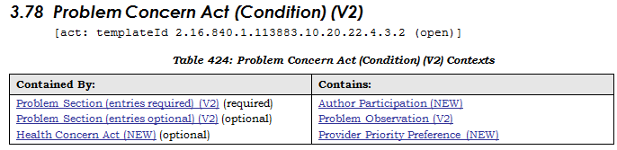
In Consolidated CDA (C-CDA) R2.0, the Problem Concern Act is described as: “reflecting an ongoing concern on behalf of the provider that placed the concern on a patient’s problem list. So long as the underlying condition is of concern to the provider (i.e. so long as the condition, whether active or resolved, is of ongoing concern and interest to the provider) …”
C-CDA R2.0 further describes the use of the Problem Concern Act as the following:
A problem concern “reflects an ongoing concern on behalf of the provider that placed the concern on a patient’s problem list….
The effectiveTime/low of the Problem Concern Act (Condition) asserts when the concern became active. This equates to the time the concern was authored in the patient's chart. The effectiveTime/high asserts when the concern was completed (e.g. when the clinician deemed there is no longer any need to track the underlying condition)
A Problem Concern Act (Condition) can contain many Problem Observations (templateId 2.16.840.1.113883.10.20.22.4.4.2). Each Problem Observation is a discrete observation of a condition, and therefore will have a statusCode of “completed”. The many Problem Observations nested under a Problem Concern Act (Condition) reflect the change in the clinical understanding of a condition over time. For instance, a Concern may initially contain a Problem Observation of “chest pain”:
- Problem Concern 1
--- Problem Observation: Chest Pain
Later, a new Problem Observation of “esophagitis” will be added, reflecting a better understanding of the nature of the chest pain. The later problem observation will have a more recent author time stamp.
- Problem Concern 1
--- Problem Observation (author/time Jan 3, 2012): Chest Pain
--- Problem Observation (author/time Jan 6, 2012): Esophagitis”
Three key themes/characteristics can be discerned from these C-CDA descriptions:
- The Problem Concern Act is a collector/organizer to “loosely hold” together related patient problems over a period of time
- The “effectiveTime” attribute provides the mechanism for implicitly “tracking” the conditions
- “Problem Concern” has a narrower scope (compared to the “Health Concern” concept defined in C-CDA): the focus is on patient’s problems and is identified from a provider’s perspective

Allergy Concern Act C-CDA R2 Section 3.6):
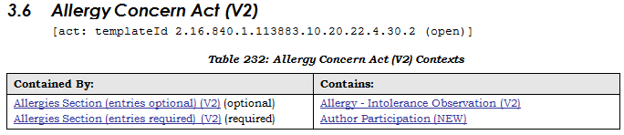
The Allergy Concern “reflects an ongoing concern on behalf of the provider that placed the allergy on a patient’s allergy list. So long as the underlying condition is of concern to the provider (i.e. so long as the allergy, whether active or resolved, is of ongoing concern and interest to the provider), the concern remains “active”. The concern is completed only when the underlying allergy is no longer of concern.
The statusCode of the Allergy Concern Act is the definitive indication of the status of the concern, whereas the effectiveTime of the nested Allergy - Intolerance Observation is the definitive indication of whether or not the underlying allergy is resolved.
The effectiveTime/low of the Allergy Concern Act asserts when the concern became active. This equates to the time the concern was authored in the patient's chart. The effectiveTime/high asserts when the concern was completed (e.g. when the clinician deemed there is no longer any need to track the underlying condition).”
It appears that the “Allergy Concern Act” is a container/organizer used “contain” allergy/intolerance observations and the “effectiveTime” attribute provides the mechanism for implicitly “tracking” the conditions.
From the clinical semantic perspective, it can be considered as a subtype or specialization of the Problem Concern and Health Concern. Therefore we will not deliberate on allergy concern seperately, but treat is as a health concern.

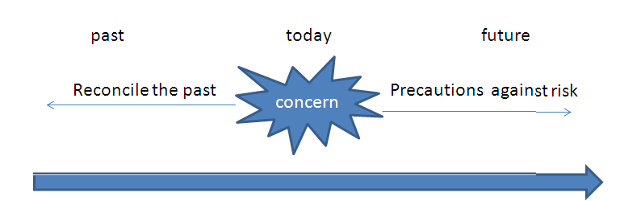
Goal / Desired Outcome
Event
Event
Event
Time
has
Allergy Observed/Verified
Requires some
Compared to
Health Concern
Risk Observation
Problem Observation
Allergy
Risk (e.g. Family History)
Problem
Concern Event

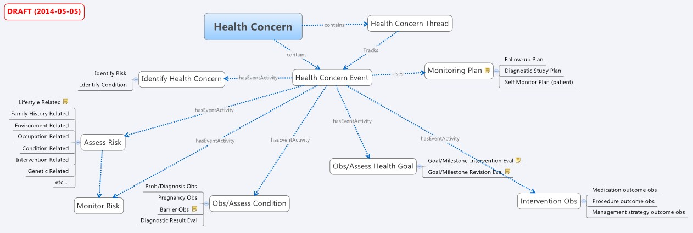

Health Concern – The Information Management/Engineering Perspective
- From information management or engineering perspective, "health concern" can been considered to encompass two subconcepts:
  - Health Concern Thread
  - Health Concern Observation Event

- From the information management/engineering perspective, a Health Concern is an abstraction of anything a person or group may wish to follow over time, but is recorded at discrete time points. For example, a Problem as listed on a problem list represents the ongoing concern (e.g. the concern for Hypertension is ongoing should be followed up, or checked again), where the problem is recorded in a note is a Concern Event (e.g. On June 25th I see the Hypertension is controlled on current medication). Similarly, the concern about an allergy should be followed to ensure that certain medications are never given, while the Allergy may be verified at periodic intervals.
- Health concern thread is used to relate/organise the events pertinent to the health concern in the health records. Events like observations, medication, diagnosis and such are grouped into concerns. This is done by looking back into the past and tagging information to a concern. This could mean that health concerns is used to personalize views on the medical records
- Health Concerns tracking by following the health concern thread allows the patient history to be filtered for a subsets of related events, filtering out other events which are unrelated to the existing concern.
- The Health Concern Thread or Health Concern tracking contains no semantics beyond that need for tracking a subset of events that are related to the Health Concern. It may be used to track the named observations of the Concern, or related observations such as which medications were prescribed or related results.
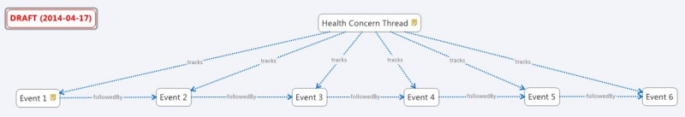

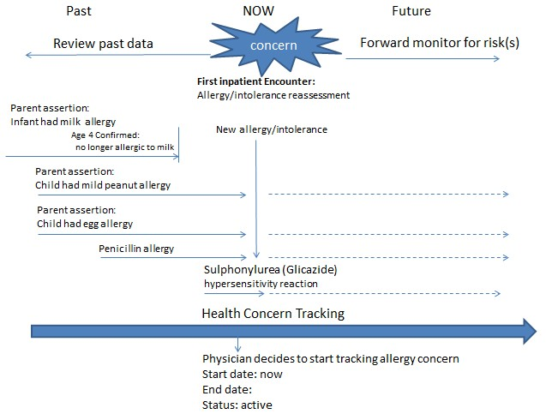
Figure 1 Example of Allergy Concern tracking
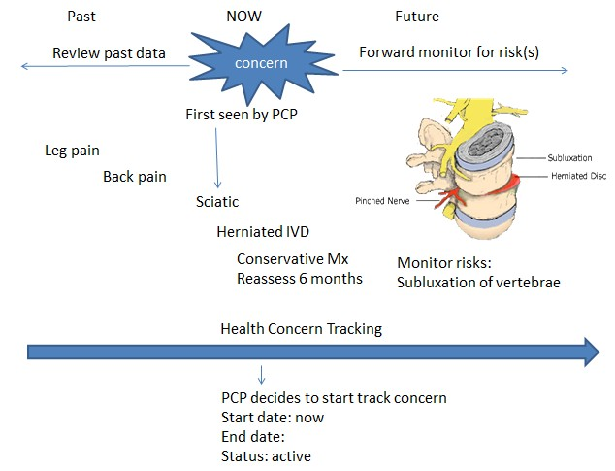
Figure 2 Example of back pain concern tracking

Health Concern Observation
- Health concern observations are observations (at a point in time) and evaluations (meta-observations) of matters related to a patient's health that are of interest or important to someone.
- The name of the Health Concern is taken from a particular observation - typically the last concern observation, or a designated naming observation.
- The observations and evaluations can be from the perspective of the patient, the patient's family, the carer, or any health care providers involved in the care of the patient
- The scope of observations and evaluations cover health issues, conditions, problems, diagnosis
- Related health concern observations are linked and tracked by the Health Concern Tracker

Tracking:
- A Health Concern or a set of related health concerns (expressed as issue(s), condition(s), problem(s), diagnosis/diagnoses, risk(s), barrier(s) are linked to a set of supporting information including complaints (by patient and/or patient family), signs, symptoms, diagnostic findings through health concern tracking
- Other related topics such as goal(s), preference(s) and intervention(s) [and their related observations/evaluations] may also be linked to health concern(s) through the health concern tracking.

Illustrative Example:
To help clarify the abstract nature of Health Concern Tracking, an example patient history may be used.
A 55 year old patient with known Type I Diabetes presented to his Primary Care Physician (PCP) with chief complaints of cough and slight shortness of breath. There was no wheezing on examination.
A week later, he returned to see his PCP with presenting symptoms of cough, shortness of breath and fever.
Two days later, he presented himself at the Emergency Department of local hospital with cough, severe shortness of breath, wheezing and fever.
In the Emergency Department he was diagnosed with asthma and pneumonia, was admitted, treated in the hospital for 2 days. During this hospitalization he is noted to have problems with his diabetes control and a new allergy is noted. After the hospitalization, he is discharged back to the care of his PCP, and see that provider a week later
For purpose of edification, the example will illustrate communication between 2 systems which share similar event structure.
Each of the above events is recorded in the electronic medical records as individual Health Concern Events. The sum of all recorded events represents the patients’ medical history as understood by the computers.
- (System A – the Ambulatory Office System)
- …
- 11/20/2013, 10:17am – Encounter Note.Assement:Diabetes, Type 1, Controlled
- …
- 3/4/2014, 2:45pm – Registration Complaint: Cough & Dyspnea
- 3/4/2014, 2:50pm – Encounter Note.Exam:No Wheeze
- 3/4/2014, 2:50pm – Encounter Note. Assessment: Probable Viral URI
- 3/11/2014,9:23am – Registration Complaint: Cough, Dyspnea , Fever
- 3/11/2014 , 9:38am – EncounterNote.Exam: Crackles, No Wheeze
- 3/11/2014, 9:38am – EncounterNote.Exam:Assessment: Possible CAP
- 3/11/2014, 9:38am – EncounterNote.Order:Azithromycin
- 3/11/2014, 9:38am – EncounterNote.Order:CXR, CBC, Chem 7
- 3/11/2014, 12:10pm –Lab.WBC: 17.3
- 3/11/2014, 12:11pm –Lab.Glucose:258
- 3/12/2014, 1:20pm – Result.CXR:Patchy Infiltrate
- 3/12/2014, 4:32pm – TelephoneNote:Patient advised to go to ED.
- …
- (System B – the ED/Hospital System)
- 3/13/2014, 7:32am – ED Triage Complaint: Cough/SOB/Fever
- 3/13/2014, 7:45am – ED Physician Note.Exam:Wheeze, Crackles, Fever
- 3/13/2014, 7:50am – ED.Order: Rocephin
- 3/13/2014, 8:15am – ED Disposition: Admit to Floor
- 3/13/2014, 8:15am – ED AdmittingDx: Pneumonia
- …
- 3/13/2014, 10:30am – Admit H&P.Assessment: Pneumonia
- 3/13/2014, 10:30am – Admit H&P.Assessement:Diabetes, Type 1
- …
- 3/14/2014, 5:40am – POC.Glucose:456
- 3/14/2014, 5:50am – Order:Insulin Regular
- …
- 3/14/2014, 9:13am – Lab.Sputum.Gramstain. Gram Pos Cocci in Pairs
- …
- 3/14/2014,10:10am – SOAP.SubjComplaint:Rash / Itch
- 3/14/2014,10:10am – SOAP.Exam – Salmon colored maculopapular Rash
- 3/14/2014, 10:10am – SOAP.Assessment: Diabetes, Type 1, Uncontrolled
- 3/14/2014, 10:10am – Order: Increase Lantus
- 3/14/2014, 10:10am – SOAP.Assessment: Rash - Likely Drug Reaction
- 3/14/2014, 10:10am – Order: discontinue Rocephin
- 3/14/2014, 10:10am - Order: Levaquin
- 3/14/2014, 10:10am – Allergy: Rocephin, Reaction Rash
- …
- 3/15/2014, 11:15am – DischargeDx: Pneumococcal Pneumonia
- 3/15/2014, 11:15am – DischargeDx: Asthma
- 3/15/2014, 11:15am – DischargeDx: Diabetes, Type 1
- 3/15/2014, 11:15am – Discharge Summary.Allergies: Rocephin, reaction: rash.
- 3/15/2014, 11:15am – Discharge Medication: Levaquin
- 3/15/2014, 11:20am – Hospital Disposition: Discharge
- …
- (System 1 – the PCP)
- 3/20/2014, 9:40am – RegistrationComplaint: Hospital F/U
- 3/20/2014, 10:00 am – Office Spirometry: <report>
- 3/20/2014, 10:12am – Allergy: Rocephin, reaction Rash
- 3/20/2014, 10:15am – EncounterNote.Exam: Wheeze
- 3/20/2014, 10:15am – EncounterNote.Assessment:Recent Pneumococcal Pneumonia.
- 3/20/2014, 10:15am – EncounterNote.Assessment:Asthma
- …
- 4/20/2014, 3:45pm – EncounterNote.Assessment:Pneumococcal Pneumonia - resolved
Without concern tracking, all these events record the history of the patient as seen by the EMR(s). The patients Diabetes, Asthma, and Pneumonia are mixed together. For example, It is not possible to match up that Elevated Glucose on 3/14 is related to Diabetes, or that the Rocephin was related to the ED admitting Dx: Pneumonia, but unrelated to problem of Diabetes. Any problem list entry or allergy list maintenance is unrelated.
With Concern tracking, the events are typically entered based on a concern identifier as a starting point. For example, in this case, the physician might order the CXR in the context of a concern that started with the registration event Cough & Dyspnea (later renamed Possible Pneumonia and finally winding up as S/P pneumococcal Pneumonia). Furthermore, the EMR may allow for additional tagging or correction of relationships with in a concern history, however the implementation details may vary significantly from system to system, where some systems only track major name changes, others might only record that a particular note exists related to the concern, and others might use sophisticated inference to automatically bind concerns and orders and results based on known relationships like the fact that Glucose Results are generally relevant for Diabetes so any observation of a concern recently named Diabetes Type 1, Uncontrolled might automatically include glucose results.
In our example, let us examine where and how these concern identifiers get established.
- 11/20/2013, 10:17am – Encounter Note.Assement:Diabetes, Type 1, Controlled,
  - Concern id A.1 previously recorded with additional history.
- …
- 3/4/2014, 2:45pm – Registration Complaint: Cough & Dyspnea
  - Concern id A.2 – start of a new concern on system A, and current name of the concern.
- 3/4/2014, 2:50pm – Encounter Note.Exam:No Wheeze
  - Concern id A.2 - because the exam finding was recorded in the complaint context “Cough/Dyspnea”. Some systems may merge all exam into on consolidated exam in which case the exam findings may not necessarily be shown related to the concern, or it might be bound based on static known associations (respiratory exam findngs are relevant for complaints of cough/dyspnea). Alternatively exam finding may be related because they are included in a note that included an assessment related to the concern. Exam findings would generally be used as naming observations.
- 3/4/2014, 2:50pm – Encounter Note. Assessment: Probable Viral URI
  - Concern id A.2 - because of complaint context of encounter. In the note, the Assessment/Plan section, the “Assessment” (sometimes called “Impression”) is an observation event that names the concern at a point in time. The name of the concern is now “Probable Viral URI”
- 3/11/2014,9:23am – Registration Complaint: Cough, Dyspnea , Fever
  - Concern id A.3 – At registration desk, a clerk may not know that the patient had just been seen, and might accidently create a new concern. That can be corrected by merged to concern id A.2 after it is realized this represents the same complaint / concern. As the concern is merged, the name of the concern needs selected from one or the other.
- 3/11/2014 , 9:38am – EncounterNote.Exam: Crackles, No Wheeze
  - Concern id A.2 because of the complaint context
- 3/11/2014, 9:38am – EncounterNote.Exam:Assessment: Possible CAP
  - Concern id A.2 because of the complaint context. This is the new name of the concern A.2
- 3/11/2014, 9:38am –Order:Azithromycin
  - Concern id A.2 - placed from the context
- 3/11/2014, 9:38am –Orders: CXR, CBC, Chem 7
  - Concern id A.2 – placed from the context
- 3/11/2014, 12:10pm –Lab.WBC: 17.3
  - Concern id A.2 because result is from ordered under this this context
- 3/11/2014, 12:11pm –Lab.Glucose:258
  - Concern id A.2 because of the order context of Chem7. It might later be tagged as part of Concern id A.1 because known relationship that Glucose is relevant for Diabetes, and concern A.1 is named as a child of this term. Alternatively it might be manually tagged as relevant for concern A.1. Importantly, the same event may be to multiple concerns.
- 3/12/2014, 1:20pm – Result.CXR:Patchy Infiltrate
  - concern id A.2 because of order
- 3/12/2014, 4:32pm – TelephoneNote:Patient advised to go to ED.
  - Concern Id A.2 because of complaint context
For sake of edification, the hospital/ED is a separate system, thus concerns are prefixed B. The patient arrives without electronic transmission from ambulatory system so new concerns started. If this was the same system, then concern ids could/would be just carried forward. If Electronic transmission were received history would merged. This is shown later in the example.
- 3/13/2014, 7:32am – ED Triage Complaint: Cough/SOB/Fever
  - concern id B.1 – start of new concern in ED.
- 3/13/2014, 7:45am – ED Physician Note.Exam:Wheeze, Crackles, Fever
  - concern id B.1 because of complaint context of the encounter
- 3/13/2014, 7:50am – ED.Order: Rocephin
  - concern id B.1 because of complaint context of the encounter
- 3/13/2014, 8:15am – ED Disposition: Admit to Floor
  - concern id B.1 because of complaint context
- 3/13/2014, 8:15am – ED AdmittingDx: Pneumonia
  - concern id B.1 because of complaint context. This is the new naming observation of the concern
- …
- 3/13/2014, 10:30am – Admit H&P.Assessment: Pneumonia
  - concern id B.1 - Carried forward from ED because this is the same system.
- 3/13/2014, 10:30am – Admit H&P.Assessement:Diabetes, Type 1
  - concern id B.2 – started new because Inpatient Resident asked the patient.
- ...
- 3/14/2014, 5:40am – POC Lab.Glucose:456
  - concern id B.2 –Lab was ordered under complaint context of inpatient stay “Diabetes, type 1”
- 3/14/2014, 5:50am – Order:Insulin Regular
  - concern id B.2 – ordered under complaint context
- …
- 3/14/2014, 9:13am – Lab.Sputum.Gramstain. Gram Pos Cocci in Pairs
  - Concern ID B.1 because of order context.
- …
- 3/14/2014,10:10am – SOAP.SubjComplaint:Rash / Itch
  - concern id B.3
- 3/14/2014,10:10am – SOAP.Exam: Salmon colored maculopapular Rash
  - concern id B.3 - because recorded in context of new complaint
- 3/14/2014, 10:10am – SOAP.Assessment: Rash - Likely Drug Reaction
  - concern id B.3 renames the concern.
- 3/14/2014, 10:10am – Order: discontinue Rocephin
  - concern id B.3 & B.1. Discontinue is from B.3, but Start was from B.1
- 3/14/2014, 10:10am – Allergy: Rocephin, Reaction Rash
  - Concern id B.3 & B.4. Allergies are concerns of themselves, so a new allergy concern is created in this event. In this case the same observation history relevant to both an active problem “Likely Drug Reaction” and the allergy “Rocephin”.
- 3/14/2014, 10:10am – SOAP.Assessment: Diabetes, Type 1, Uncontrolled
  - Concern id B.2 - renamed. In the problem list this now reads “Diabetes, type 1, Uncontrolled”
- 3/14/2014, 10:10am – Order: Increase Lantus
  - concern id B.2 - because place in context of concern.
- 3/14/2014, 10:10am – SOAP.Assessment: Pneumonia, likely Pneumococcal, Improving
  - Concern id B.1 – renamed.
- 3/14/2014, 10:10am - Order: Levaquin
  - Concern id B.1
- …
- 3/15/2014, 11:15am – DischargeDx: Pneumococcal Pneumonia –
  - Concern id B.1
- 3/15/2014, 11:15am – DischargeDx: Probable Asthma
  - Concern id B.5
- 3/15/2014, 11:15am – DischargeDx: Diabetes, Type 1
  - Concern id B.2
- 3/15/2014, 11:15am – DischargeSummary.Allergies: Rocephin
  - Concern id B.4
- 3/15/2014, 11:15am – Discharge Medication: Levaquin
  - Concern id B.1
- 3/15/2014, 11:20am – Hospital Disposition: Discharge
  - Concern id B.1 - because admitted under this concern.
For sake of edification, assume ambulatory system now receives electronic summary of ED and hospital stay with concern tracking ids.
- 3/20/2014, 9:40am – RegistrationComplaint: Hospital F/U
  - Concern id A.4 – new. But, physician reads the electronic discharge documentation from hospital and merges that history. He recognizes the hsoptial Discharge Dx “Pneumococcal Pneumonia” (concern ID B.1) represents the item on his problem list called “Possible CAP” (Concern ID A.2) . He drags the “Pneumococcal Pneumonia” onto “Possbile CAP” and gets a dialog “Would you like merge these problems? Y/N”. His problem list item is now named “Pneumococcal Pneumonia” because that is the more recent naming observation.
  - Similarly, he recognizes that the hospitals “Diabetes Type 1” (Concern ID B.2) is his “Diabetes Type 1” (Concern id A.1) and merges these.
  - He adds the problems B.5 as a new problem. In his system this is concern id A.5. This history from the hospital is already there.
- 3/20/2014, 10:15 am – Office Spirometry: <report>
  - concern id A.5. Note that the reference to observations/events may be discrete data, or very often large blobs such as pictures, or scanned documentation.
- 3/20/2014, 10:15am – EncounterNote.Exam: Wheeze
  - Concern id A.2 &/or A.5, depending on how /where he records this, provides additional problem (concern) tagging and system function to automatically bind known relevant relationships.
- 3/20/2014, 10:15am – EncounterNote.Assessment:Recent Pneumococcal Pneumonia.
  - concern id A.2 – The naming observation looks the same as the hospital, but this is an additional time point where this is known state /name of this concern. The observation timing and verification is important for decision support systems to know if the problem is stale or not.
- 3/20/2014, 10:15am – EncounterNote.Assessment:Asthma
  - complaint id A.5
- …
- 4/20/2014, 3:45pm – EncounterNote.Assessment:Pneumococcal Pneumonia – resolved
  - Concern id A.2 now marked ‘inactive’. Additionally, the PCP may wish to create a new concern A.6 in the patients ‘Past Medical History’ representing the fact that this may affect his risk of pulmonary issues in the future. In this case the PCP might click on the item “Pneumococcal Pneumonia – resolved” and select “add to Past Medical History”, which makes a reference of the concern A.2, including all it’s history.
As can be seen, this is a very simple example – much more simple than exists in real patients where the history of events is hard to follow because problems/concerns are coming and going and the thinking about the evolves over time. But the benefits are seen because a history can how be constructed for each concern separately. For example, if the PCP is interested in what has been happening with Diabetes, and how/why the Lantus was increased in the hospital – he can easily see the history of only events that are associated with concern id A.1. This might look like:
- 11/20/2013, 10:17am – Encounter Note.Assement:Diabetes, Type 1, Controlled
- 3/13/2014, 10:30am – Admit H&P.Assessement:Diabetes, Type 1
- 3/14/2014, 5:40am – POC.Glucose:456
- 3/14/2014, 5:50am – Order:Insulin Regular
- 3/14/2014, 9:13am – Lab.Sputum.Gramstain. Gram Pos Cocci in Pairs
- 3/14/2014, 10:10am – SOAP.Assessment: Diabetes, Type 1, Uncontrolled
- 3/14/2014, 10:10am – Order: Increase Lantus
- 3/15/2014, 11:15am – DischargeDx: Diabetes, Type 1

Analogy
The health concern tracker and health concern observations relationship can be akin to the health concern tracker as the connecting vines of a bunch of grapes
The entry point is the principal health concern observation: e.g. asthma in the simple patient journey storyboard
Each health concern observation (e.g. chief complaints on first encounter, presenting problems at local hospital emergency department, etc) can be considered as a grape
From the entry point, navigation can be made along the branches of the vine to individual grape

Use Case examples
The use cases collected can be divided into the following categories:
- From various points of view (Care giver/ Patient)
- How individuals interact with system
- Tracking a concern over time
- Transitions

Various Points of View

User story Nr 1: Abdomal Pain
Ricardo D.: healthy young mechanic 22 years old has pain in the abdomen. He cannot digest his meals and vomits all the food he eats. He complains about his ache to his mother.
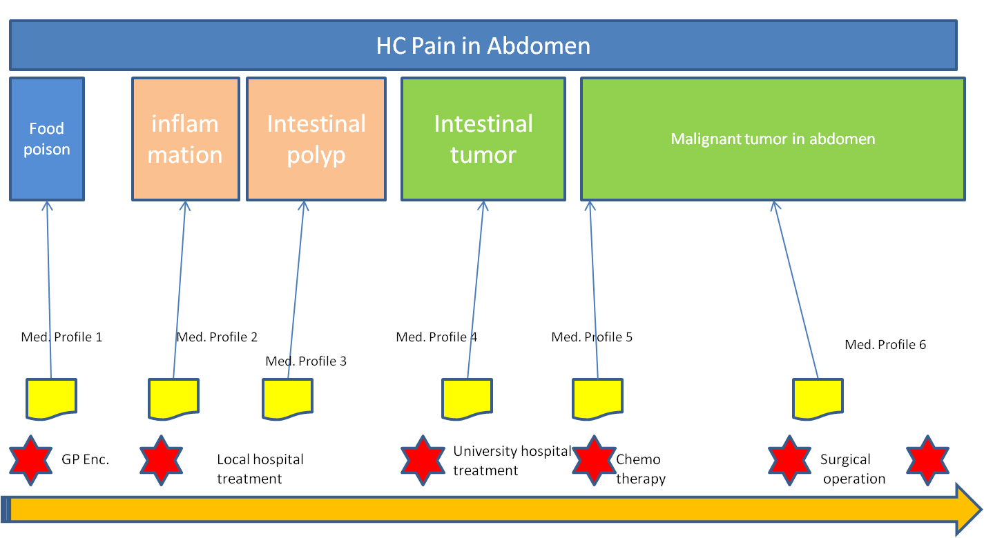
Figure 3 Logitudinal view health concerns
The first diagnosis of the GP is food poisoning. Medication is given for diarhea and food poisoning. The vomiting and pain still remain after 3 weeks. The GP suspects some inflammation in the abdomen. New medication is given and meanwhile the boy is referred to the general hospital.
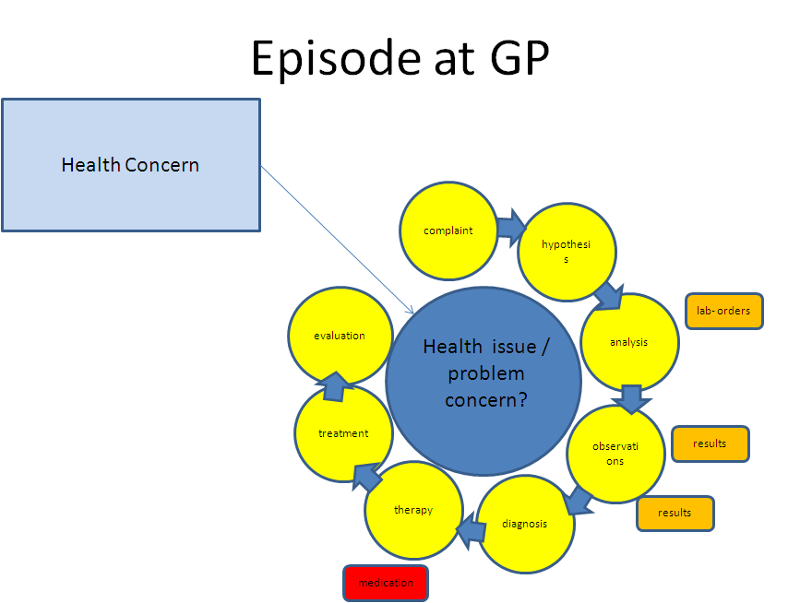
Figure 4 Events and flow primary care
The general hospital investigates a possible inflammation, but do not find the cause. The hypothesis changes to a possible polyp in the intestines. Meanwhile Ricardo is severely weakened and is put on tube feeding. The scans are showing no results. Six months have passed since the initial complaints.
Health Concern

Health issue
complaint
hypothesis
analysis
observations
diagnosis
therapy
treatment
evaluation

lab- orders
results
results
medication

Health issue
complaint
hypothesis
analysis
observations
diagnosis
therapy
treatment
evaluation

lab- orders
results
results
medication
radiology
Figure 5 Events and flow general hospital, while reflecting back at concerns within the primary care

The parents have no confidence in the general hospital and consult the university hospital. The medical records are submitted to the university hospital. The physician suspects intestinal tumor, but the scans show no results. Finally after 8 months they find the cause of the problems: a malignant tumor in the abdomen.
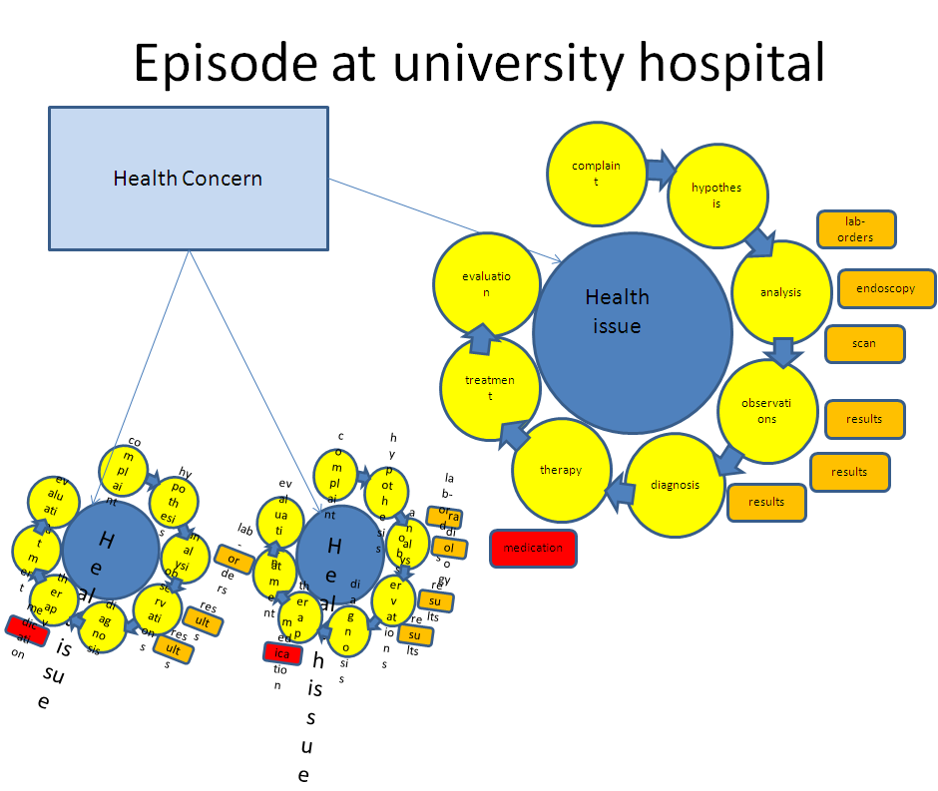
Figure 6 Events and flow in University hospital, while reflecting back at concerns in the past
Ricardo is being treated with chemo therapy, but the therapy is not successful. The physician decides for surgery to remove the malignant tumor.
The surgery showed that the cancer has spread over a large part of the abdomen. The physician removes as much malignant tissue, but concludes that the situation is too grave to be saved.
Ricardo is brought home and the doctors give him 2 months to live.
Ricardo celebrates his last birthday (23d) with his family and friends. On the 14th of June 2013 he passes away.

Assigning definitions
- The overarching health concern is pain in abdomen. This is the view from the patient and is the constant thread throughout the history.
- The GP thinks it is food poisoning. The problem concern could be defined as food poisoning.
- The general hospital suspects at first an inflammation of the abdomen. The problem concern could be called inflammation.
- After investigation the hospital revised their findings and suspects an intestinal polyp in the large intestine. The problem concern would then be intestinal polyp.
- The university hospital review the results and are convince that the problem must be an intestinal tumor. The problem concern is then intestinal tumor.
- An endoscopic research traces the source of the tumor and the problem concern is set to malignant tumor in upper region of abdomen.
- The overarching health concern ( pain in abdomen) is the view from a patient. The patient does not have a system to put this input.
- Most probably the care providers will define the problems like inflammation as their health concerns.

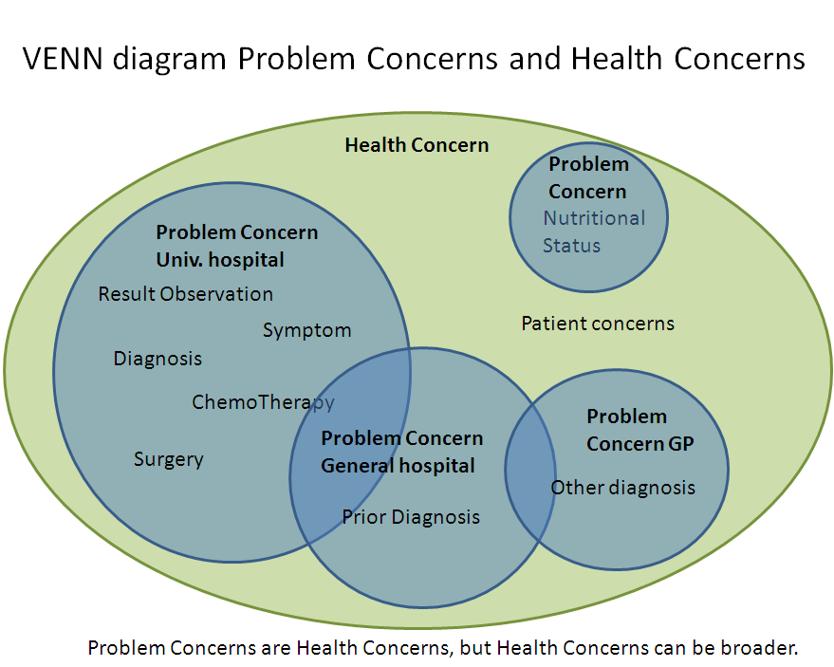

User story Nr 2: Adverse Drug event

Background
- 87 year old white male.
- Dementia and cardiovascular disease
- Lives in an assisted living facility in the memory care unit
- Daughter is primary care giver, legal guardian, and health care power of attorney
- Daughter keeps a PHR to track her Dad’s medical history
- Dad has had adverse reactions to medications in the past

The Story
- In March, 2011, nurses at the assisted living facility found Dad sleeping in the chair in his room and when they tried to get him up he seemed really hard to wake. He felt dizzy and was unable to stand up on his own. When they checked his blood pressure, it turned out to be dangerously low. His Heart rate was 32 beats per minute. He was taken to the Emergency Room.
- All the usual evaluations were conducted, and orders were written. Daughter was not present to discuss Dad’s medical history. Prior medication intolerances were documented in the paper work from the home, but didn’t get entered into the ER system. An order for Lorazepam was written. (Indication was not documented.)
- A pacemaker was recommended and was implanted the next day. The anesthesia left Dad very confused and disoriented. He kept getting out of bed and a bed alarm had to be used.
- He was driving the nurses crazy because he was constantly setting off the bed monitor. They had to check on him repeatedly. He wasn’t responding to their instructions about staying in his bed. On the day he was to be discharged (Friday), a nurse noticed that the ER physician had ordered a sedative for use if needed. So it was ordered and given in the early morning hours.
- Shortly afterward, Dad became severely disoriented, and unable to speak clearly. This led to another round of evaluations and the discharge had to be postponed. The weekend hit, and I wasn’t sure what was going to happen next. The situation seemed to have taken a real turn for the worse.
- It turned out that the sedative Dad had been given was similar to a medication I knew he had a bad reaction to several months back, but Dad can’t remember those things and I wasn’t there so the caregivers didn’t have the right information.
- Doctors were able to reverse the effects but three extra days were added to Dad’s hospital stay.
- I was very concerned about arranging for where Dad would go for rehabilitation. Each new environment made him more confused and agitated.
- Frequent visits helped Dad stay calm and that helped him rest as needed.
- Finding a bed in a rehab facility was difficult. It took the better part of two days to find a bed in a nearby facility and coordinate the transfer. Lost almost two days of work.
- The day Dad was supposed to be discharges was a third day out of work
- The change in plans meant the bed situation and transfer had to be rescheduled and pushed care into the weekend which was difficult on coordination and communication. The care team changed over the weekend—more new people to bring up to speed. The bed options all changed, and that planning had to be rethought and rearranged.
- My work outage extended unexpectedly into the next week and took another day out of the office to following Monday.

Health Concerns
- Prior adverse reactions to medications:
  - Risperdal in 2010
    - Severe hallucinations, confusion
  - Lexapro in 2009
    - Moderate reaction: confusion, disorientation, depression
- Care arrangements for rehabilitation
- Dependence on daughter for care/living arrangements
- Work outages for daughter

Problem concerns
- Cardiovascular Disease
  - Low blood pressure
  - Low heart rate
- Atrial Fibrillation
- Vascular Dementia

Health Concern
Low blood pressure
Low heart rate
Familiar surroundings to reduce confusion

Important to have rehab near home for visitations
Problem Concern
Problem Concern
Reliance on daughter for all medical history
Low Blood Oxygen Level
Vascular Dementia
Dizzy; Confused
Unresponsive
Can’t stand
Cardiovascular Disease

Problem Concern
Mental Status
Financial Concerns – double cost of 2 rooms

Problem Concern
Atrial fribrillation
Fall risk
Impact on caregiver’s job
Bed availability

Notes:
- If we want to track and understand to true cost of Adverse Drug Events, we need to be able to account for the full impact (ie full cost) of these events, not just to patients and their safety, but to care givers (which includes family members, not just practitioners) and to society as a whole.
- The Health Concern Tracker is what allows us to use systems to identify and track issues that are broader than the medical concerns the practitioners are focused on addressing.
- The Health Concern also shows a bigger picture across multiple Problem Concerns. Sometimes the right plan of care depends on considering more than just the primary Problem Concern.

Figure 7 Health concerns over time

User story Nr. 3 Concern for Cancer with tracking to observations of others (Jolie, 2013)

Background
- Healthy 38 year old actress.
- Observation 1: Mother diagnosed and died of cancer
- Observation 2: BRCA-1 gene positive.
- Patient is concerned of the high risk of cancer.

The Article
MY MOTHER fought cancer for almost a decade and died at 56. She held out long enough to meet the first of her grandchildren and to hold them in her arms. But my other children will never have the chance to know her and experience how loving and gracious she was.
We often speak of “Mommy’s mommy,” and I find myself trying to explain the illness that took her away from us. They have asked if the same could happen to me. I have always told them not to worry, but the truth is I carry a “faulty” gene, BRCA1, which sharply increases my risk of developing breast cancer and ovarian cancer.
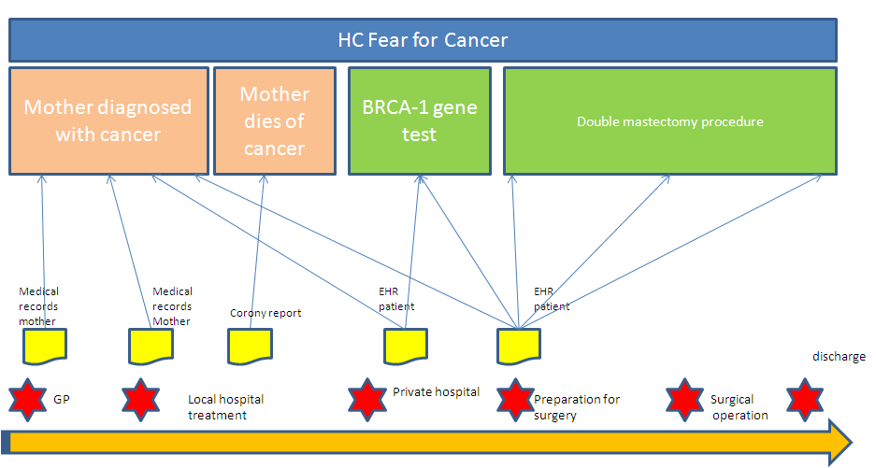
Figure 8 Time line with reference to other medical records
My doctors estimated that I had an 87 percent risk of breast cancer and a 50 percent risk of ovarian cancer, although the risk is different in the case of each woman.
Only a fraction of breast cancers result from an inherited gene mutation. Those with a defect in BRCA1 have a 65 percent risk of getting it, on average.
Once I knew that this was my reality, I decided to be proactive and to minimize the risk as much I could. I made a decision to have a preventive double mastectomy. I started with the breasts, as my risk of breast cancer is higher than my risk of ovarian cancer, and the surgery is more complex.
On April 27, I finished the three months of medical procedures that the mastectomies involved. During that time I have been able to keep this private and to carry on with my work.
But I am writing about it now because I hope that other women can benefit from my experience. Cancer is still a word that strikes fear into people’s hearts, producing a deep sense of powerlessness. But today it is possible to find out through a blood test whether you are highly susceptible to breast and ovarian cancer, and then take action.
My own process began on Feb. 2 with a procedure known as a “nipple delay,” which rules out disease in the breast ducts behind the nipple and draws extra blood flow to the area. This causes some pain and a lot of bruising, but it increases the chance of saving the nipple.
Two weeks later I had the major surgery, where the breast tissue is removed and temporary fillers are put in place. The operation can take eight hours. You wake up with drain tubes and expanders in your breasts. It does feel like a scene out of a science-fiction film. But days after surgery you can be back to a normal life.
Nine weeks later, the final surgery is completed with the reconstruction of the breasts with an implant. There have been many advances in this procedure in the last few years, and the results can be beautiful.
I wanted to write this to tell other women that the decision to have a mastectomy was not easy. But it is one I am very happy that I made. My chances of developing breast cancer have dropped from 87 percent to under 5 percent. I can tell my children that they don’t need to fear they will lose me to breast cancer.
It is reassuring that they see nothing that makes them uncomfortable. They can see my small scars and that’s it. Everything else is just Mommy, the same as she always was. And they know that I love them and will do anything to be with them as long as I can. On a personal note, I do not feel any less of a woman. I feel empowered that I made a strong choice that in no way diminishes my femininity.
I am fortunate to have a partner, Brad Pitt, who is so loving and supportive. So to anyone who has a wife or girlfriend going through this, know that you are a very important part of the transition. Brad was at the Pink Lotus Breast Center, where I was treated, for every minute of the surgeries. We managed to find moments to laugh together. We knew this was the right thing to do for our family and that it would bring us closer. And it has.

Health Concerns
- Fear of cancer

Problem concerns
- Fear for breast cancer
- Fear for ovarian cancer
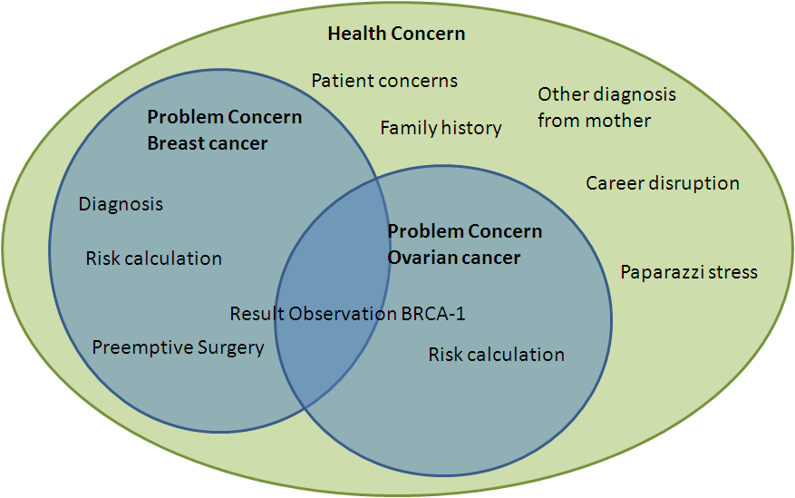
Figure 9 Venn Diagram breast cancer concern

User Story nr 4 Multiple concerns with various providers

Background
- Obese 24 year old man with multiple multi-layered concerns
- Diabetes concern
- High cholesterol problem
- Poor physical condition
- Unhealthy eating habits

The story
Chubby Chuck has always had a good appetite for fast food. His weight has always been a problem and a reason for teasing, but Chuck is a cheerful fellow who manages to survive through hard times. He does not like to exercise, because he is ashamed to hoist his flabby waistline in a flashy sport suit.
The office where he works has recently moved into a two story building with no elevators. One day while he had to climb the stairs he tried to catch his breath, but instead he saw stars and fainted. His manager Mr. George Masterson helped him to recover and advised him to consult his doctor. Chuck made an appointment with his GP for the next morning .
Doctor Robert Pill has been the family doctor since his childhood, but had not seen Chuck for many years. Dr. Pill was surprised that Chuck had gained so much weight and decided to carry out a thorough medical checkup with Chuck. Analysis of his blood showed that Chuck had a glucose level of 13 mmol/l. His total cholesterol level measured 10 mmol/l. Chuck is diagnosed with Diabetes type 2. Dr Pill registers his findings in the medical records of his system and prescribes insulin. But besides the medication Dr. Pill advised Chuck to follow a diet and start exercising. Dr. Pill sends the prescription electronically and a concern-id as a tag to the prescription.

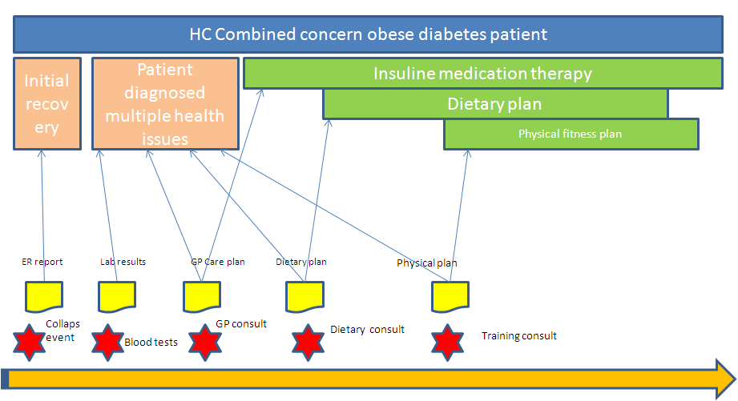

Chuck visited a dietitian in the same healthcare center and Mrs. Agatha Breadcrumb and read the referral that Dr. Pill had sent along to Mrs. Breadcrumb. Mrs. Breadcrumb explained to Chuck what kind of food he should omit and advised him on the diet he should follow. Chuck agreed to a dietary plan that she set up and mrs. Breadcrumb noted down her findings in her system and the dietary plan under her own problem concern, but also referring to same concern-id as mentioned in the referral of Dr. Pill.
Mr. Masterson, his manager wanted Chuck back in healthy condition, because Chuck was a valuable employee. He understood that Chuck would need coaching for his physical training and offered to pay for a personal trainer for Chuck. Marc Muscleman was recommended to him by Dr. Pill. Marc understood the problem and together with Chuck they made a training schedule, gradually building up his physical condition in 3 months. Marc measured the progress of Chuck and noted that down in the a physical progress report. The concern-id from Dr. Pill was attached to the progress file of Chuck.
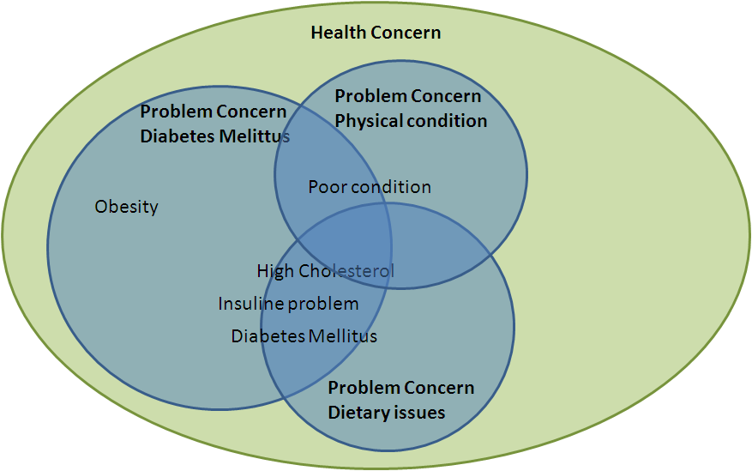

Health concerns
- Bad physical condition

Problem concerns
- Diabetes Mellitus concern
- Obesity
- High cholesterol concern
- Weak Physical condition

User story Nr 5: Advance Care Planning
My Dad is 87 years old. He has Vascular Dementia, Congestive Heart Failure, High Blood Pressure, High Cholesterol, Hypertension and Glaucoma. He lived with me for a year and a half after his care became too much for my 86 year-old mother. After an elopement issue where he wondered across the street in the middle of a cold night, the family agreed it would be best for him to move to a facility that specialized in caring for patients with memory loss issues.
Last year he had a bad case of Pneumonia and we nearly lost him. He spent 7 days in the ICU, 5 days in a step-down unit, and then two weeks in a rehabilitation facility. During this episode, the whole family became acutely aware that the time for Dad’s eventual departure could be coming in the not too distant future. We all came to terms with it, even Dad.
Last Sunday, our minister preached a great sermon titled, “What will be engraved on your headstone?” The readings talked about how Paul did not fear death when he knew his life was coming to an end. The message explained how Paul was able to feel resolved at the time when he realized his life was coming to an end, knowing he had been a “good and faithful servant” and had “run a good race”. After church we sat down as a family over lunch. We talked about the things that were important to us, as we each considered the end of our lives.
Dad shared that he was concerned about becoming a burden on his family. He didn’t want to ever be a financial burden, or a time burden. He was concerned about how much all his care was costing, and how much effort it took to take care of him. He said that in the future, should something happen where he was “dead, but not really dead”, and the doctors said there was little chance of any real recovery from this condition, he did not want us to keep him alive with medical machinery or feeding tubes which would prolonged that sort of life. He asked that we record his wishes not to have CPR performed. He said that if it was possible, and not too much of a burden on us, that he would prefer to die at home, in the company of his family, rather than in a hospital. He also added that after he had gone, since he would no longer need them, he would like to donate any of his organs which could be of use to others.
I recorded all of his concerns, and wrote down his instructions about where he wanted to be buried and his wishes regarding funeral arrangements. A few tears were shed, and the conversation was really heartfelt and genuine. I was so glad to know what Dad thought and how he felt about all this. It made me feel more at ease knowing that the whole family knew what was important to Dad and that if the time ever came when I needed to do my duty as his healthcare power of attorney, I would know in my heart what Dad wanted me to do.

User Story nr 6: Conflicting Interventions

My Father is 87 years old. He lives in a Memory Care Center because he has vascular dementia. He also has congestive heart failure, has had quadruple by-pass surgery (in 2007), and now has a pace maker (in 2011). I am his legal guardian and his healthcare power of attorney.
Dad has very bad back pain. It keeps him from moving around much, and consequently he spends a lot of time sitting in his room by himself. This is not good for his quality of life. He is much happier when he is up and about and participating in activities with other residents. His PCP prescribed Celebrex for his back pain. After taking this medication for four weeks, he was getting noticeable relief and was spending more time walking outside of his room and partaking in activities. At his 6-month check-up with his Cardiologist, the Celebrex was discontinued due to concomitant risks of use. Dad takes Warfarin, so the Cardiologist was concerned the Celebrex could increase Dad’s risk of bleeding complications. The
Cardiologist was also concerned that the Celebrex could decrease the effectiveness of the ACE Inhibitor medication that Dad takes. When the nurses at the Memory Center got the order to discontinue Celebrex, they destroyed the remaining 2-month’s supply of the medication. (Dad’s insurance company requires that all medications are filled via mail-order with a 3-month’s supply.)
At the 6-week follow-up visit with his PCP, Dad said his back was feeling better for a while and he was happy about doing a few more activities, but explained that lately he was feeling more pain again. The PCP explained the risks to me (I take Dad to all his appointments). We agreed that concerns about Dad’s pain and low enjoyment of life, outweighed the concerns about the risks associated with the potential complications. The PCP provided orders for Dad to go back on the Celebrex. The nurses at the Memory Care Center ordered another 3-month’s supply.
Two weeks later, when the Cardiologist reviewed Dad’s medical record to check on the recent lab results and INR levels, he noticed that Dad’s medication list included Celebrex and he ordered it to be discontinued. The nurses destroyed the supply of Celebrex a second time.
A week later when I came to visit, Dad’s back was really bothering him. I checked his medication log and noticed that he was not being given any Celebrex. I asked the nurses why and they told me the Celebrex order had been discontinued.
I’m concerned. I don’t know how to communicate effectively about our choices regarding these trade-offs. I need a way to explain to the whole care team our decision to accept the risks associated with taking this medication, so that Dad’s life can be more enjoyable, even if that means it might be shorter. What point is there for Dad to live longer, if he can’t engage in activities and be free from pain? I am concerned about how to resolve the doctor’s conflicting points of view. I am also concerned about the cost of the medications that are being wasted.

User story nr. 7 Health Concern Observations:
A 48 year-old male patient was seen by a primary care provider (PCP) on 20 June 2012.
Health concern observation: presenting signs and symptoms:
He presented to the PCP with complaints of lethargy, polydipsia, polyuria, difficulty in concentration, and recent weight loss. Spot blood glucose level revealed a reading of 11mmol/litre. Patient has no family history of Type 1 or Type 2 Diabetes Mellitus
Health concern observation: problem/diagnosis
Patient’s spot blood pressure was 156/90 (hypertensive) .
Body weight was 88 kg, height 170cm, BMI = 30.4 (obese)
Based on medical history and physical assessment, the GP made a provisional diagnosis of type 2 diabetes mellitus
The GP requested fasting blood glucose and glucose challenge, HbA1C, serum lipid profile tests
Patient was seen again by his GP on 25 June to discuss the test results. The GP made a diagnosis of Type 2 diabetes taking into consideration clinical history, physical examination and diagnostic test results.
Health concern observation: presenting signs and symptoms:
On 30 June, patient presented at the ED of his local hospital with the following presenting signs and symptoms: fever, productive cough, dyspnoea for 3 days, severe thirst, muscle weakness and increasing lethargy since onset of respiratory symptoms, warm dry skin, dry oral mucosa, blurred vision, , and mental confusion.
Health concern observation: problem/diagnosis
Diagnostic tests showed: chest x-ray lateral view showed lobar pneumonia left lower lobe, spot blood glucose level 30 mmol/L, serum osmolality = 325 mOsm/kg, serum pH = 7.40. Based on the clinical history, presentation and diagnostic tests
The treating physician diagnosed the patient to be suffering from hyperosmolar hyperglycemic nonketotic syndrome. The patient was treated in the hospital and discharged back to the care of his PCP. An electronic discharge summary was sent to the PCP
Health Concern Tracking:
From June 2012, the health concern tracker application of the PCP medical record system continues to track the patient’s diabetes problem and related issues:
- Presenting signs, symptoms, clinical evaluation at each encounter/visit
- Risks for complications: cardiovascular, neurological, renal, ophthalmic, etc
- Prognosis of the condition

User story nr 8:– tracking of health risks as concern

Health Concern (Risk Factor) observation:
- A male patient has the following health profile:
- High BMI: 31.2
- High blood pressure: 14 days average >157/93
- Smoking: 15 pack year (1.5 pack/day for 10 years)
- Elevated lipid profile (including high LDL and LDL:HDL ratio)
- Cardiovascular risk (based on Framingham Risk Equation) and stroke risk are assessed to be high

Health Concern Tracking:
The risk of atherosclerotic heart disease and stroke associated with this patient’s risk factors are considered immediate health risks. The health risk factors as health concerns are continuously tracked by the PCP medical record system health concern tracking application

-------------------------------------------------------------------------------------------------------------------------

User story nr. 9– no health concern tracking required
Health Concern (family history related risk factor) Observation:
- A 35-year old female patient has a family history of breast cancer in three first degree female relatives.
- The patient is recently diagnosed with aggressive malignant brain tumour.
- Prognosis of brain tumour is assessed by neurologist to be very poor

Health Concern Tracking:
The risk of breast cancer as a health concern will not be considered in her case. Health concern tracking of breast cancer risk will not be initiated

User story 10– health concern observations and tracking: Head Trauma

Health Concern Observations:
A 57 year-old female patient was brought into the Emergency Department of the local hospital suffering from concussion. The car she was travelling in collided sideway with a light post. Her head hit the B pillar of the car. She lost consciousness (LOC) for approximately 7-8 minutes.
Imaging studies (CT/MRI) showed no organic lesions such as skull fracture or intracranial haemorrhage.
She was hospitalised for 2 days and was discharged to the care of her primary care physician (PCP).
Problem concern observation: presenting signs and symptoms:
Her chief complaints/presenting signs/symptoms include: severe headache; dizziness; nausea; LOC for 7-8 minutes prior to arrival at ED
Problem concern observation: discharge problem/diagnosis
The hospital discharge summary contains a discharge diagnosis: concussion
Three weeks later, the patient presents at her PCP office with a number of complaints which are documented by the PCP in the patient’s EMR
Health/Problem concern observation: presenting signs and symptoms:
Fatigue; insomnia; increased sensitivity to noise and light
Cognitive problems: deteriorated memory, concentration and thought processes
The PCP advises patient to take adequate rest and prescribes amitriptyline for post-traumatic injury; dihydroergotamine combined with metoclopramide for [chronic] headache; refers patient for cognitive and relaxation therapy, recommends supportive care and use of diary to help with memory problem
The PCP organises follow up visits for the patient to continue monitor and manage the condition.
Health/Problem concern observation: problem/diagnosis
The PCP associates the continuing problems with the head injury/concussion event and makes a diagnosis: post traumatic injury/disorder; post-concussion syndrome
The follow-up visits continue until 4 months later the patient presents with a set of new complaints
Health/Problem concern observation: presenting symptoms/problems
Irritability; anxiety; mood changes; depression mood
The PCP prescribes anti-depressant and refers patient for psychotherapy
The difference between health concern and problem concern is not clear in this part. How does it differ? We think health concern has a broader perspective than problem concern. Is this the case in this story?

Health Concern Tracking:
The PCP discusses with the patient the importance of tracking the health/problem concern observations to monitor the clinical status and progress in relation to treatment/management.
The followings are tacked under post-concussion syndrome Health Concern Tracker:
- Presenting signs, symptoms, clinical evaluation at each encounter/visit
- Medication and therapy treatment, patient compliance and outcomes
- Prognosis of the condition including risks of organic brain lesions
Need to explain the tracking mechanism to the health concern

User story 11– Nutrition Focus

A 50-Year-Old Hispanic Man With Metabolic Syndrome:
Background
The patient works in maintenance for the apartment building where he lives. He has been overweight since childhood and has been unable to lose weight despite many attempts. Several fad diets have resulted in as much as a 15-lb weight loss, but eventually he regains all the lost weight and rebounds past his baseline weight, becoming even heavier. The patient does not exercise except for walking associated with his job. His family has expressed concern about his risk of developing type 2 diabetes mellitus or heart disease, and they have convinced him to seek medical consultation. The patient states he has not seen a physician in 2 years, and he has not adhered to his cholesterol-lowering therapy because of the cost of the drug.
Physical Examination
- Height 6 ft 1 in
- Weight 350 lb
- Body mass index (BMI) 46.2 kg/m2
- Waist circumference 50 in
- Blood pressure 150/100 mm Hg
Assessment
Morbidly obese male, alert and oriented, in no acute distress.
Laboratory Values:
- Fasting plasma glucose 115 mg/dL
- High-density lipoprotein cholesterol (HDL-C) 41 mg/dL
- Triglycerides 220 mg/dL
- Total cholesterol 250 mg/dL
- Low-density lipoprotein cholesterol (LDL-C) 171 mg/dL
Lifestyle/Family History
  - Exercise status Patient does not exercise
  - Smoking status Nonsmoker
  - Alcohol consumption None
  - Drug history Denies drug abuse
  - Past medical history Hypertension, hypercholesterolemia
  - Diet Patient nonadherent to a sodium-modified (4 g/day) diet
  - Family history Significant for hypertension and T2DM in father diagnosed
- at 40 years of age; history of hypertension in mother
Medications
• Lisinopril 10 mg daily
Health Concerns:
- Morbid Obesity (provider)
- Atherogenic dyslipidemia (provider)
- Hypertension (provider)
- Risks
  - Type 2 Diabetes (provider and family)
  - Stroke (provider)
  - Myocardial Infarction (provider and family)
  - Cost of medications

User Story 12 Prolonged Hospital Stay Could Have Been Avoided

Value Case Name
WHO  WHAT  WHERE  WHEN | My Dad has Dementia and heart problems. He now lives in an Assisted Care Facility about 25 miles from where I live. My sister lives out of state so I play the largest role in the management of services that Dad needs. It also means I have the most knowledge of his medical history.  Awhile back I got a call from staff at the place where my Dad lives. They told me they had found him sleeping in his chair in his room and when they tried to get him up he seemed really hard to wake and he felt dizzy when they helped him up. When they checked his blood pressure, it turned out to be dangerously low. He ended up being taken to the ER as a precaution. All the usual evaluations were conducted, and orders were written. I was not present to provide the full medical history.  Dad was admitted to the hospital and the Cardiologist recommended a pacemaker. The implant went well, but the recovery was a challenge. The anesthesia made Dad’s dementia worse and he was very confused. Doctor’s orders were for him to lie still in bed, but he kept trying to get out of bed to go home.  He was driving the nurses crazy because he was constantly setting off the bed monitor. They had to check on him repeatedly. He wasn’t responding to their instructions about staying in his bed. On the day he was to be discharged, a nurse noticed that the ER physician had ordered a sedative for use if needed. So it was ordered and given in the early morning hours.  Shortly afterward, Dad became severely disoriented, and unable to speak clearly. This led to another round of evaluations and the discharge had to be postponed. The weekend hit, and I wasn’t sure what was going to happen next. The situation seemed to have taken a real turn for the worse.  It turned out that the sedative Dad had been given was similar to a medication I knew he had a bad reaction to several months back, but Dad can’t remember those things and I wasn’t there so the caregivers didn’t have the right information.  Doctors were able to reverse the effects but three extra days were added to Dad’s hospital stay.
HOW IS A PHR VALUABLE?  Cost  Quality  Time/Speed  Risk | Having a PHR would have saved thousands of dollars, My Dad would not have had to recover from a medication reaction while he was also recovering from a medical procedure. The amount of time required to recover would have been less and the problems stemming from missing information would not have been an issue.
Quantification | Per Aetna.com, the average cost of one hospital day is $1700. So when Dad’s hospital stay was extended by three days because of an avoidable adverse drug reaction...over $5000 more cost was incurred.
Additional details | Adverse Reaction to ATIVAN (Lorazepam) Experienced on 3/4/2011, dose of 1 mg. March, 2011. Severe reaction: confusion, disorientation, altered ability to speak.  Adverse Reaction to RISPERDAL (Risperdone). Nov. 2010. Severe reaction: Hallucinations, confusion.  Adverse Reaction to LEXAPRO (Escitalopram) October, 2009. Moderate reaction: confusion, disorientation, depression

User story 13: Medication Management Approach

Background
Granny Mabel Smith has become 82 this year. She has recently lost her husband Joseph and is now living alone in her apartment. She still manages on her own , despite the high blood pressure and artery problems. The medication prescribed currently are Ascal and Metoprolol. She also takes Calcium tablets because of the risk of Osteoperosis. Since her husband died, her son noticed an increasing loss of short term memory and the early signs of dementia are now apparent.
Mabel Smith is currently under supervision of her General Practioner ( GP) dr. Brenda Buttercup.
In the EHR of Mrs. Smith dr. Buttercup has listed the ailments and medication under the health concerns:
- Hypertension
- Arterial problems
- Dementia
- Risks
  - Osteoperosis.

In the night of November 17th while Mabel just had a taken a shower, she slipped on the wet floor and fell against the toilet basin. She felt an immense pain in her hips and could not stand up anymore. She managed to crawl to the phone and dialled 911. The ambulance arrived shortly afterwards and after forcing the front door took her to the hospital.
A hip fracture was diagnosed and Mabel had to be hospitalised.
This resulted in a new concern : hip fracture. Mabel had to be operated and therefore the use of Ascal had to be temporally stopped. The medication is linked to both health concerns Arterial Problems and Hip fracture.
The hip fracture itself is linked to the concern of Osteoperosis.
The operation itself was successful. But the recovery of Mabel itself was not without problems. On one hand the bleeding on the surgical wounds did not stop and on the other hand Mabel suffered a CVA in the second week after her operation. Mabel could not speak clearly anymore and suffered from aphasia.
The physician reviewed her medication profile and resumed the use of the anti-clotting medication to prevent worsening of her condition. In the third week Mabel’s wounds were still not recovered and an inflammation started to develop.

User story 14: Structured Primacy Care Approach

The General Practitioners in the Netherlands work according to a highly structured method which is set as guideline for the practitioners for working with their EHR. IT systems for the GP's are certified against the reference information model of the GP association. Using the same reference information model makes access to an EHR more transparent and transfer from one system to another more simple.
The structure of the information model reflect a problem oriented approach. This is called the Problem Oriented Registration ( POR) . The characteristics of this POR is very much similar to the health concern topic. Another word frequently used in this context is the Episode Oriented Registration. Somewhere along the line this last word seemed to be preferred above a POR and the GP's often talk about the episode list of a patient, probably because the GP's first screen should give a quick dashboard view of the patients episodes in time from which you can drill down to retrieve more detailed information. Let run through a use case which took place in January 2014 of John Doe visiting his general practitioner.
John visits his GP dr. Pil because he has trouble breathing and coughing. The GP looks at John's medical records, which displays episodes of concerns. John has a long medical history and on the active health concerns are displayed on the top part of the screen, while health concerns that are no longer open are displayed under the category: terminated episodes.
The active health concerns are gastritis, problems with work, malaria prophylaxis and tuberculosis. The heading of the health concerns contain a description of the problem, and also an ICPC code ( International Classification of Primary Care) . John Doe has been on holiday in Tanzania and has been coughing since he returned. John has been referred to the pneumonologist Dr. Lung from the hospital where he has been diagnosed for tuberculosis and has been treated with Rifinah.
The consult is also registered under this episode . To speed up the analysis Dr. Pil has written an order to the radiologist of the X-ray Diagnostic Centre to make a n X-ray of John's lungs. The result was also sent to dr. Lung. Dr. Pil instructs the X-ray centre to include the health concern reference number in the identity of the results.
The diagnosis of Dr. Lung was this was not an open TBC and a six month cure should relief John from his TBC. In November John complained about gastritis to Dr. Pil. This could be caused by the Refinah medication and therefore Dr. Pil decided to adjust the medication and change to a different brand.
Although the gastritis might be linked to the episode of TBC dr. Pil decided to register it under a seperate concern-id.
The last note from the pneumonologist is from november 2013 from the regular checkup of John. It showed that the situation of TBC was under control.
The cold and windy winter months were now heading and Dr. Pil decided to give John an influenza vaccin to prevent John from getting the flu. The main reason is John has been diagnosed for TBC and influenza could be disastrous for John. The vaccin is therefore also noted under the episode of TBC.
Health concerns can contain a attention flag. This flag can be seen as a reminder even if an episode has been terminated. The fact that Jan Janssen has had TBC has already been flagged since his first encounter with TBC.

