Object Definitions
A = Object that exists in storage intended to be permanent (aka: designated permanent storage).
A’ = Object in designated permanent storage resulting from some activity operating on any other object.
0 = Object in storage intended to be temporary, such as any type of cache.
0’ = Object in storage intended to be temporary resulting from some activity operating on an object.
M = A message selected at one point.
M’ = The entity resulting from an activity reproducing at one point either exactly or approximately a message selected at another point
Definitions General
Address space: A defined range of discrete addresses, each of which may correspond to a network host, peripheral device, disk sector, a memory cell or other logical or physical entity.
Cache (in computing): A collection of data duplicating original values stored elsewhere on a computer (from https://en.wikipedia.org/wiki/Cache_%28computing%29 )
  - CPU cache, a small area of fast memory used by the central processing unit
  - Disk buffer, the small amount of buffer memory present on a hard drive
  - Page cache, the cache of disk pages kept by the operating systems, stored in unused main memory
  - Web cache, a mechanism for the temporary storage of web documents to increase performance
  - DNS cache, a server in the domain name system which stores queried results for a period of time
  - P2P caching, a technique used to reduce bandwidth costs for content on peer-to-peer networks
  - Database caching, a mechanism used to cache database content in multi-tier applications
Agent: An agent ◊ is something that bears some form of responsibility for an activity taking place, for the existence of an entity, or for another agent's activity. (http://www.w3.org/TR/prov-dm/ Section 5.3.1 Agent)

Activity: An activity is something that occurs over a period of time and acts upon or with entities; it may include consuming, processing, transforming, modifying, relocating, using, or generating entities (http://www.w3.org/TR/prov-dm/ Section 2.1.1 Entity and Activity)
Entity: An entity is a physical, digital, conceptual, or other kind of thing with some fixed aspects; entities may be real or imaginary (http://www.w3.org/TR/prov-dm/ Section 2.1.1 Entity and Activity)
Message space <placeholder-need definition>

Template: A preset format used as a starting point or guide for a particular application so that the format does not have to be recreated each time it is used. (Derived from http://www.thefreedictionary.com/template)

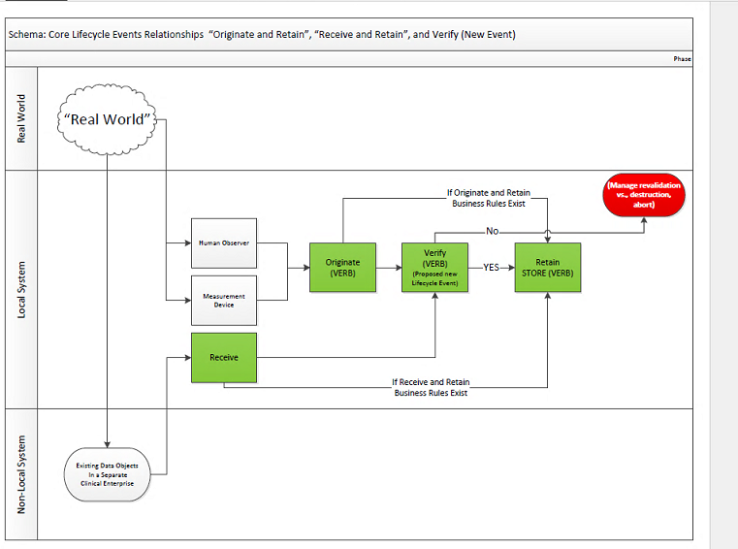

Originate
Originate (v) | Definition:  To initiate entry of data objects as potential content for an EHR record. Contrast with "To Receive." | Pre-Conditions:  - Agent has logged into the EHR system.  - Agent has “Create” Permission  - “Create” function activated  - Entity 0 at T₀ contains, at most, data associated with a template.  Process:  - The object is defined, iterated.  - At T₁, iteration is complete (0’)  Post-Activity Options  - Discard object 0’  - Verify and/or Validate object 0’  - Retain object 0’  Key:  0 represents a transient object.  0’ represents a transient object that has been  A represents an object that has been retained in the system.  A’ represents iterations of A. | "To Originate" is an action within EHR Records Management. "To Originate" includes the option of an interim state that permits an intermediate assessment of new data or data objects prior to commitment to long-term management. That intermediate assessment is intended to determine whether to store the initially captured data or data objects or to destroy them as ephemera or a rejected draft. "To Originate" may include the use of volatile memory or other means which offer a temporary cache or cache-like status for the interim state.  Properties:  1. New data object  2. Potential, interim status (or State)
Ontological View:
1.2.2 Class: <provisional> EHR Records Management
1.2.3 Class differentiating characteristics are "new" and "potential" content, an interim state to be acted on (ex: To Verify or To Store or To Dispose/Destroy)

*See Notes, Item 1. The text is included to provisionally identify a Class termed "EHR Records Management" to which the verb action belongs, in conformance with our draft style sheet and guidelines for definitions.

Receive

Receive (v) | Definition:  To acquire data objects that existed elsewhere for potential inclusion in an EHR record. Contrast with Originate.  The act of reproducing at one point either exactly or approximately a message selected at another point. [Derived from a quote from Claude Shannon] | Pre-conditions:  - Communications channels between sender and receiver are open and available  Process:  - At T₀, object M is presented to receiver.  - At T₁ Object M is copied into the message space as M’.  - At T₁, copy is complete and temporary object 0 is available in receiver’s address space.  Post-Activity options  - Discard Object M’  - Copy M’ into receiver’s address space as O.  - Verify and/or Validate object O.  - Retain O.  - Send return receipt. | Extended Definition:  "To Receive" is an action within EHR Records Management "To Receive" includes the option of an interim state that permits an intermediate assessment of data objects that existed elsewhere and is conveyed for consideration for commitment to long-term management. The data object existing elsewhere is processed as a message M pending qualifying it as a local object A or 0. The intermediate assessment is intended to determine whether to store initially captured data objects or to destroy them as ephemera or rejected data objects. "To Receive" may include the use of volatile memory or other means which offer a temporary cache or cache-like status for the interim state.  Properties:  1. Existing data object from sender is used in a message.  2. Object received resides exclusively in the receiver’s message space as M’.
Ontological View:
1.2.2 Provisional Class: <EHR> Records Management
1.2.3 Differentiating characteristics are "existing" and "potential" content, an interim state to be acted on (ex: To Verify or To Store or To Dispose/Destroy)
*See Notes, Item 1. The text is included to identify a Class to which the verb belongs, in conformance with our draft style sheet and guidelines for definitions.
January 10 2PM Eastern: RDG Edits stop here

Verify (Placeholder-would like review, rethink this. As LRI workflow illustrates, Verify may be applied sequentially to O to O’ to O(n) or O to A. Diagram in box would change too if amenable)

Is O verify a special case where, in a sequence workflow, O would always be an O’ of some upstream Activity?
How would we represent sequential Verify events?
How would we represent differentiations between Pass Verify and Fail Verify? I think that the outcome is embedded in the attributes of the A’ or O’. The fact is that the object was required to undergo Activity “Verify”. The pre-activity object, if A, is still permanent and accessible for use. The post Activity A’ is also permanent, and is either Verify-attribute Pass or Verify attribute Fail. The system log records that the Activity “Verify” was applied to A and the fact that A’ exists securely evidences the prior existence of A (in case that is of future interest.
In this logic, IMO there is a need for a Verify Entity T-1 O’ but not every Entity at Verify T-1 is an O’

(Removed version with “Result”

Verify (v) | Definitions:  - To evaluate the compliance of data objects with regulations, requirements, specifications, or other internally imposed conditions based on organizational policy. Contrast with validate.  - To affirm the compliance of data or data objects with specified trust qualifications. Contrast with To Attest | Pre-Conditions:  - Data object has been originated/received (0) or retained (A)  Process:  - At T₀, an object is selected for verification.  - Object parameters are compared with internal specifications.  - At T₁, a result is returned that if comparison is successful, object(s) is verified, else verification failed.  Post-event Options  - Discard Object 0  - Retain object A | Extended Definition  Properties:  - Can be performed on an interim or retained object.  - Uses internally imposed criteria.  - Returns a result that shows success or failure of verification.  Note: How the verification attribute is bound to the object is a business decision.
 | Ontological View

Validate
Validate (v): | Definitions:  to confirm that the contents of data objects meet the needs of identified stakeholders (i.e., healthcare providers, patients). Contrast with verify. [Derived from PMBOK definition of validation.] | Pre-Conditions:  - Data object has been originated/received (0) or retained (A)  Process:  - At T₀, an object is selected for verification.  - Object parameters are compared with external specifications.  - At T₁, a results are returned that if comparison is successful, object(s) is validated, else validation failed.  Post-event Options  - Discard Object 0  - Retain object A | Extended Definition  Properties:  - Can be performed on an interim or retained object.  - Uses externally imposed criteria.  - Returns a result that shows success or failure of validation.  Note: How the validation attribute is bound to the object is a business decision.
 | Ontological View

Retain

Retain (v) | Definition:  To persist data or data objects by saving onto electronically accessible devices. | Pre-Conditions:  - An object 0 exists or an object A exists which needs to be re-saved.  Process:  - At T₀, object is selected and space is opened in memory.  - Object is written to and manipulated in memory.  - Object is placed in a permanent storage location.  - At T₁, data object has been persisted as a new EHR information object with a designation, object A’.  Post-event Options  - Object A’ available for use | Extended Definition  Properties:  - Can be performed on any object, whether previously retained or not.  - Multiple actions can be performed on attributes of the object during the retention process, such as:  - Change of name  - Updates to provenance (eg: last agent who saved/modified object)  - Change of storage location  - Change of time stamp  - Is performed on objects in memory.  - Final results are written to designated storage location.
 | Ontological View

