SDWG - PHMR Subgroup Meeting

Logistics:
Date / Time: Feb. 11, 2015, 10:00am to 10:50am EDT
Location: Telco
Facilitator: Martin Rosner
Note taker: Martin Rosner

-------------------------------------------------------
Meeting information
-------------------------------------------------------
Join WebEx meeting
Meeting number: 499 933 849
Join by phone
1-650-479-3208 Call-in toll number (US/Canada)
Access code: 499 933 849
Global call-in numbers
Can't join the meeting? Contact support.
-------------------------------------------------------

Attendees:
Name | Affiliation | Present
Vinayak Kulkarni | Cerner | X
Martin Rosner | Philips | X
Brian Reinhold | Lamprey Networks | X
Chris Johnson | Blue Cross / Blue Shield
Asim Muhammad | Philips
Darrell Woelk | SocialCare
Igor Gejdos | Roche
Russ Leftwich | State of Tenn.

Agenda:
- Review ballot schedule
- Review latest draft PHMR objects in Trifolia tool

Minutes Approval:
Minutes from January 28, 2014 – approved

Action Items:
- Martin – draft NIB and send to SDWG
- Martin & VK – export PHMR document and compare against the old DSTU; also review the human readable text
- Brian – finish drafting PHMR results section in Trifolia

- Review ballot schedule
We reviewed the ballot schedule:
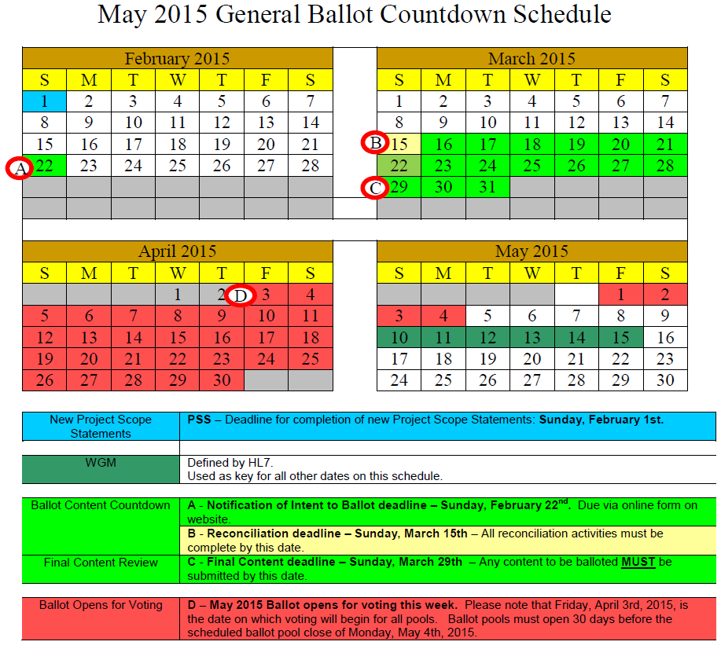

Martin will draft the NIB today and send to SDWG. We need to have a draft specification for SDWG review by end of Feb. Brian will work on finalizing the rest of the PHMR objects and examples. Martin and VK will review current exported draft of the spec and compare against the PHRM DSTU version (see action items).

- Review latest draft PHMR objects in Trifolia tool

We reviewed the latest Trifolia draft. Brian added the waveform component during the call. The results section still needs to be finalized in Trifolia. The current PHMR draft spec is available on the wiki here.

AOB

Next Regular Call
- February 18, 2015

