SDWG - Form Definition and Questionnaire Response Subgroup Meeting

Logistics:
Date / Time: March 21, 2013, 3:00pm to 4:00pm EDT
Location: Telco
Facilitator: Martin Rosner
Note taker: Martin Rosner

-------------------------------------------------------
Meeting information
-------------------------------------------------------
Topic: Questionnaire and Response HL7 IG Drafting
Date: Every Monday, from Monday, January 28, 2013 to no end date
Time: 3:00 pm, Eastern Standard Time (New York, GMT-05:00)
Meeting Number: 499 376 271
Meeting Password: (This meeting does not require a password.)

-------------------------------------------------------
To start or join the online meeting
-------------------------------------------------------
Go to https://continuaalliance.webex.com/continuaalliance/j.php?ED=18250233&UID=492541537&RT=MiMxMQ%3D%3D

-------------------------------------------------------
Audio conference information
-------------------------------------------------------
To receive a call back, provide your phone number when you join the meeting, or call the number below and enter the access code.
Call-in toll number (US/Canada): 1-650-479-3208
Global call-in numbers: https://continuaalliance.webex.com/continuaalliance/globalcallin.php?serviceType=MC&ED=18250233&tollFree=0

Access code:499 376 271
-------------------------------------------------------

Attendees:
Name | Affiliation | Present
Asim Muhammad | Philips | X
Brian Scheller | Healthwise | X
Chris Melo | Philips Healthcare
Emma Jones | Allscripts
Jessi Formoe | Intuit Inc.
Jim Kretz | SAMSA
John Feikema | ONC
Lisa Brooks Taylor | AHIMA
Lisa Nelson | Life Over Time Solutions
Martin Rosner | Philips | X
Rick Geimer | Lantana
Stephen Chu | National E-Health Transition Authority
Vin Sekar | National E-Health Transition Authority
Vinayak Kulkarni | Siemens

Agenda:
- Review of Form Definition Document draft IG
- Status on Questionnaire Response draft IG

Minutes Approval:
Mar.19.2013 (available on wiki) - deferred

Action Items:
- Lisa – check on LOINC code assignments – Done – follow-up expected from Jamalynne Deckard – asking for review of drafts and should be no problem to issue LOINC codes – we should capture the places in the spec where we need those.

Review of Form Definition Document draft IG

We discussed how we can address the following question example. Use static multiple choice with ‘other’ as the option.

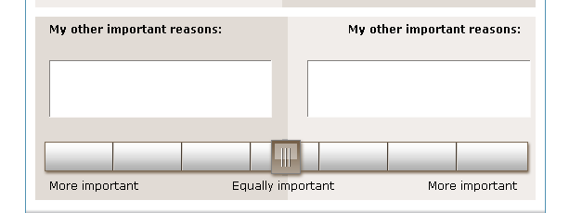

How do we codify the labels in Likert scales?

You can organize the questions/observations into one set. So treat as two component organized into one.

Organizer{

Rightside Observation

Leftside Observation

}

In Questionnaire Response IG

Add informative text - If it’s a multiple choice question where you can select only one, then you need to specify the referenceRange to ‘1’.

Section 2.2.11 DocumentationOf/serviceEvent – we don’t strictly need it. It is optional if we remove it. We will remove it.

Section on authorization and consent is also seen as not needed. We will remove it.

Form Definition IG

We got the HQMF specification to see if we can extend to use logic to realize OR or XOR. We would need to create a template that would use something from HQMF.

AOB

Next Regular Call
- Mar. 26th, 2013, 3:00-4:00 ET

