Orders & Observations - Nutrition FHIR Resources
Conference Call
March 3, 2015

Attendees:
Name | Organization
1. Margaret Dittloff | CBORD | X
2. Lindsey Hoggle | Academy Nutrition and Dietetics | X
3. Eric Haas | Health eData Inc | X
4. Simon Sum | Academy Nutrition and Dietetics | X
5. Cathy Welsh | St. Jude’s Children’s / Academy Nutrition and Dietetics | X
6..Michelle Salas | Academy Nutrition and Dietetics
7. Donna Quirk | Lexington Medical Center | X
8. Cathryn Stauffer | CBORD | X
9. Charles Paule | Abbott | X
10. Paul Doyle | Eigen X | X – phone only
11. Marty Yadrick | Computrition | X
12. Curt Coulter | CBORD | X
13.

Chair / Note Taker: Margaret Dittloff

Agenda for 2015-03-03
Proposed Agenda:

- Agenda Review
- Meeting Minutes – see attached from 2015-02-03 and 2015-02-17
  - Motion to approve as amended: Cathy Welsh / 2nd Eric Haas
    - Opposed: 0 Abstain: 0 In Favor: 10
- Review Value Sets
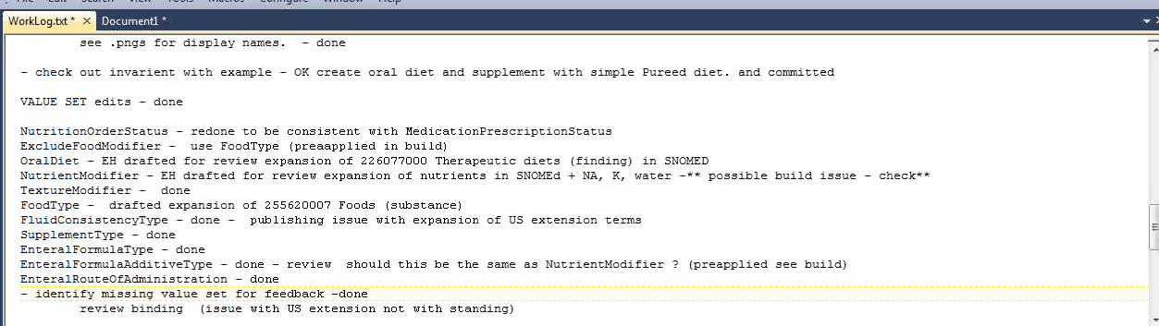
  - Side by side review of latest changes as compared to the Development version per last ballot.
    - Added all the missing definitions.
    - Status: didn’t align with other statuses
      - Proposed
      - Planned
      - Requested
      - Active – request is actionable
      - On-Hold (replaces Held)
      - Completed – keep this in for enteral formulas and supplements
      - Entered in Error - from medication resource
      - Cancelled vs Stopped - group discussion (see below)
      - Superceded – don’t use this

Cancelled = this is more of an action than a status;
Discontinued/Stopped – the diet order has been permanently halted
  - Action: Review for next week – Cathy W. / Margaret D. – to fill in definitions and decide on cancelled or stopped
- Fluid Consistency-type = DONE
- Texture Modifier type = enumerated list which includes both SNOMED CT core and US Ext SNOMED codes
- Nutrient-modifier (from the oral diet) - - currently pulled from Nutrient (substance) – NEEDS DISCUSSION
  - Action Item: Eric will send email to vocab group advisors Jim Case and Rob McClure) for guidance.
- enteralAdditiveType = List includes: Protein, Fat, Carb, Fiber, Water (for water flushes)
- DietTypes – Regimes/Therapies
  - Action Item: Send Eric the US Ext list of procedures/regimes and therapies. Include codes from concepts e.g., Is a dietary regime
- Texture.FoodTypes – lumped together with Exclude food types
  - Action Item: NEED spreadsheet from Lindsey)
  - Per Eric, they can be examples only as this is only DSTU.
    - 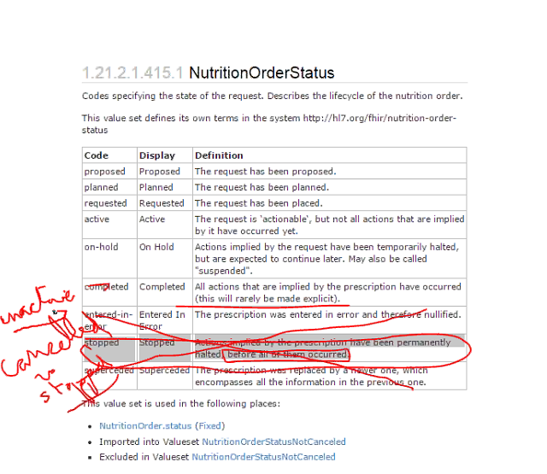

- Diet Examples Discussion/Edits – e.g., Rename Cardiac Diet Example (Donna)
  - Low Sodium + Cholesterol-lowering Diet
  - Change name of Cardiac Diet Example:– call it Low Sodium/Fluid Restriction
  - If we see any errors let Eric know. Not being rendered programmatically currently
  - Should we schedule another call to walk through these?
- FHIR Tracker (Eric )
  - #5162 - OO block vote removed (rename of NutritionOrder to NutritionRequest) – same for DiagnostiOrder to DiagnosticRequest
  - Discussion: Struggling as it is a domain recognizable entity; is there a legal ramification? There are regulatory requirements that govern a diet order in U.S. and Canada.
    - Motion to make this non persuasive: Eric / Donna –
      - Discussion – can follow up from the policy side if needed.
      - Opposed: 0 Abstain: 0 In favor: 8

Supplement Instruction – added definition. (please review)
- Mappings – Next call

Next Call – . 3/17/2015

