Chapter 8 V2.6 MFI-3; see Note in box, lost first paragraph in V2.7 (below):
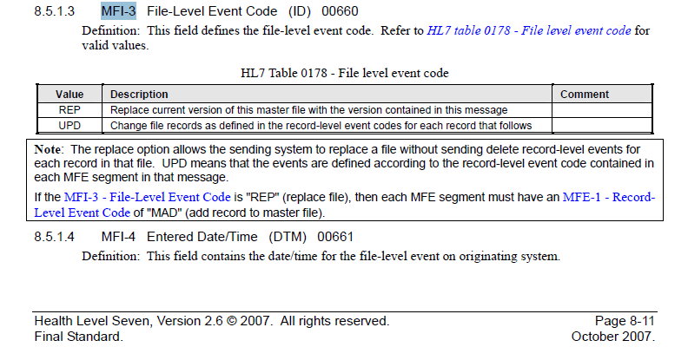

Chapter 8 V2.7 – lost first part of the note from V2.6 – need to add back in V2.8.2
Also see Chapter 2C below – missing section of note was not moved to 2C.
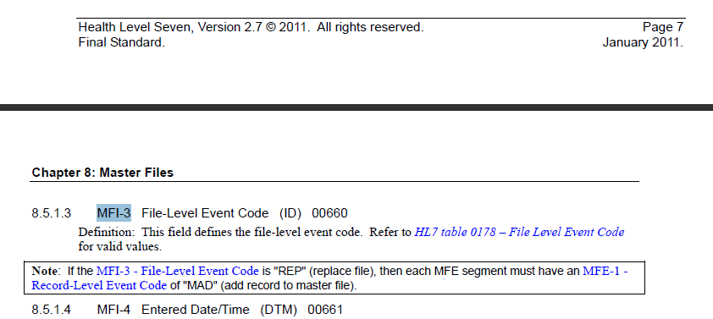

Chapter 2.C V2.7
