SDWG - PHMR Subgroup Meeting

Logistics:
Date / Time: Mar. 4, 2015, 10:00am to 11:00am EDT
Location: Telco
Facilitator: Martin Rosner
Note taker: Martin Rosner

-------------------------------------------------------
Meeting information
-------------------------------------------------------
Join WebEx meeting
Meeting number: 499 933 849
Join by phone
1-650-479-3208 Call-in toll number (US/Canada)
Access code: 499 933 849
Global call-in numbers
Can't join the meeting? Contact support.
-------------------------------------------------------

Attendees:
Name | Affiliation | Present
Vinayak Kulkarni | Cerner | X
Martin Rosner | Philips | X
Brian Reinhold | Lamprey Networks | X
Chris Johnson | Blue Cross / Blue Shield
Asim Muhammad | Philips
Darrell Woelk | SocialCare
Igor Gejdos | Roche
Russ Leftwich | State of Tenn.

Agenda:
- Review of latest draft

Minutes Approval:
Minutes from February 25, 2014 – approved

Action Items:
- Martin & VK – review latest version of the draft
- Martin – find the correct document template for the ballot (with correct copyright, title page …)
- Brian – finish drafting PHMR results section in Trifolia

- Review of latest draft

Input from Brian

Review of final issues to address before ballot. Based on email from Brian, we have the following items:
- Device Accuracy: In the DSTU this entry was in the device organizer and only once. That is incorrect. The device accuracy is reported in the Accuracy attribute of a measurement and there may be such an attribute for every numeric metric, for example one for SpO2 and one for heart rate on a pulse ox. The accuracy is reported in the units of the observation. Thus there must be at least more than one such entry allowed. One accuracy for the deviation of % and one for the deviation of beats/minute. One could argue this should be attached to the Numeric observation entry as an entryRelationship of some type and that is probably correct. That is what PCD-01 does (it is a facet). But that maybe too much rocking the boat at this stage. The attribute IS static making a one time reporting in the device section pretty good UNLESS there is a situation where a measurement reports the same units but has different accuracies.
  - Brian sent response to Clem but has not received anything further. For now we will leave in the device organizer and have more than one report of the accuracy.
- Template OIDs. I have borrowed the vital signs, results, and medical device section template ids from C-CDA 2. However there is a problem because the C-CDA already specifies what observation organizers these things have and the organizers we need are slightly different since the organizers themselves refer to different observation entries than the C-CDA observation entries.
  - What is the solution here? New template ID? Perhaps bring this up on the SDWG call again?
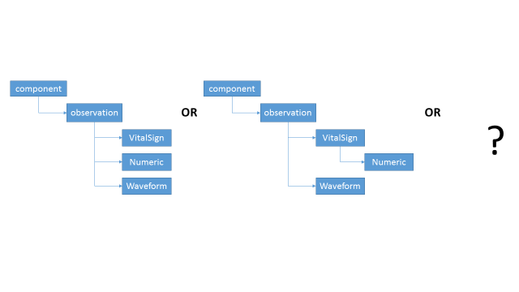

  - We discussed that we perhaps can just create device specific organizers with IODs derived from PHMR OID. Before we do that, Brian wants to discuss this issue in SDWG.

- For the Device properties like serial number, firmware version etc that were just a list in a generic string (unparsable) I have mapped it to the PCD-01 equivalent using PCD-01 syntax right down to the OR-bar and carat separators and escaping. Essentially what is being done is to map it as an OBX-3. However, could map it as OBX-3 followed by OBX-5 as |OBX-3|OBX-5|. I suppose I could do it as |OBX-3||OBX-5| indicating an empty OBX-4. Could even go as far as |OBX-2|OBX-3||OBX-5| where OBX-2 is ‘ST’ which means string. In any case the OBX-3 is the critical identifier with |code^ref-id^codeSystem^^value| where the value would normally go in OBX-5. But CWE-5 is also a perfect place for a descriptor string (which these things are)
  - We decide to use CWE in OBX-3 only.
- There is an IHE profile in the making mapping IEEE codes to LOINC. However, the mapping is still degenerate; more than one IEEE code will map to the same LOINC. This means we still need to keep the LOINC as a translator option and not the primary coding value.
  - We lose information as we map from MDC to LOINC – we lose information about the source of the measurement.

Input from Martin

Martin also provided comments on the latest version of the draft specification.
- Brian has made changes since comments the Martin put in. We will consolidate Martin’s comments for the latest draft of the document.

Document for SDWG Review
- Martin will send notice of new doc weekly.

Examples
- Currently we have entry level examples – in the end.

AOB

Next Regular Call
- March 11, 2015

