Thursday, 4 October 2018, Quarter 2 (1100-1230)

Lead: Gary Dickinson
Scribe: Pele Yu
Guest: Dr. David Freedman, DPM

SUBJECT: "Reducing Clinician Burden" Project - Link to documentation - http://wiki.hl7.org/index.php?title=EHR_Interoperability_WG#Reducing_Clinician_Burden
- Introductions
- Project started 2017 in HL7, EHRWG established the EHRFM, informed CCHIT activities. Later ONC was established and 2009 Meaningful Use effort, much of functional requirements are dictated by regulations. Wayne suggests EHRWG to look into physician burden related to EHR use. Since then EHRWG began outreach and compiling documentation related to the issue.
- Gary defined some terms
  - Reducing – to bring down, diminish, simplify, to restore to normal conditions, to lower intensity, to narrow down
  - Clinicians – front line, administrative clinicians, health professional
  - Burden – a source of great worry or stress, to load or overload, something worrisome, oppressive
- Focus of Discussion
  - Clinical burden including time and data quality associated with use, capture, exchange of health information
  - Regulatory, design, usability, administrative, payors
  - References, literature, personal experience
- Quantifying burden – chart review, clerical work, in box
  - 3 out of 4 physicians believe that EHRs increase practice costs, outweighing any efficiency savings
  - 7 out of 10 physicians think that EHRs reduce their productivity
  - 4 in 10 primary care physicians (40%) believe there are more challenges with EHRs than benefits
  - 7 out of 10 physicians (71%) agree that EHRs greatly contribute to physician burnout
  - 6 out of 10 physicians (59%) think EHRs need a complete overhaul
  - Only 8% say the primary value of their EHR is clinically related
- Categories of Burden (Topics)
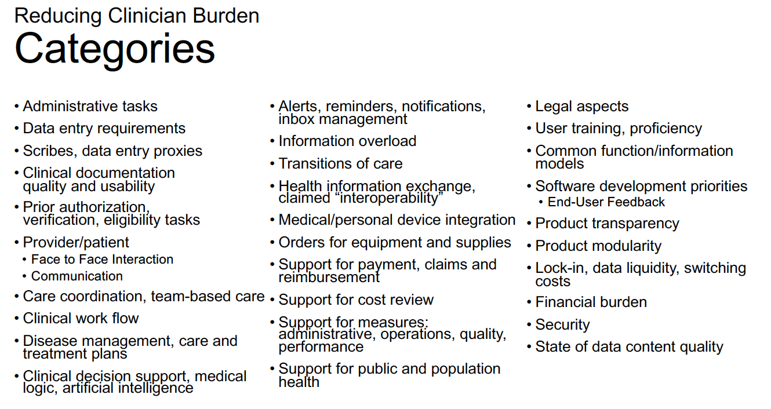
- Gary references the Discussion framework/approach (Excel)
  - Tabs
    - Burdens
    - Time Burdens
    - Data Quality Burdens
    - Terms: Reducing, Clinician, Burden
    - Reference Sources
    - Contacts: Co-Leads
    - Acknowledgements: Reviewers + Contributors
  - Columns
    - Clinical Burdens – Raw Input
    - Recommendations – Raw Input
    - Reference Sources
    - Targeted Recommendation(s) - based on identified burden topic
    - Who Might Best Address Burden(s)
    - Current Proposals and Successful Solutions
- Moving forward, is it possible to divide and conquer topics above
  - Focus on what the problems is first
  - Reed Gelzer shares that there are services that may not have suffered the same “burden” compared to other services (i.e. anesthesia). There are places that have better process and approaches to reduce burden
  - Mike Padula – many of the challenges in the implementation are lack of design principles, a lot opportunity to refine requirements (billing, compliance, documentation); those who do this best are iterative process, refining through time
  - Robert Anthony (ONC representative) – burden reduction report related to Health IT
    - 21st century cures act – required congress report to recommend reduction burden, mandated to be a public process, produce a draft report, for public comments, send to secretary
      - Listening sessions through out the year
      - The first draft of report in clearance with ONB, published later for public comments; breaking down different burden; opportunity to inform progress
  - Gora Datta – clinician burden seems to be “boiling the ocean”; clinicians adopt HIT based on requirements may not be aligned with their needs (costs, resources, free, etc.) thus already setting them up for burden. Changing reimbursement model, moving to value-based, burdened by stress related to penalties. He is worried that the focus is on clinician burden and systems, but not on contributing factors.
  - Michael Brody – clinicians are sometimes stuck with EHR system because of fear of losing data about their clinical practice. If clinical practice data portability is easy, then clinicians can move to another EHR system, with less worry that they would lose their clinical practice data.
  - Gary continues with next steps
    - Project Plan
      - Continue environmental scan
      - Continue to compile burden topics
      - Next - Establish small teams to address burden topics/categories
        - Refine, develop targeted recommendations to reduce burdens
        - Identify:
          - What is the Burden Targeted?
          - Who might Best Address Burden?
          - Burdens already tackled: with proposals or with successful solutions
    - Then Publish and work to implement recommendations
  - Dr. David Freedman (Podiatry)
  - Clinicians should be trying to spend vast majority of time interacting with patients; EHR is NOT Interaction
  - Asked his docs in practice – young and older docs
      - Struggling to keep eye contact with patients; interaction with EHR keeps this from happening
      - Can you digitally record a session without documentation (minimal); via wearable device
      - Record management continues at home because of work load in data entry
      - They reduce number of patients to see to accommodate EHR workload; eating up personal time
      - Spending too much time with EHR, less with friends and family, negative impact, want to retire early; creates problems with less doctors over time
      - People suggest scribe, but scribes are not reimbursed! Extra staffing issue, less pay for each patient, expected to do more
      - Failure to note pertinent positives and negatives during interaction is a problem, that’s why work follows at home
      - Interacting with EHR is a balancing act, being rated at public ratings
      - Too many clicks!
      - Feels like we are “performing arts” than “healing arts”
      - Increasing $$ rates for Health IT support, no reimbursement for cybersecurity policies, IT infrastructure, hire an IT company, we are physicians and not IT!!
      - Best part of EHR
        - eRx! Electronic prescribing is values
        - Dictation was more efficient! Great notes and documentation
      - EHRs can interoperate, how to move data from old practices to new system. Hiring new docs, its critical to have bidirectional communication with disparate systems
      - Why cant we have video digital record of patient visit and recorded as part of documentation?
  - Gora Datta – reacting to eye contact during interaction, is it due to office design? Freedman says its is still different even if facing the patient. It’s like texting and driving. Robert from ONC shares that – studies have shown that Px perceptions does not align with clinicians; patients feel that looking at computer is like looking at the paper record. The interruption is the same quality.
  - Standard documentation with dictation could be a solution, templates that follow clinician’s requirements.
  - Reed – until State/payers deem video is proper documentation, then this is not part of the solution space.
  - Michael Brody – cost associated with maintain Health IT increases each year, however, physician pay schedule decreases, numbers cant keep up maintain EHR systems. MIPS program incentives could get an increase with Medicare fees, but when it came out, increased in fees is untenable. The economics does not exist for the ambulatory practice, more cost-effective to go to old way than adopting EHRs. Important for regulatory to make it affordable for adopting maintaining EHRs.
  - Mark Janczewski – how do we reconcile the need for EHR to capture data, can’t be done with video recording
  - Carle Beebe – video recording not sufficient for researchers, somehow we need a “DARPA” project to solve this
  - Lynne (Dental) – amazed are dentists on how they engage patient in EHR
  - Scribes need to be reimbursed!
  - Gary summarized next steps
  - Open project, want input and feedback
  - Shares construct of the Excel document
  - Convene small teams, and focus on specific areas, and those with volunteers will be the priority areas to be addressed.

