HL7 Patient Care WG
FHIR Resources Management
Meeting Minutes

March 27, 2014

Participation Information
Phone Number: +1 770-657-9270
Participant Passcode: 943377

Web Meeting Info
www.webex.com
Meeting number 198 139 396

Attendees:
Elaine Ayres
David Hay
Becky Angeles
Lee Unangst
George Koromia
Jay Lyle
Gordon Raup
Stephen Chu
Carmela Couderc
Lisa Nelson
Margaret Dittloff
Emma Jones

AGENDA:
- Review Agenda
- Approve Minutes From March 20
- David Hay will give a tutorial on FHIR Profiles
- Review of Stephen Chu’s PSS for referrals
- Plan agenda for next meeting – Thursday, April 3 at 5 PM.

Minutes Approval:
March 20 – Stephen/Jay Abstain – 2, Negatives – 0, Approve - 7

(link on wiki) http://fhirblog.com/2014/03/26/fhir-profiles-an-overview/

Presentation by David Hay –

FHIR Profiles:
- Describe restrictions based on use and context
- Support elements not in the core resource
Profiles are used to:
- Provide metadata
- Extend the resource
- Constrain the resource
How do you define re-use? Vs. same capabilities as existing ones (e.g. same constructs)

No defaults – a recipient receives a resource and a field is empty you by default presume the meeting. Rather every part of a resource is explicit.

Anyone can publish a profile:
- HL7 – for example religion could be used by everyone
- Country or Realm – may have profiles
- Organization –
No explicit hierarchy of profiles.

A server can support a conformance resource to host profiles and provide a link to them.
A client can tell a server that they conform to a profile using a tag.
Receipt of a resource with an extension not recognized, it will point to a profile using a URI.

A tag – outside the resource as metadata. The resource claims consonance with a particular profile.

Profile: Includes Metadata, Resource and datatype constraints and Extension definitions.

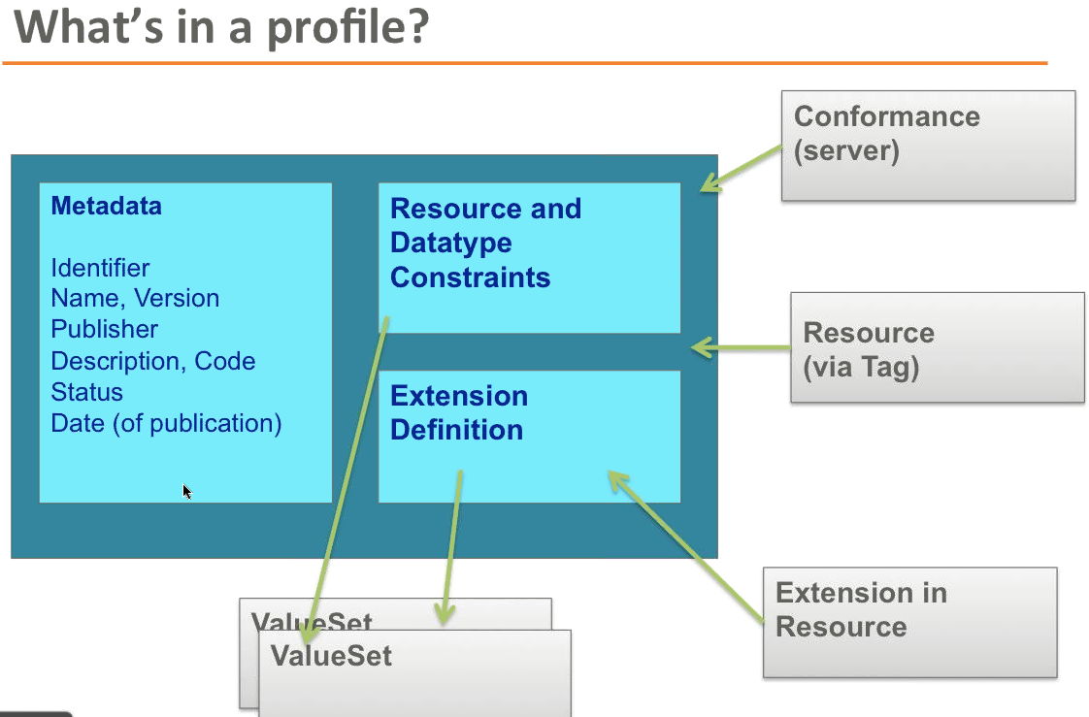

Metadata means information about the profile.
The tag claims conformance to a profile.

Profiles designed to be machine processable.

An extension applies to a resource. You must give an extension a definition that describes how it modifies a specific resource. The modifier is significant – describes how it might change the resource.
Extensions are embedded into a resource.
Can have an extension (optional) or modifier extension (need to look up)

Profiles are key.

A tag is an http header.

Next Call – Thursday, April 3 at 5 PM.

- Review Agenda
- Plan agenda for next meeting – Thursday, April 10 at 5 PM.

Current Patient Care FHIR Resources: http://www.hl7.org/implement/standards/FHIR-Develop/?ref=learnmore

The FHIR issue tracker in gForge:
http://gforge.hl7.org/gf/project/fhir/tracker/?action=TrackerItemBrowse&tracker_id=677

All resource proposals
http://wiki.hl7.org/index.php?title=Category:FHIR_Resource_Proposal

Referral skeleton
http://wiki.hl7.org/index.php?title=Referral_FHIR_Resource_Proposal

Current Clinical FHIR Resources
- Adverse Reaction
- Allergy Intolerance
- Care Plan
- Condition
- Family History
- Procedure
- Questionnaire

