C-CDA Task Force Report
  - A proposal to the HL7 Structured Documents Work Group recommending a method to provide implementer support for Consolidated CDA
March 29, 2013
Task Force Participants
Benjamin Flessner | Epic
Brad Monroe | Deloitte
Brett Marquard (Lead) | River Rock
Brian Scheller | Healthwise
Brian Zvi Weiss | Independent Consultant
Calvin Beebe | Rochester Mayo
Caryn Just | Accenture
Catherine Welsh | St Jude
Diana Behling | IATRIC
Keith Boone | GE
Gaby Jewell | Cerner
Justin Facteau | Deloitte
Jennifer Sisto | Accenture
Jonathan Tadese | Deloitte
Kate Hamilton | Lantana
Laura Heermann Langford | Intermountain Healthcare
Lisa Brooks Taylor | AHIMA
Lisa Nelson (Co-lead) | Life Over Time Solutions
Mark Roche, MD | Northwestern
Mike Kingery | HL7
Rita Altamore | Washington DOH
Russell Ott | Deloitte
Sean Muir | VA
Serafina Versaggi | Eversolve
Stephen Jacobs | Athena Health
Thomas Kuhn | American College of Physicians
Wendy Scharber | Registry Widgets
Wes Rishel | Gartner
William Dyer | Pyramed Research
William Ryan | Deloitte

Contents
Introduction iii
Scope and mission iii
Problem statement iii
Method and Approach iii
Participation iv
Results iv
Solution requirements iv
Support workflow vi
Supporting details vii
C-CDA Task Force process pilot xii
Lessons learned from the pilot xiii
Tooling assessment xiv
Discussion xvii
Strengths and weaknesses of the plan xvii
Recommendations xix

Introduction
Consolidated CDA (C-CDA) is a new standard required by Meaningful Use (MU) stage 2 for vendor certification. The standard consolidates 9 document types into a single guide, and reconciles many of the ambiguities in the HITSP C32, the document required for MU stage 1. In Q4 of 2012, the SDWG listserv traffic grew significantly with questions on the standard from vendors, implementers, and consultants.
In response to the increased demand for implementer guidance, SDWG chartered a task force to develop, and recommend a process to provide support for C-CDA. SDWG approved the task force on January 3rd, 2013 and the task force held its first meeting on January 10th.

Scope and mission
Recommend to SDWG a process for managing, and responding to implementer questions on C-CDA.

Problem statement
ONC named the HL7 SDWG published C-CDA in MU Stage 2. A support mechanism is required to support the increased demand, due to limited examples, and ambiguous conformance statements. The industry does not currently have a mechanism to respond to implementer inquires.
This report summarizes the support work flow, and recommendations developed by the task force for SDWG.

Method and Approach
SDWG asked Brett Marquard and Lisa Nelson to lead the effort to develop a process to manage and respond to implementer questions on C-CDA. A timeline with high-level tasks is included in Table 1: C-CDA Task Force Timeline
The success of the task force depended on a public, open work group, with a diverse stakeholder group. Participation was solicited through the SDWG listserv. Over 15 participants attended the first meeting to develop the charter and goals. The task force developed the charter incrementally, with regular reviews with SDWG. On 2/7, the task force presented, and received approval, from SDWG. A wiki page houses all approved artifacts, agendas, and meeting minutes.
After approving the charter, the task force launched development on a support workflow. The workflow was developed by reviewing an example question submitted by an HL7 member: how to encode no known allergies. The sample question helped the task force identify the states a question and an answer must move through prior to completion. The process required several weeks of analysis. The study identified two primary roles to support the process: a moderator and a subject matter expert (SME).These roles and the support workflow are discussed in the results section.
After completing the workflow, the task force ran a secondary pilot with five questions to confirm the developed process design. Three HL7 members, Benjamin Flessner, Calvin Beebe, and Lisa Nelson tackled the questions which were selected from the Q4 2012 backlog of support requests. The second pilot revealed minor issues, and adjustments were made to finalize the proposed process.
While developing the support workflow, a subset of the task force explored a set of potential tools to support the process. GForge, JIRA and HingX were assessed as the most likely options to offer rapid deployment. Mike Kingery of HL7 reviewed several other tools and provided a summary of functionality and cost.
Table 2: C-CDA Task Force Timeline
 | 1/3 | 1/10 | 1/17 | 1/24 | 1/31 | 2/7 | 2/14 | 2/21 | 2/28 | 3/7 | 3/14 | 3/21 | 3/28 | 4/4
Task force approval
Task force launch
Charter development |  |  |  |  |  | *
Example: coding unknown allergies |  |  |  |  |  | *
Define support work flow |  |  |  |  |  |  |  |  |  | *
Tooling assessment
HL7 tooling WG reviews
Secondary pilot of work flow
Task Force Report |  |  |  |  |  |  |  |  |  |  |  |  |  | *
*Indicates the day SDWG reviewed and/or approved an item

Participation
The subgroup hosted 10 meetings with over 30 participants representing more than 25 organizations. On average, more than 15 people attended each meeting.

Results
The task force’s results include solution requirements, a support workflow for receiving and answering questions, and an assessment of other considerations, such as scalability, tooling support, and other HL7 governance issues.

Solution requirements
A successful process to support implementer questions on C-CDA should include the following characteristics:
- Rapid start-up, and results, validated by implementer feedback
- Tools to support communication process, and governance process
- Common terminology to parse issues and determine which process they go through
- Mechanism to collaborate with other HL7 working groups when C-CDA content overlaps
- Includes a searchable “examples library” for C-CDA
- Prioritized support for MU stage 2 data elements
- Ensures both immediate/tactical/interim resolution, and monitoring and follow-through of longer-term validation of interim solution and/or alternative via standards evolution process

As a new business process for HL7, the solution must also:
- Provide value for implementers of C-CDA
- Provide value for HL7 members
- Include measurement mechanisms to confirm that needs are being met

Further, the new support process must address three types of core functions:
- knowledge base – to store answers, and provide search and access capabilities,
- discussion forum – to permit the community of users to discuss their questions and prior answers, learn from each other in real time, and surface questions that require new authoritative answers, and
- a workflow management system – to track escalated question through the an authoritative channel.
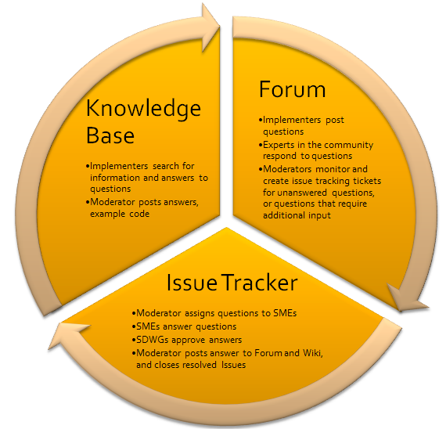

Support workflow
The support workflow tracks open questions, authoritative answers, and includes support to publish answers for implementers to reference. It requires two distinct roles, a moderator and a subject matter expert (SME). The moderator role administers the inputs and outputs of the process. The SME generates answers and follows them through the review and governance steps, until an authoritative, publishable answer is produced. The workflow enables a moderator to quickly address previously answered questions. The workflow supports linking an answer to multiple questions when the questions are closely related and it is more efficient to address them simultaneously.

The workflow also allows SMEs to proactively generate answers on particular topic, without a question triggering the generation. SDWG, or other committees, will use this aspect process to proactively address special topics where more implementation guidance is needed.

The workflow is complete when the moderator posts an answer to the knowledge base, and notifies the implementer. In order to track implementer satisfaction, the task force recommend two implementer satisfaction questions.
- Was this answer helpful? (Yes/No/Somewhat)
- Did the response provided answer your question completely? (Yes/No)

The process enables monitoring and HL7 oversight in the standard flow of operation. For example, the following queries could be deployed:
Queries to identify stuck tickets
- Q-ticket in pending status with no activity in last 24-hours
- Q-ticket in open status with no activity in last 48-hours
- A-ticket in pending status with no activity in 48-hours
- A-ticket in open status with no activity in 48-hours
Moderator queries
- All Q-tickets in status pending
- All A-tickets in ready to publish
SME Queries
- All Q-tickets in status open
- All Q-tickets assigned to them
- All A-tickets open and assigned to them
- All A-tickets approved and assigned to them
- All A-tickets ready for review
SDWG
- A-ticket in ready for review status with no activity in XX days

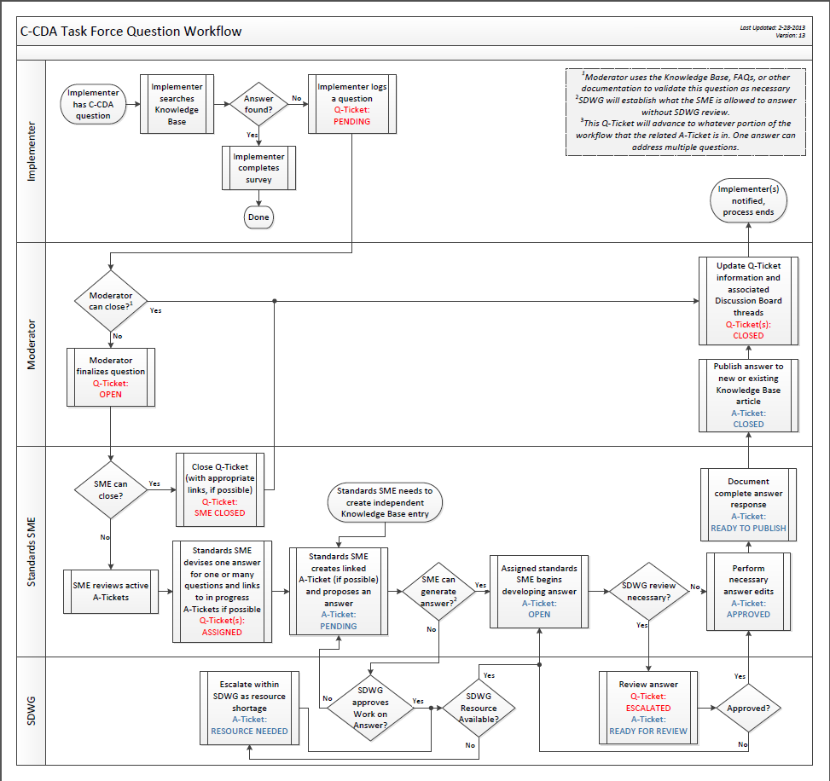

Supporting details

Categorization of questions and answers
To support the proposed process, questions and answers are categorized. The following categorizations were developed for the initial design.
Categorization for Questions | Action to take
Request for C-CDA Clarification | Use pilot process
C-CDA Errata Report | Escalate to SDWG
C-CDA Consider For Future Use | Escalate to SDWG (added during pilot)
CDA R2 Extension | Escalate to SDWG
CDA R2 Consider for Future Use | Escalate to SDWG
CDA R3 Consider for Future Use | Escalate to SDWG
CDA Request for Specific Assistance | Respond with “standard message” explaining that the Support Process does not provide assistance to address specific implementation questions.
Not a standards question | Respond with “out of scope message” and close the question.

Categorization for Answers | Action to take
C-CDA Clarification | Post answer to K-base
C-CDA Clarification with linked Errata Report | Link the answer to the topic that may change in the future so a SME can update the knowledge base when changes occur.
C-CDA Clarification with linked C-CDA Consider for Future Use | Link the answer to the topic that may change in the future so a SME can update the knowledge base when changes occur.
CDA R2 Clarification with linked Extension Report | Link the answer to the topic that may change in the future so a SME can update the knowledge base when changes occur.
CDA R2 Clarification with linked Consider for Future Use | Link the answer to the topic that may change in the future so a SME can update the knowledge base when changes occur.
CDA R3 Clarification with linked Consider for Future Use | Link the answer to the topic that may change in the future so a SME can update the knowledge base when changes occur.

State model
Process flow for questions and answers is directed by the following state model.
Questions |  | Answers
Pending | An implementer proposes a question.
Open | The Moderator refines the proposed question into standard form and Opens the question.
SME Closed | The Q-ticket is closed by referencing an existing answer in the K-Base
Assigned | The Q-ticket is linked to an A-ticket. | Pending | An answer is opened and linked to associated subordinate questions.
 |  | Resource Needed | A resource is not available to work on the defined answer.
 |  | Open | A resource took ownership of a ticket.
 |  | In Progress | The assigned resource started work on an answer.
 |  | Ready for Review | A proposed answer is ready for review to determine if it is correct as proposed and if it needs to be escalated to SDWG for approval or not.
Escalated | The question is sent for review and disposition by SDWG
 |  | Approved | The answer received approval.
 |  | Ready to be Published | A well written answer is completed and meets publishing requirements for all needed copy/disclaimers, etc. required for publishing.
 |  | Closed | The answer has been published to the K-Base.
Closed | The Moderator has reported the final disposition of the question in any linked Discussion Threads.

The following diagram shows the flow of control envisioned for questions and answers.
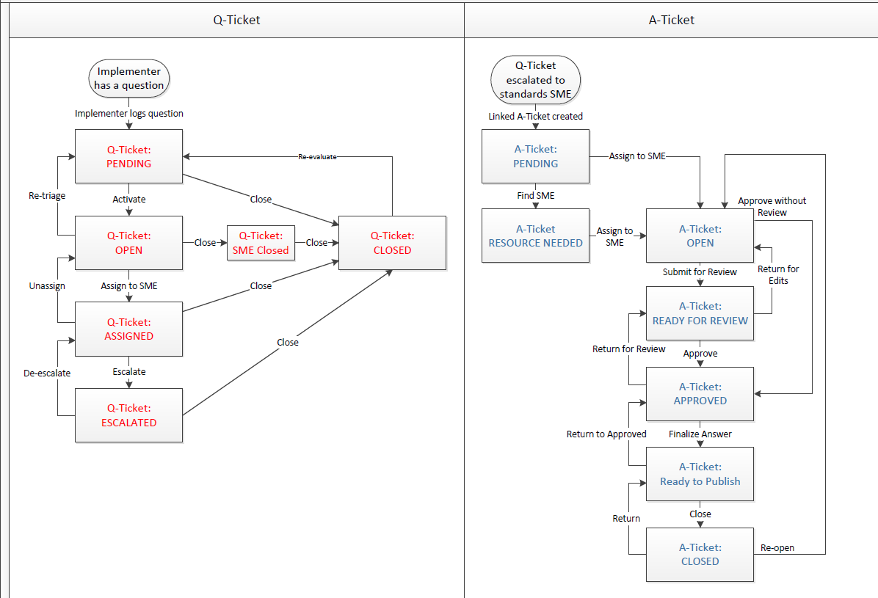

Content for questions and answers
The task force identified, and confirmed during the pilot, the key elements for management of questions and answers in the support process.

Question Content
- Submitter
  - Date of submission
  - Submitter Info
    - Name, telecom phone and e-mail contacts for Implementer
    - HL7 Member number (can be blank)
    - check box to hide identity when posted to K-base
  - Short description to clarify the question
  - Referenced sample(s), if appropriate/provided
  - Single, well-formed question
  - Tagging:
    - CDA RMIM-based classification
    - Template identification: (filling in one, populates the other)
      - Template name
      - Template OID
    - C-CDA Guide heading
    - CDA R2 standard Heading
    - Other meaningful phrase(s)
- Moderator
  - Q-ticket type
    - Link to prior Question/Answer pair which did not meet the Implementer’s need
  - Question Owner
  - Status (see Q-ticket state model for possible values)
  - Status Comment (notes)
  - Group with: (list of other similar Q-tickets – used to show the set of questions linked to a single A-ticket)

Answer Content
- Date of creation
- Owner info
  - Could be standards SME or SDWG if the A-ticket gets escalated to SDWG
  - check box to hide identity when posted to K-base
  - Name, telecom phone and e-mail contacts for Implementer
- A-ticket type
- Status (see A-ticket state model for possible values)
- Status comment (notes)
- Single, well-formed Primary question (should encompass all underlying questions)
- Questions addressed: used to show the set of Q-tickets linked to this A-ticket (sub questions under the Primary question)
- Short description to clarify how/why the included explanation and example(s) address the question being answered.
- Referenced sample(s), where appropriate
  - example included in stub at the document-level, or section-level,
  - validate against the CDA-schema
  - Schematron, if appropriate, in a standard stub document.
- Tagging:
  - CDA RMIM-based classification
  - Template identification: (filling in one, populates the other)
    - Template name
    - Template OID
  - C-CDA Guide heading
  - CDA R2 standard Heading
  - Other meaningful phrase(s)

Roles and responsibilities
The task force identified the following characteristics and capabilities for the two roles based on the envisioned responsibilities within the process.
Characteristic/Capability | Moderator | SME
Role | Hired resource | Depends on business model. Could be hired resource(s), contracted resource(s), volunteer resource(s).
Strong problem solving skills | Capable of forming single, central question appropriate to the content summarizing the issue. | Capable of performing in-depth analysis referencing multiple highly technical sources. Significant experience with CDA R2 standard and other CDA implementation guidance documentation. Strong background in relevant vocabularies and semantic modeling guidance provided in TermInfo project.
Availability | High level of availability and responsiveness. (Hours of coverage would need to be an operational consideration.) | Depends on business model regarding how SMEs will be incented to do the needed work to support the process.
Ability to generate/propose answers | Could provide answers from FAQ sheets, or knowledge of prior answers published in the Knowledge Base. | Responsible for generating answers which include well-formed xml examples. Requires strong written communication skills.  Responsible for working through SDWG review process. Requires strong follow-through and verbal communication skills.
Success criteria | Minimal delays for processing inputs or outputs from the process. | Throughput of the process matches demand for answers. Minimal delays for answers in the review step of the process.

Governance
The proposed process enables SDWG governance over the development of authoritative answers in several ways:
- SDWG utilizes the block voting process to approve answers developed by SMEs offline and propose them to SDWG at one time
- SDWG establishes the criteria which controls what type of questions the support SMEs can include in a block vote, and which require individual review.
- SDWG establishes the criteria about what types of answers SME’s can develop without seeking approval by SDWG to authorize the work to begin
- SDWG identifies resources to develop answers that are beyond the level of skill available in SME resource pool, so as the ensure that properly qualified resources are assigned to more challenging issues

Bandwidth
The task force identified resources to support the process as a top concern. The current informal listserve processes relies on volunteers from the community to contribute their knowledge on a volunteer basis. This process does not guarantee that quality, authoritative answers will be generated. No expectation of timely responses can be made. If the proposed process is to work, a business model will need to be developed a supply of moderator and SME resourcing which matches implementer demand for questions to be answered in a reasonable period of time.
Bandwidth issues for SDWG will also need to be addressed if the proposed process is adopted. The incremental review work required by SDWG to govern over proposed answers will likely represent a significant new piece of work which will need to be absorbed in the existing agenda or added as a topic on an additional meeting established to meet this new governance need.

C-CDA Task Force process pilot
To assess the proposed process, the task force piloted 6 issues as a test of the design.
This table summarizes the questions selected for the pilot:
 | Question | Observations | SDWG review needed? | # of hours to produce answer needed?
1 | No known allergies | - Generating answers is much more challenging than expected  - Errata was generated  - Developing guidance on how to represent no known allergies was possible | Yes | 20-hours+
2 | Maiden Name | - Errata was generated  - Guidance on how to represent maiden name could not be provided | Yes | 2-hours
3 | Custodian vs. Author | - Guidance was developed | No | 2-hours
4 | Smoking Status | - Developed additional guidance for the Smoking Status observation  - Identified value set gap between the MU stage 2 rule and C-CDA | Yes | 3-hours
5 | Recoding Problem Status | - In Progress
6 | Results Organizer Requirement | - In Progress

Lessons learned from the pilot
Adjustments were made to the process as a result of the pilot.
- An additional question type: C-CDA Consider For Future Use
- A new requirement to link answers to DSTU comments/errata was identified
  - Five additional answer types to support anticipated future maintenance of the knowledge base:
    - C-CDA Clarification with linked Errata Report
    - C-CDA Clarification with linked C-CDA Consider for Future Use
    - CDA R2 Clarification with linked Extension Report
    - CDA R2 Clarification with linked Consider for Future Use
    - CDA R3 Clarification with linked Consider for Future Use
- A SME team review was added prior to the workflow decision diamond
“SDWG review necessary”. Pilot experience revealed a team review significantly improved the quality of the proposed answers.
- The pilot leveraged excel and word to track questions and answers. Task force members expressed interest in using more sophisticated tools to track status and orchestrate work flow. Deployment of more sophisticated tooling is not a pre-requisite to support implementers with C-CDA questions.

Tooling assessment
The Task Force identified three types of tools for C-CDA support: a knowledge base, discussion forum, and issue tracker. The HL7 tooling work group provided tool demos for HingX and Gforge, and other task force participants provided input on other suggested tools. A high-level summary of requirements vs tools capabilities is provided in the matrices below.
This matrix identifies tooling functionality required for the knowledge base component:
 |  | Knowledge Base
 |  | Wikispaces | Confluence | HingX
Shared  Requirements | Access controls | Yes | Yes - unified accounts with Jira | Yes
 | Anonymous Access | Yes | Yes | Yes
 | Searching | Yes - basic capabilities | Yes - robust searching through Jira tie-ins | Yes
Knowledge Base  Functionality | Cross-referencing | Yes - basic linking capabilities to other wiki pages | Yes - robust linking to other articles and related Jira issue tickets | Yes - can link external resources and add metadata about resource; in general, resource is hosted elsewhere and must be created prior to linking to HingX
 | Issue ticket integration | No | Yes - integration with Jira issue tickets | No
 | Threaded Comments | Yes - basic comments, but not well integrated on page | Yes | Yes
 | External access | Possible via site specific Google search | Possible via site specific Google search | Possible via site specific Google search

This matrix identifies tooling functionality required for the discussion forum component:

 |  | Discussion Forum
 |  | phpBB | Confluence | HingX
Shared  Requirements | Access controls | Yes | Yes | Yes
 | Anonymous Access | Yes - anonymous users may post after completing a CAPTCHA | Yes - anonymous users may post after completing a CAPTCHA | No - anonymous users can read discussion forum but cannot write
 | Searching | Yes | Yes | Yes - robust searching based on resource metadata
Discussion Forum  Functionality | Threaded Discussions | Yes | Yes - able to be linked to KB and Jira issue tickets | Yes
 | Categorized Discussion Areas | Yes | Yes | Yes
 | Moderator Administration | Yes | Yes
 | Graphical User Group Differentiation | Yes - profile picture | Yes - profile picture | Yes - profile picture
 | Supports Anonymous Posts | Yes | Yes
 | External Access | Yes | Yes | Yes

This matrix identifies tooling functionality required for the issue tracker component:
 |  | Issue Tracker
 |  | Jira | Gforge
Shared  Requirements | Access controls | Yes - unified accounts with Confluence knowledge base and discussion forum | Yes
 | Anonymous Access | Yes - anonymous users can submit issues and browse dashboards | Yes - anonymous users can browse issues, but cannot submit issues
 | Searching | Yes - saved searches for dashboard creation | Yes
Issue Tracker  Functionality | Customize Issue Metadata | Yes - very customizable | Yes - initial customization may be difficult due to interface
 | Support multiple attachments per issue | Yes | Unknown
 | Support cross-linking of disparate issue types | Yes - robust linking | Unknown
 | Customize workflow per issue type | Yes - very customizable | Yes
 | Workflow automation scripting | Yes | Unknown
 | Notifications | Yes | Yes
 | Customizable Role-based Dashboards | Yes | Unknown
 | Customizable Queries | Yes | Yes
 | Reporting | Yes - dashboards and reporting | Yes

Discussion

Strengths and weaknesses of the plan
Strengths | Discussion
Permits “small scale” startup | HL7 can launch a help desk with a part time effort and then ramp-up to match demand. Initial resource requirements are at least 1 moderator and 2 SMEs. All 3 roles are less than full time to start, but to minimize delays, the moderator functions should be performed daily. A minimum of 2 SME’s are required to ensure internal SME review of proposed answers.
Scalable | The process is designed to be highly scalable through the addition of new resources. As the help desk grows, additional management and operational oversight will be needed.
Feasible | Pilot tests of the process indicate this design is feasible.
Weaknesses | Discussion (mitigations)
Represents a paradigm shift and adoption of a new type of work | A help desk to provide implementer guidance is a new business process for HL7. Management oversight is needed to address the challenges of integrating a new type of work into the existing HL7 business model.
Potential to take up too much time on the SDWG agenda | SDWG meeting time is already often over utilized for handling existing project work. The SDWG would need to address additional answer review, volume of errata, and maintenance issues.
Does not address the need to collaborate across multiple HL7 Working Groups to develop “right answers” | Proposed answers approved by SDWG and published will likely expose more “cross domain” issues. Additional cross-domain discussion time and to resolve issues should be anticipated.
Threats | Discussion (mitigations)
Multiple answer resources may confuse implementers | Authoritative answers require input from the HL7 community. HL7 and ONC should collaborate on a process that provides differentiated access to implementer guidance where HL7 membership offers greater levels of participation and “inside access” to the question and answer generation process.
Standards which leave implementers with unanswered questions could be viewed as poor quality and not meeting the needs of the implementation community | High quality standards require ongoing maintenance and support, especially during early adoption phases. HL7 must acknowledge the true cost of ownership for a standard. Resource budgets (time and money) needs to be allocated to sustainability activities if high quality standards are to be achieved.
Lack of processes to address sustainability needs could begin to impede organization’s ability to work on developing new standards; undermine core competency | Maintaining existing standards should be a core HL7 mission. The majority of SDWG time is allocated to new standards. What is the right balance of the two types of work? Greater emphasis on improving existing standards may be needed during this period.
Opportunities | Discussion
Develop a Support Helpdesk as a strategic lever to grow retain and grow membership, strengthen existing standards, identify areas of growth for new standard | The C-CDA proposed process is a starting point for developing a larger “helpdesk service” for all HL7 standards. Access to the helpdesk could be a member benefit.
Develop courses | All information generated from helpdesk activity could feed training courses covering aimed at transferring the most up-to-date knowledge on evolving standards.
Publish materials | Information published in the knowledge base in response to technical questions could be repurposed and repackaged into “composite materials” and marketed to new implementers who need to absorb domain knowledge rapidly.

Recommendations

Recommendation | Proposed Action
Adopt the proposed process immediately | - Initiate a phase I support community to utilize the proposed process and begin answering questions on a larger scale.  - Track resource requirements, question volumes, and other implementation measures to support business planning.
In parallel with adopting the process, develop a business plan to address resource requirements | - Review cost of tools, Moderator and SME staffing, and ongoing maintenance.  - Establish a budget for the project.  - Develop the needed internal governance SOPs to support the process
Deploy tooling incrementally | - Identify a readily available tooling environment and leverage for initial implementation.  - Incrementally improve, or identify alternate tooling, to match full work flow for later deployment
Integrate with larger HL7 strategic business plans | - Develop support level tiers for the process and align them with HL7 membership levels  - Consider integration of knowledge base content into training, webinars, and other revenue generating services.

http://wiki.hl7.org/index.php?title=Consolidated_CDA_Task_Force
The task forces added this categorization during the pilot to identify questions that require future consideration for C-CDA.
³⁻⁷The task forces added these categorizations during the pilot to identify answers with dependencies on future C-CDA or CDA updates.

